Сontents
MODULE 1 – SOCIALIZING 3
1A 3
1B 7
1D 12
MODULE 2 – FOOD & SHOPPING 16
2B 16
2D 19
MODULE 3 –
GREAT MINDS 22
3B 22
3D 26
MODULE 4 –
BE YOURSELF 30
4B 3
MODULE 5 – GLOBAL ISSUES 34
5B 34
5E 38
MODULE 6 – CULTURAL EXCHANGES 41
6B 34
6D 44
MODULE 7 – EDUCATION 45
7B 45
MODULE 8 – PASTIMES….. 48
8B 48

Module 1 – Socializing
Ex. 7
page 11
What are the qualities of a good student and a good teacher? Which personal quality do you want to develop?
1. Try to learn the key words.
Key words:
a sort of – что-то вроде
one's own way – по-своему
deep down – в глубине души
to make sense – иметь смысл, быть понятным
to put sb/sth first – относиться к кому-то или чему-то как к наиболее важному
to look after – присматривать за, заботиться о

2. For whom are the following statements true?
Notes:

1) I get pleasure from meeting people.
a) Ann b) Sue c) Billy
2) I take care of myself.
a) Ann b) Sue c) Billy
3) I have a mind of my own.
a) Ann b) Sue c) Billy
4) I don't care what others say.
a) Ann b) Sue c) Billy
5) I am a person who likes communicating with people.
a) Ann b) Sue c) Billy
6) There is nothing wrong with being concerned for yourself.
a) Ann b) Sue c) Billy

3. Choose the best adjective to describe each person.
sociable, sensitive, patient, stubborn, honest, selfish, reliable, shy

4. Read the statements listed below. Which person do you think Ann, Sue and Billy could get along with best?

Lily: I am selfish. I admit that. I care about others, but not enough to sacrifice my own interests.

Fred: I don’t like telling people what to do. I know how to respect personal boundaries.

Iris: People are everything!

5. Choose the qualities you think are most important in a good friend. What other personality traits do you value most in a friend? Why? Discuss in pairs.
Notes:
My friend should be…
kind respectful
honest playful
protective patient
trustworthy loyal
helpful adventurous
_____________________________
_____________________________
_____________________________
Ex. 5
page 12
Why is family important to a person? What is your definition of the term “family ”?
1. Try to learn the key words.
Key words:
it's not that <…> – дело не в том, что…
to be desperate |ˈdesp(ə)rət| for – крайне нуждаться в ком-то или чем-то
old-fashioned |əʊldˈfæʃ(ə)nd| – отдающие предпочтения методам, идеям или обычаям более раннего времени
to trouble |ˈtrʌb(ə)l| – mревожить, волновать, расстраивать
interrupted |ɪntəˈrʌptɪd| – прерванный
to find sth impossible – считать что-либо невозможным
to fight over (sb/sth) – cпорить о том, кто получит доступ к кому-то или чему-то
incapable |ɪnˈkeɪpəb(ə)l| (of sth/doing sth) – неспособный
a point of view – точка зрения

2. Give the correct definition of the word
1) 'Сomplain.'
a) to say that sth is wrong
b) to say sth in a quick way
c) to express sth with strong feeling
2) 'Bored.'
a) unhappy and angry because of unfair treatment
b) feeling unhappy because sth is not interesting
c) very bad
3) 'Interrupt.'
a) to ask someone a lot of questions for a long time in order to get information
b) to stop a person from speaking for a short period by something you say or do
c) to expect or think that something will happen
4) 'Useful.'
a) helping you to do or achieve something
b) arriving at the right time and not too late
c) continuing for a long time
5) 'Lunch.'
a) a meal that is eaten in the middle of the day
b) the main meal of the day
c) a very small meal

3. Listen to some teenagers talking about their relationships with their family. Number the statements (A – F) in the order you hear them. There is one extra sentence.
A. I have no privacy at home.
B. My father’s views are rather old-fashioned.
C. I get on very well with my parents.
D. I wish I wasn’t an only child.
E. Family meals usually end in arguments.
F. I enjoy hanging out with my grandparents.
 | 1 | 2 | 3 | 4 | 5
(A – F)
Notes:

4. Decide whether each statement is true or false.
1) Speaker 1 doesn't have anything to do at home.
2) Speaker 2 doesn’t know how to respond to criticism.
3) Speaker 3 lacks personal space at home.
4) Speaker 4 thinks that old people are nice company.
5) Speaker 5 believes that all parents are nearly impossible to communicate with.

5. 'Would you rather...? ' is a game that provokes interesting conversations. How will you answer these tricky questions? Let's find out!
Would You Rather:
have a famous family member | be the famous family member
eat out by yourself | eat at home with your family
wear the same clothes to school every day | have your parents pick out a new outfit for you every day
have 10 siblings | have only one sibling
forever be the youngest sibling | forever be the oldest sibling
take care of other people’s kids | take care of other people’s dogs
go on holiday with your parents | go on holiday with your friends
have a really big family | have a super small family

Ex. 6
page 17
How would you describe your personality? What qualities do all your friends have in common?
1. Try to learn the key words.
Key words:
to sound – создавать впечатление, казаться
(“she sounds great”)
a sense of humour – чувство юмора
on the heavy (plump) side – в теле
plump |plʌmp| – имеющий мягкое округлое тело
a beard |bɪəd| – борода, растительность на лице
a moustache |məˈstɑːʃ| – усы
bald |bɔːld| – лысый
a rucksack |ˈrʌksæk | – рюкзак, походный мешок

2. Complete the sentences with the missing words.
1) I hear you’ve got a new _________________.
2) Oh, and she loves _____________________.
Just like me.
3) – What’s her name?
– ____________ Smith.
4) He was a bit on the ___________ side and not very 5)__________________.

6) Did he have a beard and a __________________?
7) That was my ___________ , Roger.
8) We were ______________________________________.
9) She’s very talkative, not ________ and _______________ like Mrs Brown.
10) Mrs Jones is in her early _______________.
11) Is he holding a _________________?

3. Listen to two friends describing these people. Number the people in the order you hear the descriptions. Name the people in the pictures.
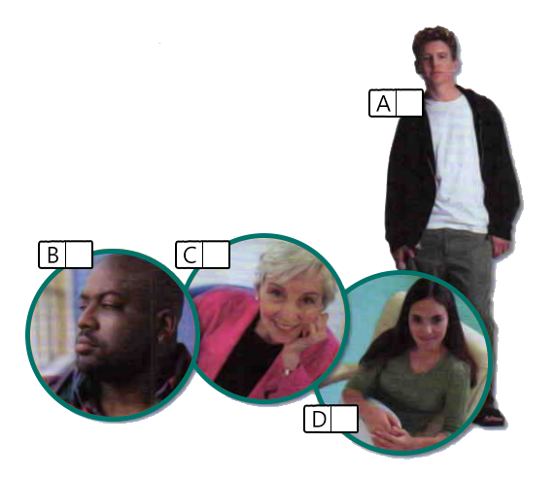
A
B
C
D

4. Describe Harry Potter characters .
- Cho Chang has…
___________________
__________________
_________________
_________________
_________________
___________________
2.Draco Malfoy has…

_____________________________
_____________________________
_____________________________

3.Luna Lovegood has…
_____________________
____________________
____________________
____________________
_____________________
_______________________
_________________________
4. Severus Snape has… __________________________________________________
__________________________________________________
__________________________________________________
_________________________
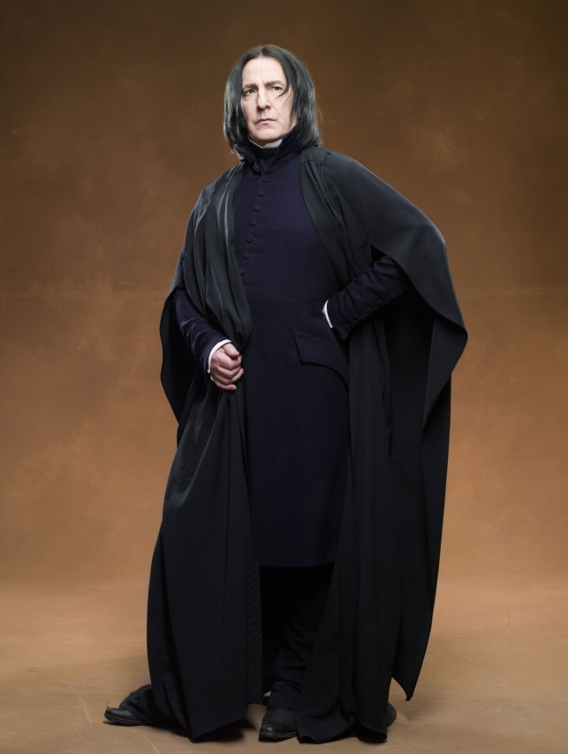
Module 2 – Food & Shopping
Ex. 1
page 28
Do you prefer online shopping or going to a mall? Did you ever regret what you bought?
1. Try to learn the key words.
Key words:
a department |dɪˈpɑːtm(ə)nt| – отдел (в магазине) (the book/electrical department)
a pound (£) |paʊnd| – фунт
a fiver |ˈfaɪvə| – пять фунтов
to throw in – предложить что-то еще в качестве бесплатного бонуса
*Между «throw» и «in» можно использовать существительное или местоимение.
to take ages = to take a very long time

2. Listen to three dialogues.
Read the statements and decide if each of them is true, false or not given.
Dialogue #1: Speaker B
a) recommends that speaker A takes the lift (T/F/NOT GIVEN)
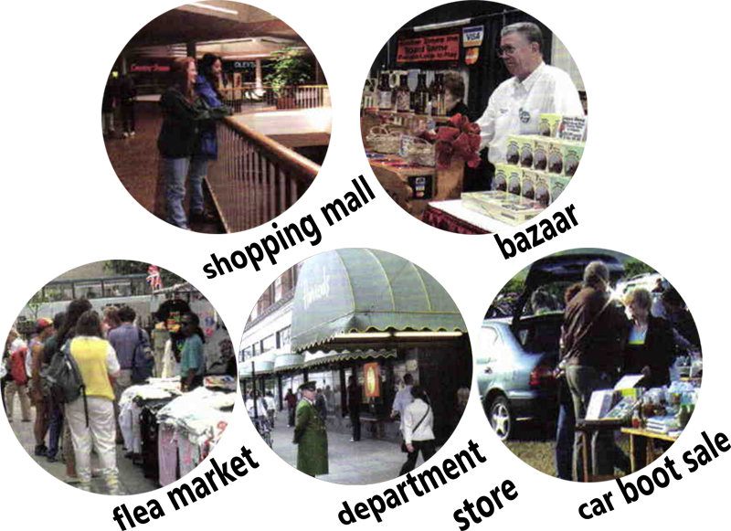
b) says that speaker A can take both the lift and the escalator (T/F/NOT GIVEN)
Dialogue #2: Speaker B
a) wants to give away the cassette player (T/F/NOT GIVEN)
b) is lying about the condition of the player (T/F/NOT GIVEN)
Dialogue #3: Speaker A and speaker B
a) decide to go for a coffee first (T/F/NOT GIVEN)
b) really love shopping (T/F/NOT GIVEN)

3. Listen to the dialogues once again. Decide in which of the places in the pictures (p. 16) they are taking place.

1
2
3

4. Imagine that you are at the florist's. You want to buy something. Make up a micro-dialogue with a salesperson.

For example,
Notes:
A: Good morning, can I help you?
B: Good morning! Yes, please. I need a large bouquet.
A: What’s the occasion?
B: Oh, I want to surprise my friend with a “just because” gift. She likes tulips.
A: I see! Here are they. Tulips are fresh, I just brought them.
To be continued!

Ex. 7
page 33
How often do you eat out? What makes a good restaurant?
1. Try to learn the key words.
Key words:
to feel like sth / doing sth – захотеть сделать что-либо, хотеть(ся)
the other day – недавно
to eat like a horse = to eat a great deal
to be full – насытиться

a let-down – разочарование (что-то произошло не так, как вы ожидали)
a queue |kjuː| – очередь
to mix up – перепутать
ridiculous |rɪˈdɪkjʊləs| – абсурдный, смехотворный, возмутительный
to overcharge |ˌəʊvə(r)ˈtʃɑː(r)dʒ| – назначать завышенную цену
to sort sth out – улаживать (проблему)
2. Complete the sentences.
A) 1) The new sushi place is located next to ____________________________.
2) The Italian restaurant is located opposite ____________________________.
3) The food was _________.
4) The staff are ____________________________.
B) 1) The new restaurant down the road was a total let down, because, first of all ____________________________.
2) The service was ____________________________.
3) The waiter not only mixed up the order but also _______________________.
4) The food was ___________, and the prices _________________________________________________________.

3. Look at the phrases. Which of the dialogues do they belong to?
When we left, I was still hungry.
The prices turned out to be reasonable.
The waiter mixed up our order.
I wouldn’t recommend it.
There was a really long queue.
First of all, there were so many dishes to choose from.
They overcharged us.
The portions were huge!
I was really full when we finished.

4. Let's play a little game called, 'Have you ever...'
You can read through the questions and mark the answers that are things you've done.
- Have you ever...had food or a drink spilled on you at a restaurant?
I have/I have NEVER.
- Have you ever...ordered food in English?
I have/I have NEVER.
- Have you ever...eaten at a restaurant that served terrible food?
I have/I have NEVER.
- Have you ever...eaten at a restaurant and felt you could’ve made better food?
I have/I have NEVER.
- Have you ever...been served something that you weren’t sure how to eat the “proper” way?
I have/I have NEVER.
- Have you ever...eaten in a restaurant and realized you can’t pay?
I have/I have NEVER.
- Have you ever...returned food at a restaurant?
I have/I have NEVER.
- Have you ever...eaten like a horse?
I have/I have NEVER.
- Have you ever...eaten sth a restaurant even though it wasn't what you had ordered?
I have/I have NEVER.

Module 3 –
Great Minds
Ex. 6b
page 45
You are studying at school and want to start working part-time. Where and how could you work in your free time? Give some examples.
1. Try to learn the key words.
Key words:
a part-time job | pɑːt taɪm ʤəʊb| – работа на неполный рабочий день

a shop assistant
| ʃɒp əˈsɪstənt| – по-своему
over(age) |ˈəʊvə| – старше (какого-то возраста)
enthusiastic | ɪnθjuːzɪˈæstɪk| – воодушевленный
well-organised | wel ˈɔːgənaɪzd| – хорошо организованный
definitely |ˈdefɪnɪtlɪ| – определенно, конечно

to work flexible hours |wɜːk ˈfleksəbl ˈaʊəz| – работать с гибким графиком
to interrupt | ɪntəˈrʌpt| – нарушать
to manage sort of duties |ˈmænɪʤ sɔːt ɒv ˈdʒuːtiz| – выполнять какие-то обязанности
to carry out |ˈkæri aʊt| – выполнять
to serve customers |sɜːv ˈkʌstəməz| – обслуживать клиентов
a previous experience |ˈpriːvɪəs ɪksˈpɪərɪəns| – предыдущий опыт (работы)
a pay | peɪ| – зарплата, выплата

2. Listen to the recording and match the statements.
1) We need someone who is communicative and well-organised. | a) What sort of duties will I have to carry out?
2) Is there anything you would like to ask me about the job? | b) Yes, I am.
3) Are you over sixteen years old? | c) Oh, that’s great.
4) We would need you to work flexible hours. | d) I can say this about myself.
5) Are you here about the part-time job? | e) I can work this way.
6) You don’t need to have any previous experience and we will train you when you start. | f) Yes, I’m eighteen.
1
2
3
4
5
6

Notes:

3. Open your Student’s Book on page 45 and complete task 6b. Complete the missing information.
Is looking for a part-time shop assistant
Are you:
- over 1) ……… years old?
- enthusiastic and 2) …………… ?
- able to work flexible 3) …………..?
Join us
Your duties will include:
- 4) …………….. customers.
- taking 5) ………….
No previous experience required – full training given.
Pay: 6) ………………
For more information
call 020 7310 8821

4. You want to get a job, but you are 16 years old. What can you do for a living?
F.e.: I can work as a waiter.

5. Try to make up a dialogue using the example in exercise 3 and add your phrases to it. Imagine that you want to apply for a job as a waiter/waitress.
Skills and qualifications:
– minimum age requirements;
– customer service skills;
– critical thinking and time management; etc.
Duties and responsibilities:
– to greet guests and take drink and food orders;
– to ensure the food order is made correctly by kitchen staff;
– to deliver food from the kitchen to the guests;
– to remove dirty
plates; etc.
Ex. 6a
page 49
1. Try to learn the key words.
Key words:
a husband |ˈhʌzbənd| – муж, супруг to leave behind | liːv bɪˈhaɪnd| – оставлять, оставлять позади
to regret |rɪˈɡret| – сожалеть, раскаиваться
to be promoted | bɪ prəˈməʊtɪd| – получать повышение to apply for a job | əˈplaɪ fɔː æ ʤəʊb| – подавать заявление о приеме на работу
a responsibility |rɪˌspɒnsəˈbɪləti| – ответственность
a course | kɔːs| – курс, учебный курс
upset | ʌpˈset| – расстроенный, огорченный
own | əʊn| – собственный, родной
eventually |ɪˈventʃuəli| – в итоге, в конечном счете
a tap | tæp| – кран
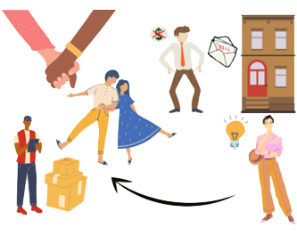
a solution |səˈluːʃ(ə)n| – решение

2. Look at the pictures and guess what's going on. Answer the questions.

A) Where does the boy study?
Did the boy have to go to another city?
Did his parents go with him?

B) Does a man have money?
What did he have to do to pay the bills?
Who did he live with?

3. Which situation do you like most? Why?

4. You will hear 5 speakers. Choose the correct answer a, b or c. You will hear the recording twice.

1) They had to change their place of residence and …
a) buy a new house.
b) leave behind their relatives and friends.
c) drive 300 miles in searching of a job.
2) At his previous job there was…
a) no money to pay taxes.
b) lots of money and responsibilities.
c) no opportunity to earn a lot and develop.
3) It’s still difficult for him to…
a) go to university.
b) be away from his parents.
c) choose the course to study.
4) To solve the problem with the bills, he decided to…
a) live with someone else.
b) ask Sofia to lend him money.
c) start living a new life.
5) Grandpa was constantly forgetting things and he…
a) left the tap on in the bathroom.
b) came to live with his family.
c) started being checked by us every hour.

5. Open your student’s book on page 49 and complete task 6a. Listen to the recording and choose statements (A-F) for each speaker.
A. I couldn’t pay the bills.
B. His family didn’t want him to live alone.
C. I still miss my family.
D. We had to find a new house.
E. I didn’t want to go somewhere new.
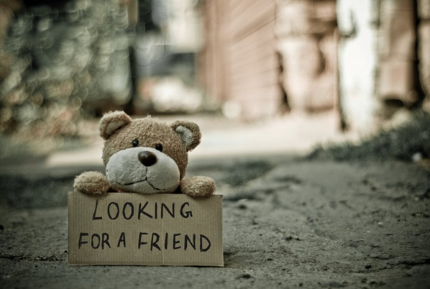
F. I wanted better job opportunities.
1
2
3
4
5

Notes:

6. Imagine that you were offered a job/studying abroad. Would you agree to that? Why? What problems can you face? Write 5-10 sentences.

Module 4 –
Be Yourself
Ex. 8
page 61
Think and tell what you are wearing now. Would you wear it to a party? Why? What would you wear then?
1. Try to learn the key words.
Key words:
a mall |mɔːl| – торговый центр
to go shopping on your own |ɡəʊ ˈʃɒpɪŋ ɒn jə(r) əʊn| –самостоятельно совершать покупки
a birthday party |ˈbɜːθdeɪ ˈpɑːtɪ| – вечеринка по случаю дня рождения
to match | mætʃ| – совпадать, соответствовать
formal |ˈfɔː(r)m(ə)l| – формальный, официальный
a particular one |pəˈtɪkjʊlə wʌn| – конкретный
to be/take long – занимать много времени / ALWAYS IN NEGATIVES OR QUESTIONS
a notice | ˈnəʊtɪs| – уведомление
a fitting room |ˈfɪtɪŋ ruːm| – примерочная
fabulous |ˈfæbjʊləs| – потрясающий, невероятный

2. Listen to the recording again and choose the correct answer.
1) What celebration does Ann have?
a) Halloween
b) Birthday
c) Easter
2) What does she want to buy?
a) a shirt
b) a dress
c) a skirt
3) What colour of a shirt does Steve prefer?
a) black
b) blue
c) yellow
4) What size did Ann ask for a shirt?
a) small
b) medium
c) large
5) Did she agree with Steve in the end?
a) Yes
b) No
c) She called her mother to ask

3. Open your Student’s Book on page 61 and make task 8. Choose the correct answer (True, False or Not Stated).
1) Ann wants to buy a plain black shirt.
A. True B. False C. Not Stated
2) Steve thinks black doesn't suit Аnn.
A. True B. False C. Not Stated
3) Ann doesn't wear bright colours.
A. True B. False C. Not Stated
4) Steve and Ann don't have much time for shopping.
A. True B. False C. Not Stated
5) Ann can't go to her favourite shop.
A. True B. False C. Not Stated
6) The shop doesn't have any black shirts.
A. True B. False C. Not Stated
7) Ann eventually buys a yellow shirt.
A. True B. False C. Not Stated

4. Imagine that you have been invited to the prom, but you have nothing to wear. Make up a similar dialog between you and your friend.
Notes:

5. You can see different outfits. Which outfit would you choose and where can you wear it?

Module 5 – Global Issues
Ex. 3
page 76
1. Try to learn the key words.
Key words:
to prevent | prɪˈvent| – предотвращать
proper | ˈprɒpə(r)| –правильный, подходящий
(a) medicine |ˈmed(ə)s(ə)n| – лекарство (особ. жидкое) / to take medicine
a large-scale disaster |lɑːʤ skeɪl dɪˈzɑːstə| – крупномасштабная катастрофа
to destroy |dɪˈstrɔɪ| – разрушать
an emergency |ɪˈmɜː(r)dʒ(ə)nsi| – чрезвычайная ситуация

charity |ˈtʃærəti| – благотворительность
the Earth |ɜː(r)θ| – Земля
labour |ˈleɪbə(r)| – труд
to wipe out |waɪp aʊt| – уничтожить, стереть с лица земли
warfare |ˈwɔː(r)feə(r)| – военные действия
a cause |kɔːz| – причина
mankind |mænˈkaɪnd| – человечество
2. What global issues can you see in these pictures? What do you know about them? Try to answer the questions.
Why are animals dying out?
Why are many people currently starving?
How to get rid of poverty?
What could be the consequences of these global issues?
A. B.
C. 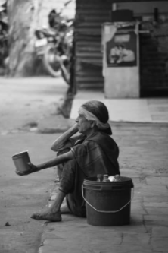
1
2
3
4
5
6
D.

3. Listen to the recording. What problems are the speakers talking about? Match global issues (a-f) to each speaker.

a) Global warming
b) War
c) Endangered species
d) Pollution
e) Homelessness
f) Child labour

4. Answer the questions. Make up 2-5 sentences.
1) How do we help animals?
2) What is the result of climate change?
3) Why should people live in peace and stop starting wars?
Notes:

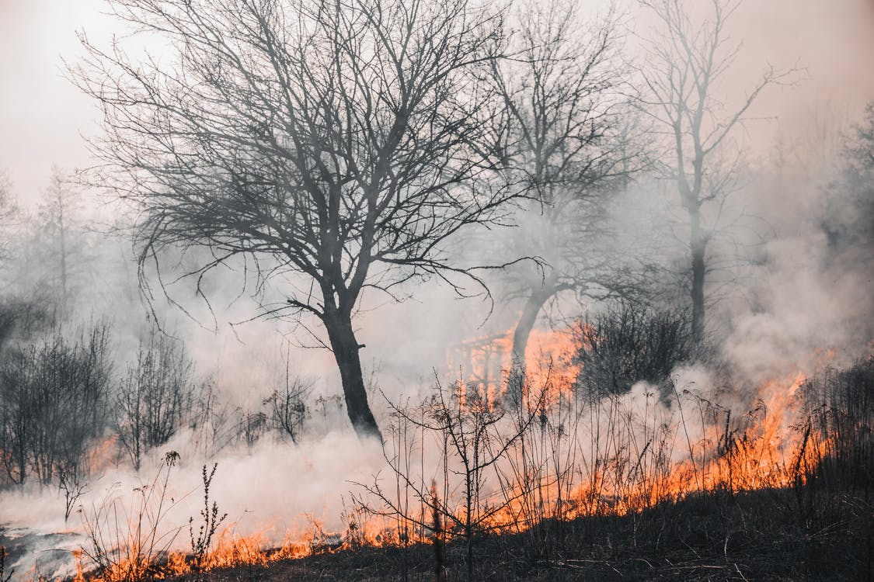

5. Imagine that you are a scientific researcher. You need to choose one of the disasters that you worry about and tell how to avoid it. Make up 5-10 sentences using your Student’s Book.

Ex. 5
page 83
1. Try to learn the key words.
Key words:
litter |ˈlɪtə(r)| – мусор (в общ. месте)
a tin |tɪn| – консервная банка
to spill |spɪl| – проливать
a rubbish bin |ˈrʌbɪʃ bɪn| – урна для мусора
a neighbourhood |ˈneɪbə(r)ˌhʊd| – определенный район города
a council |ˈkaʊns(ə)l| – орган местного самоуправления
a recycling scheme |riːˈsaɪklɪŋ skiːm| – программа утилизации отходов
household |ˈhaʊshəʊld| – домашний
to reduce | rɪˈdjuːs| – уменьшать
to fine |faɪn| – штрафовать
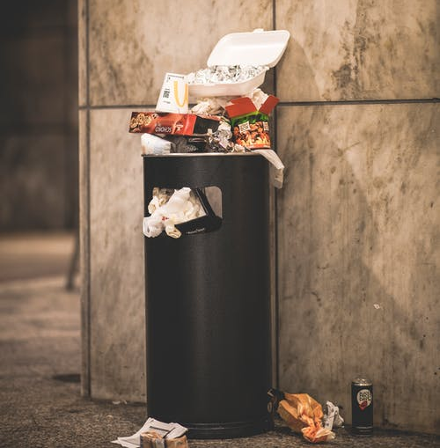
2. Look at the words. Underline the things that can be recycled for secondary raw materials.
garden waste food tins
paint fridges and TV’s
metal clothes
glass electronics
plastic textiles
food old newspapers motor oil cardboard
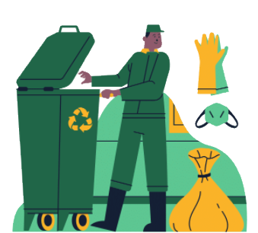
batteries

3. Complete the sentence.
If it isn’t litter in the park and on the streets then it’s
__________________________________________________________
4. Open your Student’s Book on page 83 and make exercise 5. Listen to the recording and match the suggestions to the results. Then listen and say which ideas Sally mentions in the conversations.
Suggestions:
- Fine people who litter.
- Get young people involved in clean-up programmes.
- Set up recycling schemes in your area.
- Only buy products with biodegradable¹ packaging.
¹things that can break down or decompose on their own.
Results:
a) If people know that they will have to pay if they litter, they will stop doing it.
b) This way landfill sites will not become so full.
c) They will become interested in keeping parks and their neighborhoods clean and tidy.
d) Household rubbish will be put to good use and the amount of garbage will be greatly reduced.
__________________________________________________________

5. Imagine that you are a volunteer participating in a recycling programme. What would you recycle? How would you recycle it?
Notes:

Module 6 – Cultural Exchanges
Ex. 4
page 92
1. Try to learn the key words and answer the questions.
a) Key words:
sunstroke |ˈsʌnˌstrəʊk| – солнечный удар
seasick |ˈsiːˌsɪk| – страдающий морской болезнью
b) Questions:
Greece, Italy and Spain, what do these countries have in common?
Where would you spend your holidays?
Do you like the climate of this country?

2. Listen and mark the statements True or False.
1) Bella spent her holidays only in Greece.
1) True
2) False
2) She got a seasick in Greece.
1) True
2) False
3) Her purse was stolen while she was waiting for a bus.
1) True
2) False
4) Money was still in purse.
1) True
2) False
5) These things didn’t spoil Bella’s holiday.
1) True
2) False
6) She wants to go back.
1) True
2) False

3. Listen to the recording again and match the sentences from the dialog.
1) What happened?
2) Don’t make me jealous, tell me about it.
3) That’s bad luck.
4) The important thing is that you’re back safe and sound.
5) How was your holiday?
6) Did you manage to go to Spain?
7) I got seasick on the ferry.

a) It was fantastic!
b) That’s true!
c) Oh, poor thing! Hope it didn’t spoil your holiday.
d) I know, but I didn’t let it spoil my holiday.
e) Maybe next year.
f) My purse was stolen.
g) Greece was amazing, I took a lot of pictures.
1
2
3
4
5
6
7
h) Yes, but I had a bit of trouble.

Notes:

4. Write a small dialogue based on the example from the Student’s Book. You can use your imagination and visit other countries and cities.

Speaker | Sophie | Peter | Greg
Statement
Ex. 4
page 96
1. What types of transport do you know? Which of them are shown in the pictures?

2. Match the statements with the speakers.
a) Travelling by boat is the best.
b) Travelling by train is most comfortable.
c) This speaker doesn’t like travelling by bus.

3. What type of transport do you prefer most of all? Why? Make up 2-5 sentences.
Notes:

4. Imagine that you are going to spend your holidays in Venice. What type of transport is most comfortable? Why?
Module 7 – Education
Ex. 8
page 109
Answer the questions.
1. Do you like schooling? Why?
2. What school subjects do you like learning at school? Why?
3. Do you have fun in the lessons or feel bored?
4. Do you feel scared when you answer in class?
5. How do you usually feel when you have an exam?

1. Read the words and word combinations, transcriptions and translation.
to manage |ˈmænɪdʒ| – преуспеть в выполнении или решении чего-либо
due to |dʒuː| – благодаря, вследствие
a canteen |kænˈtiːn| – столовая (в школе, на заводе и т. п.)
(a) delay |dɪˈleɪ| – задержка
to board sth |bɔːd| – садиться (на автобус/корабль/в самолет)
disappointed |dɪsəˈpɔɪntɪd| – разочарованный
(a) detention |dɪˈtenʃ(ə)n| – оставление после уроков (как наказание) experience |ɪkˈspɪəriəns | – опыт
a position |pəˈzɪʃ(ə)n| – место, должность

2. Listen and number the statements in the order you will hear them.
A. If I feel nervous it is not easy for me to study.
B. I was able to do all the work on time.
C. This is a great opportunity to have a position in this company.
D. Lessons and lunch break will end earlier today.
E. He mustn’t write anything on the school walls.

3. Listen to the speakers. Choose a, b or c.
1. Listen to a boy talking about an exam. How does he feel?
a) disappointed b) happy c) angry
2. Listen to the announcement. Where would you expect to hear it?
a) at school b) in the cinema c) in a gym
3. Listen to a girl talking about her French teacher. What is the problem?
a) She never marks the homework. b) She's very strict. c) She's often absent.
4. Listen to a teacher talking about an incident at school. Why was the student kept back after school?
Notes:

a) He was caught hitting another pupil. b) He was caught copying in an exam. c) He was caught writing graffiti in the school corridors.
5. Listen to a woman talking. What did she do well in?
a) her driving test b) her oral exam c) her job interview

4. Think and continue each story. Present it to the class

Module 8 – Pastimes
Ex. 8
page 125
1. Choose a card and name the kinds of sport or a game according to the definition.
A game for two people played by striking a ball with rackets over a net.
This sport is played on a large open field where players can only use their feet to kick a ball into a goal.

This sport is the movement of the body through water using arms and legs.

This sport is the activity of travelling down snowy slopes using a specially shaped board.

This sport is the activity of moving on ice, wearing boots with thin metal bars.

Say what sport you play and what you like about it.

2. Read the words and word combinations, transcriptions and translation.
to take part | teɪk pɑːt| – принимать учатсие
different |ˈdɪf(ə)r(ə)nt | – разный
a tournament | ˈtʊənəmənt| – турнир
to miss – пропускать
a rush of energy |ə rʌʃ ɒv ˈenədʒi| – прилив энергии
therapy | ˈθerəpi| – терапия, лечение
to carry on | ˈkæri| – продолжать
to take seriously – серьезно относиться к / принимать всерьез
to compete |kəmˈpiːt| – состязаться, соревноваться
a competition |ˌkɒmpəˈtɪʃən | – состязание, соревнование

3. Read the statements. Listen to the radio interview with some British teenagers talking about their sporting experiences. Who says what? Write the speakers’ numbers.
A. It used to be fun but now I take it seriously. ____
B. I don’t care about prizes and competing. ____
C. Such a sport is a very important thing in my life. ____
D. I feel adrenaline rush doing this. ____
E. I actually like it. ____

1
2
3
4
5
4. Do ex. 8 (p.125) in Student’s book Unit 8b.
Notes:

5. Speaking:
1) What sports would you like to do? Explain your choice.
2) You and your friend want to take part in competitions. Discuss the possibility of preparing.
3) Imagine you are a radio DJ. Find the information about what’s on in our settlement (town) this week and prepare a radio announcement.

Tapescripts
1A
Ann: I consider myself to be the sort of person who enjoys other people’s company. I like to meet new people and I love to chat.
Sue: I like to do things my own way and I don’t listen to other people even if deep down I know that what they are saying makes sense.
Billy: I don’t think there’s anything wrong with putting yourself first. I mean, let other people worry about themselves. We’ve all got our own problems and I always look after my own needs before I think about anyone else.
1B
Interviewer: I spoke to some young people to find out about their relationship with their family.
Speaker 1: I often feel lonely at home. Both my parents work so I spend a lot of time alone. It’s not that I don’t have anything to do but I’m desperate for some company. If I had a brother or a sister, my life would be a lot different.
Speaker 2: Many of my friends complain about their parents being old-fashioned and strict. Luckily, I don’t have such problems at home. I can discuss anything that troubles me with my parents without being afraid that they will criticize me.
Speaker 3: I live with my parents, my two sisters and brother and my grandparents. I never feel bored or lonely at home but I sometimes wish I could do my own thing without being interrupted by anyone.
Speaker 4: I believe old people are great company. You can learn a lot from them about the past and they can give you useful advice about the present. l enjoy spending time with my grandparents and I visit them regularly for lunch.
Speaker 5: I find communicating with my parents almost impossible. Dinner time is the only opportunity for us to see each other and discuss things but we always end up fighting over something. They seem incapable of seeing things from my point of view.
1D
Al: Hey Jane, I hear you’ve got a new neighbour. What does she look like?
Jane: She’s very tall and has long brown straight hair. She’s also slim and rather pretty.
Al: Umm... she sounds great.
Jane: Yes, she’s a lovely girl. She’s friendly and has a great sense of humour, too. Oh, and she loves photography. Just like me.
Al: What’s her name?
Jane: Laura, Laura Smith.
Al: Who was that man I saw you with in the town centre last week?
Jane: Which one?
Al: He was a bit on the plump side and not very handsome.
Jane: I can’t think who you mean. Did he have a beard and a moustache?
Al: Yes, and he was almost bald.
Jane: That was my uncle, Roger. We were shopping for shoes.
Al: Have you met the professor at college yet?
Jane: No, why? Is she nice?
Al: She is, actually. She’s very talkative, not dull and boring like Mrs Brown. The whole class wasn’t falling asleep for once during the lesson!
Jane: That’s good. I saw a short thin woman going into your classroom earlier. Was that the new teacher?
Al: No, no. Mrs Jones is in her early fifties, has short white hair and is about average height.
Jane: I’ll look forward to meeting her.
Al: Who’s that young man over there?
Jane: Which one?
Al: The one with short curly fair hair and green eyes.
Jane: Is he holding a rucksack?
Al: Yes, he is.
Jane: That’s my cousin, Bill.
2B
1. A: Excuse me. Can you tell me how to get to the menswear department, please?
B: Certainly. It’s on the third floor. You can take the lift which is on your left or the escalator over there.
A: Thank you very much.
B: You’re welcome.
2. A: Excuse me, how much is this cassette player?
B: It is £7.50 but I’ll let you have it for a fiver.
A: I’m not sure.
B: It’s in very good condition. It was my son’s and he has looked after it. I’ll even throw in a couple of tapes for free.
A: Oh, alright then. Five pounds. Here you are.
3. A: Let’s go in this boutique. I want to look at that dress.
B: All right but don’t take ages. I want to go to the bookshop.
A: OK. Then we can go for a coffee. There’s a nice coffee shop on the upper level.
B: Right. Agreed
2D
1. A: Do you want to go and get something to eat?
B: Yeah. Do you have anywhere in mind?
A: We could try that new sushi place, next to the post office.
B: Sorry, but I don’t really feel like sushi. Do you know anywhere else?
A: What about that Italian restaurant opposite the university?
B: Right. Have you been there before?
A: Yes, we went after class the other day and I ate like a horse!
B: Really?
A: Yes. First of all there were so many dishes to choose from. The food was great and the portions were huge! I was really full when we finished. Plus, the staff are friendly and fun!
B: Why waste another minute then? Let’s get going!

2. A: What do you think about that new restaurant down the road?
B: Oh, I wouldn’t recommend it. We went there the other day and it was a total let down.
A: Why? What’s wrong with it?
B: First of all, there was a really long queue. It took us 45 minutes to get seated.
A: Really? Was the service quick at least?
B: No, the service was really bad. The waiter mixed up our order. He also spilled Coke all over me! My white shirt was totally ruined!
A: Oh, no! What about the food?
B: It was so spicy that I barely touched anything. When we left I was still hungry.
A: And the prices?
B: At first we thought it was ridiculously expensive but then we realised that they overcharged us. After sorting that out, the prices turned out to be reasonable but I’m not going back there ever again!
A: I can see why!
3B
A: Good afternoon Miss Shields. Are you here about the part-time shop assistant job?
B: That’s right.
A: Great… I have a few questions to ask you, so please take a seat.
B: Thank you.
A: Firstly, I see you are still at school. Are you over sixteen yet?
B: Oh, yes. I turned sixteen a month ago.
A: Now, we need someone who is enthusiastic and well organised.
B: I’m definitely both of those things, well, according to my teachers anyway.
A: Now talking of teachers, we would need you to work flexible hours. Do you think the job would interrupt your lessons?
B: No, I’m sure I can manage it. Remember, I’m very well organised!
A: So, is there anything you would like to ask me about the job?
B: Yes, actually. What sort of duties will I have to carry out?
A: Oh, lots of things. You will have to serve customers and take payments and much more.
B: I was a little worried, as I haven’t worked in a baker’s before.
A: There’s no need to worry. You don’t need to have any previous experience and we will train you when you start. One last thing you might like to know is that the pay is 5 pounds fifty an hour.
B: Oh, that’s great. Thank you very much.
A: OK, when do you think you can you start?
3D
Speaker 1
A year ago my husband got a great new job, but there was only one problem…it was 300 miles away! We had to move house and leave behind our friends and family. But we don’t regret it. It was difficult for the first few months, but now we love it here.
Speaker 2
I loved my job at first, but I slowly realised that I had no future there. There was no chance of being promoted or earning more money. So, I applied for a job at another company, and here I am now, in a new job with more money and responsibility.
Speaker 3
My family is very close, so I found it difficult when I had to go to university. The course I wanted to do was miles away, so I had to leave home and go and live near the university. I was very upset when I left, but after a while I began to enjoy myself. Of course, it’s still
difficult being away from my family, but I visit them most weekends.
Speaker 4
At first I was really excited about finding my own flat, but after a while, I found it difficult to afford the bills. So, I tried to find someone to share the flat with. I eventually found Sophia. She is a wonderful girl and we have become great friends and I don’t have to worry about money so much anymore!
Speaker 5
Grandpa had never lived on his own, so we were really worried about him. We checked on him every day, but he kept forgetting things and one day he left the tap on in the bathroom and water went everywhere. In the end he came to live with us. It was the perfect solution to the problem.
4B
A: Thanks for coming to the mall with me Steve. I don’t like shopping on my own.
B: No problem Ann. So, what do you want to buy today?
A: Well, I want to wear something really special at my birthday party tomorrow. I have a nice black skirt and I want a black shirt to match.
B: Why black? I mean it suits you but how about choosing something in a brighter colour?
A: I don’t think it would look formal enough.
B: I see. We’d better hurry though, because the shops will be closing in an hour. You kind of left your shopping till the last minute.
A: I know but I have a particular shop in mind where I buy most of my clothes. It won’t take us long to find something there.
B: Where is it then?
A: Right here.
B: But it’s closed!
A: Oh no! But wait a minute. There’s a notice on the door. It says that it’s moved to the second floor.
B: Thank goodness! Let’s go.
C: Good afternoon. May I help you?
A: Yes. I’m looking for a black shirt. Have you got any?
C: Yes, we have this one here, or this one.
B: Ann, look at this yellow one! It’s lovely!
A: Yellow? Oh, I don’t know, Steve.
B: Come on, just try it on. You might like it!
A: Oh, OK then. Have you got this in a medium?
C: Yes, here you are. The fitting rooms are over there.
B: Ann, this looks great on you.
A: Yes, doesn’t it? I think I’ll have it.
B: Great! You’ll certainly look fabulous tomorrow!

5B
Interviewer: We spoke to some young people to find out their opinion about some current global issues.
Speaker 1: I know it seems hard to believe in this day and age but in some parts of the world people don’t even have clean water to drink. They can become ill really easily and die. Also many children around the world die from infections or illnesses that could be prevented by giving them the proper medicine.
Speaker 2: There have been a number of large scale disasters around the world lately which have destroyed many people’s homes and left them with nowhere to live. That’s why I think an international emergency housing charity or scheme should be set up to help rebuild them.
Speaker 3: Extreme weather is one result of climate change which is what happens when the planet heats up. We all need to do our bit to help cool the planet down and stop the earth’s temperature from rising any more.
Speaker 4: I have a part-time job because I choose to work to earn some extra money. But I would not like to have to do hard labour all day every day for very little pay from the age of 6 or something to look after my family - that’s just not fair!
Speaker 5: It’s terrible. One by one all the animals will die out until there are only humans left. There may be animals we haven’t even discovered yet and we never will because they have been wiped out by mankind.
Speaker 6: National and international conflict and warfare has caused more death and destruction than anything else in the history of the world. We should all learn to live in peace and stop starting wars over political or religious differences. Why can’t people just agree to disagree?
5E
(A = Sally, B = Janie)
A: Hi, Janie. Why are you looking so glum?
B: Oh, I don’t know. It’s just …. Well, it’s just that it seems that everywhere I look nowadays all I see is litter, litter and more litter. If it isn’t litter in the park and on the streets then it’s tins, bottles and old newspapers spilling out of rubbish bins. It drives me mad.
A: Yes, I know. I’ve noticed it too. What really makes me angry is that it would be so easy to fix the problem.
B: What do you mean?
A: Well, just think about it for a second. Let’s say a bunch of people in our neighbourhood got together and told the council that we wanted a recycling scheme set up. If there were enough of us, it would have to listen. And if we had a recycling scheme then household rubbish would be put to good use and the amount of rubbish generally would be greatly reduced.
B: Wow. You know I’ve never thought about that Sally.
A: And not only that. People who litter should be fined. When people know that they will have to pay if they do something bad, they stop doing it!
B: You know, that’s true. Sometimes you have some really good ideas … (fade)
6D
Sophie: I usually travel by bus but I don’t really like to. You wait at the bus stop for ages and then when the bus does finally come, it’s really crowded. I prefer cycling. I love travelling by bike. You don’t get stuck in traffic, it’s free and it keeps you fit, too. All my friends go to school on their bikes but my mum won’t let me. She says it’s too dangerous.Peter: My favourite means of transport is actually the train. It’s usually a fast way to travel and I love looking out of the window at the beautiful countryside. I don’t mind travelling by car, either, but I live in a big city so there’s always a lot of traffic, which of course I don’t enjoy. On the whole catching the train is a more pleasant way to travel, in my opinion.
Greg: When we go on holiday as a family, we either go by coach, plane or boat. I’m not very keen on travelling by coach because you can’t move around a lot and the journey can be really long. I love it when we go by boat because you can walk around or go outside and look out to sea. It’s a really interesting way to travel. Travelling by plane’s OK, too, because it’s usually the fastest way to travel, but sometimes I feel nervous of flying and the seats can be quite uncomfortable.
7B
1. Teenage boy: I felt really nervous when I went into the exam room as I was expecting the worst. I thought the questions would be much harder, actually. But, thankfully, I managed to answer everything quite easily and I had plenty of time to check my work at the end. I am so happy it’s all over! I just have to wait for the results now!
2. Headmaster: Due to the bad weather we will be closing after lunch today. Lesson five will end at 12.45 and the lunch break will last forty minutes, not the usual fifty. When the bell rings, year 7 and 8 pupils should go to the canteen without delay so that everyone can have their lunch quickly. At the
end of the lunch break you should board your bus immediately.
3. Teenage girl: I like learning French but I wish we could have more fun in the lessons. I can’t relax in Mrs Muroe’s class. It is really difficult to learn when you are feeling scared. When I answer in class she always corrects every little thing ― I get so nervous now! And when I get my homework back I am almost always disappointed. She never gives me an A or a B, only a C.
4. Male teacher: There will be another student in detention today, Mr Kerr ― Jason Greene. This is the second time this year that I have caught him decorating the walls of the Science block. He must learn to respect the school building. He should find somewhere else to use his artistic talents, if you ask me.
5. Young woman: I think I did well! I was in there for over an hour! They were really interested to hear about my experience in marketing and sales. I spoke a lot but I also asked a lot of questions as well. I am really interested in working for them ― they’re a good company and there would be possibilities for promotion in a few years. Anyway, let’s hope they offer me the position!
8B
Interviewer: We spoke to some young people to find out about what sports they play and what they like about them.
Speaker 1: I love tennis. I’ve been playing since I was quite young. At first I used to play first for fun, but now I take part in different tournaments around the country. I’ve even won some prize money!
Speaker 2: Football is my life and I play as often as I can. Recently, I left my boots in another team’s changing rooms and I missed a match because I didn’t realise. I was more upset about that than losing my boots.
Speaker 3: In the winter, I go snowboarding as often as I can. Even though I’ve been doing it for a long time now, still nothing beats the thrill of sliding fast down a mountain. It still gives me a real rush of energy and an amazing feeling of excitement every time I do it.
Speaker 4: I started swimming as part of my therapy after I broke my leg. After my leg was better, I carried on going because I loved it so much. I go at least three times a week now.
Speaker 5: My sport is ice skating. I’ve been doing it for quite a long time now, but I don’t take it very seriously. I’m not at all bothered about competing. I just do it because I enjoy it and for the exercise.

Keys
1A
1. 1-a 2-c 3-b 4-b 5-a 6-c
2. Ann - sociable Sue - stubborn Billy - selfish
3. Lily-Billy Fred-Sue Iris-Ann
1B
2. 1-a 2-b 3-b 4-a 5-a
3. 1-d 2-c 3-a 4-f 5-e
4. 1. F 2. F 3. T 4. T 5. F
1D
2. neighbour, photography, Laura, plump, handsome, moustache, uncle, shopping for shoes, dull, boring, fifties, rucksack
3. 1-d (Laura Smith) 3-c(Mrs Jones) 2-b (Roger) 4-a (Bill)
2B
2. 1. F, T
2. F, NOT GIVEN
3. F, NOT GIVEN
3. The dialogues are taking place in a department store, at a car boot sale and in a shopping mall.
2D
2. А) 1-the post office 2- the university 3-great 4- friendly and fun
B) 1-there was a really long queue 2-really bad 3-spilled Coke all over me 4-so spicy that the speaker barely touched anything, turned out to be reasonable
3. First dialogue: First of all, there were so many dishes to choose from.
The portions were huge.
I was really full when we finished.
Second dialogue: When we left I was still hungry.
The prices turned out to be reasonable.
The waiter mixed up our order. I wouldn’t recommend it.
There was a really long queue.
They tried to overcharge us.
3B
3. 1-d 2-a 3-f 4-e 5-b 6-c
4. 1-sixteen 2-well-organised 3-hours 4-serve 5-payments 6-5 pounds
3D
4. 1-b 2-c 3-b 4-a 5-a
5. 1-d 2-f 3-c 4-a 5-b
4B
2. 1-b 2-a 3-c 4-b 5-a
3. 1-a 2-b 3-c 4-a 5-c 6-b 7-a
5B
3. 1-d 2-e 3-a 4-f 5-c 6-b
5E
2. metal, clothes, plastic bottles, textiles, old newspapers, cardboard, glass, electronics
3. tins, bottles and old newspapers spilling out of rubbish bins
4. 1-a 2-c 3-d 4-b
6B
2. 1-f 2-f 3-t 4-t 5-t 6-t
3. 1-f 2-g 3-d 4-b 5-a 6-h 7-c
6D
2. a-Greg b-Peter c-Sophie
7B
2. a-3 b-1 c-5 d-2 e-4
3. 1-b 2-a 3-b 4-c 5-c
8B
3. a-1 b-5 c-2 d-3 e-4
4. 1-b 2-f 3-c 4-a 5-e

