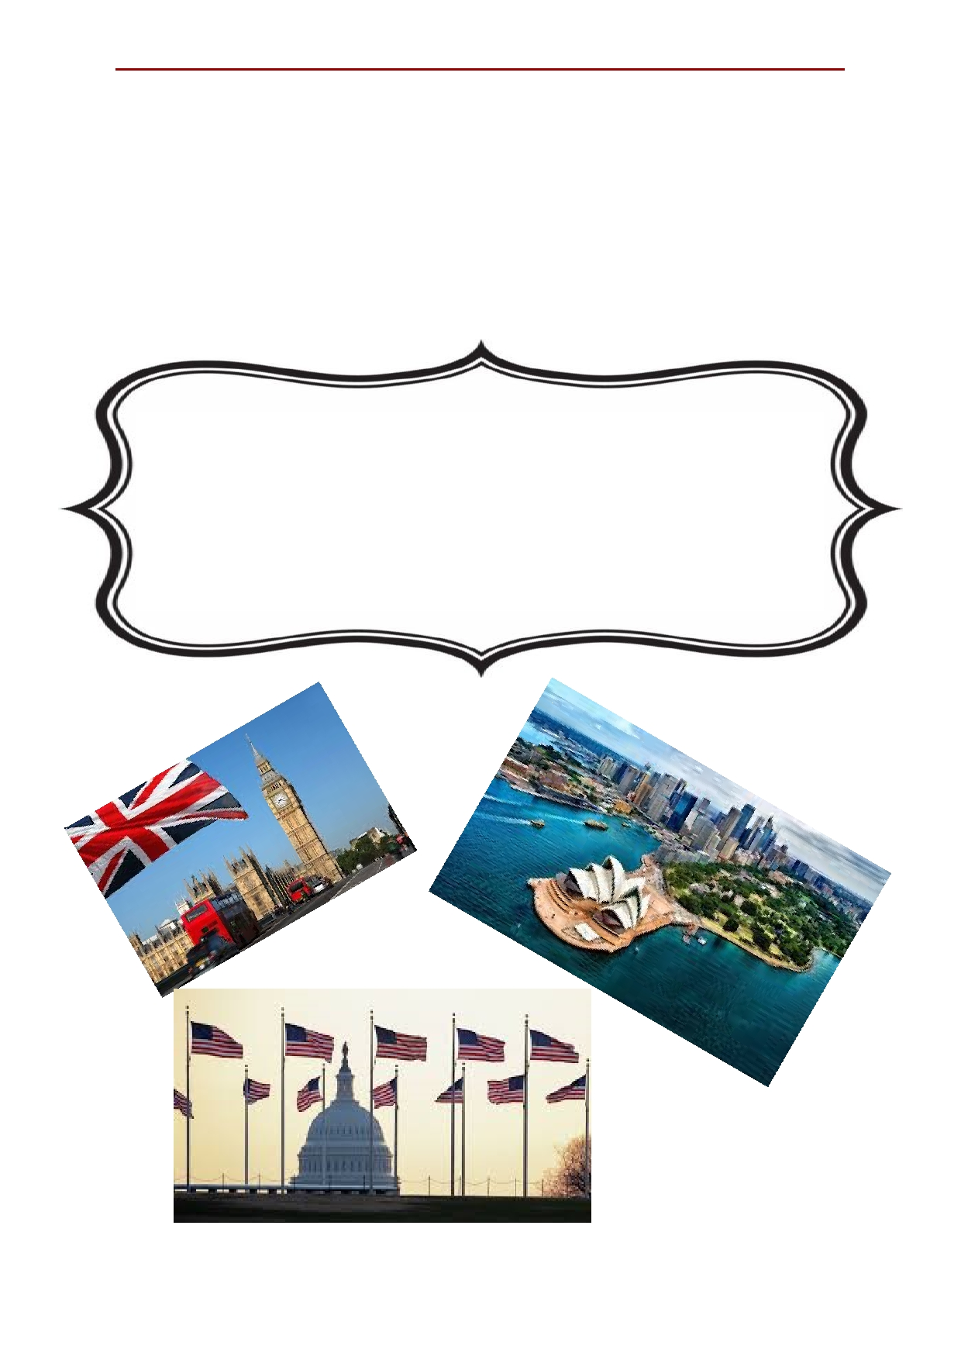Лингвострановедческий справочник
по Англии, США и Австралии.

Вокруг света за 80
минут

2020 год

Contents
Chapter 1: England……………………………………..3
Big cities of England………………………......……4 Attractions of England……………………………..9 English cuisine……………………………………..20 Famous People of England……………………….24 National symbols of England…………………….30 National holidays and traditions in England…...32 Chapter 2: Australia………………………………41 The biggest cities of Australia……………………42 Attractions of Australia…………………………...45 Famous people of Australia………………………50 National holidays and traditions in Australia….55 The national dishes of Australia…………………60 National symbols of Australia…………………...62 Chapter 3: USA……………………………………66 The big cities of USA……………………………...67 The attraction of USA……………………………..73 The American cuisine……………………………..82 Famous people of USA……………………………86 The national symbols of USA…………………….90 National holidays and traditions in USA………….92

2

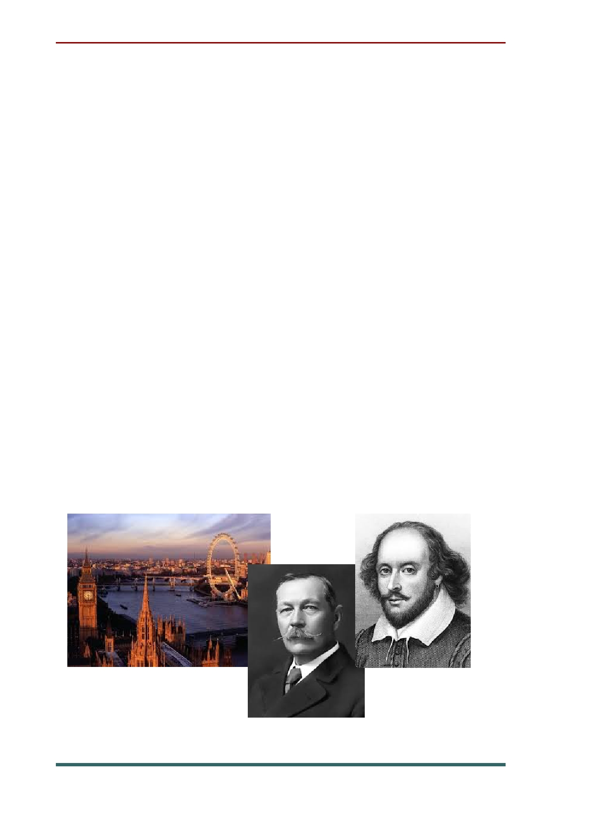Chapter 1: England

England is the biggest part of the United Kingdom. Its area is more than 130 thousand
square kilometers. The population of England is about 47 million people. The country is washed
by the English Channel, the Irish Sea and the
North Sea. There are a lot of rivers in England.
The most important of them are: the Thames, the Trent, the Mersey.
London is the capital of England and one of the largest cities. Other big cities are Liverpool, Birmingham, Manchester.
There were many famous poets and writers
from England: Arthur Conan Doyle, Daniel
Defoe, Herbert George Wells, Jonathan Swift, William Shakespeare, Charles Dickens.

3

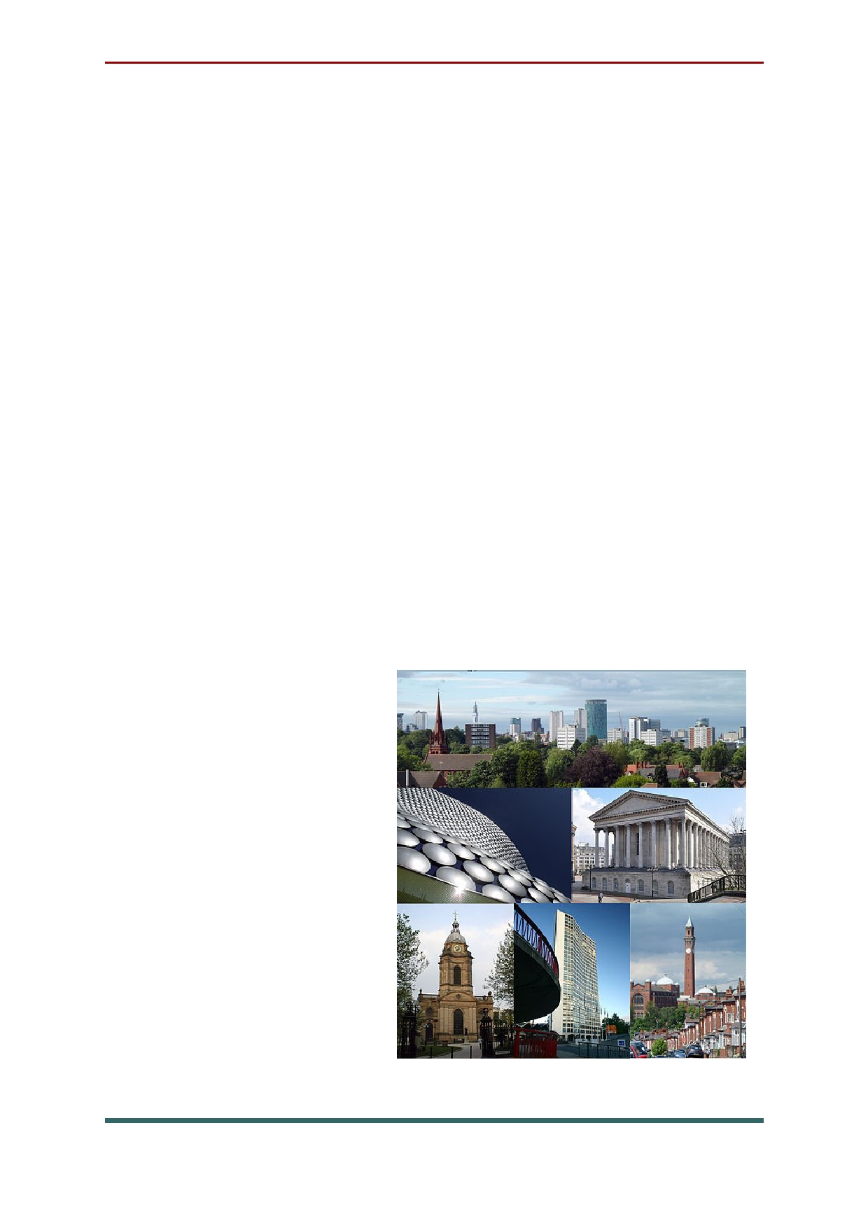Big cities of England

Birmingham is a city in the UK located in the
county of West Midlands. It is the second most
populated city in the country after London. About 1,100,000 people live in Birmingham.
Today, Birmingham is a leading research
center in the United Kingdom and Europe.
Birmingham University is the largest and most famous university in the country.
The Birmingham Museum and Art Gallery
were opened in 1885. They are located in the city center. The building is crowned with a tall clock
tower "Big Broome". The museum's collection
includes a collection of fine art, jewellery, and ceramics. There are departments of
natural history,
archaeology,
ethnography, and industrial history.

4

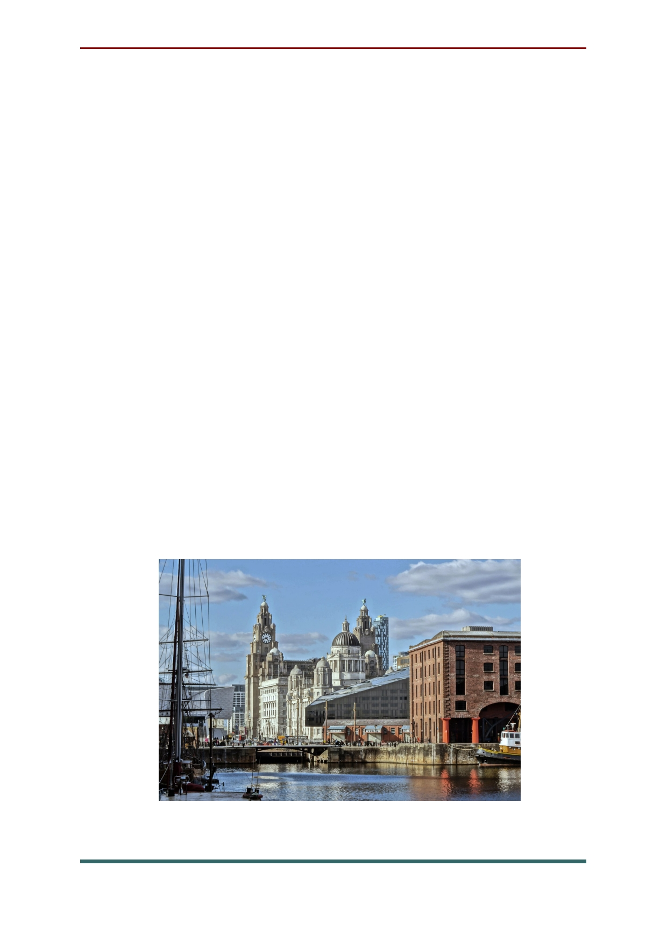Liverpool is one of Britain’s biggest cities. Its
population is more than one and a quarter million. Such persons as John Lennon, Paul
McCartney, George Harrison и Ringo Starr made
Liverpool famous. Now it has a magnificent Beatles museum.
In the 18th and 19th Liverpool was
developing as Britain's major Atlantic port. It
became a centre of cotton trade and manufacturing industry.
Liverpool is proud of its sights, especially of the two 20th century cathedrals. One cathedral is
the property of the Church of England and
startling modern paintings decorate its interior.
The other one belongs to the Roman Catholic
Church, its architecture is unique in its way, and the cathedral looks like a huge Indian wigwam.

5

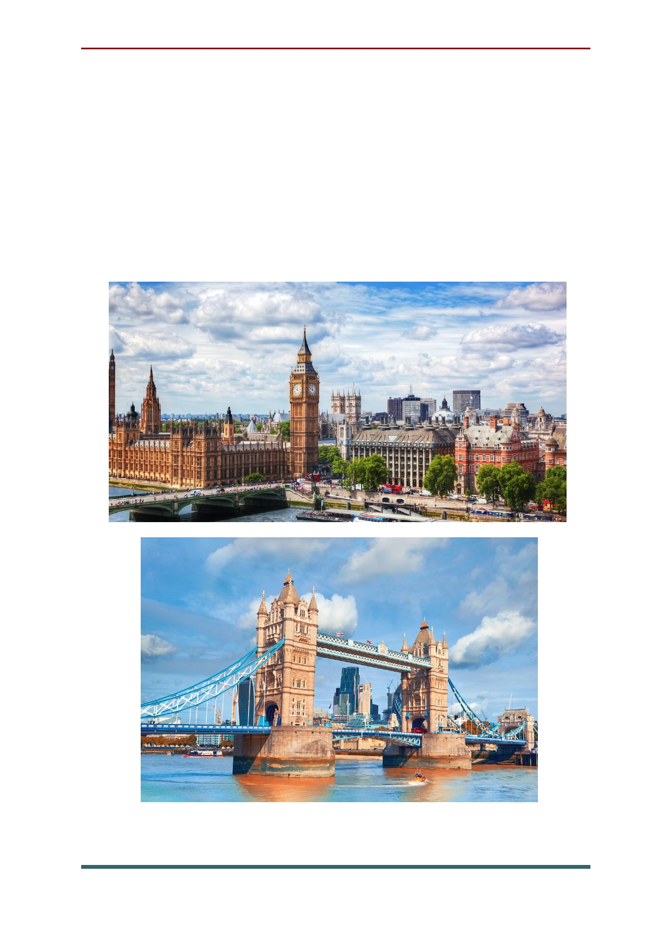London is the capital and largest city of
England an the United Kingdom, and is the
largest urban area in Greater London. The River Thames travel through the city. London is about 2000 years old. London was found by Romans. It
was called Londinum by Romans. London was also called Lunnainn in Scottish. .

6

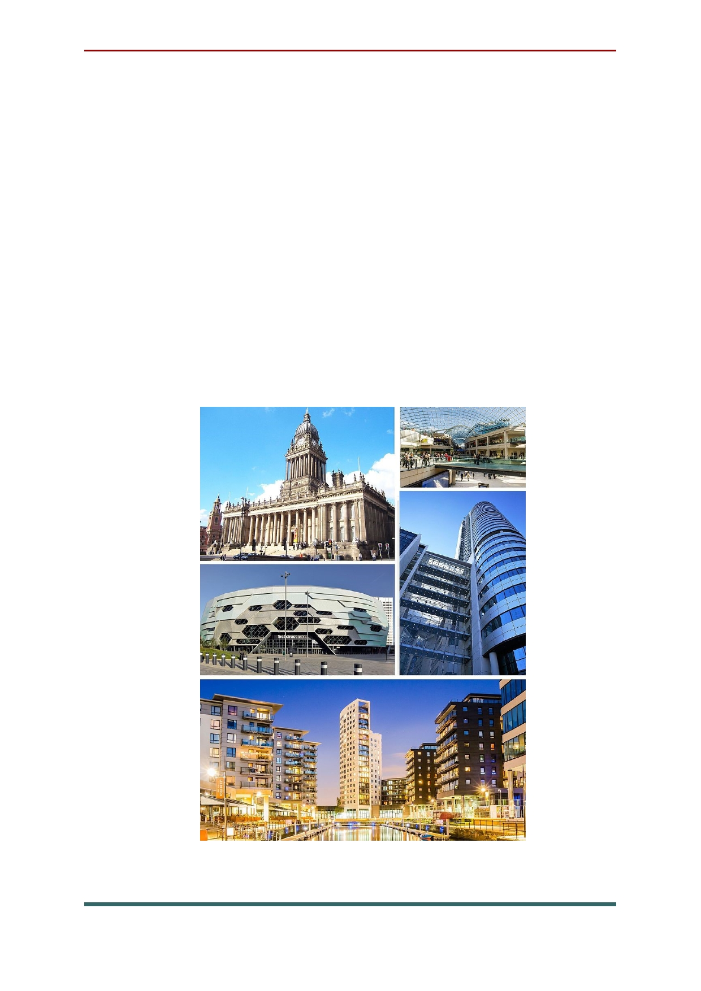Leeds is the largest city in the county of West
Yorkshire in Northern England. The city is served
by five universities, has the UK's fourth-largest
student population and the country's fourth-
largest urban economy. Leeds has become one of
the fastest growing cities in the UK today. It is
home to different business bases, 1.9 million
employment, and even considered as one of the
greenest cities in the country. This just shows that
the city has so much potential that it can be a good place to live and work for.

7

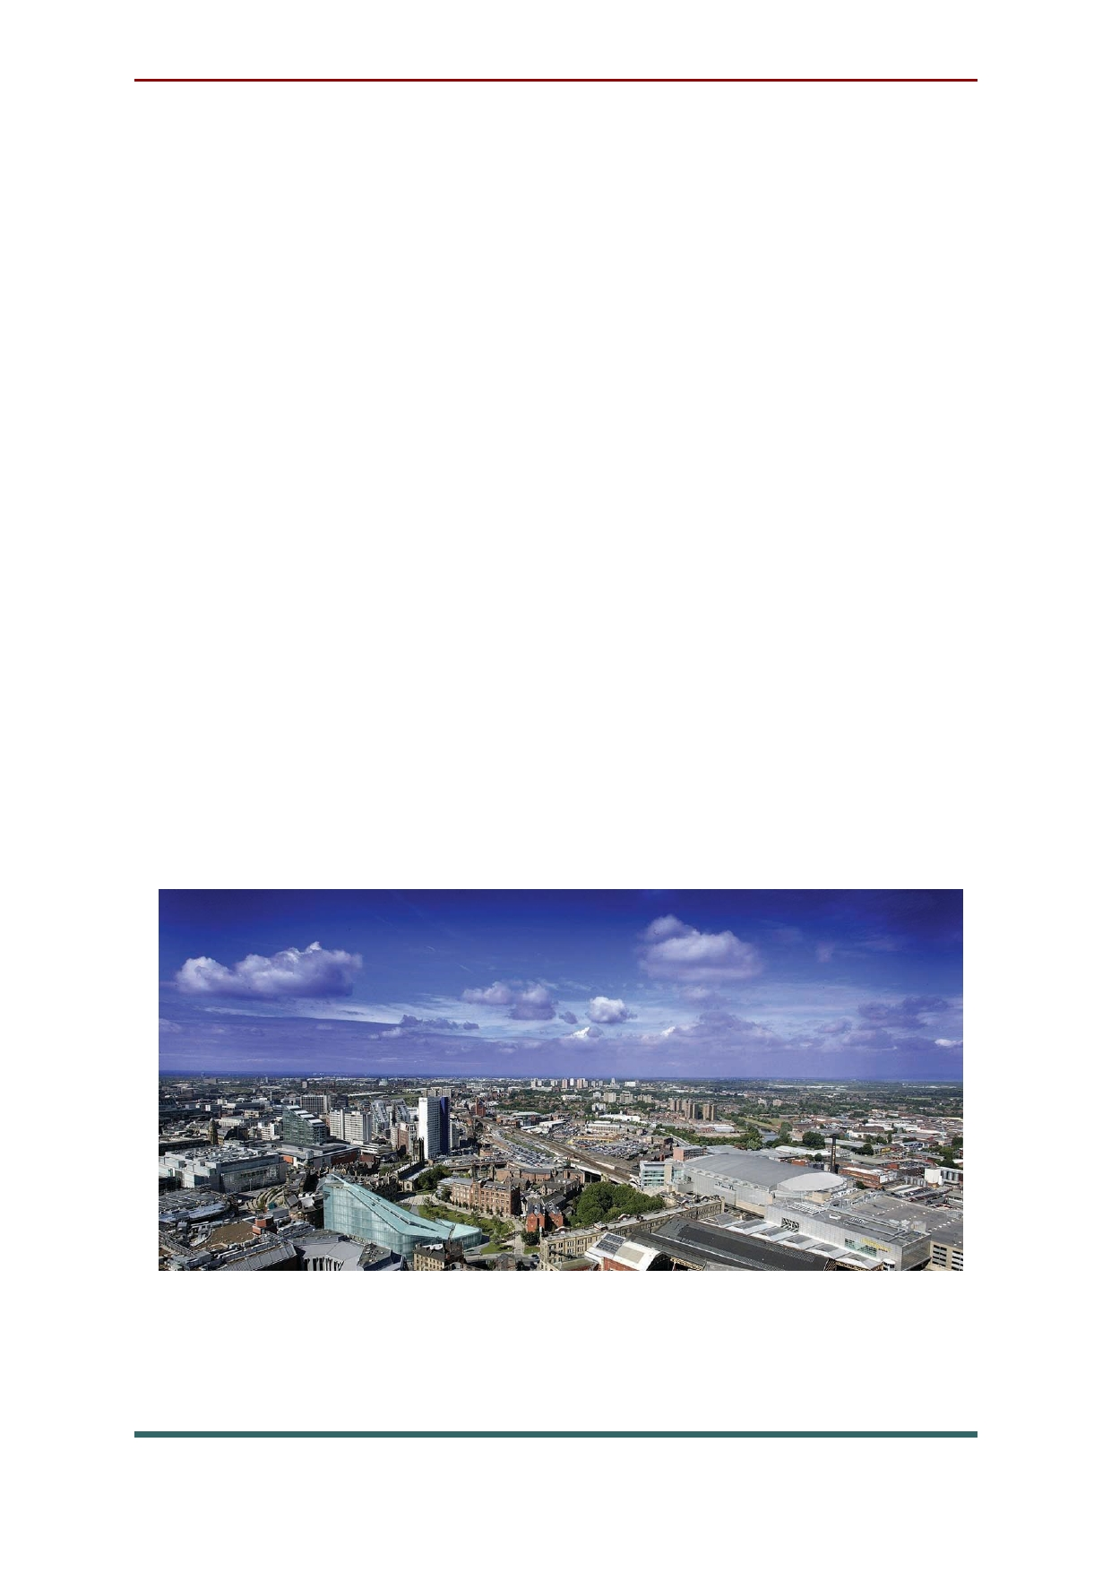Today not only is Manchester viewed as the
best city in the UK, it is also seen as a global
cultural, digital and creative hotspot. With The BBC and ITV moving to MediaCityUK, Salford Quays, the city is the second largest media and digital hub in Europe and growing faster than
anywhere else in the UK. In 2014, George Osborne
revealed plans to develop a northern "supercity" to rival London by linking Manchester, Liverpool,
Leeds and Sheffield. Should these plans still go
ahead, Manchester's economy would prosper from the increasing investment in improving
amenities throughout the region. Offering a
growing skills, Bright talent and easy worldwide
connectivity, the city is the prefect base for any business.

8

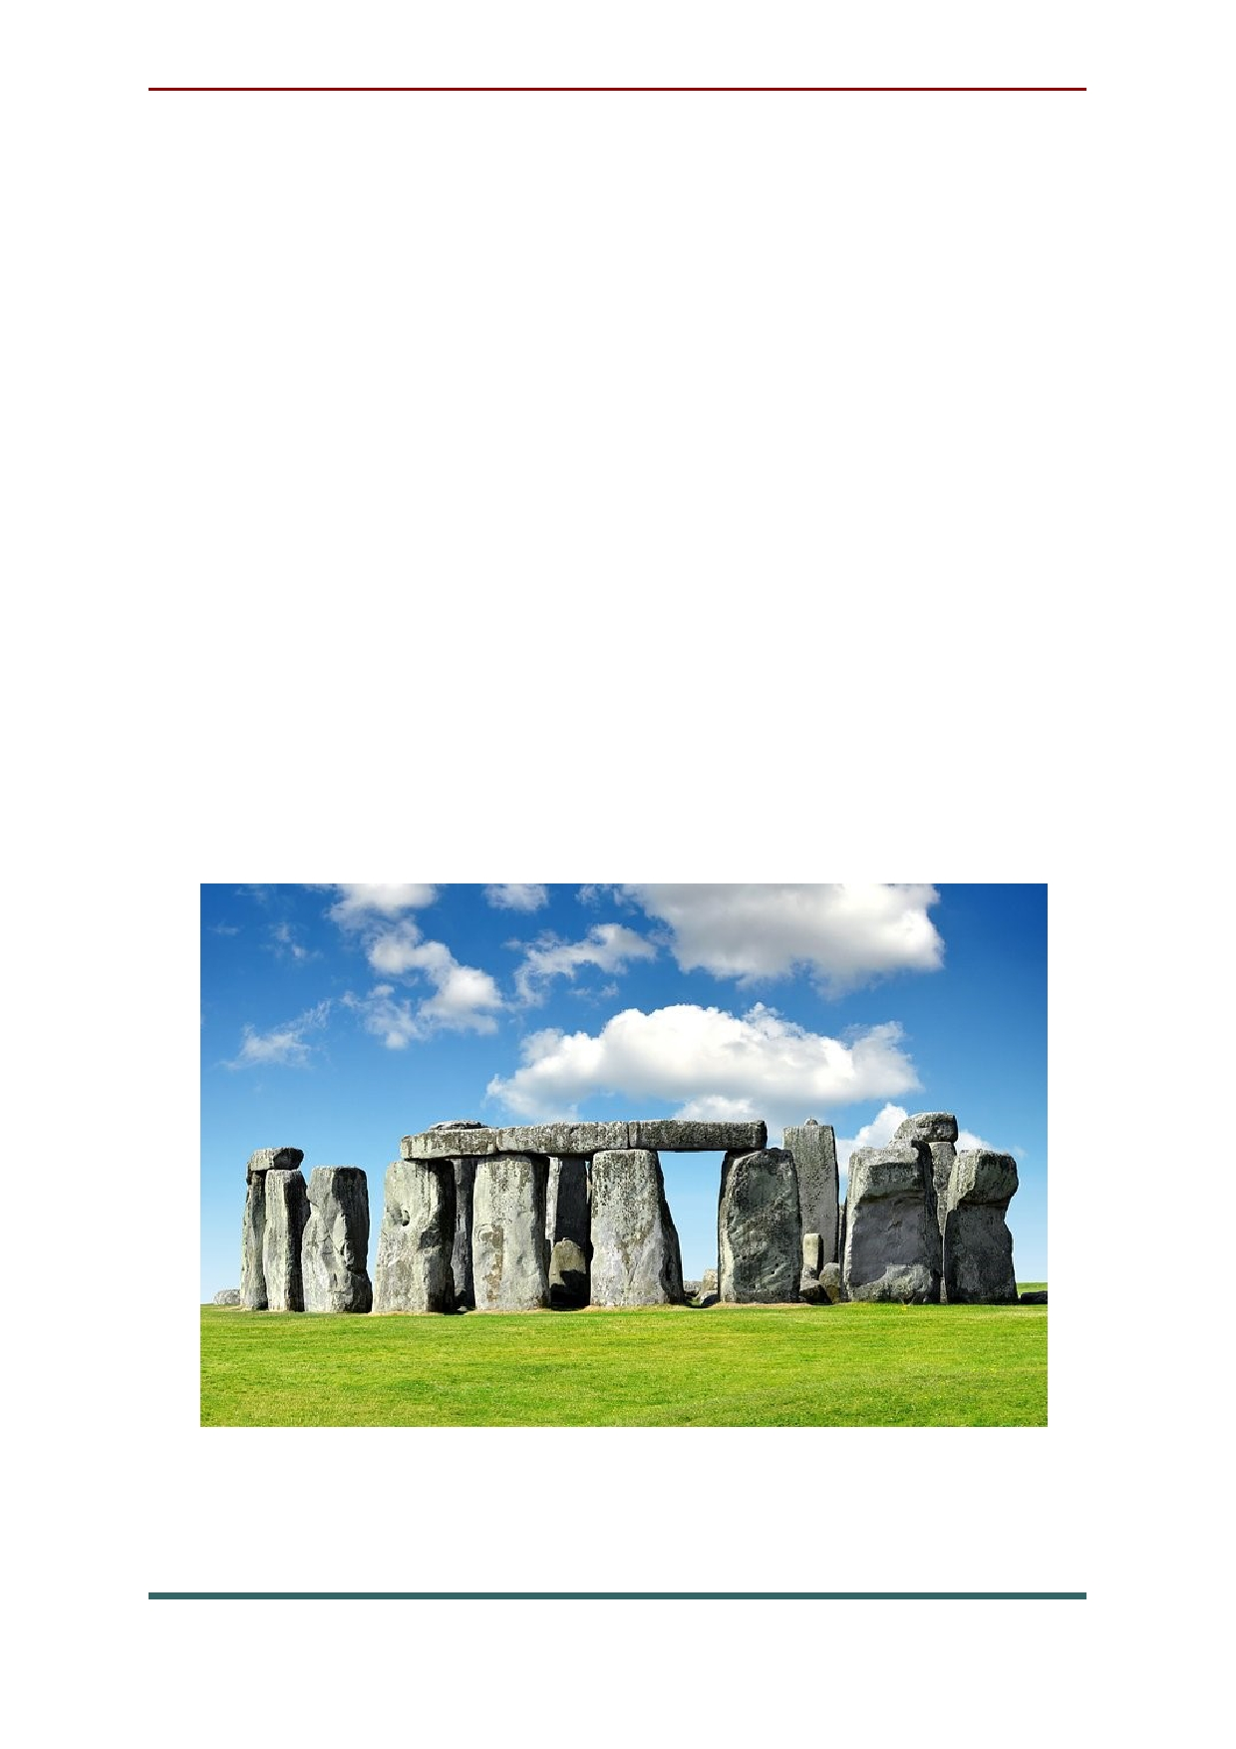Attractions of England
Stonehenge, 10 miles north of the historic city
of Salisbury on Salisbury Plain, is Europe's best-
known prehistoric monument. It's so popular that
visitors need to purchase a timed ticket in
advance to guarantee entry. Exhibitions at the
excellent Stonehenge visitor center set the stage
for a visit, explaining through audio-visual
experiences and more than 250 ancient
objects how the megaliths were erected between 3000 and 1500 BC, and sharing information about life during this time.

9

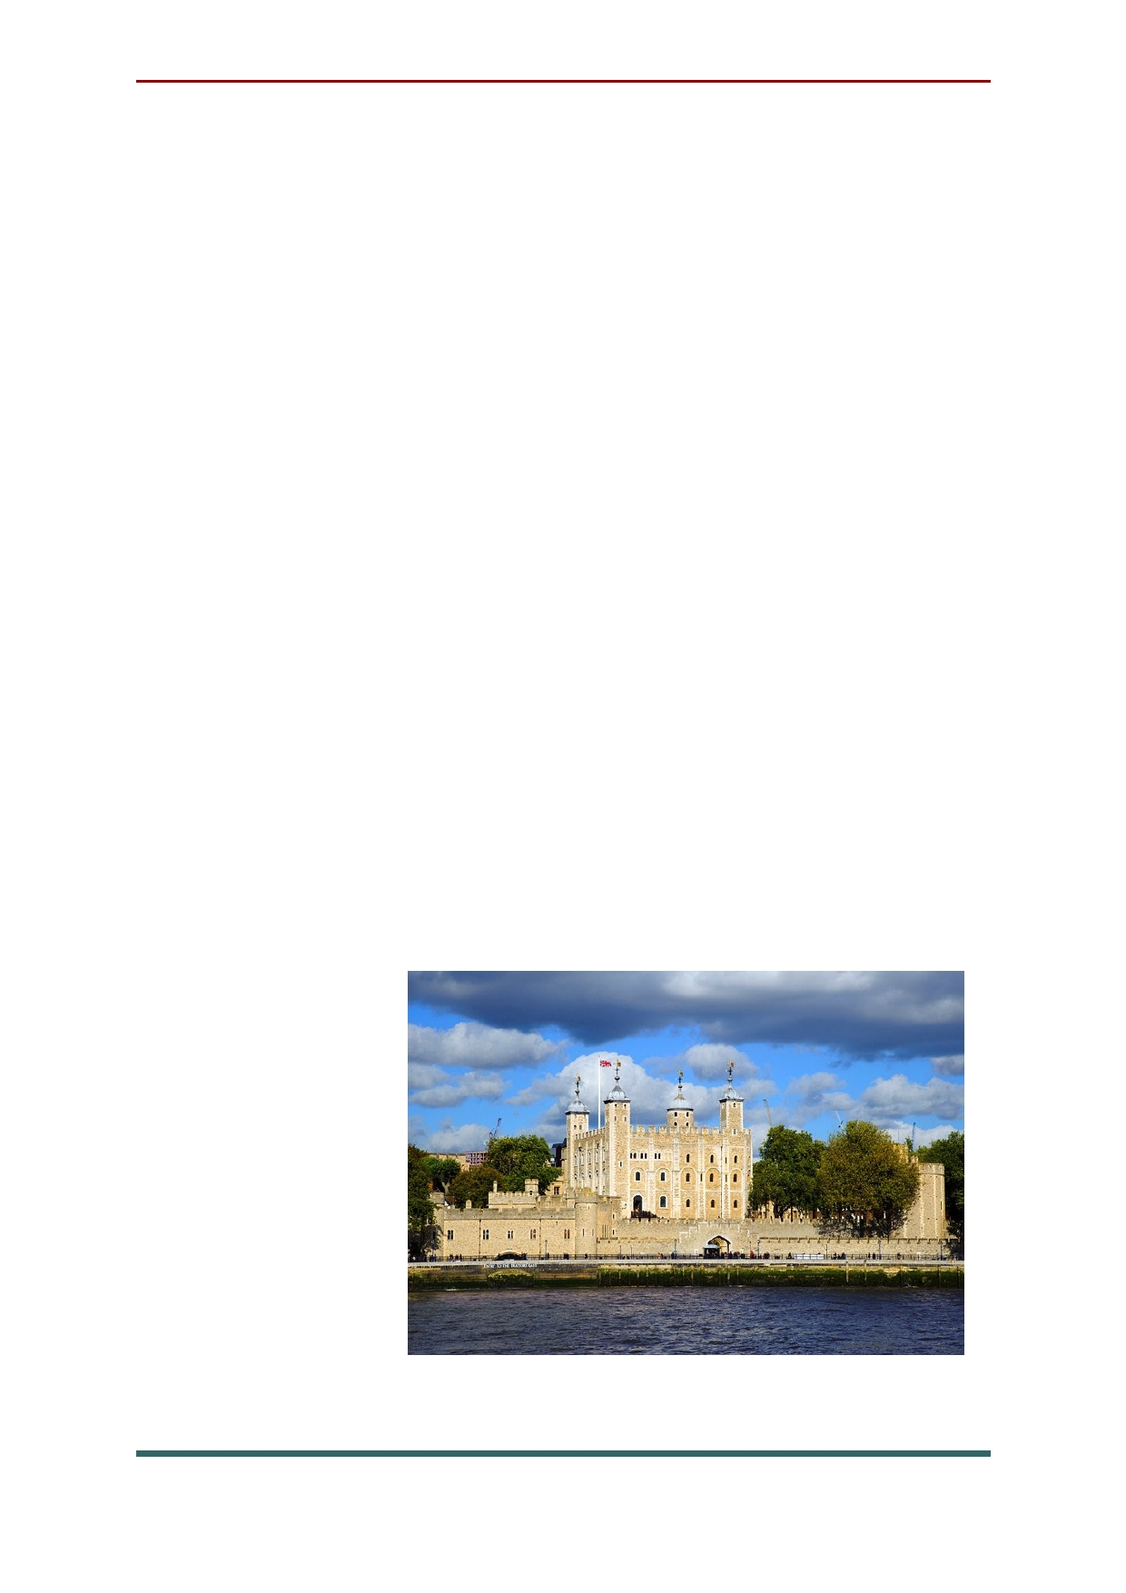Prison, palace, treasure vault, observatory,
and menagerie: the Tower of London has done it
all and it's one of the top attractions in London.
Widely considered the most important building in
England, there's enough to see and do at this World Heritage Site to keep visitors busy for hours.
The centerpiece of this Thames-side fortress is
the White Tower. Built in 1078 by William the
Conqueror, it's home to amazing exhibits, such as Line of Kings, the world's oldest visitor attraction,
established in 1652 with a remarkable display of royal armor.
Other highlights include the
impressive Crown Jewels exhibition, classic Yeoman Warder Tours, the Royal Mint, and
exhibits and displays regarding prisoners and
executions. All told, the Tower
of London
covers some 18 acres, so there's
a great deal of
exploring to do.

10

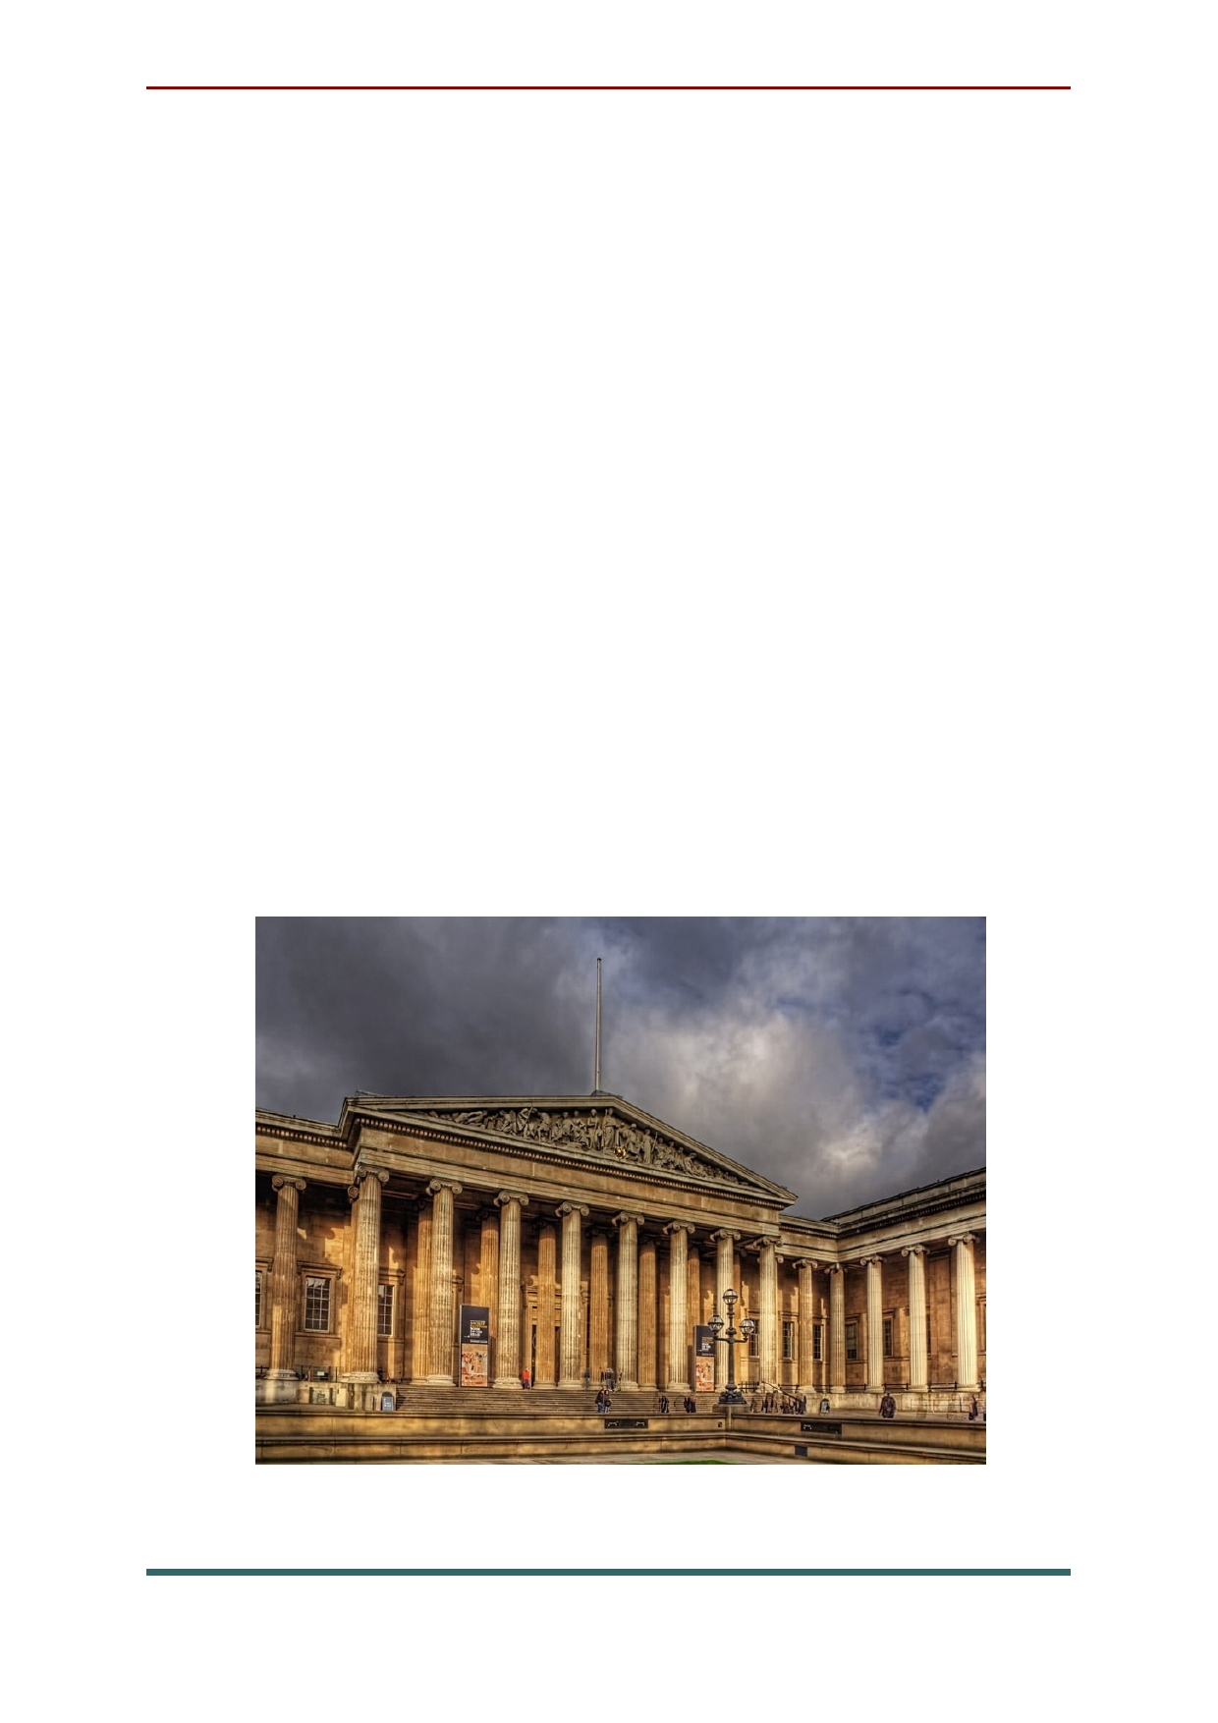With collections of antiquities that are among
the world's finest, the British Museum holds more than 13 million artifacts from Assyria, Babylonia,
Egypt, Greece, the Roman Empire, China, and Europe. The most famous ancient artifacts are
the Elgin Marbles from the Parthenon in Athens, as well as the famous Rosetta Stone.
But there are many other outstanding pieces on show here that help make this one of the best places to visit in London. The Ancient Egyptian collection is the largest outside of Cairo, and the
hoard of Roman silver dating from the fourth
century known as the Mildenhall Treasure,
unearthed in Suffolk in 1942, is nothing short of spectacular.

11

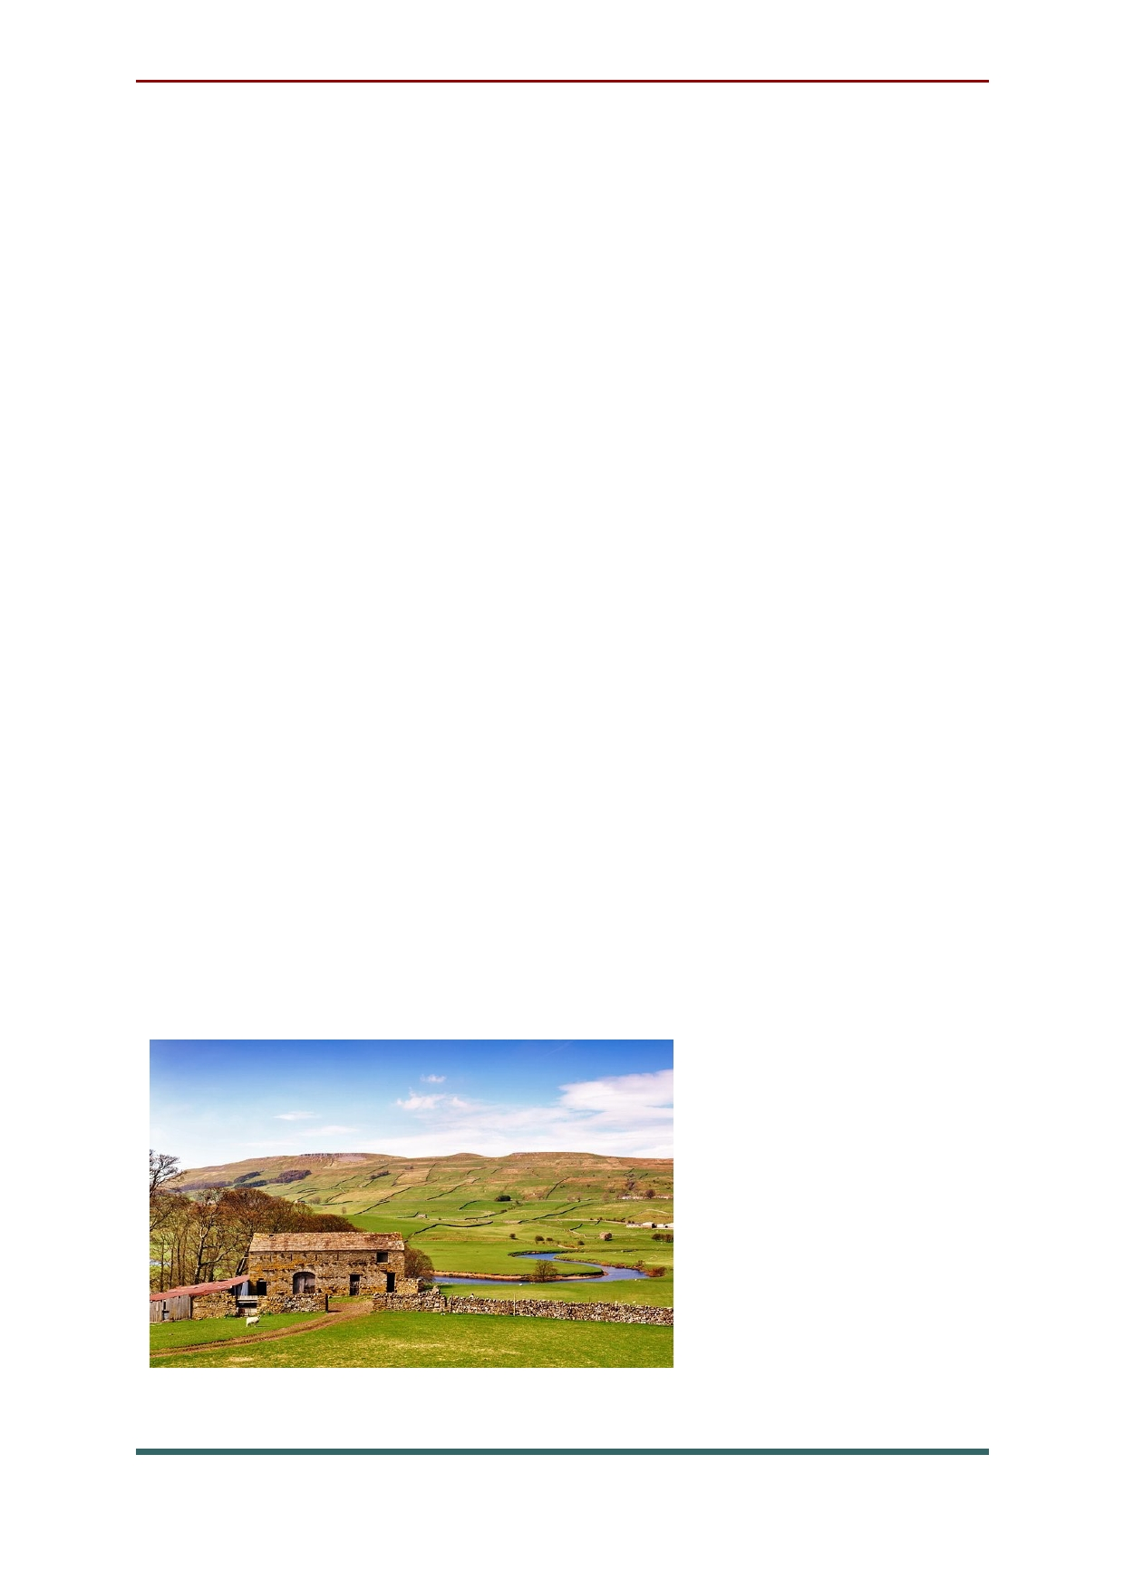The magnificent York Minster is second in
importance in the Church of England only to the cathedral at Canterbury. It stands in the center of
historic York, surrounded by half-timbered homes and shops, medieval guildhalls, and churches.
In turn, York's romantic streets are
surrounded by three miles of magnificent town
walls that you can walk atop for spectacular
views over the city and its surroundings. While here, visit the National Railway Museum, one of England's most visited tourist attractions.
York is also a good base from which to explore northeast England, in particular the
rugged beauty of the Yorkshire Dales and the
North York Moors. Elsewhere in this corner of the
country, you'll find some of England's most
beautiful historic towns and cities,
including Durham - famous for its castle and
cathedral -
and Beverley,
which also boasts
an attractive minster.

12

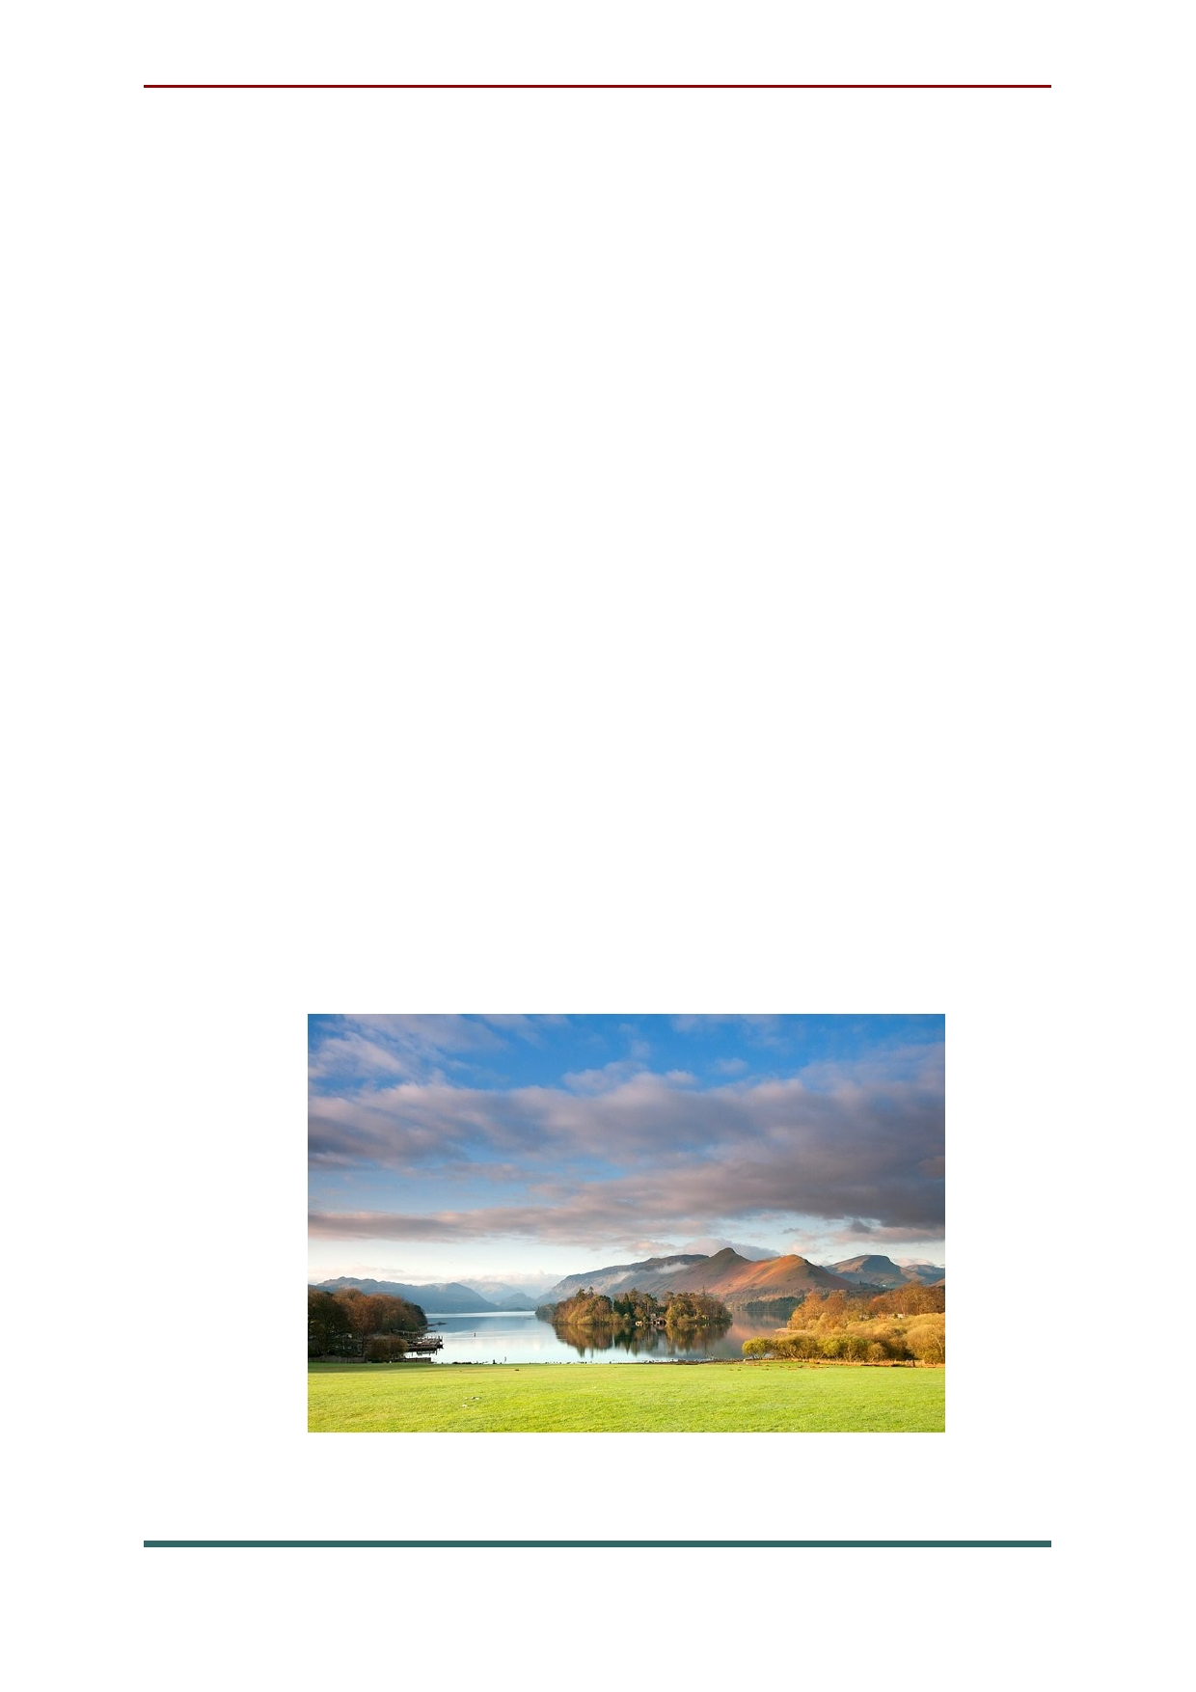Covering some 900 square miles, Lake
District National Park is a must-visit destination for travelers to England. With 12 of the country's largest lakes and more than 2,000 miles of rights
of way waiting to be explored, there's little
wonder the region continues to inspire, with its magnificent views and scenery straight out of a painting.
Other things to do include visiting the park's many fells, including Scafell Pike (3,210 feet), the
highest mountain in England. Be sure to also spend time exploring some of the lovely little
towns and villages dotted throughout the region,
such as Grasmere. Better still, hop aboard a
tour boat excursion across Lake Windermere and
Ullswater, and you'll be rewarded with some of the best scenery anywhere in the country.

13

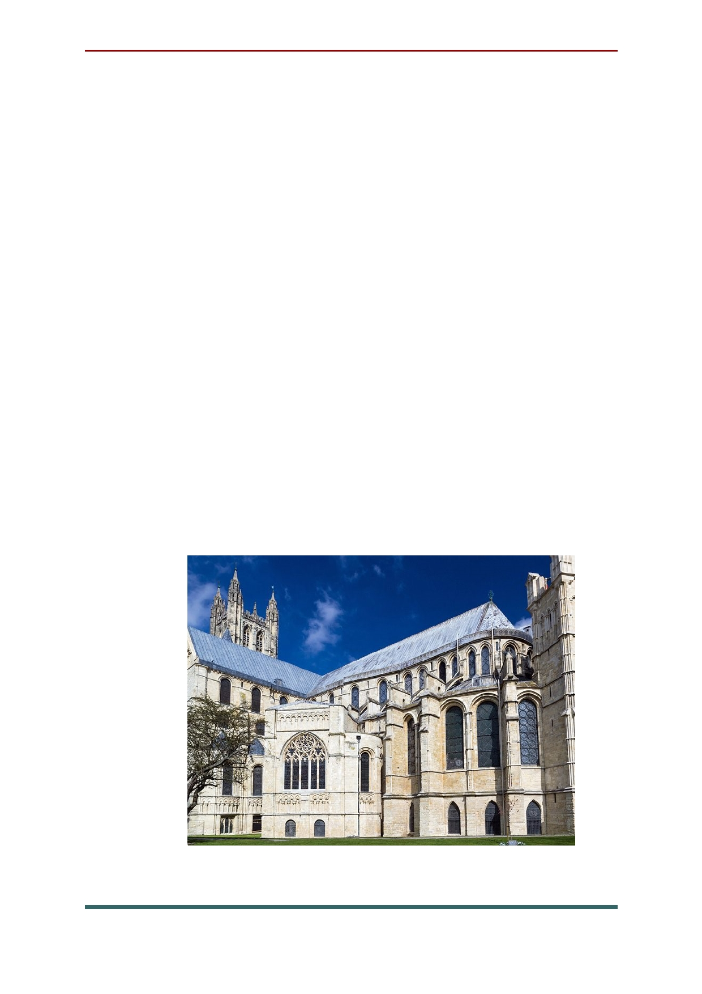Located in the heart of the historic city that bears
its name, Canterbury Cathedral (a UNESCO World
Heritage Site) is home to the Archbishop of
Canterbury and is the cradle of English Christianity. It
all started when St. Augustine converted the pagan Anglo Saxons here in 597 when he became the first bishop. Excellent guided tours of the cathedral are
available, and for a truly memorable experience,
consider booking an overnight stay in the grounds at Canterbury Cathedral Lodge.
But there's much more to this beautiful medieval
city than just its cathedral. Canterbury is also a
popular cultural and entertainment destination with
great shopping, galleries, and cafés, as well as attractions such as those focused on Chaucer's medieval England and the city's Roman past. .

14

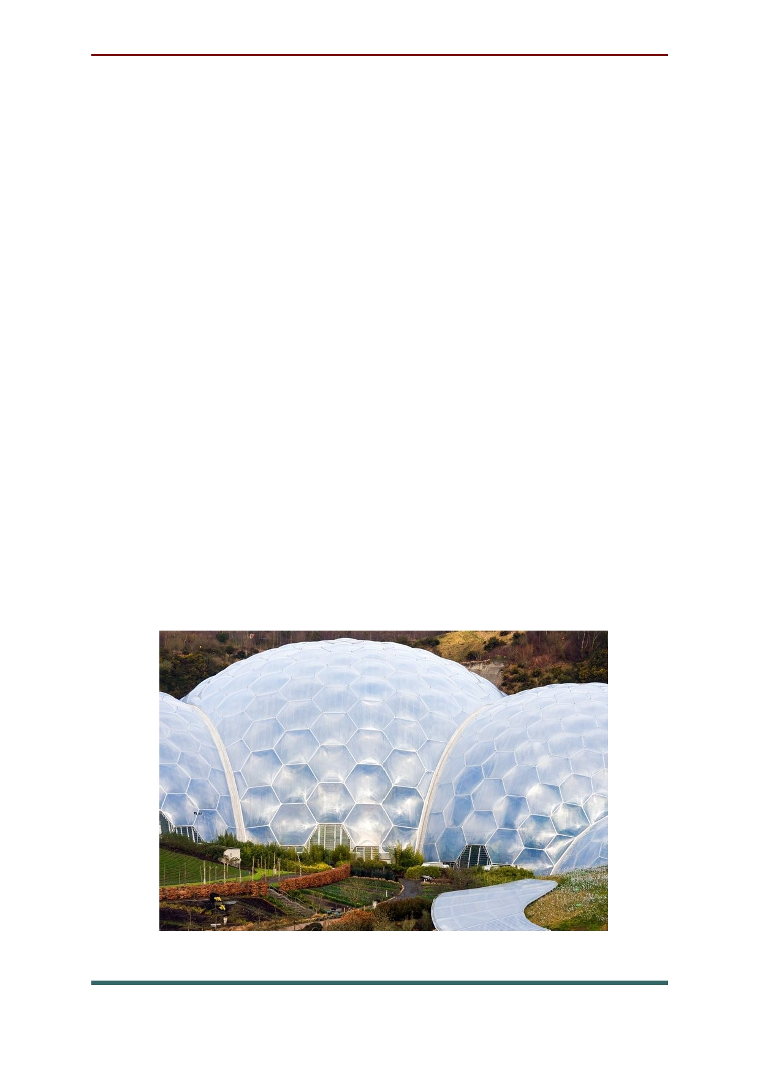The incredible Eden Project is a collection of
unique artificial biomes containing an amazing collection of plants from around the world.
Located in a reclaimed quarry in Cornwall, this
spectacular botanical gardens complex consists of
huge domes that look rather like massive igloo-
shaped greenhouses. Each of these impressive
(and futuristic-looking) buildings houses
thousands of different plant species in tropical and Mediterranean environments.
As well as these stunning displays of plant life, the Eden Project hosts numerous arts and
music events year-round. If you're able to extend your visit, consider booking a stay at the on-site hostel, or enjoy a meal in one of its restaurants. Adventure activities such as ziplining and giant swings are also available.

15

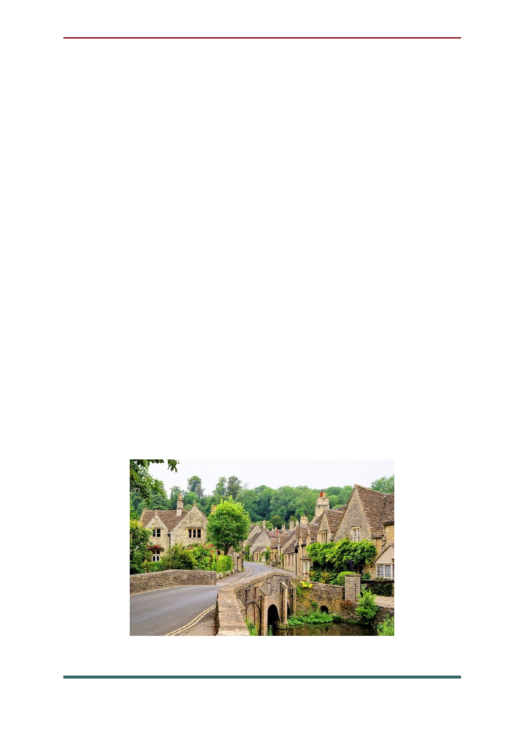The Cotswolds cover some 787 square miles
and encompass parts of some of England's
prettiest counties: Gloucestershire, Oxfordshire,
Wiltshire, Somerset, Worcestershire, and
Warwickshire. And all of it begs to be explored.
Designated an Area of Outstanding Natural
Beauty due to its rare limestone grassland
habitats and old-growth beech woodlands, the
beauty of the Cotswolds has much to do with its quaint villages and towns, such as Castle Combe, Chipping Norton, and Tetbury.
Like so much of England, the Cotswolds is
perfect to discover on foot. One of the best routes
is along the Cotswold Way, a 102-mile
footpath with spectacular views of the Severn
Valley and the Vale of Evesham. This route runs
the length of the Cotswolds, and can be picked up pretty much anywhere you visit.

16

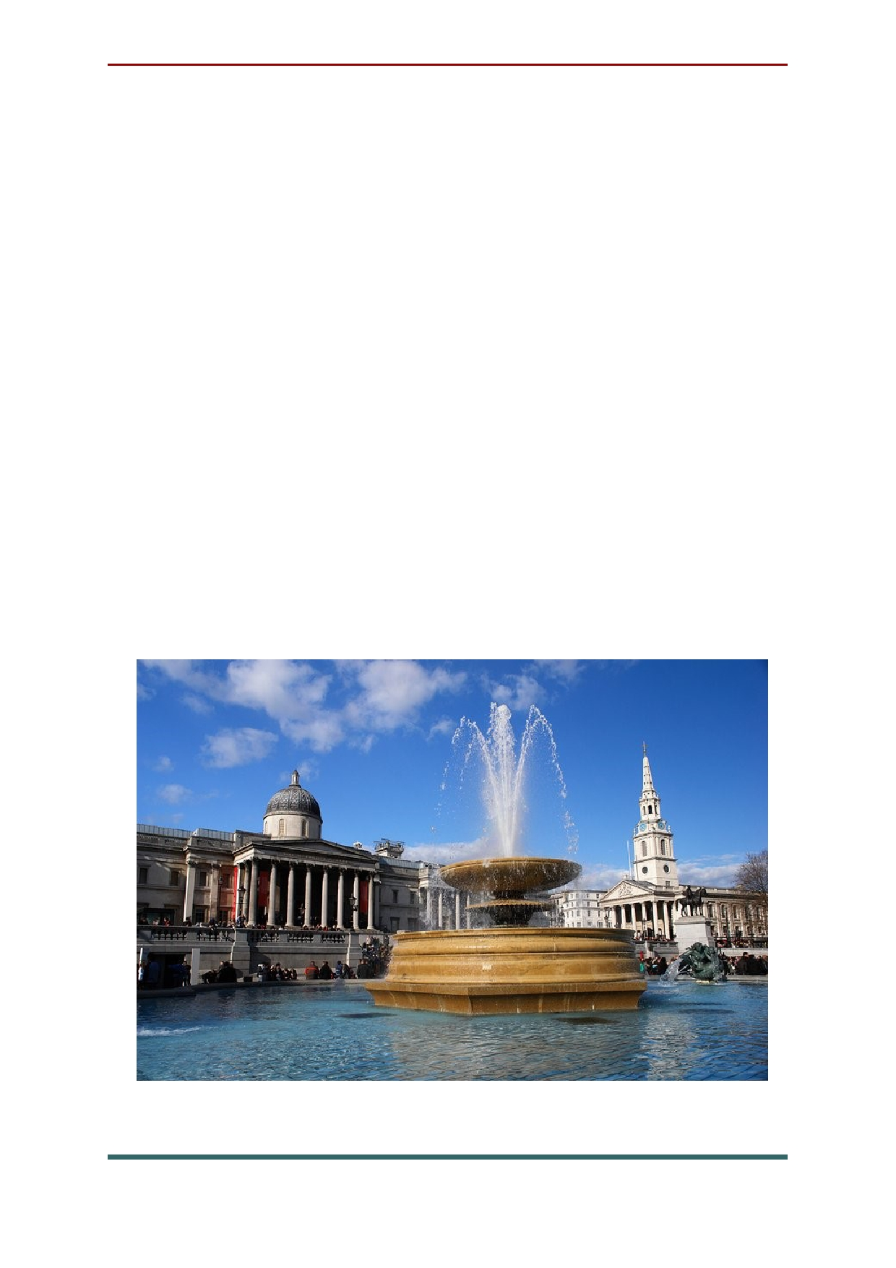Displaying one of the most comprehensive
collections of paintings in the world, the National Gallery is London's second-most visited museum. The collections, which present an almost complete
cross-section of European painting from 1260 until 1920, are especially strong in the Dutch
Masters and the Italian Schools of the 15th and 16th centuries. In the Italian galleries, look for
works by Fra Angelico, Giotto, Bellini, Botticelli, Correggio, Titian, Tintoretto, and Veronese, and especially for Leonardo da Vinci's Madonna and
Child with St. Anne and John the Baptist,
Raphael's The Crucifixion, and The Entombment by Michelangelo.

17

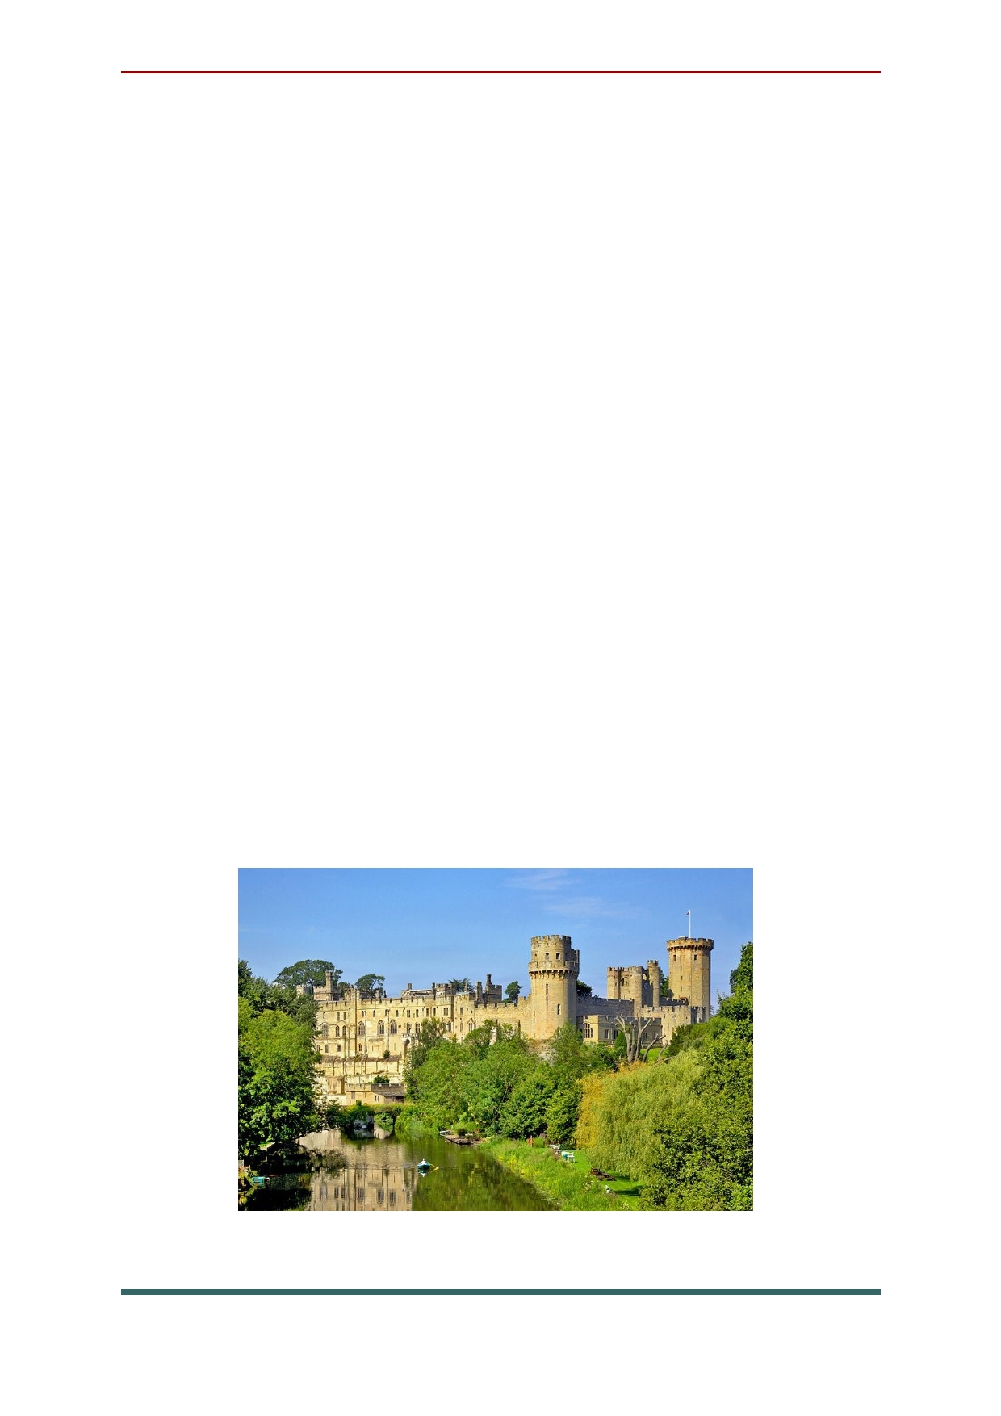If you're looking for a truly memorable
English excursion for the whole family - and one
that offers a fascinating insight into life in
medieval times - you couldn't do much better
than visit Warwick Castle. Located in the
beautiful city of Warwick on the River Avon, this impressive fortress has dominated the landscape and history of the region for more than 900 years.
Today, it serves as a backdrop to medieval-
themed events and reenactments, from jousting festivals to fairs and concerts.
Warwick is also great base from which to
explore the Cotswolds, as well as nearby towns
such as Stratford-upon-Avon, famous as the
birthplace of William Shakespeare. Bigger city
destinations, including Liverpool, hometown of
The Beatles, as well as Birmingham and Coventry, are an easy drive away.

18

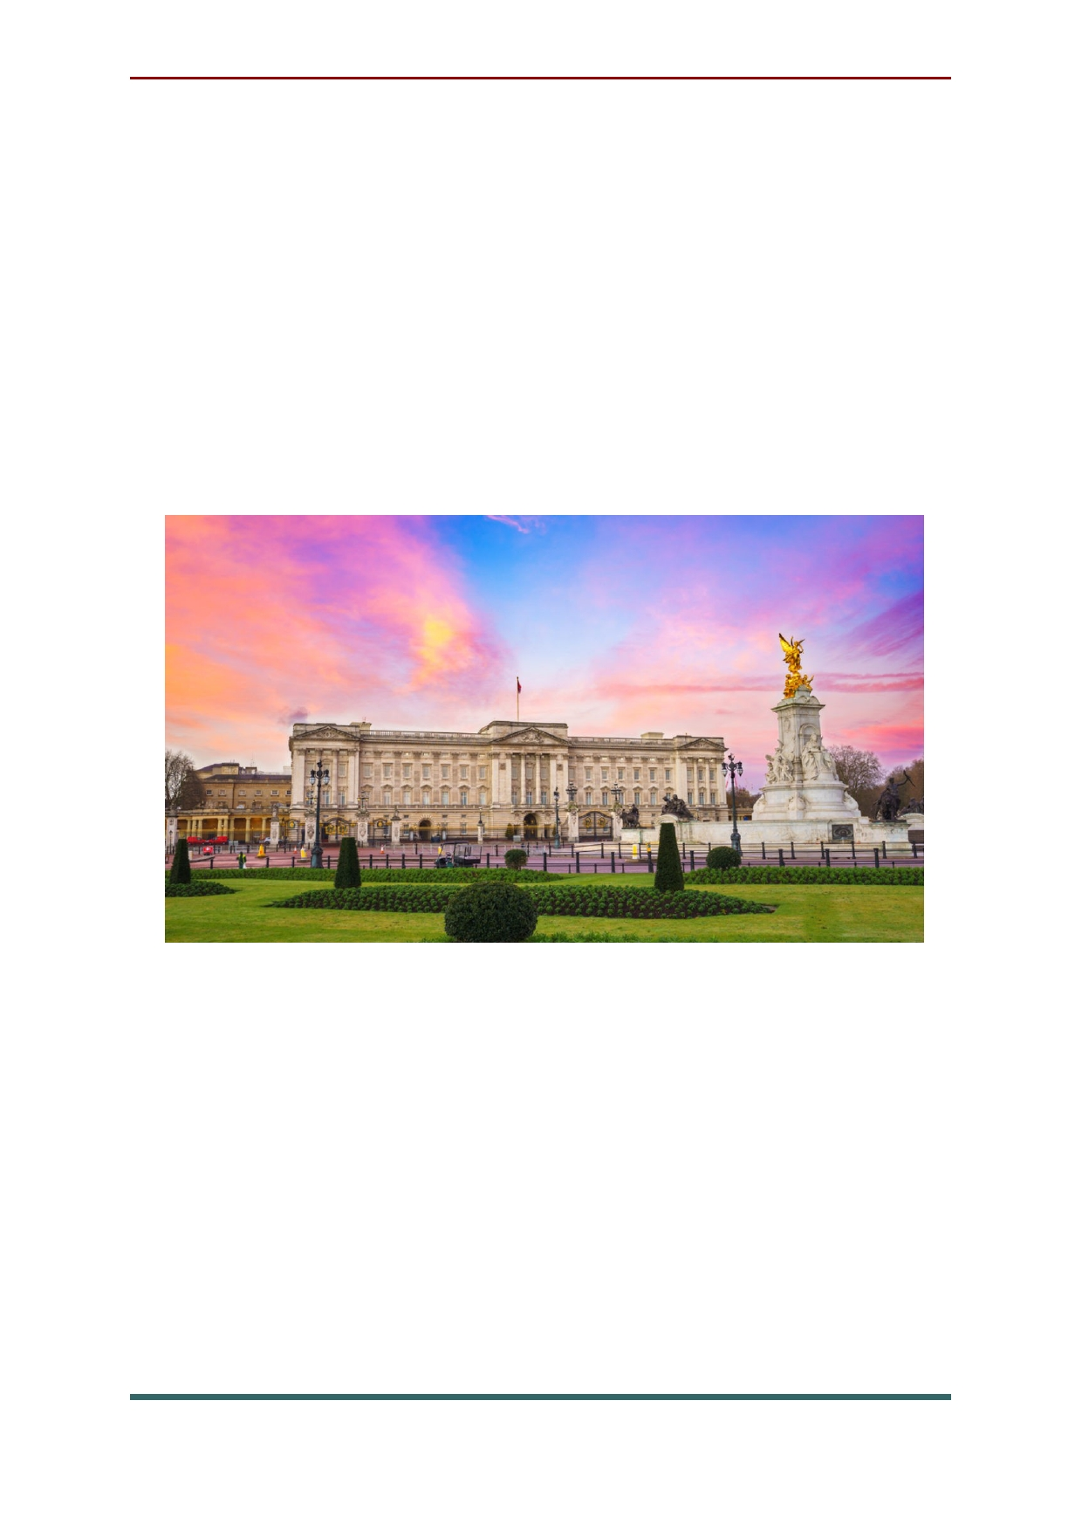Buckingham Palace was built in 1837 and has
been the London residence of the Royal Family
since Queen Victoria's accession. If you're
wondering whether the Queen is in, look at the
flagpole atop the building: if the royal standard is
flying day and night, she's at home. On special state occasions, she and members of the Royal
Family may even emerge on the central balcony.

Changing of the Guard is also very popular
event in England. Drawing crowds at 11:30am regardless of the season, this colorful and free display of precision marching and music also
takes place at St. James's Palace, after which you
can follow the band along The Mall as they march between sites.

19

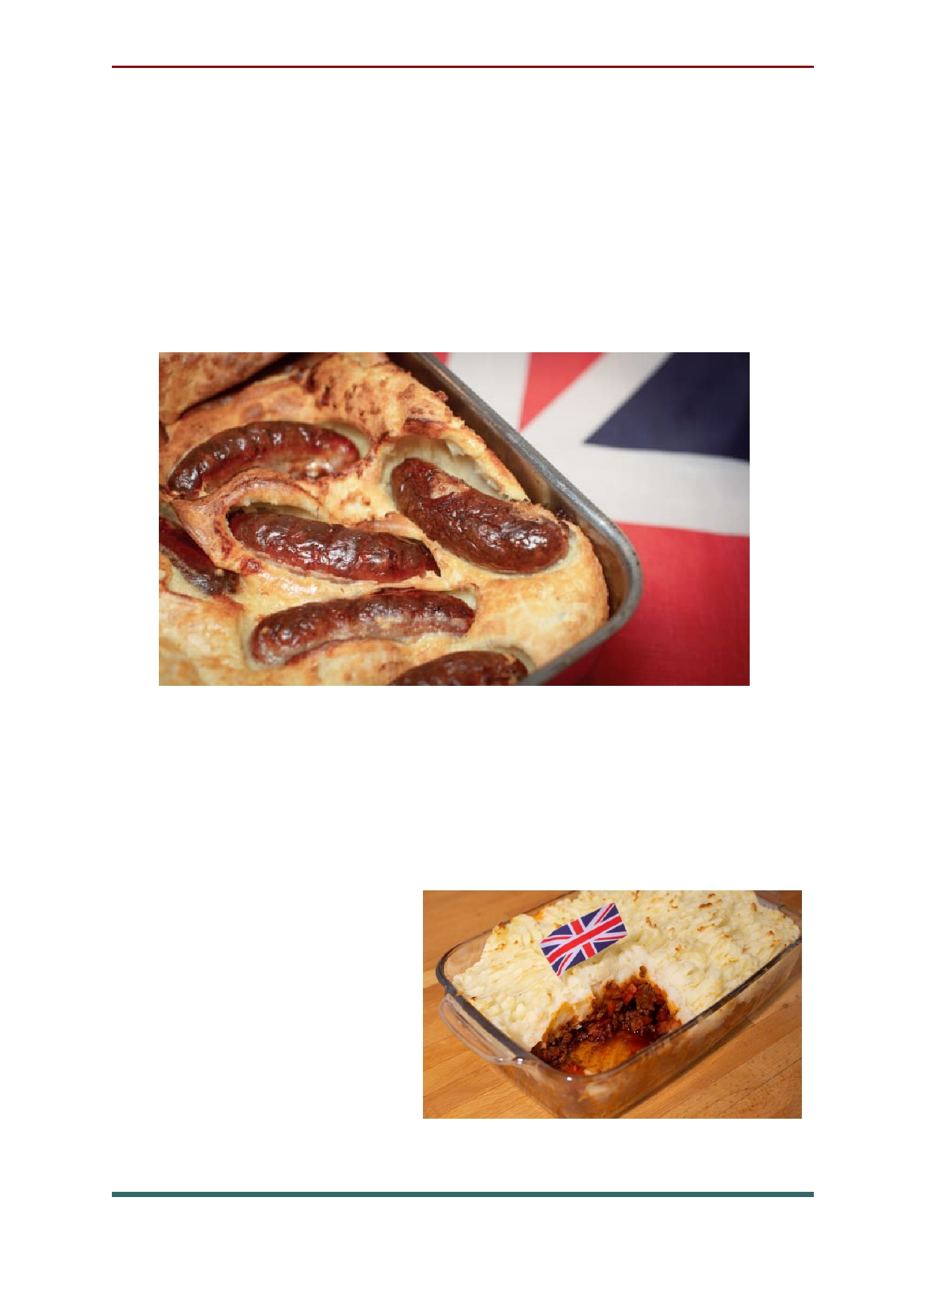England cuisine
Toad in the hole. Despite the name, there is
no mistaking this one for a dessert. It is sausage
made of blood. The trick to eating this
successfully is to shut your eyes and try not to think and breathe.

Shepherd's pie. Another national dish built
upon a tissue of lies. Not a pie but a gigantic
swamp of brown meat and gravy hidden beneath
a thick blanket of mashed potato. Excessive
consumption of this
dish risks triggering a
neurological
condition known as "mash psychosis." .

20

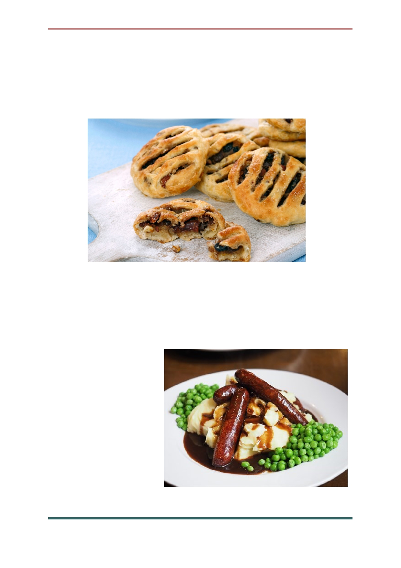Eccles cake. Named after Grater Manchester
town of the same name. Eccles are small, round
cakes made with flaky pastry and filled with currants.

Bangers and Mash . Also known as sausages
and mash, this traditional dish consists of sausages and mashed potato, and is often
accompanied with peas and gravy. This dish can
usually be found
on a menu in most
pubs across the
country, or can be made very easily at home.

21

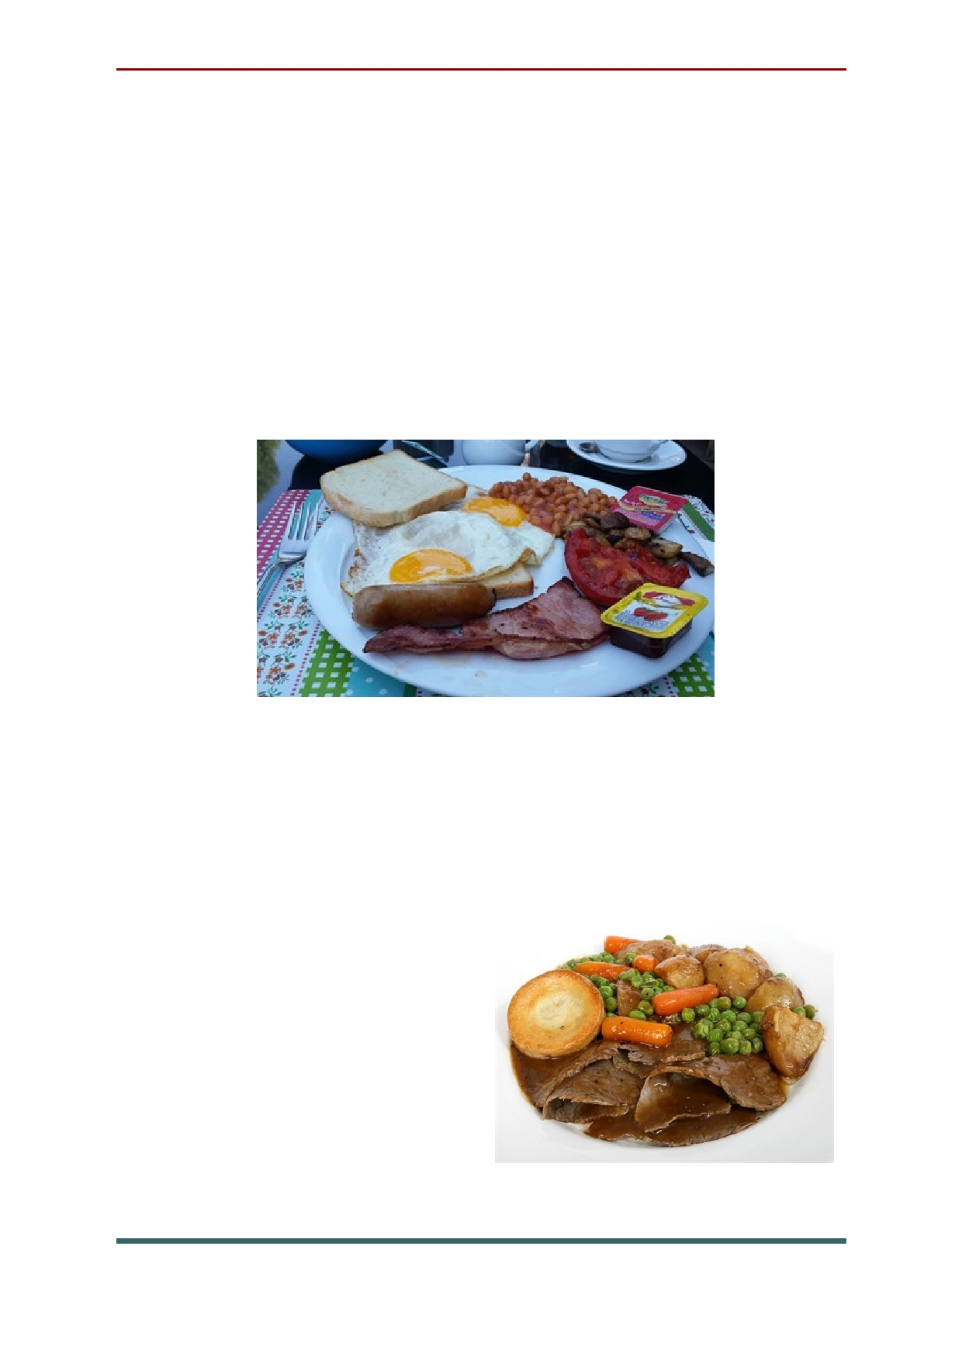Full English Breakfast. They say that
breakfast is the most important meal of the day,
which is why if you are doing something
physically or mentally demanding, such as the
IELTs exam, you need to have a full English
breakfast! This breakfast usually includes: bacon,
sausages, eggs, baked beans, toast, mushrooms, tomatoes, hash browns and black puddings.

The Brits love their Sunday Roast dinners.
This dish is made up of: roasted meat (beef,
chicken, lamb or pork), roast potato, Yorkshire
pudding, stuffing, vegetables (usually a selection
of: roast parsnips,
Brussels sprouts, peas, carrots, beans, broccoli
and cauliflower, not necessarily all) and gravy.

22

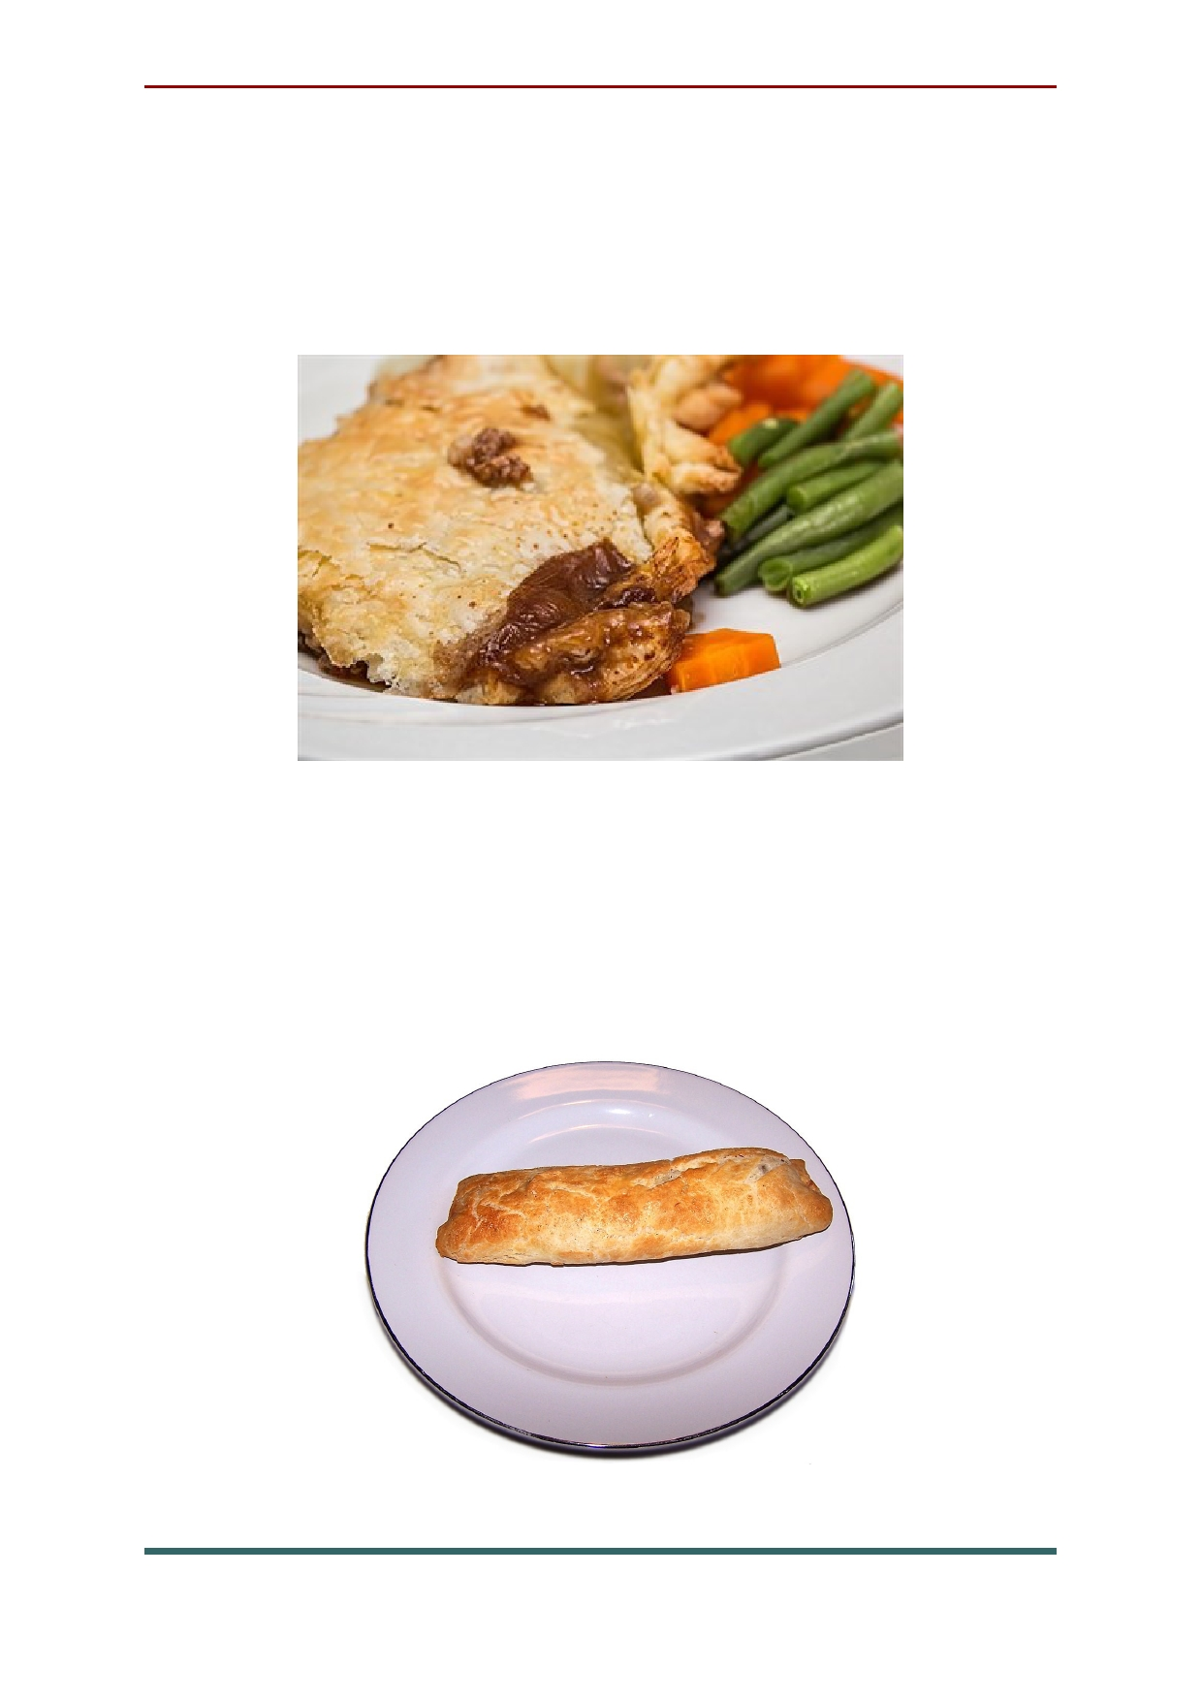Steak and Kidney Pie. This much loved
British pie is definitely a dish you must try whilst you are in the UK. The ingredients include: beef, kidney, fried onion and gravy all wrapped up in pastry.

Bedfordshire clanger. Suet crust dumpling with a savoury filling one end, sweet filling the other. The savoury filling is usually meat with
diced potatoes and vegetables. The sweet filling can be jam, cooked apple or other fruit.

23

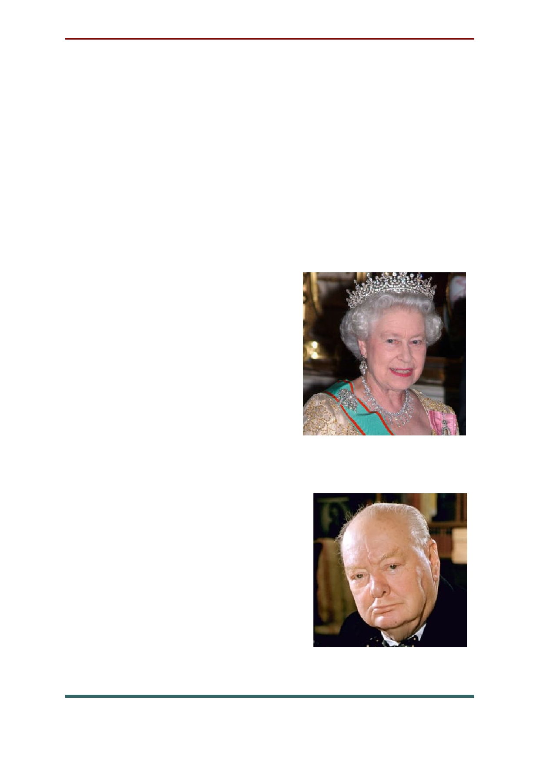Famous People of England
Queen Elizabeth II became queen on
February 6, 1952, and was crowned on June 2,
1953. She is the mother of Prince Charles, heir to
the throne, as well as the grandmother of
Princes William and Harry. As the longest-
serving monarch in British history, she has tried
to make her reign more modern and sensitive to a
changing public while maintaining traditions associated with the crown.

Sir Winston Leonard
Spencer-Churchill was a British politician, military
officer and writer who
served as the prime minister of Great Britain from 1940 to
1945 and from 1951 to 1955. After becoming prime
minister in 1940, Churchill helped lead a
successful Allied strategy
with the U.S. and Soviet
Union during World War II to
defeat the Axis powers and craft postwar peace.

24

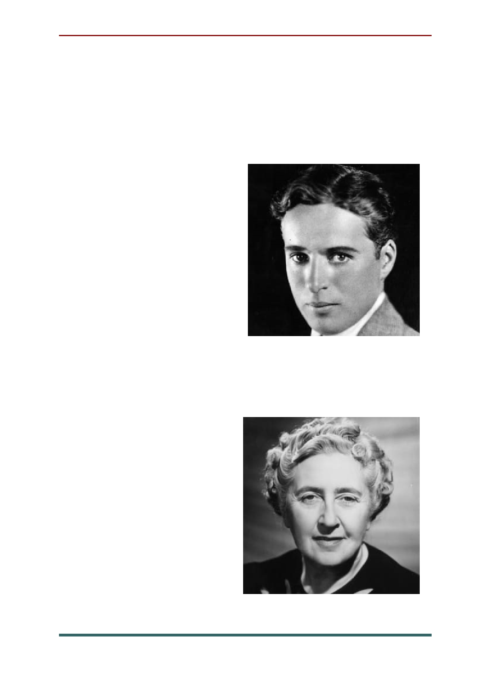Charlie Chaplin worked with a children's
dance troupe before making his mark on the big
screen. His character "The Tramp" relied on
pantomime and quirky movements to become an
iconic figure of the silent-film era. Chaplin went
on to become a director,
making films such
as City
Lights and Modern
Times, and co-founded
the United Artists Corporation.

Best-selling
author Agatha Christie published her first
novel, The Mysterious Affair at Styles, in 1920, and went on to become one of the most famous
writers in history, with mysteries like Murder
at the Vicarage, Partners
in Crime and Sad Cypress. She sold
billions of copies of her
work and was also a
noted playwright and romance author.

25

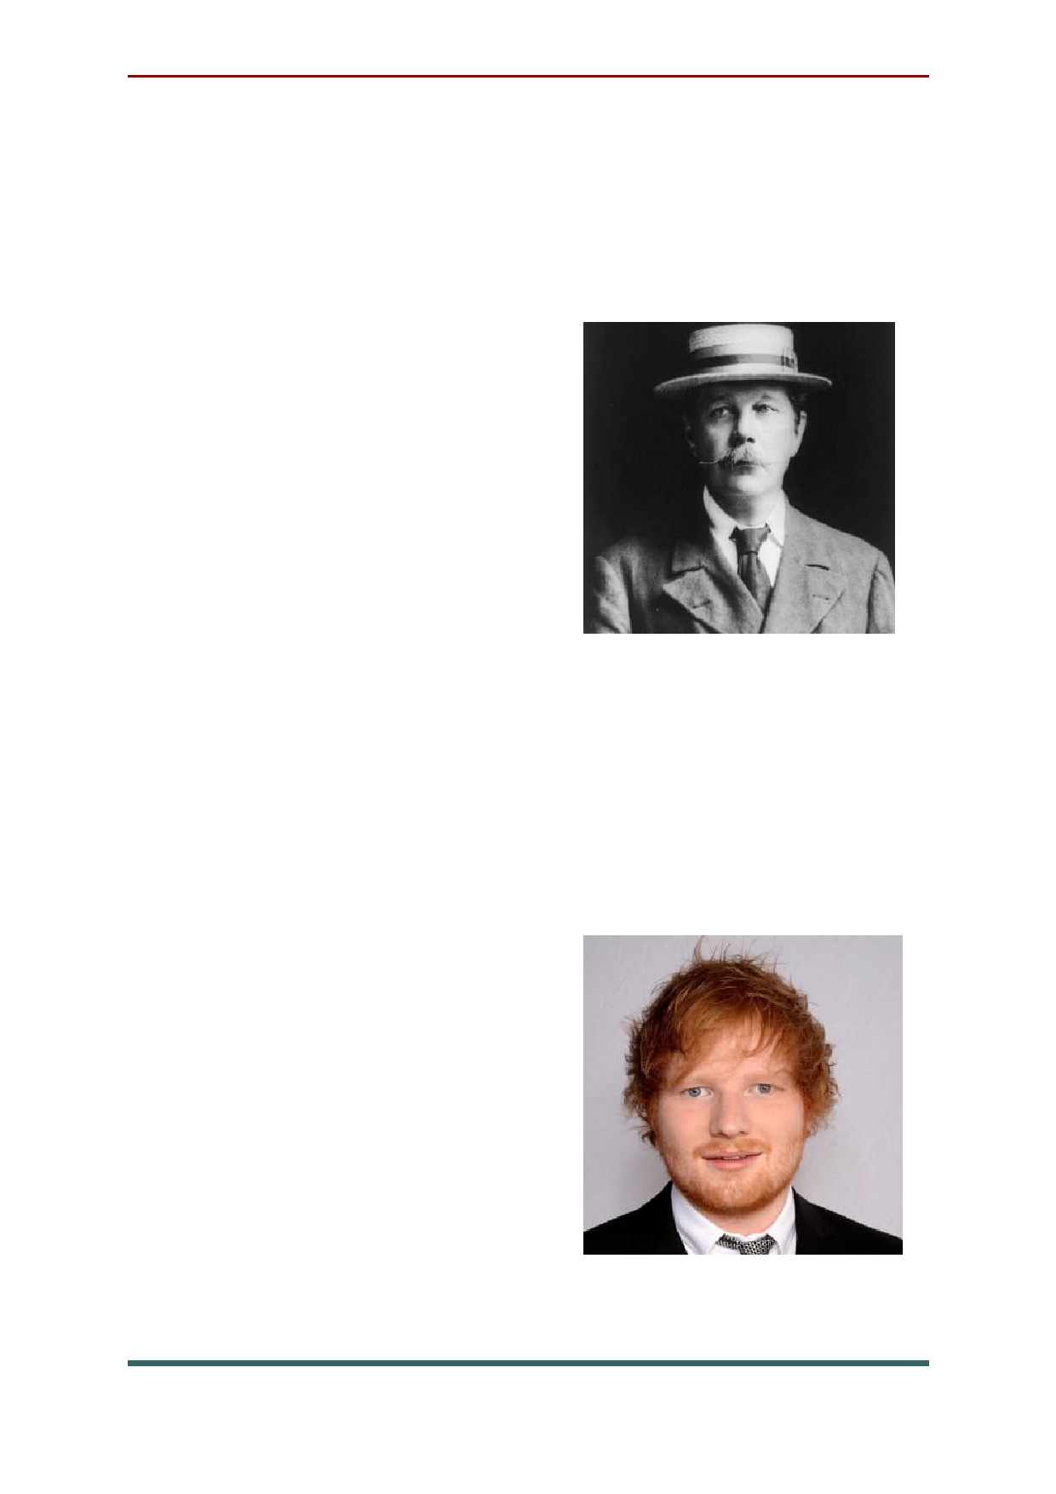In 1890, Arthur Conan Doyle's novel, A
Study in Scarlet introduced the character of
Detective Sherlock Holmes. Doyle would go on to
write 60 stories about Sherlock Holmes. He also
strove to spread his
Spiritualism faith through a
series of books that were
written from 1918 to 1926.
Doyle died of a heart attack
in Crowborough, England on July 7, 1930.

Ed Sheeran is a singer/songwriter who began
playing guitar at a young age and soon after
started writing his own songs. When he was just a
teenager, he moved to London to pursue his
music, and his outpouring of creativity added up to several early EPs and hundreds of live shows.
Since signing with Atlantic, Sheeran has sold millions of records and won Grammys for hits like "Thinking Out Loud" and "Shape of You,"
as well as his 2018 album

26

English action star Jason Statham has
convincingly portrayed a host of unsavory, yet
oddly endearing, tough guys who can generally
be counted on to dish out beat downs and lead car
chases while intercutting the action with a well- timed quip. But before he ever stepped foot on a
movie set, Statham's life was just as colorful as the
characters he's played onscreen. From being an
Olympic diver to fashion model to even having a
side gig in the black market, Statham amassed a unique set of skills that perfectly positioned him to be an action star.

Actor Tom Hardy first stepped into the spotlight
after his role in the miniseries Band Of
Brothers (2001). Other major roles followed, including in
the films Black Hawk Down (2001), Star Trek:
Nemesis (2002), Inception (2010), The Dark
Knight Rises (2012), Lawless (2012) and Mad Max:
Fury Road (2014). Hardy received his first Oscar nomination for his role as John Fitzgerald in the drama The Revenant (2015), and went on to star in the Spider-Man spinoff Venom (2018).

27

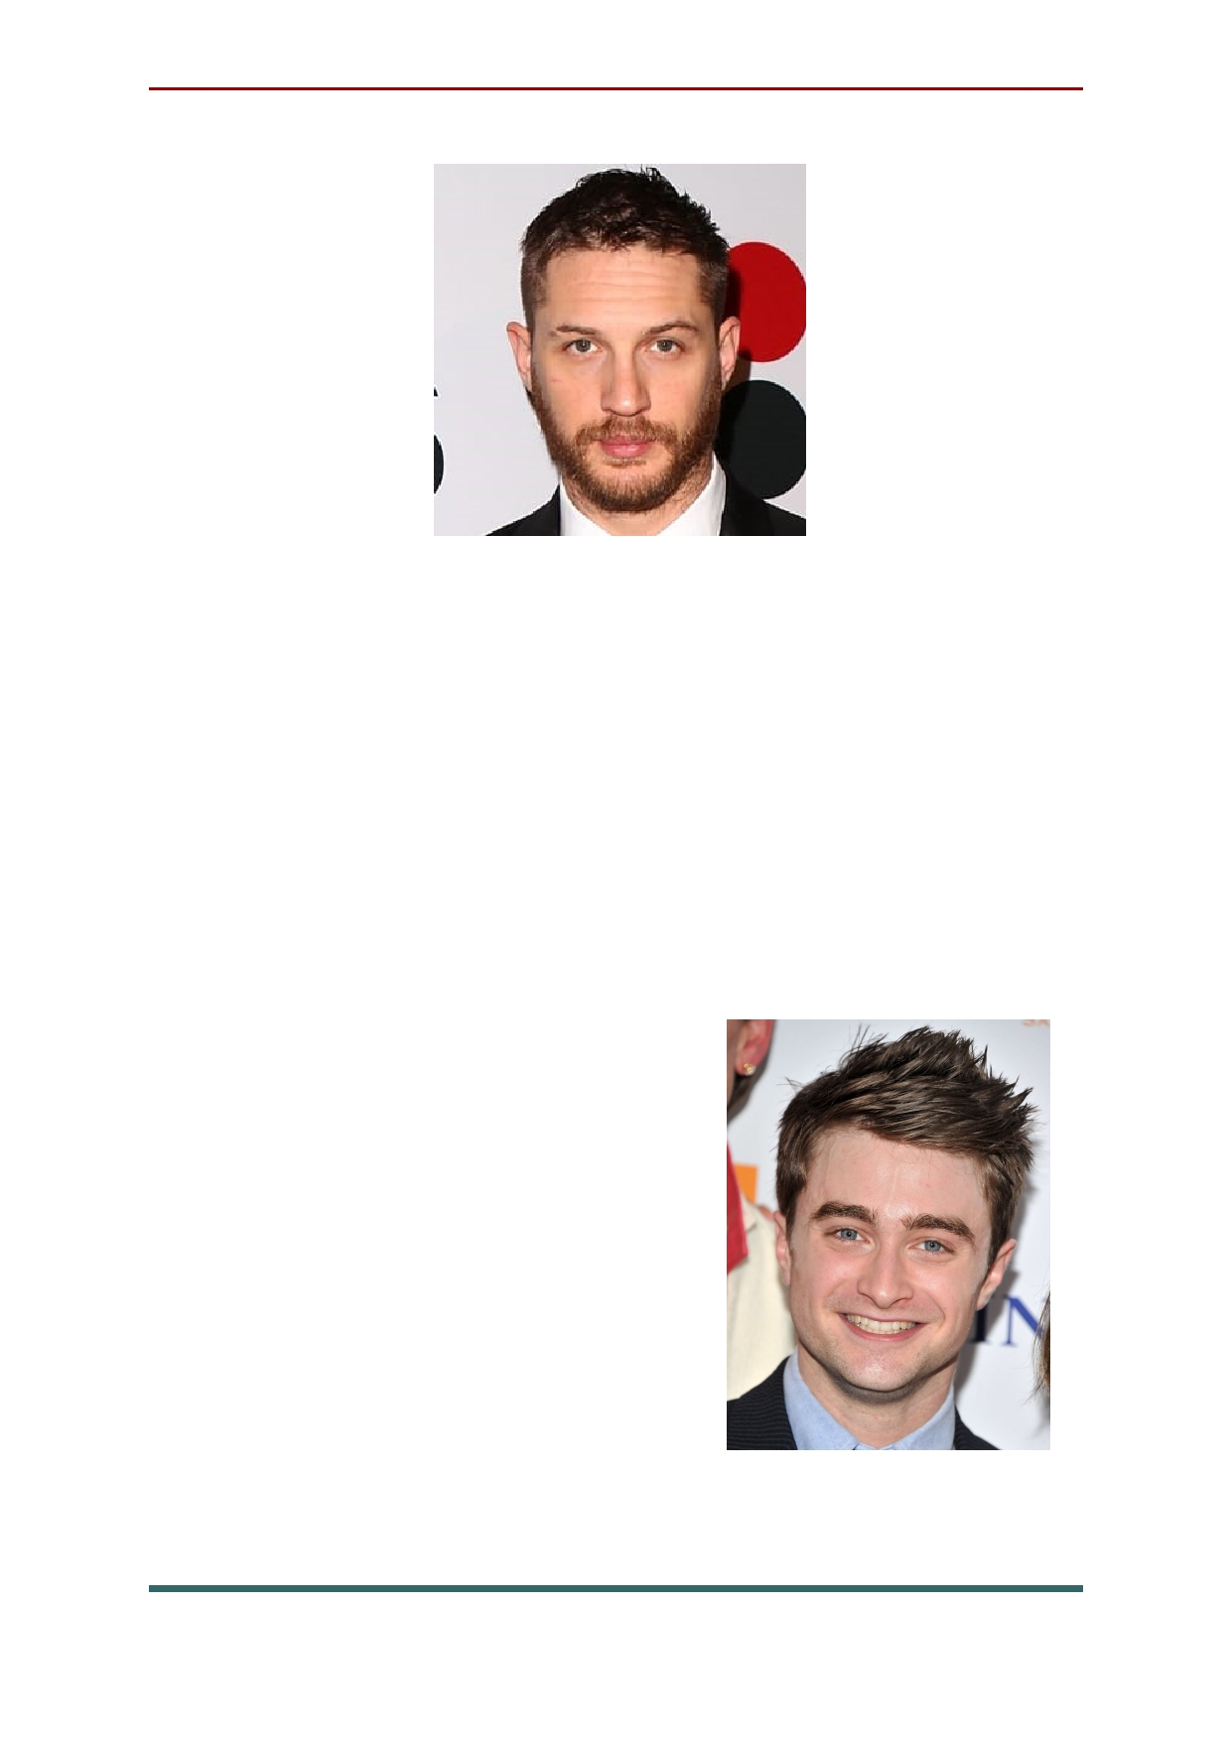Daniel Radcliffe's parents initially refused to
let him audition for the role of Harry Potter, but a
chance meeting with Harry Potter and the
Sorcerer's Stone director Chris Columbus led to
an audition. The books' legions of fans seemed to
agree that Radcliffe was perfect as the boy wizard,
and he starred in each installment of the
immensely successful eight-part film series.
Moving on from Harry Potter, the actor
performed on Broadway
in How to Succeed in Business
Without Really Trying, and
showed his versatility via
films like Kill Your
Darlings and Imperium.

28

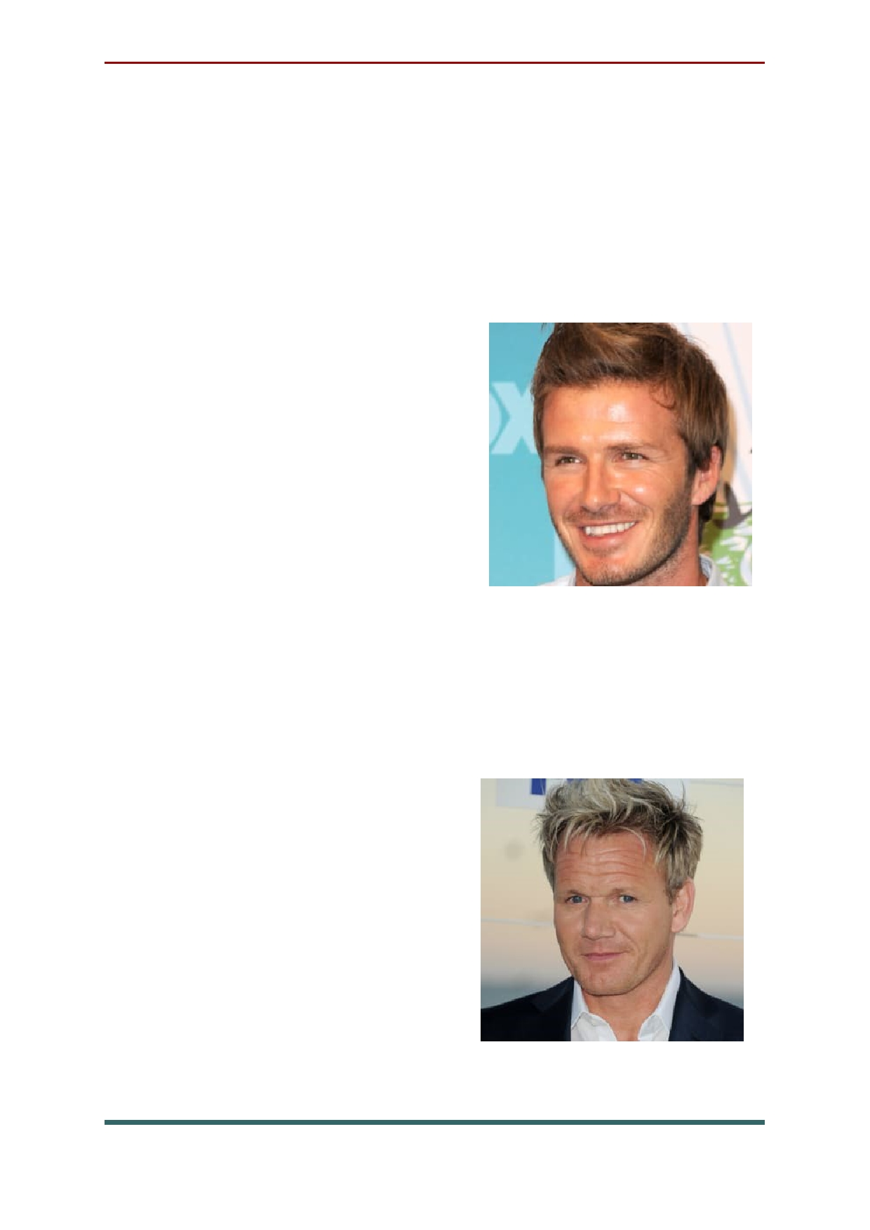A phenom almost from the moment he could
first kick a soccer ball, David Beckham began
playing for Manchester United, England's
legendary soccer team, at age 18, and was a starter
by age 20. In 2007, he signed a five-year, $250 million contract with the L.A. Galaxy. In May
2013, he announced plans to retire.

Born in Scotland in 1966, Gordon Ramsay left behind
an early athletic career to
become a renowned chef in London. By the early 2000s,
he was making his mark on British TV as the
temperamental host of Ramsay's Kitchen
Nightmares and Hell's Kitchen, shows that made
a successful transition to American audiences.
The award-winning chef
has since expanded his celebrity brand via such
programs
as MasterChef and Hotel
Hell and opening more restaurants around the globe.

29

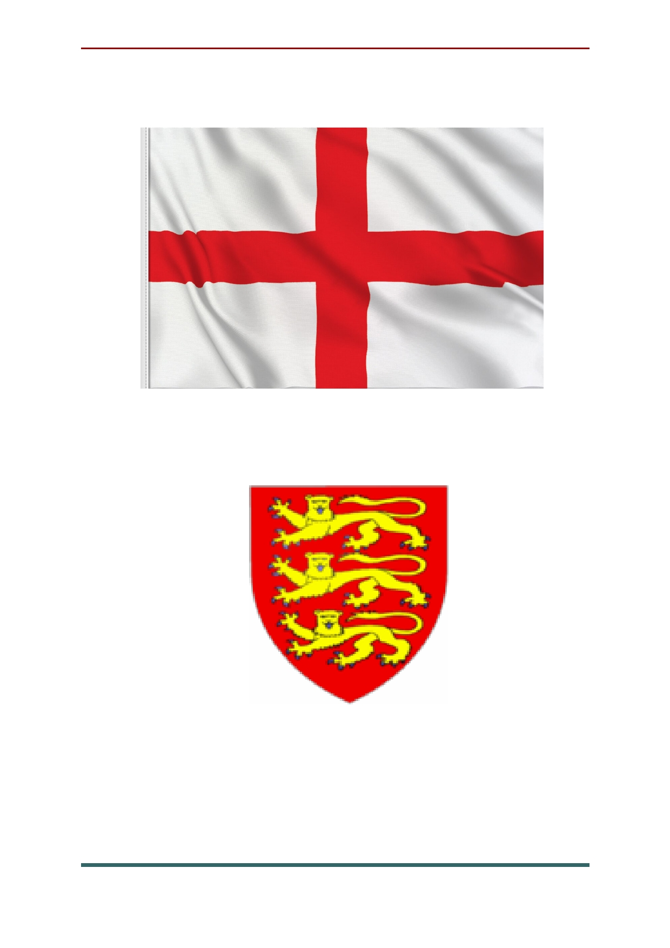National symbols of England

St George's Flag, the England Flag

The Three Lions crest (usually seen as a badge)

30

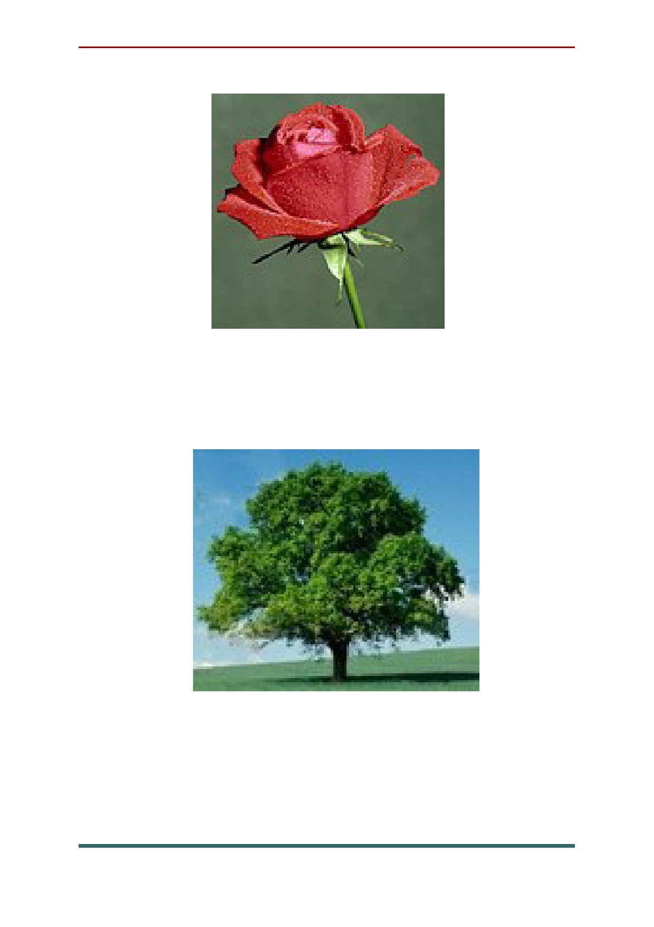The red rose is widely recognised as the national
flower of England

The oak is the national tree of England

31

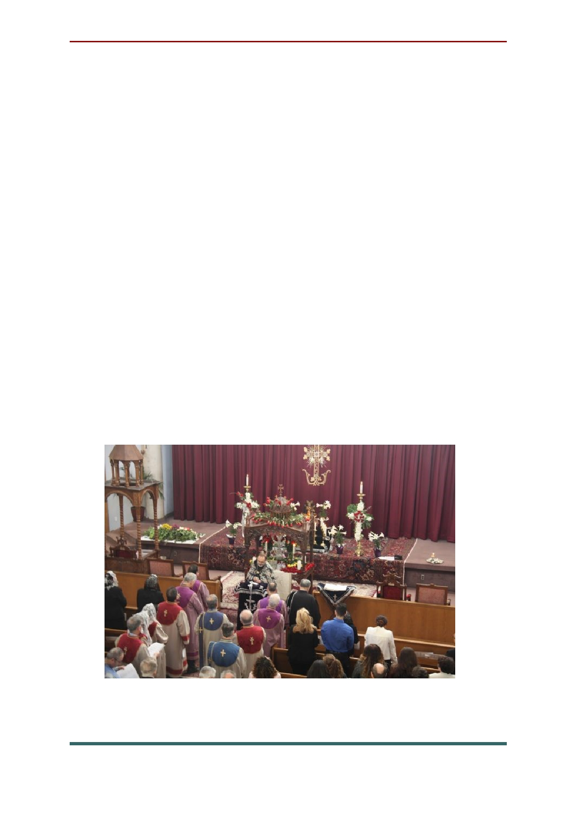National holidays and traditions in England
Good Friday. Good Friday is celebrated on
the Friday before Easter Sunday. Christians around the world observe Good Friday by
attending special church services. This day is
believed to be the day of reflection for Christians
- to remember the sacrifice made by Him. In
many churches, the services last for three hours,
which is the amount of time Jesus spent on the
cross. It's a day of mourning; in many churches, people practice Veneration of the Cross on Good
Friday. It means they bow or kneel before the
cross and kiss it. Good Friday church services also include reading of the 'Passion', the story of Jesus' death.

32

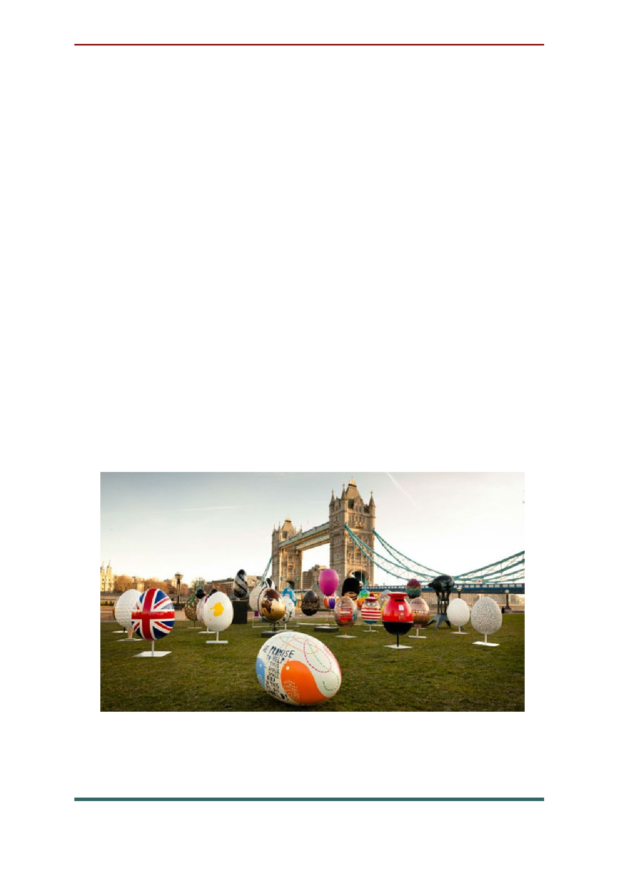Easter Monday. It is celebrated after Easter
Sunday. For many people, Easter Monday is the
last day in a four day weekend. If people have
been on a short vacation or have visited family or friends, who live some distance away, they often travel back on this day. For other people, it is just a welcome day off to enjoy the spring weather or work on their garden or home improvements. In some places, there are egg rolling competitions,
Easter bonnet parades, displays of traditional
Morris dancing fairs or special sports matches. In Biddenden, Kent, special cakes are distributed in
memory of conjoined twins born in 1100, who lived to the age of 34.

33

Early May Bank Holiday. This holiday
probably originated as a Roman festival honoring
the beginning of the summer season (in the
northern hemisphere). In more recent times, May
Day has been as a day to campaign for and celebrate workers' rights.
In many places, the first day or the first
Monday in May is celebrated as the start of the
summer season. People organize events to
celebrate the end of the winter season, fertility, and hope of the approaching summer.

Spring Bank Holiday. For many people the
spring bank holiday is a pleasant day off work or school. Some people choose to take a short trip or
vacation. Others use the time to walk in the
country, catch up with family and friends, visit garden centers or do home maintenance.
However, in some parts of the United Kingdom, there are some customs associated with this day. On Cooper's Hill in Brockworth, Gloucestershire,
people race down a steep hill following a large
round cheese. The hill is concave and has an
incline of 1:1 in some places. The first person to
cross the finishing line wins a Double Gloucester cheese weighing around 3.5kg.

34

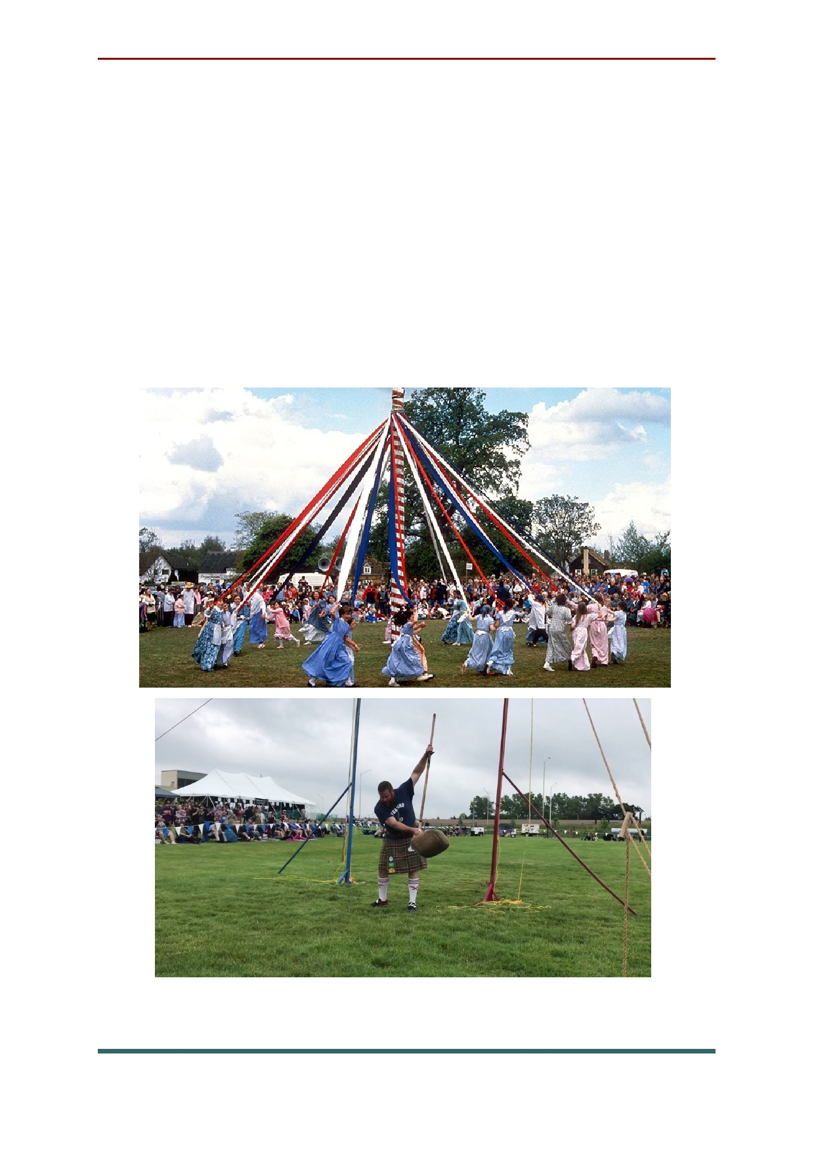In Endon in Staffordshire, the villagers dress
their well, hold a fayre (village celebration) and crown a girl as the Well Dressing Queen. Local men hold a competition, known as 'Tossing the
Sheaf', in which they compete to see who can toss
a bale of straw the highest. In other places, boats are blessed, Morris dancers put on displays and local festivals are held.

35

Summer Bank Holiday. This holiday is
celebrated on 31 August. For many people, the
summer bank holiday marks the end of the
summer. Some people take trips or short
vacations during the three day weekend. For
others, it is another opportunity to work in their gardens or carry out home improvements.
In London the Notting Hill Carnival is held.
This street festival is best known for its exuberant
costumes, dancing and music played by steel
drum bands. The festival has been held every year
since 1965 and was originally organized by
immigrants from the Caribbean, particularly
Trinidad, to the United Kingdom. It started as a
protest against the racism, poor working and housing conditions that they suffered.
Today, the Notting Hill Carnival is a
multicultural celebration, attracting over two million people. It is thought to be the second
largest street carnival in the world. In the past, a considerable amount of public disorder occurred round the event, but it has been calmer in recent years.

36

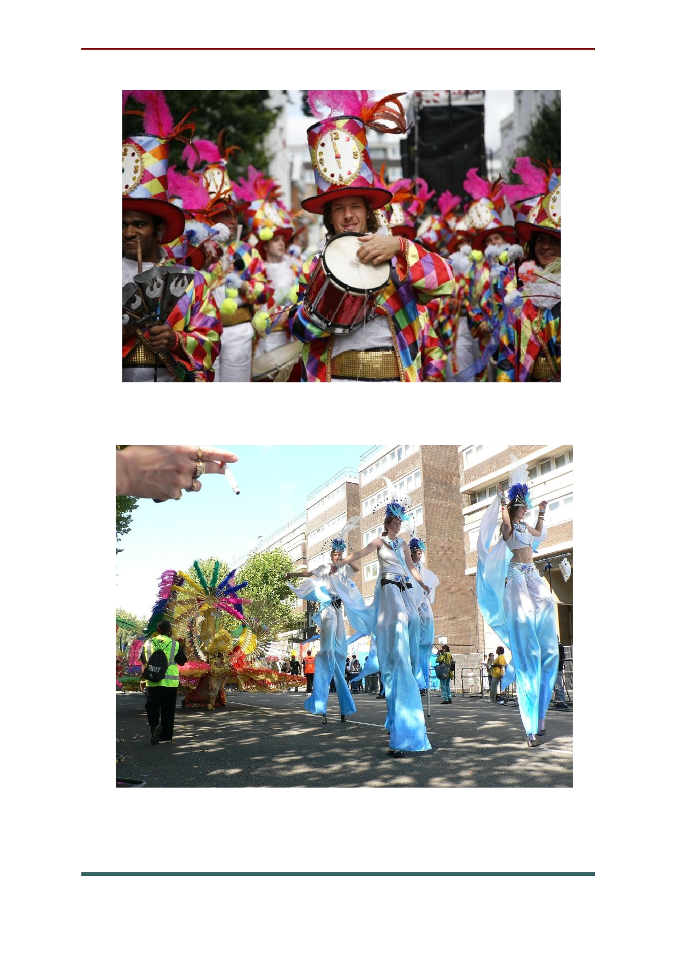

37

Christmas Day. This holiday is celebrate on
25 December. Prior to Christmas Day, people
decorate their homes and gardens prior to
Christmas Day. These decorations may include:
Christmas trees, small colored fairy lights, leaves and berries from holly trees and mistletoe bushes,
various other decorations with rich colors that spark the Christmas mood.
In many towns and cities, the shopping
streets are also decorated with lights and large
pine trees, often specially imported from Norway.
In some places a Nativity scene is arranged. This illustrates the story of Jesus' birth using statues or
actors and live animals. Many churches hold
special services in the night before Christmas Day.
Many people spend Christmas Day with
family members, with whom they exchange gifts and cards. Many children wake up to find a sock or stocking filled with small gifts on their bed or
somewhere else in the house. These have
supposedly been brought by a mythical figure called 'Father Christmas' or 'Santa Claus', who
lives for most of the year at the North Pole. Later
in the day, people may attend special church
services, even if they do not usually go to church. Nearly everyone prepares and eats a special meal.

38

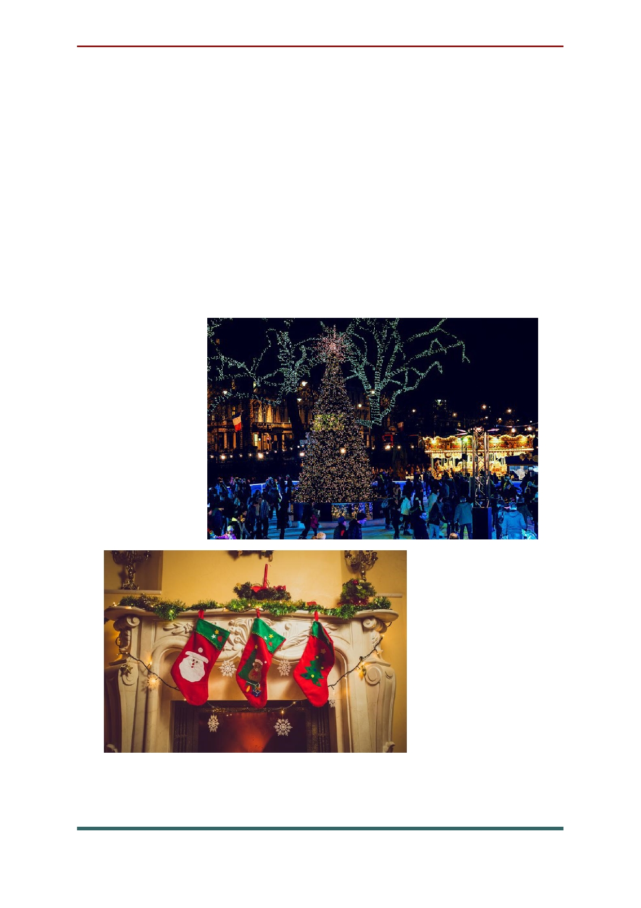This often includes roast turkey, potatoes and
parsnips, and other vegetables. After the main
course, Christmas pudding is often eaten. This is a
heavy steamed, dense, cake-like pudding filled
with dried fruit and nuts. Burning brandy is often poured over it as it is served, giving a spectacular
effect. Mince pies are also popular on Christmas
Day. They are sweet pastry cases filled with a mixture of dried fruit, fat and alcohol.

39

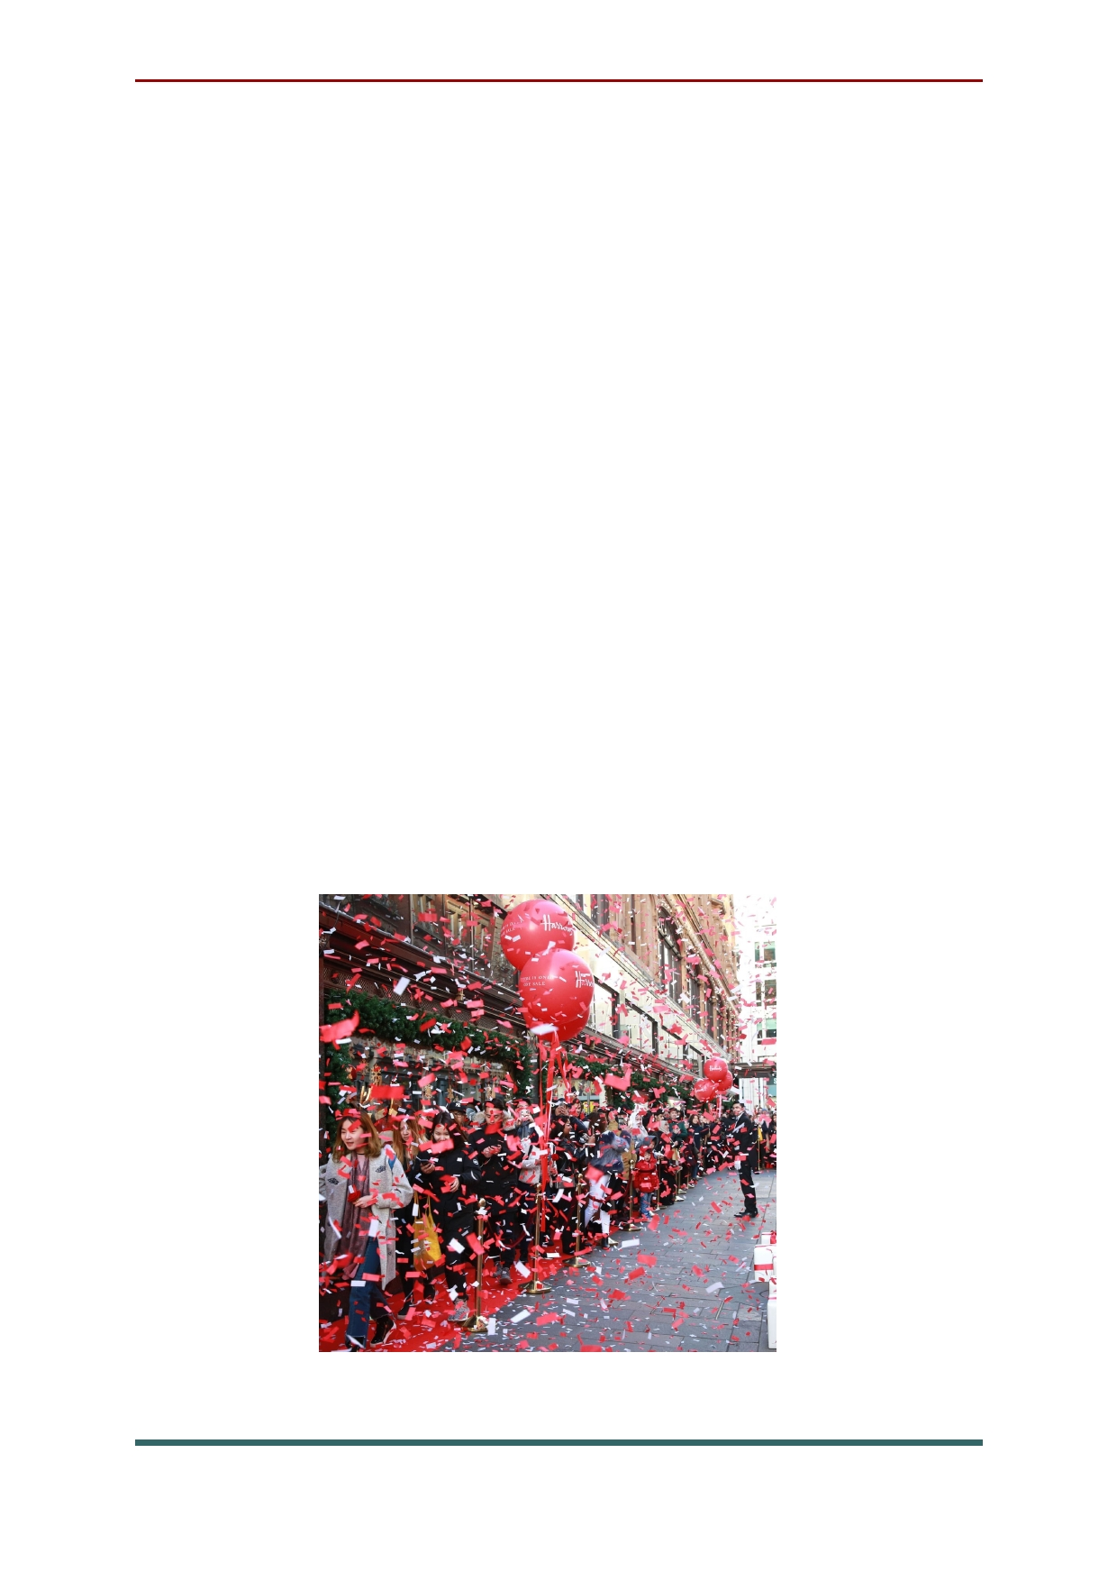Boxing Day. When Christmas day passes, the
celebration continues. For some people, Boxing
Day is a time to spend with family or friends, particularly those not seen on Christmas Day
itself. Many people will gather for meals, spend time outside, or simply relax at home and enjoy
the day off. Traditional Boxing Day food includes baked ham, pease pudding, and mince pies with
brandy butter, along with a slice of Christmas cake or another dessert.
To some extent, Boxing Day is considered a shopping holiday, with stores offering reduced
prices for Boxing Day sales, similar to Black
Friday, the day after Thanksgiving in the United
States. However, the number of people who shopped on Boxing Day has declined.

40

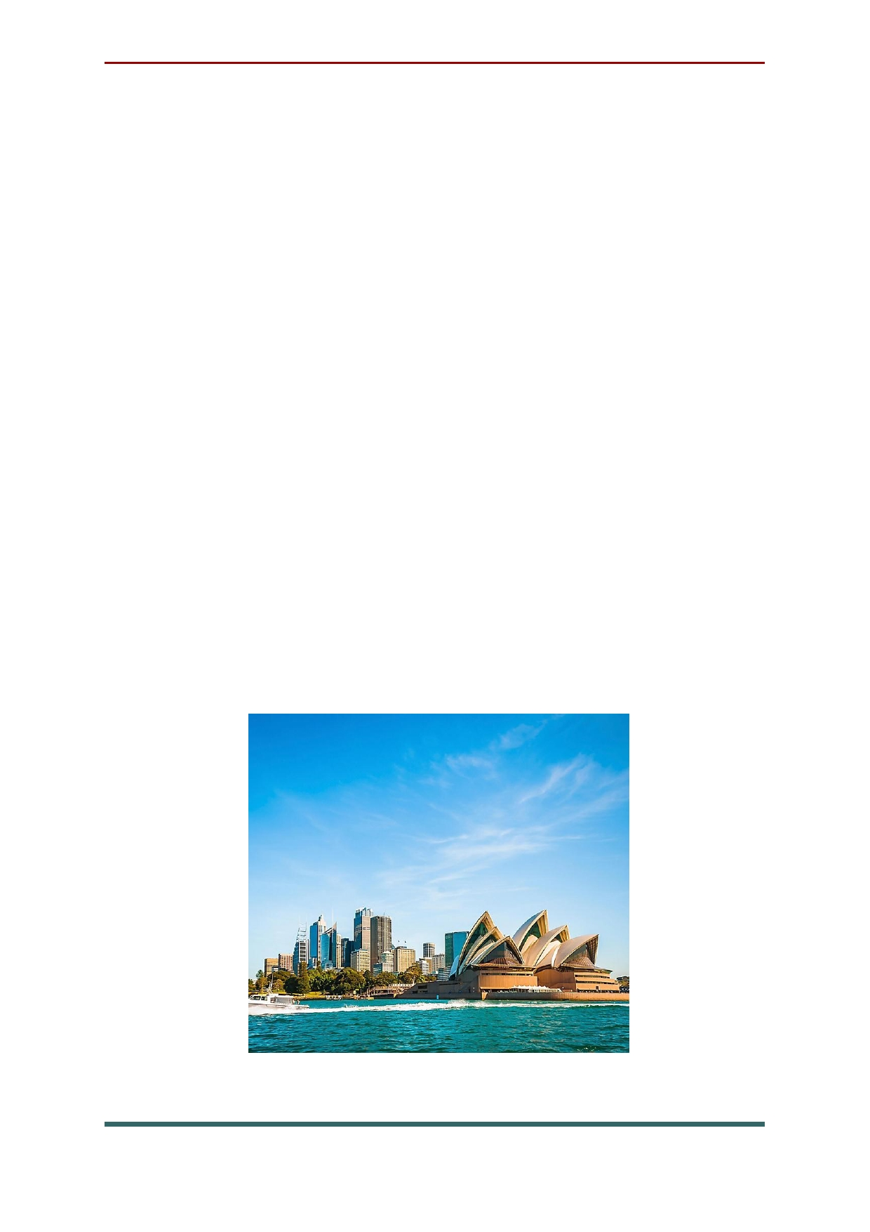Chapter 2: Australia

Australia, the smallest continent and one of
the largest countries on Earth, lying between the Pacific and Indian oceans in the Southern Hemisphere. Australia's capital is Canberra,
located in the southeast between the larger and more important economic and cultural centres of Sydney and Melbourne.
The Australian mainland extends from west
to east for nearly 2,500 miles (4,000 km) and from Cape York Peninsula in the northeast
to Wilsons Promontory in the southeast for nearly 2,000 miles (3,200 km).
Large cities of Australia are Sydney, Melbourne, Brisbane, Perth.

41

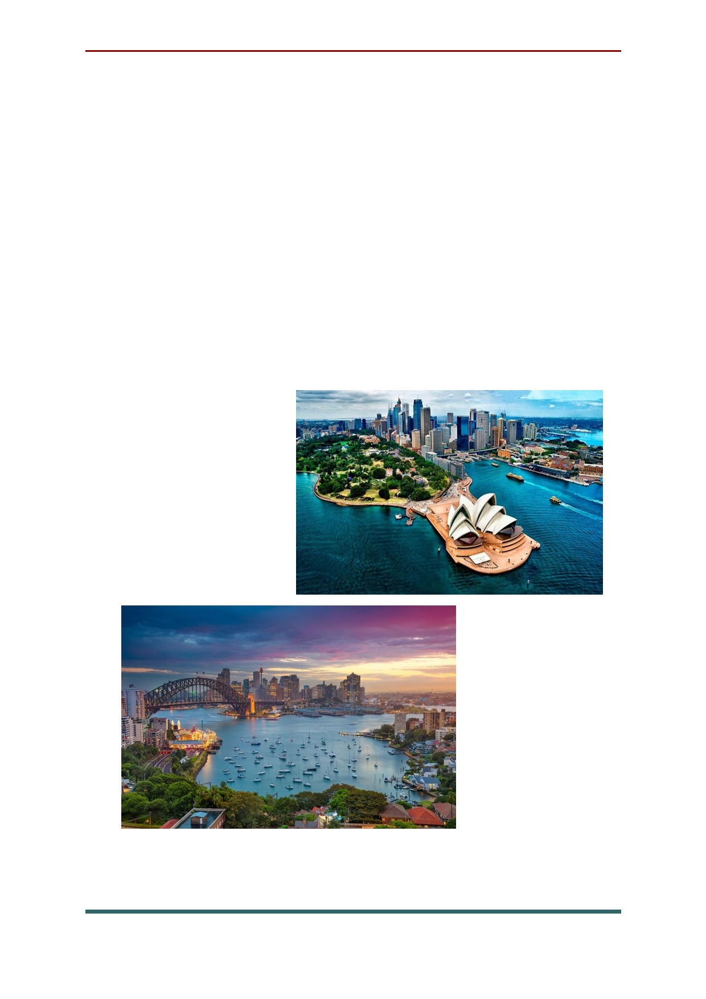The biggest cities of Australia
Sydney is an Australia's largest city and state
capital of New South Wales, located in the South- Eastern part of the country, on the Bay.
Sydney was founded in 1788 as the first
European settlement on the Australian continent,
and was named after the Minister of the British
colonies. Today, Sydney is one of the most
beautiful cities in the world, as well as the most
important cultural, business and transport center of Australia.

42

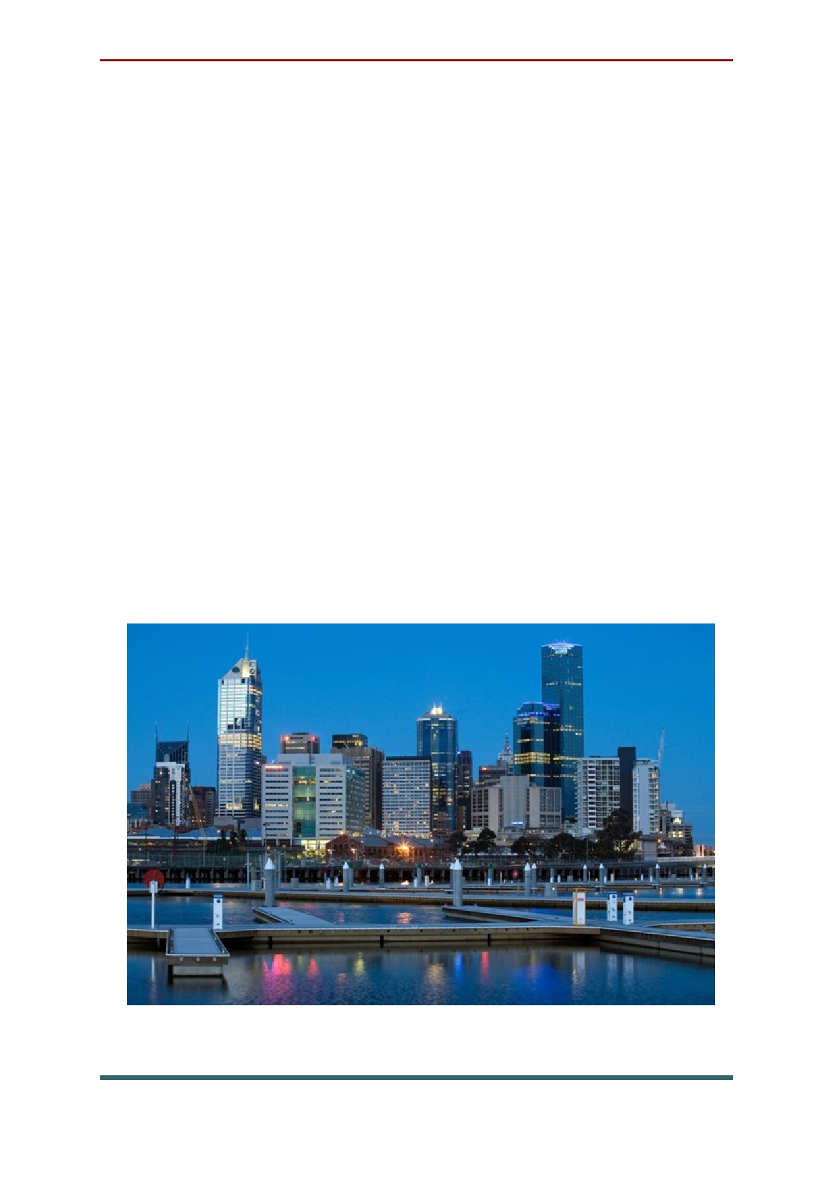Melbourne is the capital of the Australian
state of Victoria, located on the South-Eastern
coast of the country. In the city center, next to the Yarra river, there is a modern Federation square with public meeting places, bars and restaurants. Southbank is home to the Melbourne arts Centre
and the national gallery of Victoria, which
features works by European artists and Australian aborigines.
Melbourne is the southernmost millionaire
city in the world. The city has a population of
about 4.9 million people, including
representatives of various nationalities, including
Italians, English, Irish, Greeks, Vietnamese, Chinese and others.

43

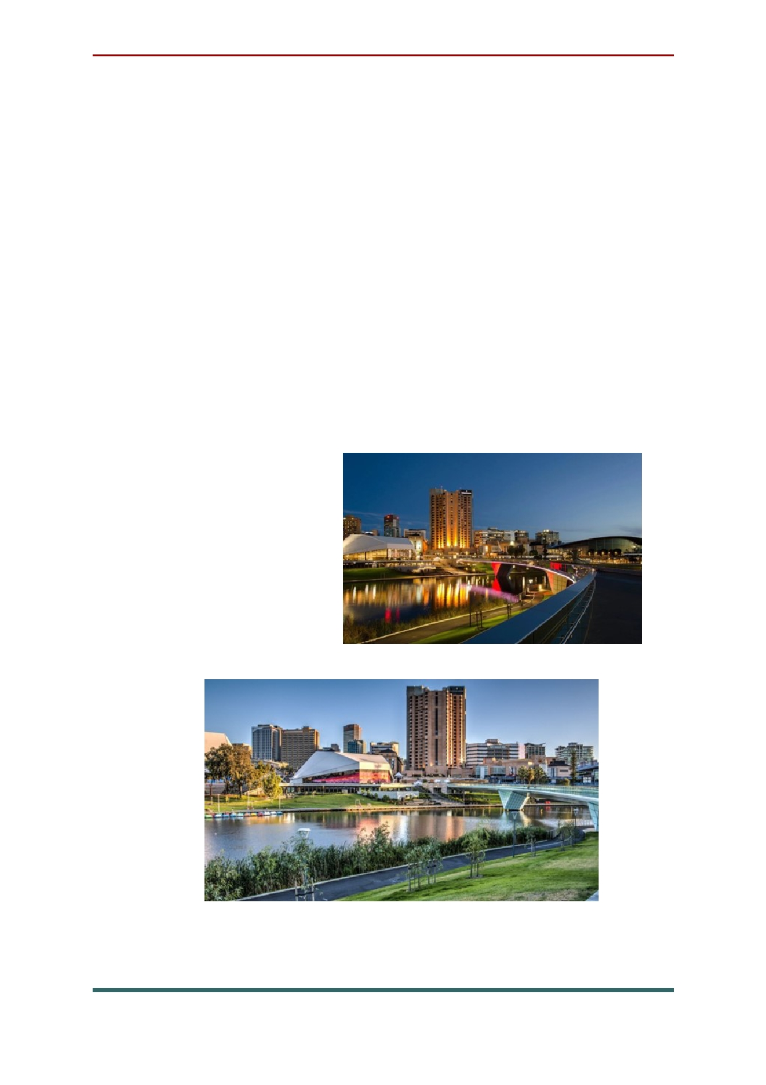The city of Adelaide is the administrative
center and largest city of the state of South
Australia, located on the shore of St Vincent's Bay,
on the Adelaide plains. Adelaide is the fifth
largest city in Australia, with a population of 1 333 900. The town was founded in 1836 by the
English captain Hindmarsh with 200 settlers.
The hallmark of Adelaide is the perfect
cleanliness of the streets, as well as the perfect
layout and decoration of buildings. Special
attention should be paid to Kangaroo island - a
unique wildlife
reserve with various types of kangaroos, a
colony of rare sea
lions and an
excellent coast for fishing.

44

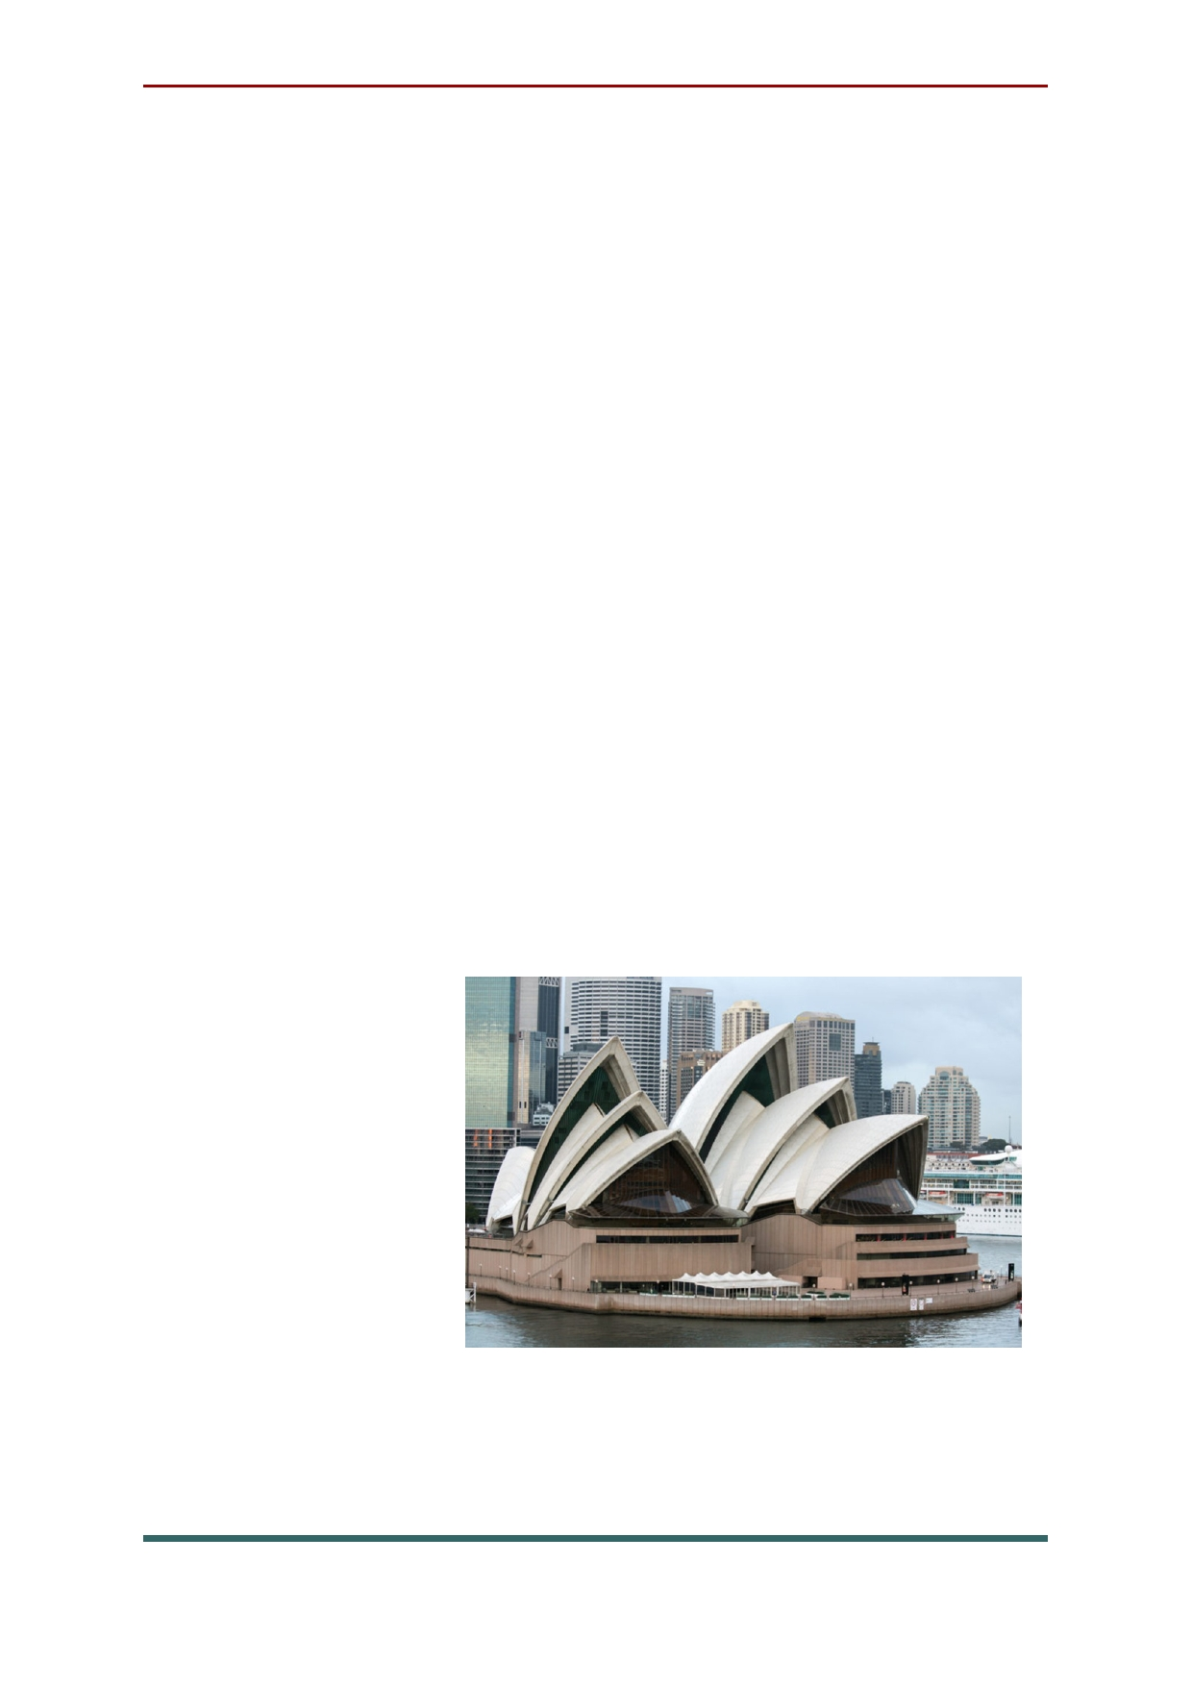Attractions of Australia
Opera house (Sydney). The Sydney
landscape is clearly recognized among thousands
of other cities thanks to the world-famous
landmark-the Opera house, one of the most
famous in the world of architecture. This unique
building was designed by a Danish architect
named Jorn Utzon. Having designed the original
shape of the roof of the theater, the Dane gave
Sydney a symbol of the city, which now almost
every inhabitant of the planet recognizes this city.
Many years after the construction of the
famous building, the architect admitted that he
was inspired to create a unique roof of the theater, removed from the fruit in triangular segments.
Opera house has always attracted the attention of
tourists with its unusual forms,
which is why
this architectural
creation has
become almost an integral part
of any tour in Sydney.

45

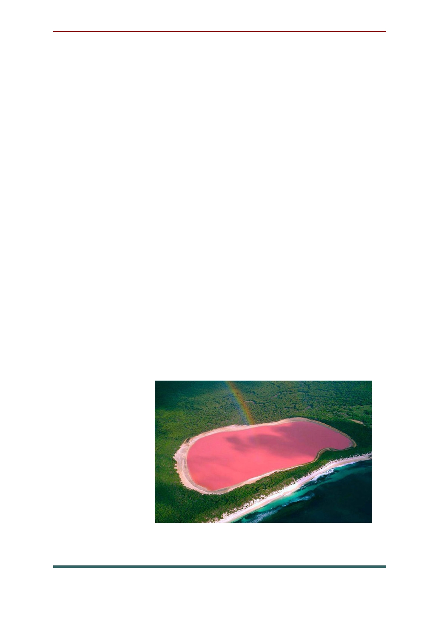Hiller lake (Middle island). If you are
wondering what to visit in Australia, be sure to include such a landmark as lake Hiller in your
travel plan. The picturesque lake, whose waters
have an unusual pink color, is located on Middle island, covered with dense eucalyptus forests. If
you look at this island from a bird's eye view,
then against the background of the rich green of
eucalyptus forests, a small bright spot will be
spotted, this is the pink lake Hiller. Even more
expressive lake gives a spectacular frame of sand and salt, which are located on its banks.
Another statement says that the pink hue is
formed due to a combination of salts contained in the waters of the lake and specific microorganism. Research conducted in the 50s of the 20th century
refuted all previous assumptions. Thus, the
mystery of lake Hiller remains unsolved to this day.

46

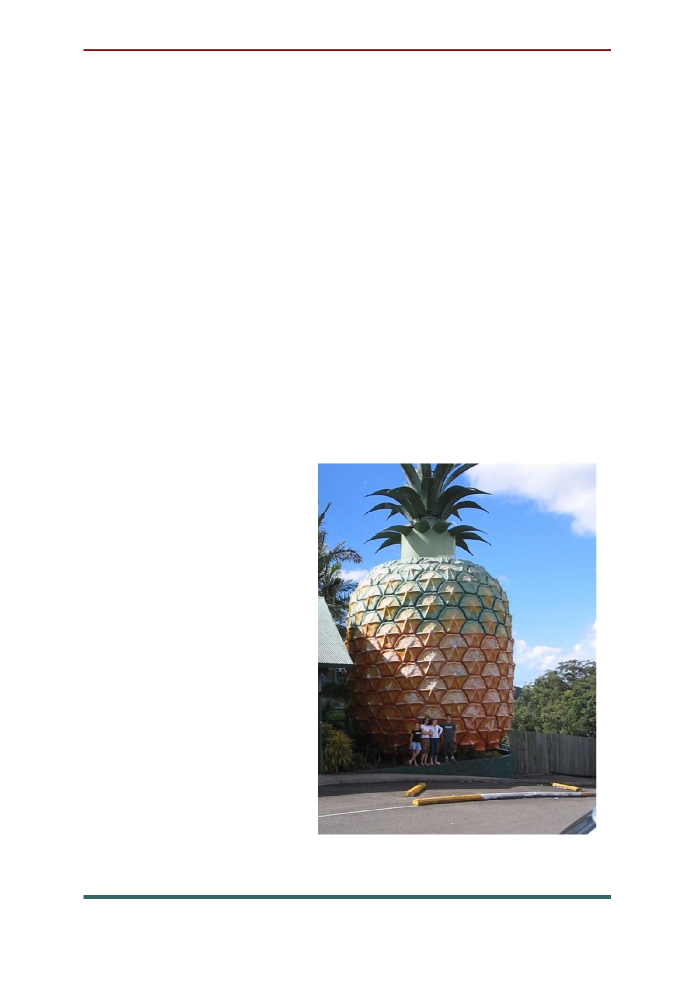The big pineapple in Queensland
(Woombye). Undoubtedly, fans of creative
architecture will find something to see in
Australia. In the state of Queensland, in the town of Wumbai, for many decades, tourists have been
pleased with the brightness and positivity of a large pineapple statue. The incessant stream of
curious travelers, eager to see this creation, does
not stop year after year. The large 16-meter
fiberglass structure was built here in 1971, when
the Taylors built a small farm and recreation Park and decided to attract the attention of visitors. It is worth admitting that they did it perfectly, because
a huge and bright
statue in the shape of
a pineapple attracts the eye from afar.
Visitors also have the
opportunity to
observe how
pineapples and
Australian
macadamia nuts are
grown on local plantations.

47

Blue mountains (New South Wales). Those
who like to contemplate natural landscapes
untouched by civilization will definitely find
something to see in Australia, because it is home to a unique natural wonder-the Blue mountains
national Park. This area got its name for a reason. A huge number of eucalyptus forests growing on the mountain range, constantly releases essential oil vapors into the air. The sun's rays, refracted in
billions of tiny oil droplets, form a bluish haze,
creating an atmosphere of mysterious
fabulousness. In the conventional sense, the Blue mountains are not mountains. In fact, this is a set
of mountain plateaus and cliffs, above which
mount Victoria rises majestically at an altitude of
about 1300 m above sea level. Sandy plateaus
interspersed with gorges and canyons are
interspersed with many crystal clear mountain
rivers and streams, creating an amazing landscape.
Unsurprisingly, the
national Park has
become one of
Australia's most
popular attractions.

48

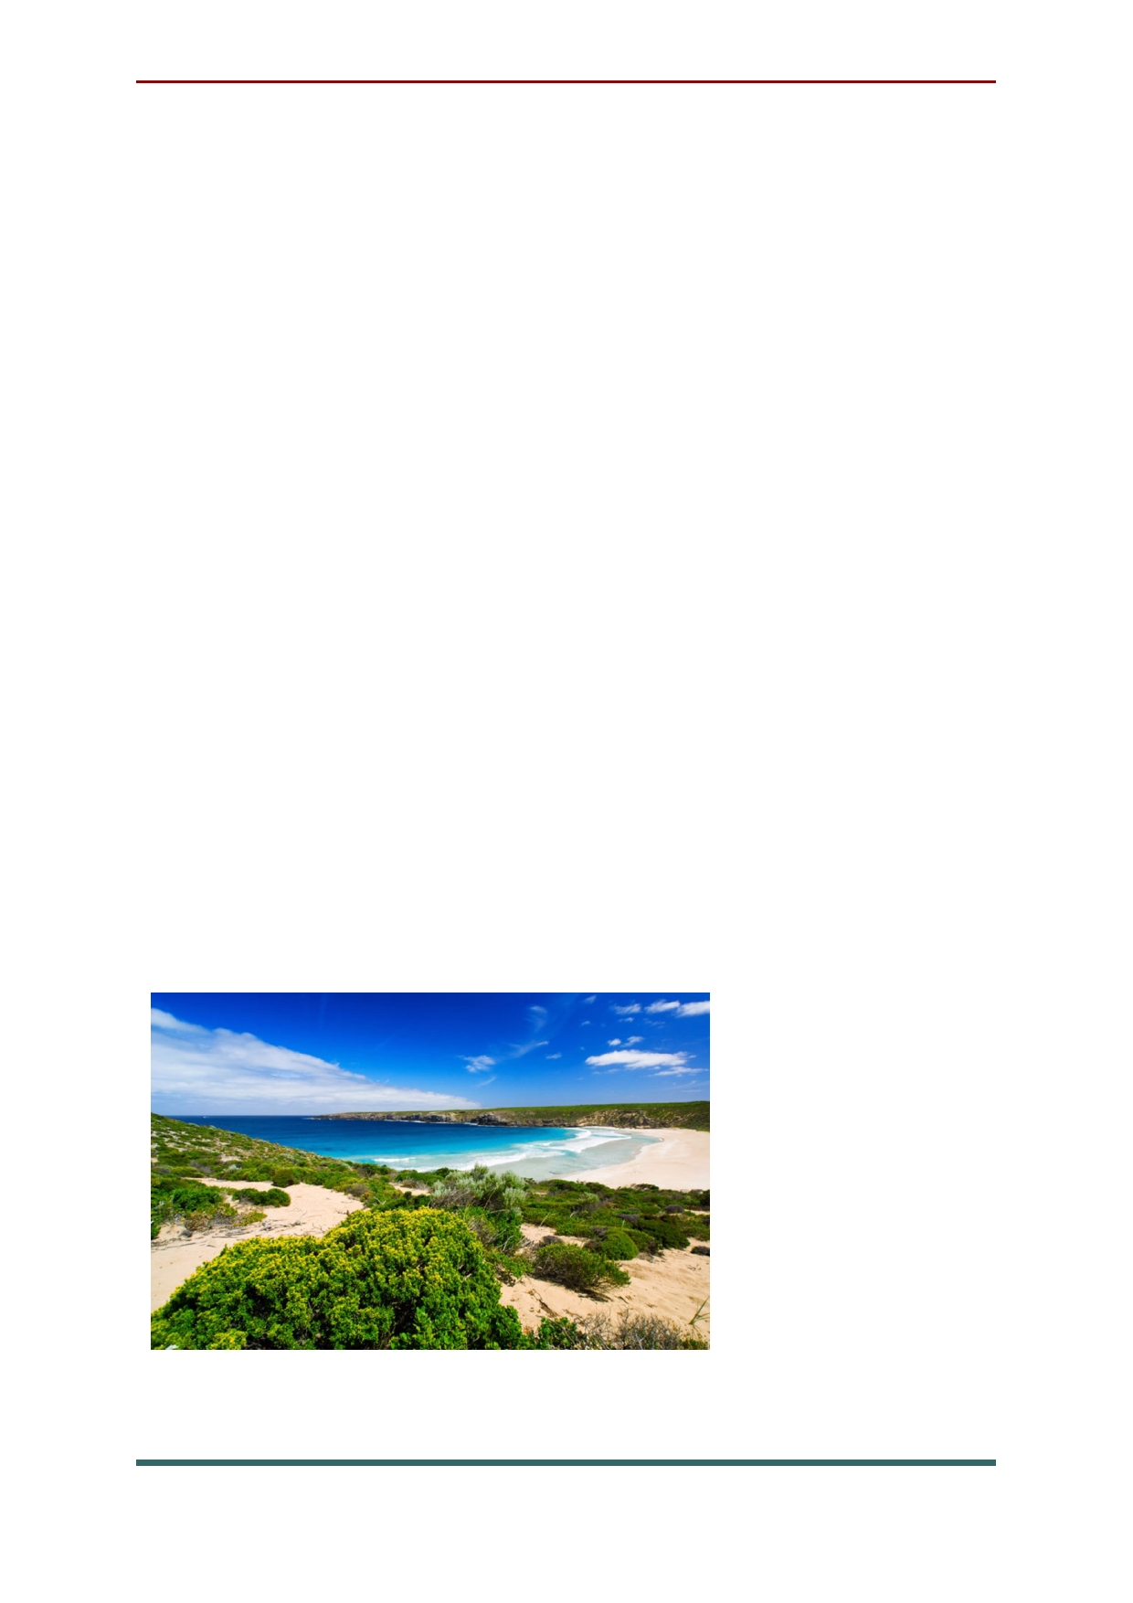Kangaroo island (St Vincent's Bay). Perhaps
everyone knows that since ancient times, the true
symbol of Australia is a kangaroo. But not
everyone knows that there is a whole island
dedicated to these amazing animals, it is called
kangaroo island. On its territory stretches a huge
area of the Park, inhabited by rare species of
ancient animals and relict plants. The island was
inhabited by aborigines several millennia ago,
after which they left this region, and all this time the land remained completely isolated from the surrounding world, giving the local animals the
opportunity to live in complete peace and
security. It was only in 1802 that the European
Flinders set foot on Kangaroo island and gave this
land its name. In addition to animals, visitors to
the Park are attracted by interesting geological
formations — the so-called Wonderful rocks,
huge boulders
of the most
unusual and
bizarre shapes, located at a low
altitude above sea level.

49

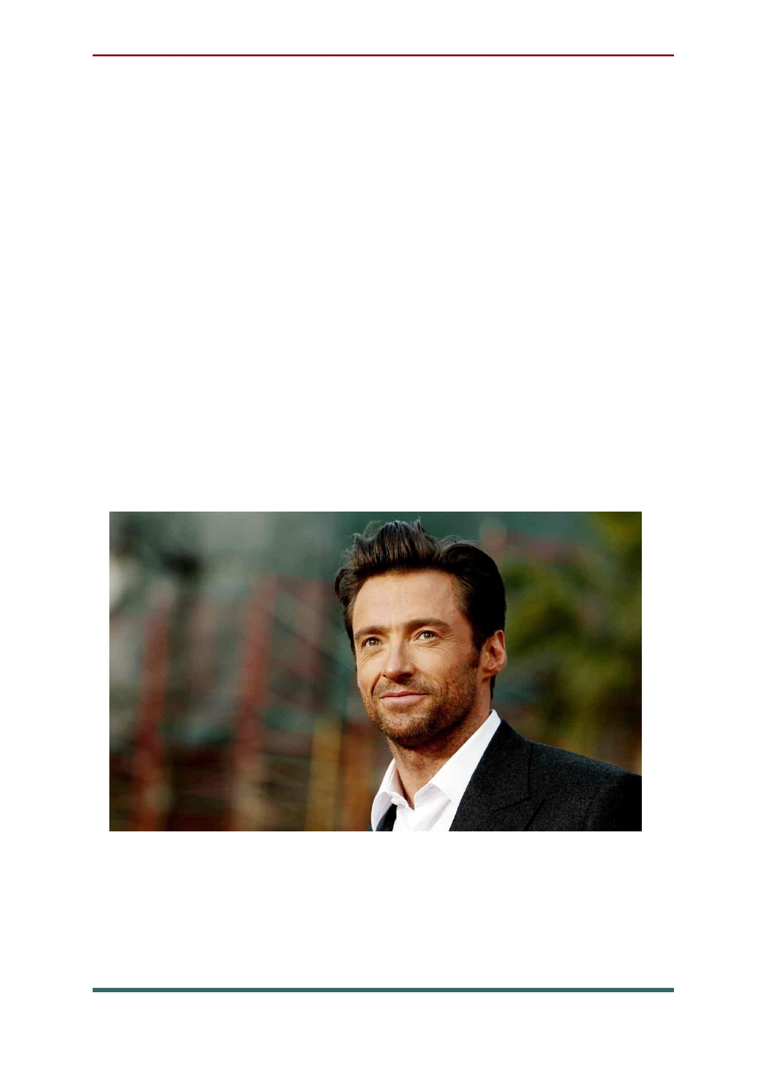Famous people of Australia
The most impressive and beloved actor Hugh
Jackman. It doesn't need to remind you what
roles this brilliant actor played, but we will do it. Well, first of all, the legendary role of Wolverine
in the series of films "X-Men" brought him success
and our love, and all the women of the planet
love the movie "Kate and Leo", where Jackman
played Prince Leopold. Well, fans of the
adventure genre adore the magician in his face in the movie "Prestige".

50

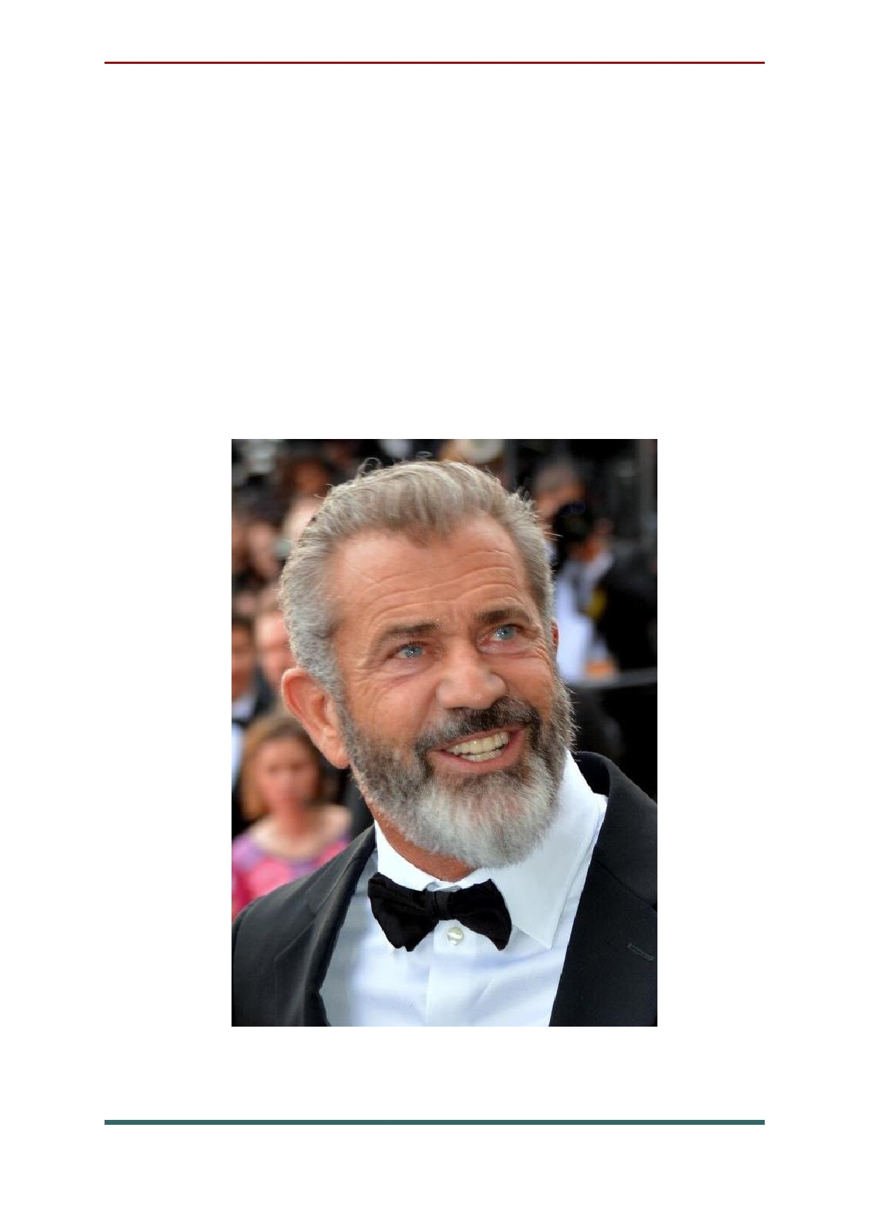You won't believe it, but the most impulsive
police hero Mel Gibson is also an Australian by the call of blood. We fell in love with this actor in a series of films called "Lethal weapon", where he
reincarnated as a young and brave police officer
named Martin Riggs. Gibson also tried his hand at
directing. For the historical film "Braveheart"
where he played William Wallace, the actor was nominated for an Academy award.

51

Such a Sunny and bright representative of
acting from boundless Australia, Chris
Hemsworth, from the first role, filled the hearts of
both Directors and viewers. Chris is not used to
listening to Directors, he plays the role in his own way, the way he sees it, which is probably why all
his roles are so interesting and characteristic. He
appears in such films as" snow White and the
huntsman"," Ghostbusters"," race"," Thor"," the
Avengers"," Thor 2: Kingdom of darkness","
Avengers: Age of Ultron "and" Thor: Ragnarok " and others.

52

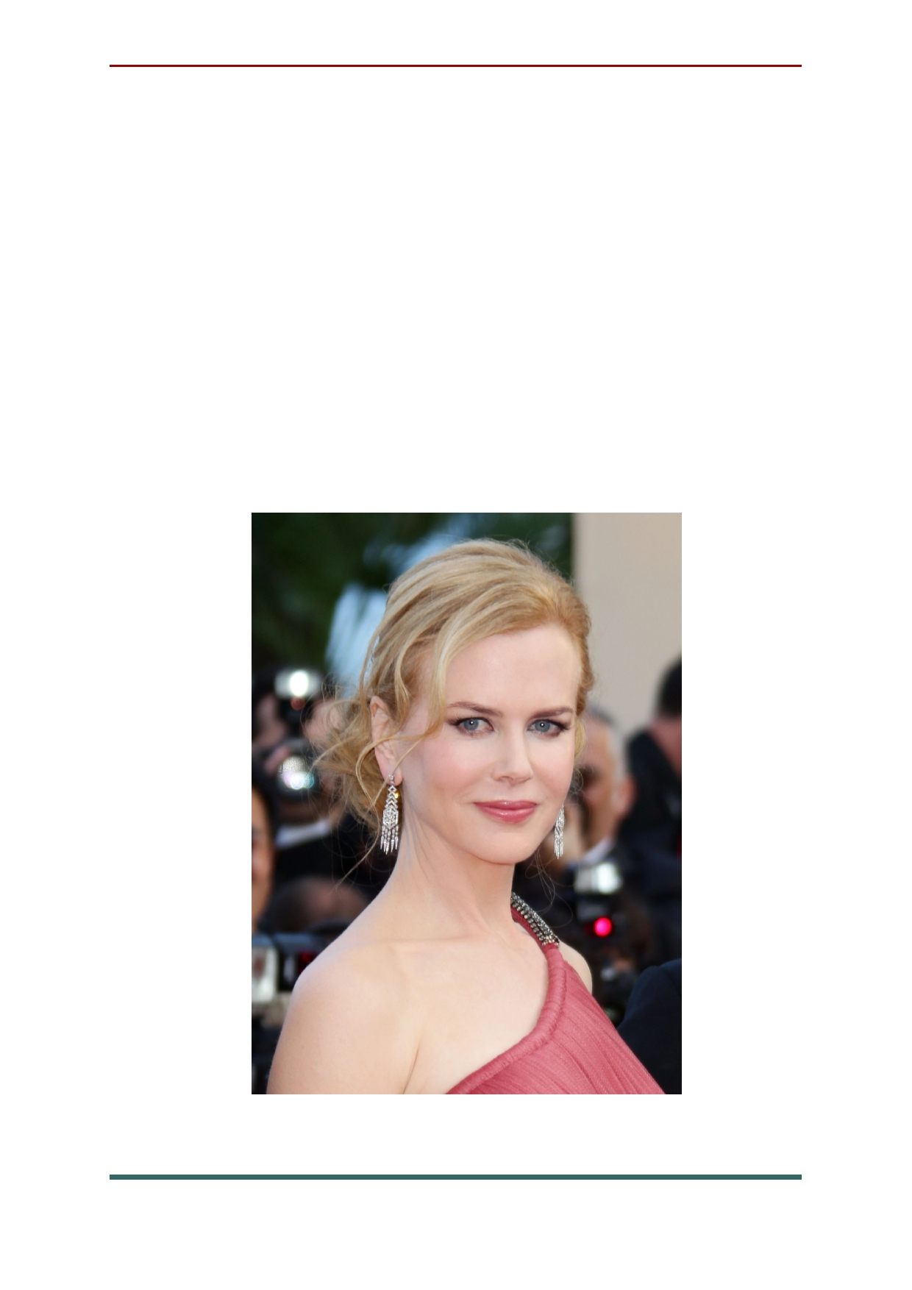Purposeful Australian women easily achieve
success in the cinema, a vivid confirmation of
which is the career of a beautiful woman Nicole
Kidman. She is subject to any genre, and the
charming actress Nicole Kidman can play
perfectly, both in dramas, and in comedies and
soulful melodramas. Tom cruise's first wife is also
known as a singer and has recorded some great
songs. In addition, in the musical" Moulin Rouge! " actress Nicole Kidman performed her own song parts.

53

Margot Robbie. Margot became widely
known after her debut in the popular TV series "Neighbors", but for our audience, she is better
known for her role as Harley Quinn in the movie "Suicide Squad".
After her career took off at Home, Margot moved to the United States, and did not lose.
Today, the young Australian has many
Hollywood works behind her, many of which are marked by high reviews from film critics.

54

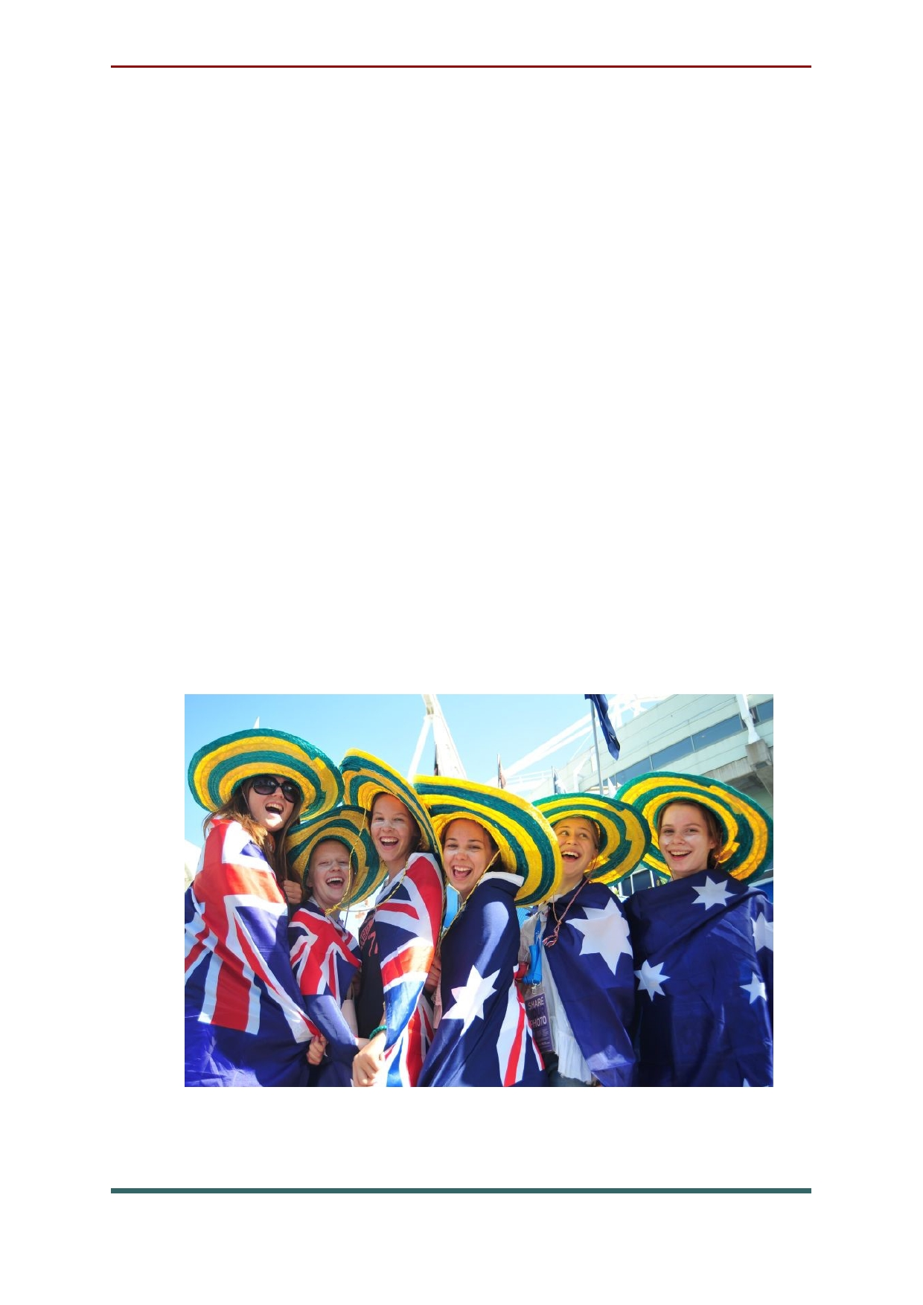National holidays and traditions in Australia
Australia day is January 26 — the national
Australian holiday. This is a day off that many
people devote to meeting friends, music events, barbecues, fireworks and fireworks. Throughout
the holiday week — it falls on the last week of
January — cities are decorated with flags of
Australia. Historically, the date is reminiscent of
the first Australian colony of Britain — New
South Wales, which is called the "Premier State".
From the lands of New Wales, which were so
named by James cook, the development of Australia began.

55

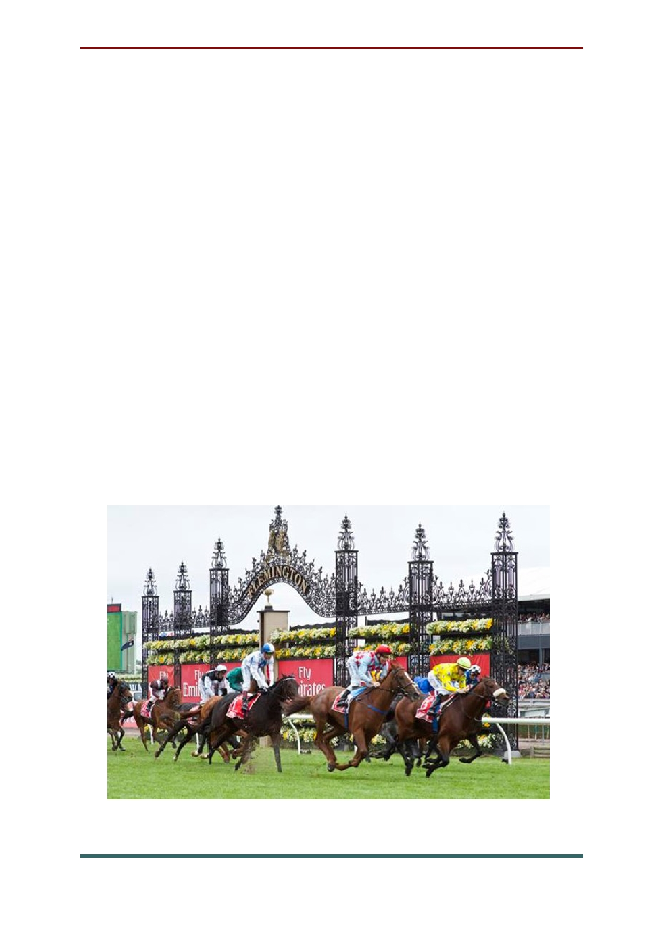The Melbourne Cup is Australia's most"
famous Tuesday", the first Tuesday in November. The Melbourne Cup is nothing more than a horse
race — a two-mile handicap. "hand in cap") — where the whole country bets. A lottery is also
held on this day. The signal that sounds at 3
o'clock in the afternoon stops everyone,
regardless of occupation and profession, and means the beginning of the Cup.
For citizens, this event also acts as a kind of
fashion festival — "style day" is held on
Thursday, and the outfit is prepared especially
carefully. The Melbourne Cup is the centrepiece
of a six-week festival held in Victoria in the spring.

56

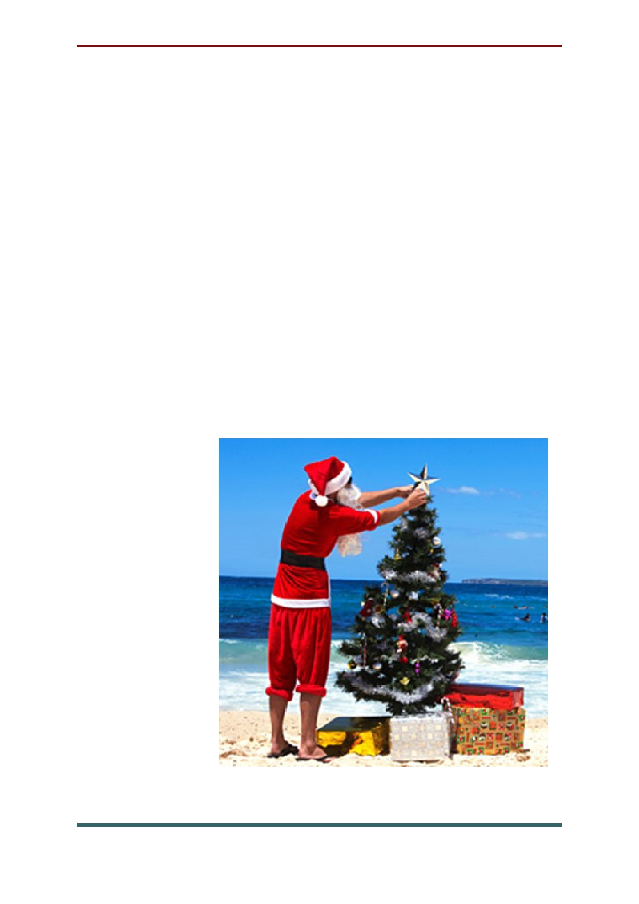Christmas in Australia, as in Europe, can be
considered the main family and Christian holiday.
The celebration takes place in December, and
Australians follow the Christmas traditions of the
Northern hemisphere of the planet: decorate
homes, sign greeting cards, arrange Christmas carols, decorate the tree, exchange gifts, and, of
course, children are waiting for the visit of Santa Claus. Many Australian plants bloom during the Christmas summer season. The first settlers were happy to use bouquets of wild Australian flowers
in Christmas decorations. The most famous of them are: Christmas bell, Christmas Bush and
Christmas Orchid.

57

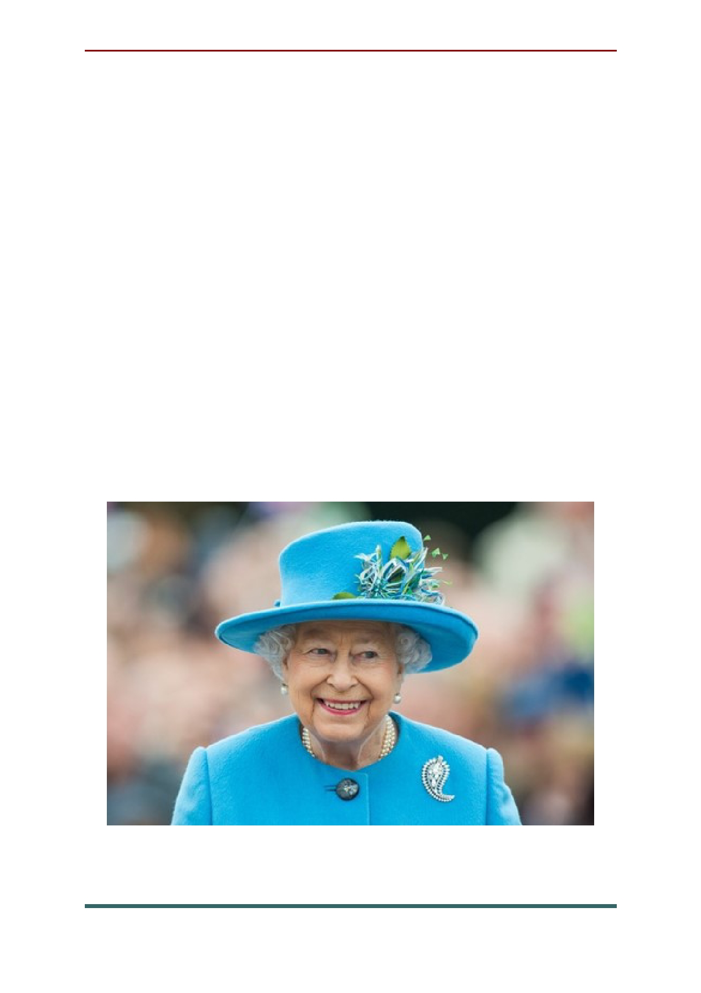The Queen's Birthday is celebrated in June
by Australians. Australia is a member of the
Commonwealth and, although it has been
politically independent from Britain since 1942, Queen Elizabeth II of great Britain remains the
monarch for Australians. The tradition of celebrating the monarch's birthday in the
summer, regardless of the actual date of birth,
was laid by Edward VII in the early XX century
and has not changed since. Queen Elizabeth
Alexandra Maria of Windsor was born on April
21. During her reign, the Queen made 15 visits to Australia.

58

Musical traditions of Australia
The rich cultural life of the Australian
continent is impossible to imagine without
musical traditions. Can do without at least one
music festival? The music of any culture reflects
the intonation of language, the rhythms of speech, the sounds of nature, various aspects of social life — everything that culture itself is made of. Music in any country largely determines the identity of
its people, or, as we say, the soul of the people.
One of the characteristic musical features is
the so-called "Australian musical sound", a sound that draws rhythms and melodies from the source of the surrounding nature and from the life of the
aborigines. There are many musical genres and
styles represented in Australia, and a special
Australian approach to music that remains unique is recognized all over the world.
Classical music in Australia is primarily
represented by its traditional Sonata and
Symphony forms, which follow strict rules of
rhythm and style, and make it distinct from simpler or more popular music.

59

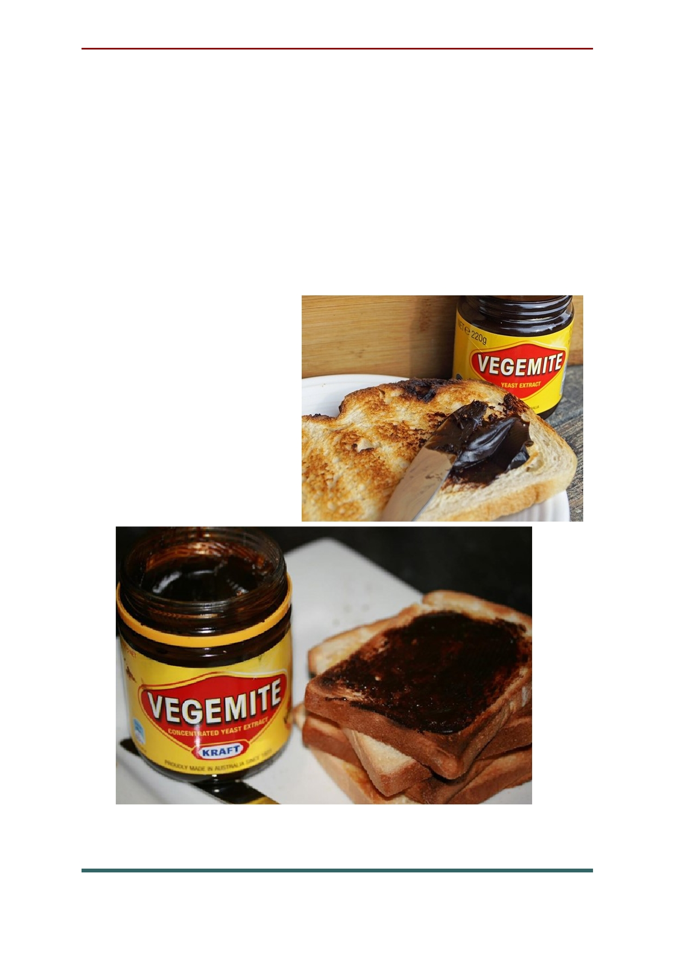The national dishes of Australia
Vegemite is truly a national dish. There isn't a
single Australian who hasn't tried this thick dark-
brown paste. The consistency of it is similar to peanut paste, but it tastes very salty and even a
little bitter, something like the taste of beef broth.
Its main purpose is to spread it on bread,
sandwiches and
crackers. It is very
popular with locals,
but for tourists it
may seem like
something tasteless, even disgusting.

60

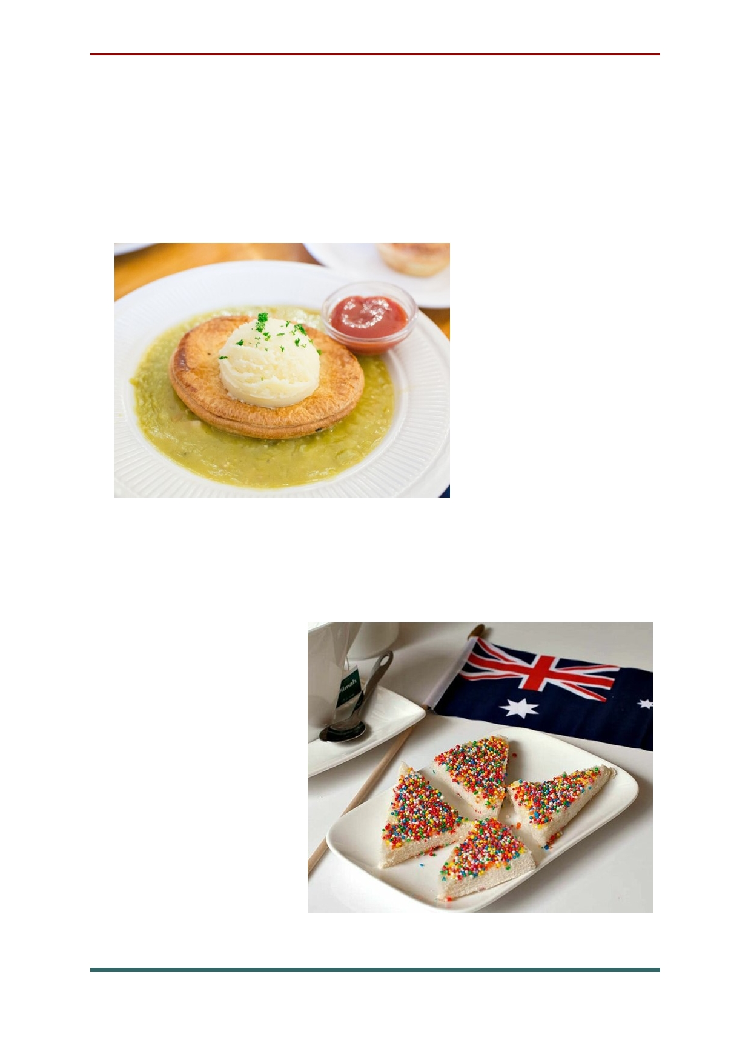A classic of Australian cuisine is a floating
pie. The dish is an ordinary meat pie, partially or completely submerged in a bowl of pea soup. It is
often topped with sauce, most often flavored
tomato or mint sauce, depending on preference.

Elvish bread is prepared very
simply: take the
bread, spread
butter on it, and sprinkle it with
colored jelly beans for confectionery. This is one
of the most popular Australian dishes. Most often, it is prepared for some holiday, for example, on a
Birthday or
Australia Day. The dish looks
beautiful and will look good on the holiday table.

61

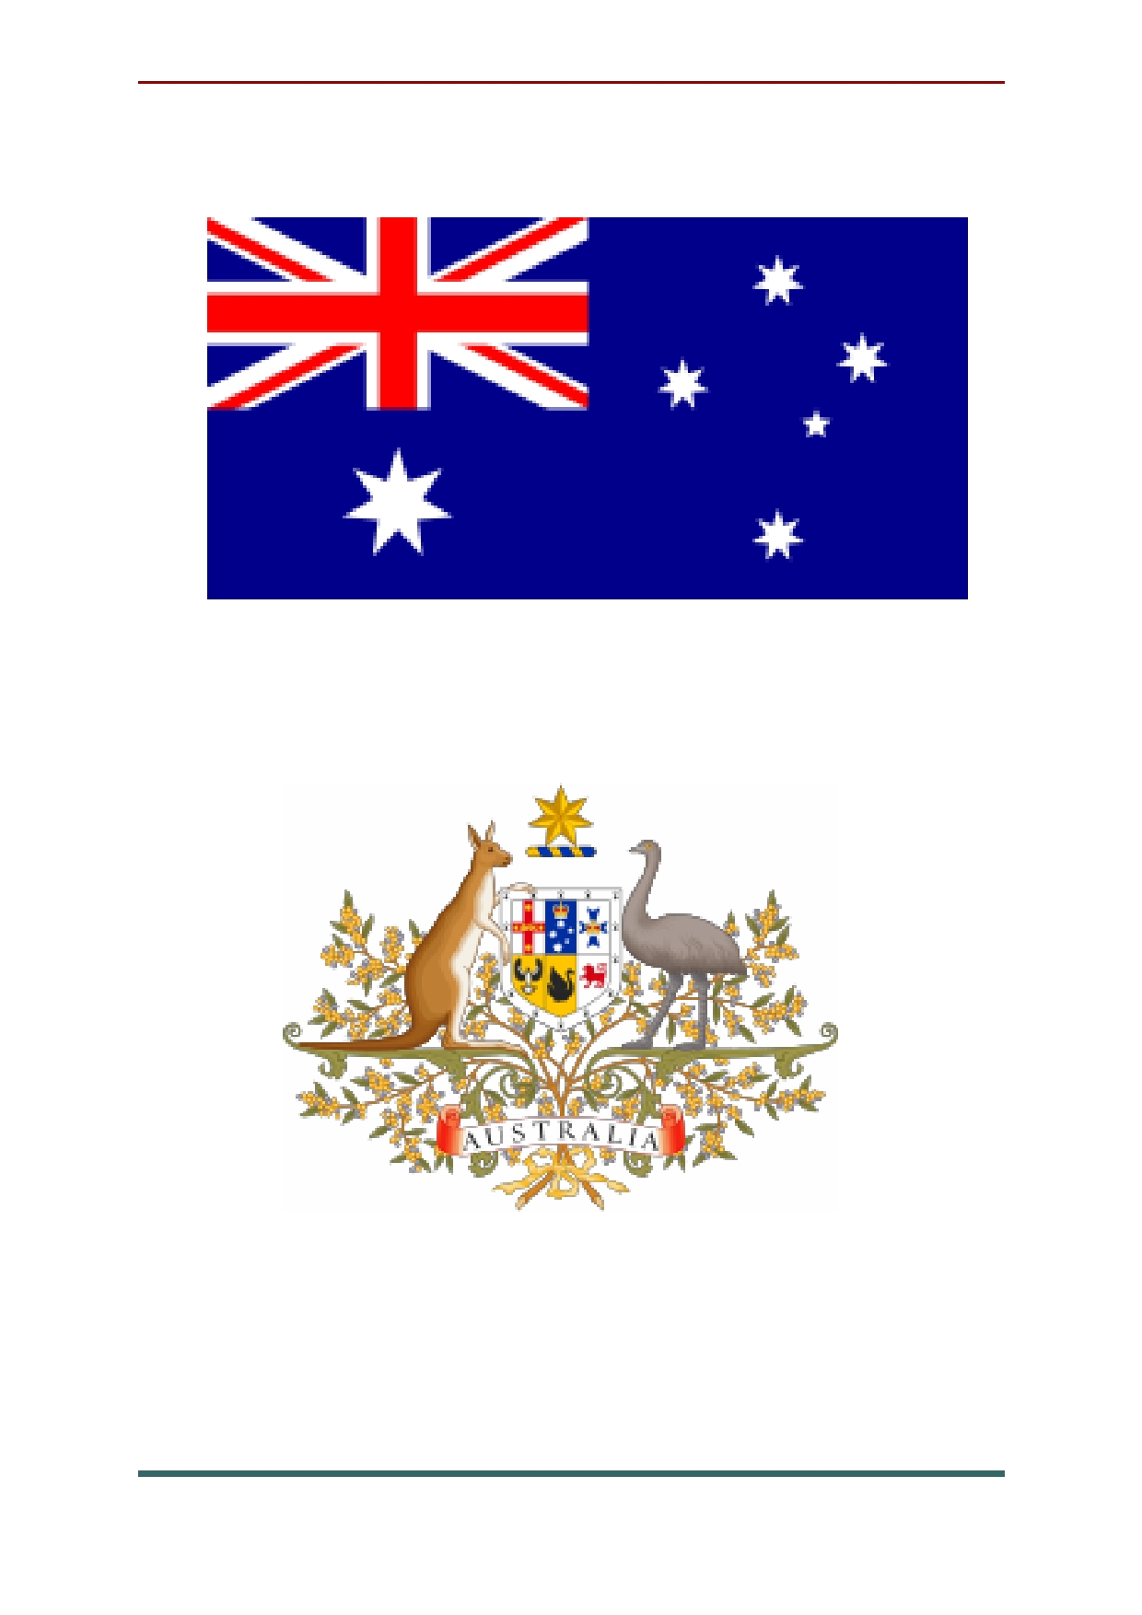National symbols of Australia

The flag of Australia

Coat of arms of Australia

62

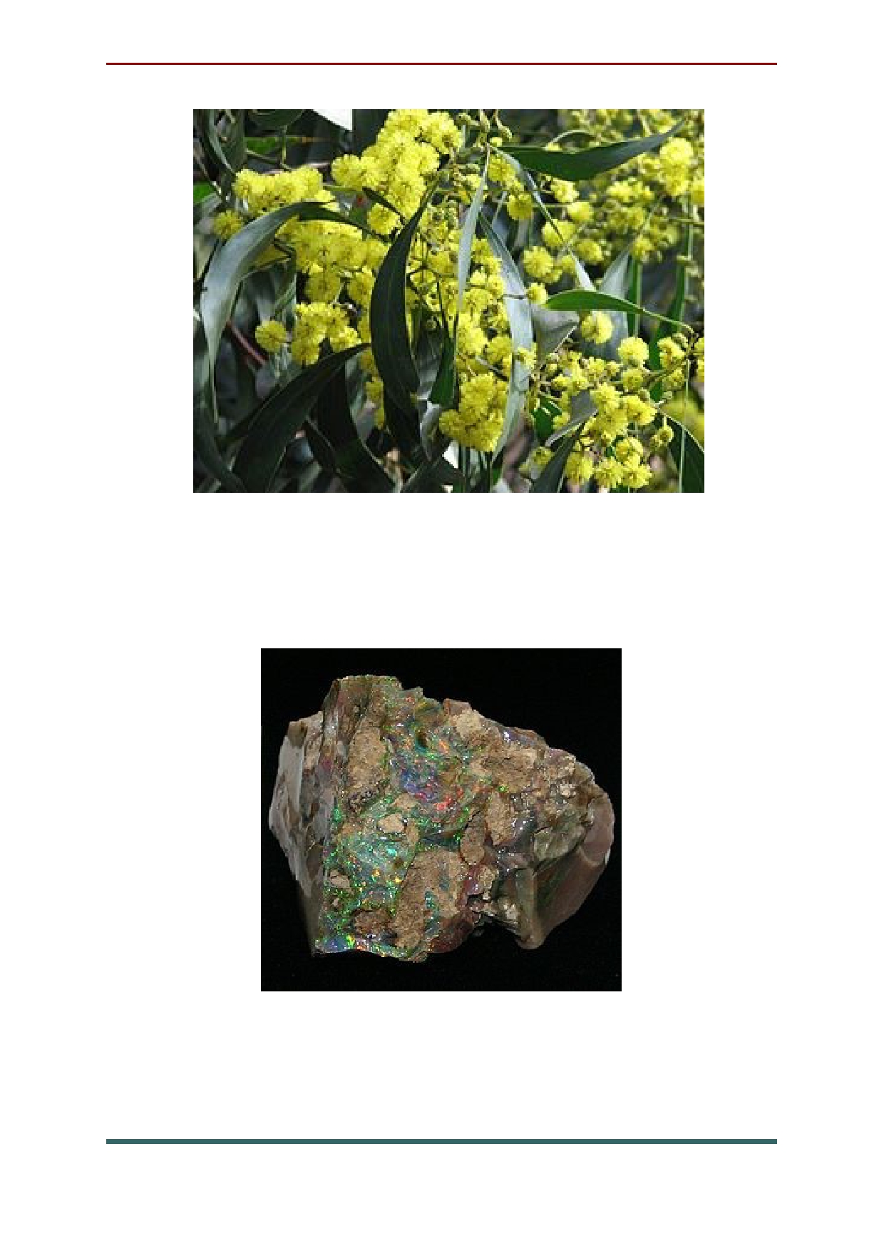National floral emblem of Australia is Golden
Wattle

The national gemstone of Australia is opal

63

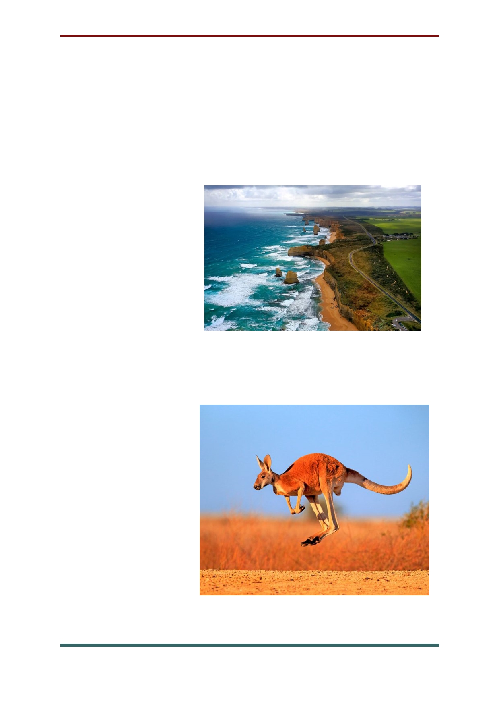The Great Ocean road is 370 km long. It
stretches along the coast of Victoria. The scenic
road helps motorists from all over the world get
to know the beauty of Australia closer. Along the route, tourists can see beautiful views of the coast, as well as the Twelve Apostles - rocks rising from the ocean floor.
The living
symbols of
Australia are
kangaroos. The growth of these
animals can reach human height.
Their powerful hind legs allow them to jump
huge distances, and the bag on their stomach is
designed for
raising offspring. Kangaroos do not
live anywhere else except the
Australian
continent, so they are its symbols.

64

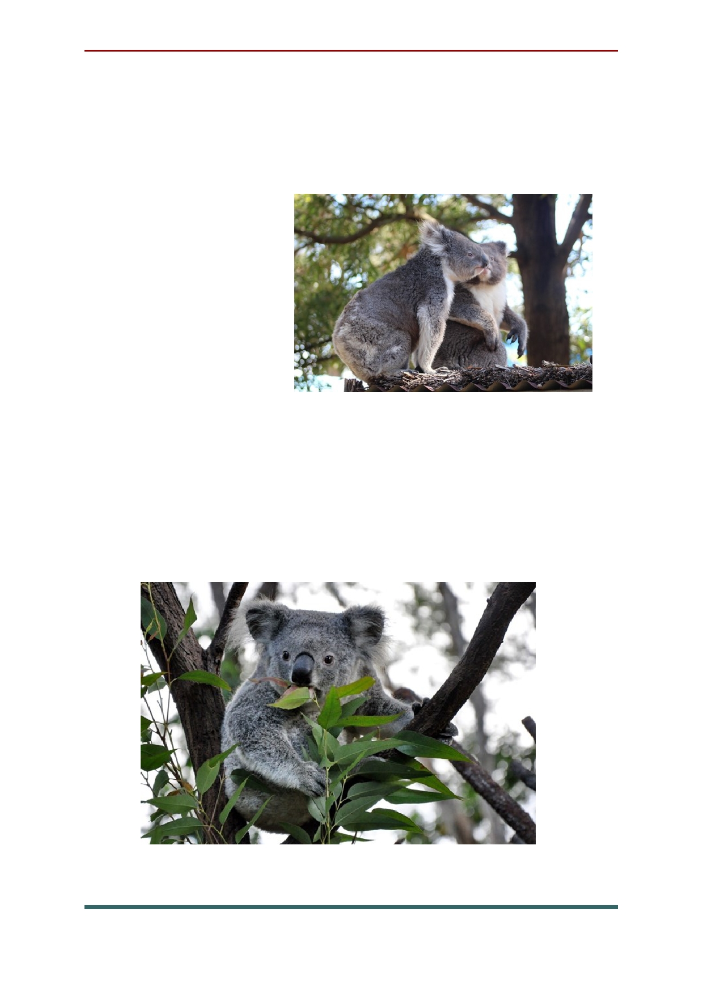The translation of the word "Koala" sounds
like "not a drinker". Animals are so named
because they never drink water, getting moisture
from the only food
source -
eucalyptus leaves. Even in Australia,
koalas are a rare living species. Today they are
under protection,
but once the animals were mercilessly
exterminated because of the valuable fur. It is believed that koalas almost never come down from the trees, and sleep most of the day. Cute animals are recognized as unofficial symbols of Australia all over the world.

65

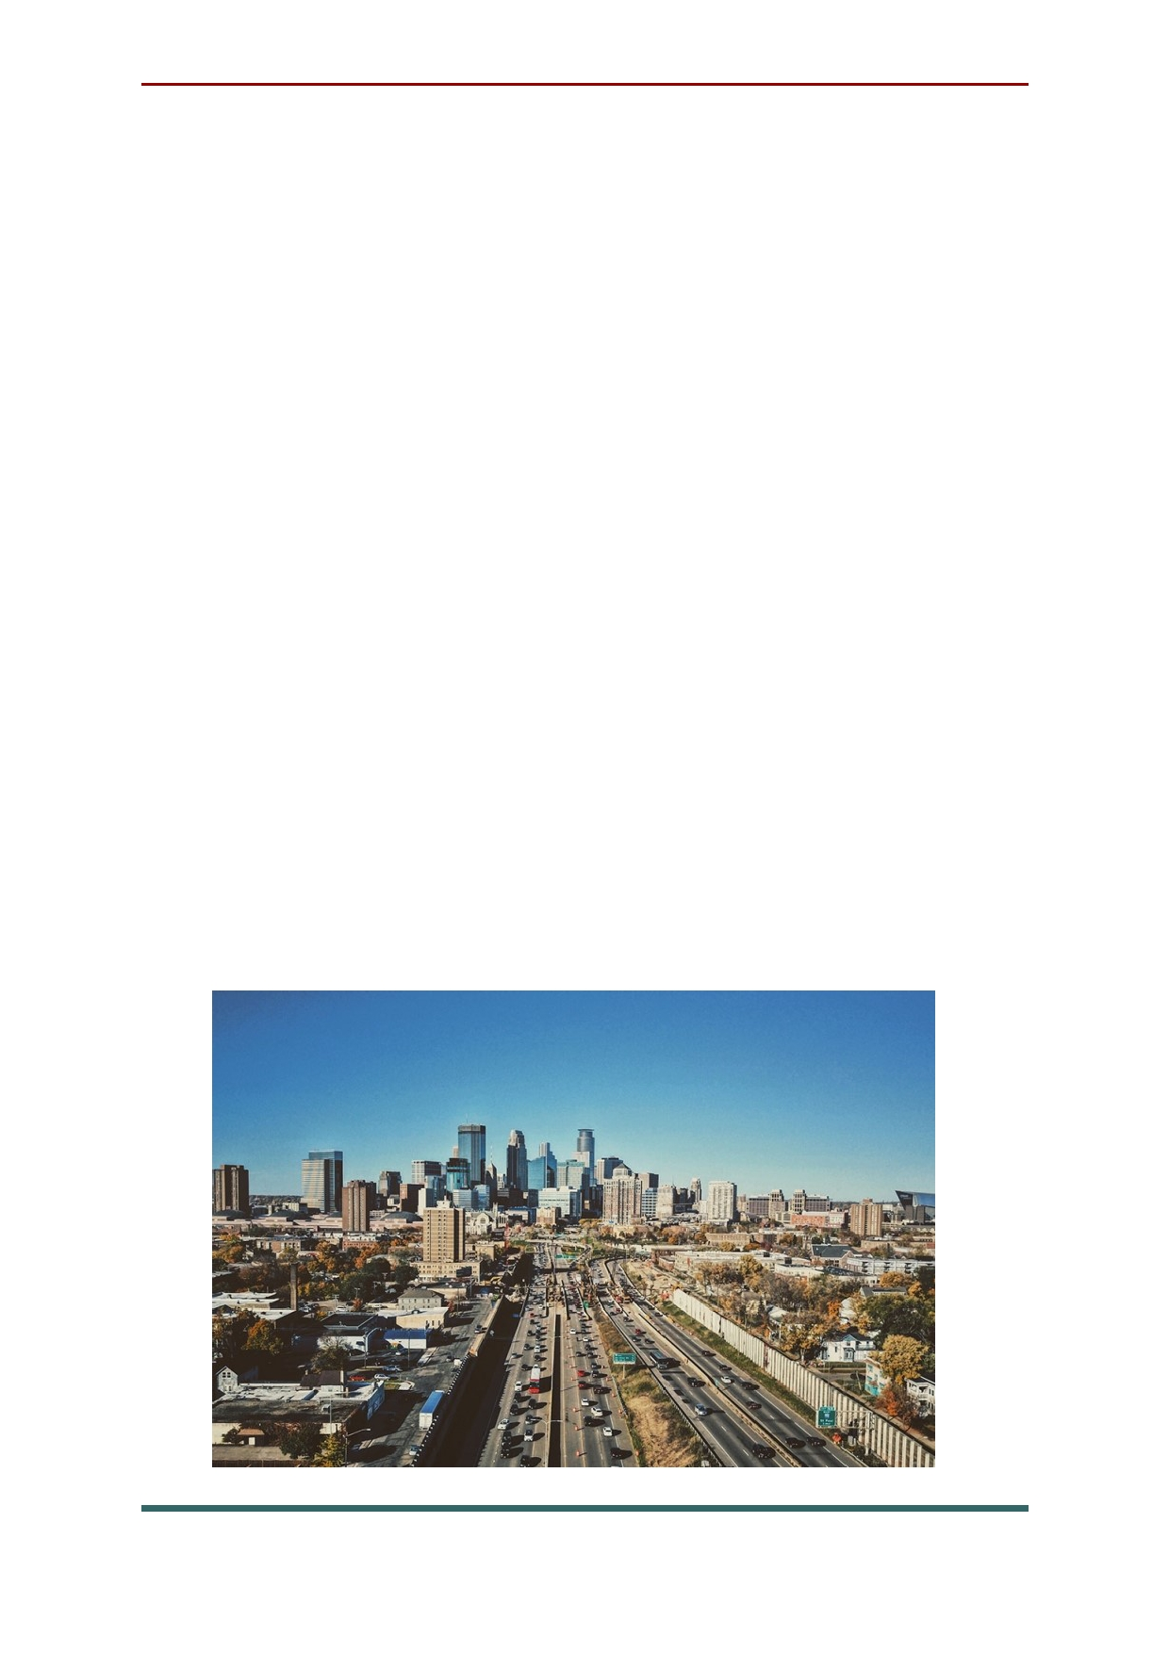Chapter 3: USA

The United States of America is the world's third largest country in size and nearly the third largest in terms of population. Located in North America, the country is bordered on the west by the Pacific Ocean and to the east by the Atlantic
Ocean. Along the northern border is Canada and
the southern border is Mexico. There are 50 states and the District of Columbia.
More than twice the size of the European
Union, the United States has high mountains in
the West and a vast central plain. The lowest
point in the country is in Death Valley which is at
-282 feet (-86 meters) and the highest peak
is Denali (Mt. McKinley) at 20,320 feet (6,198 meters).

66

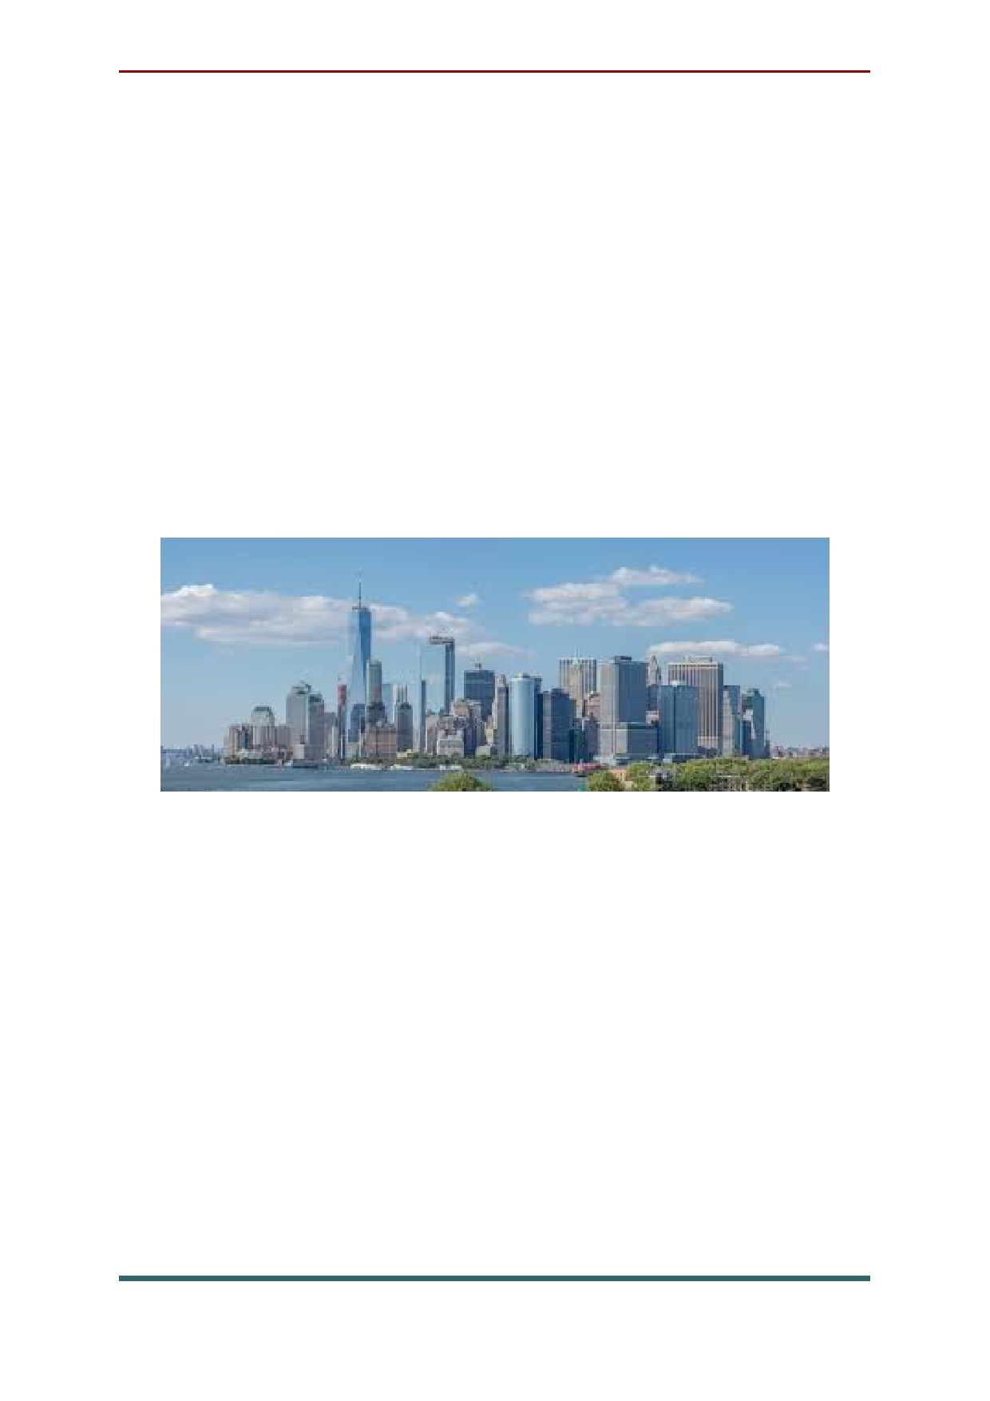The big cities of USA
New York City. Fast-paced and energetic,
New York City is home to many of the world's
most iconic neighborhoods, restaurants, museums
and neighborhoods. The Big Apple is also one of
the largest cultural and financial hubs in the
world. Though real estate in the city is
exceptionally expensive, the plethora of amenities
and job opportunities make it one of the best places to live in the world.

Los Angeles. Home to celebrities, artists and
free spirits, Los Angeles never stops attracting
people from every corner of the globe. This
cosmopolitan city offers a hub for the
entertainment industry as well as easy access to beaches, forests and hiking trails. Those looking
for ideal weather, ample job opportunities and plenty of diversity will find it in LA.

67

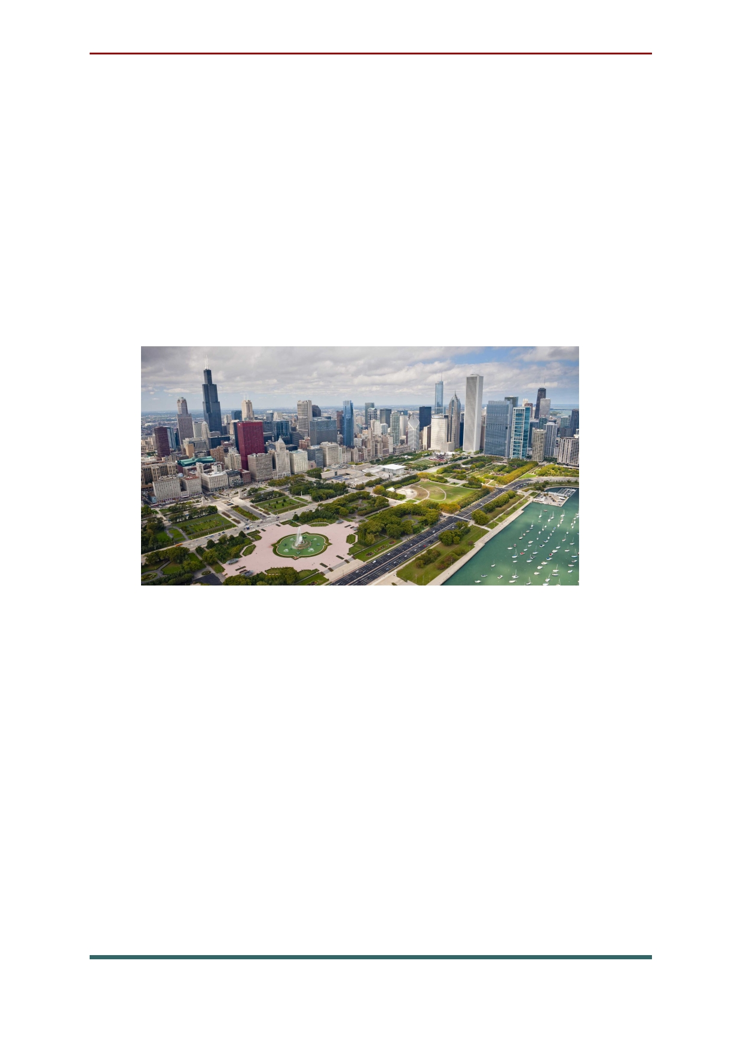Chicago. Chicago is located along Lake
Michigan, Chicago's phenomenal restaurant
scene, world-renowned museums, relatively low
housing costs and Midwestern charm make it a great place to call home. The city is also famous for its iconic architecture and beautiful skyline. All of these incredible upsides make those cold, bitter winters in Chicago worth the hassle.

San Antonio, home of the famous Alamo, is
rich in history and the wild west culture. The city offers a thriving job market, delicious Tex-Mex, a
family-friendly environment, and a slew of festivals and community gatherings.
AreaVibes gives San Antonio high marks for its many amenities, low cost of living, affordable real estate, excellent schools and sunny weather.

68

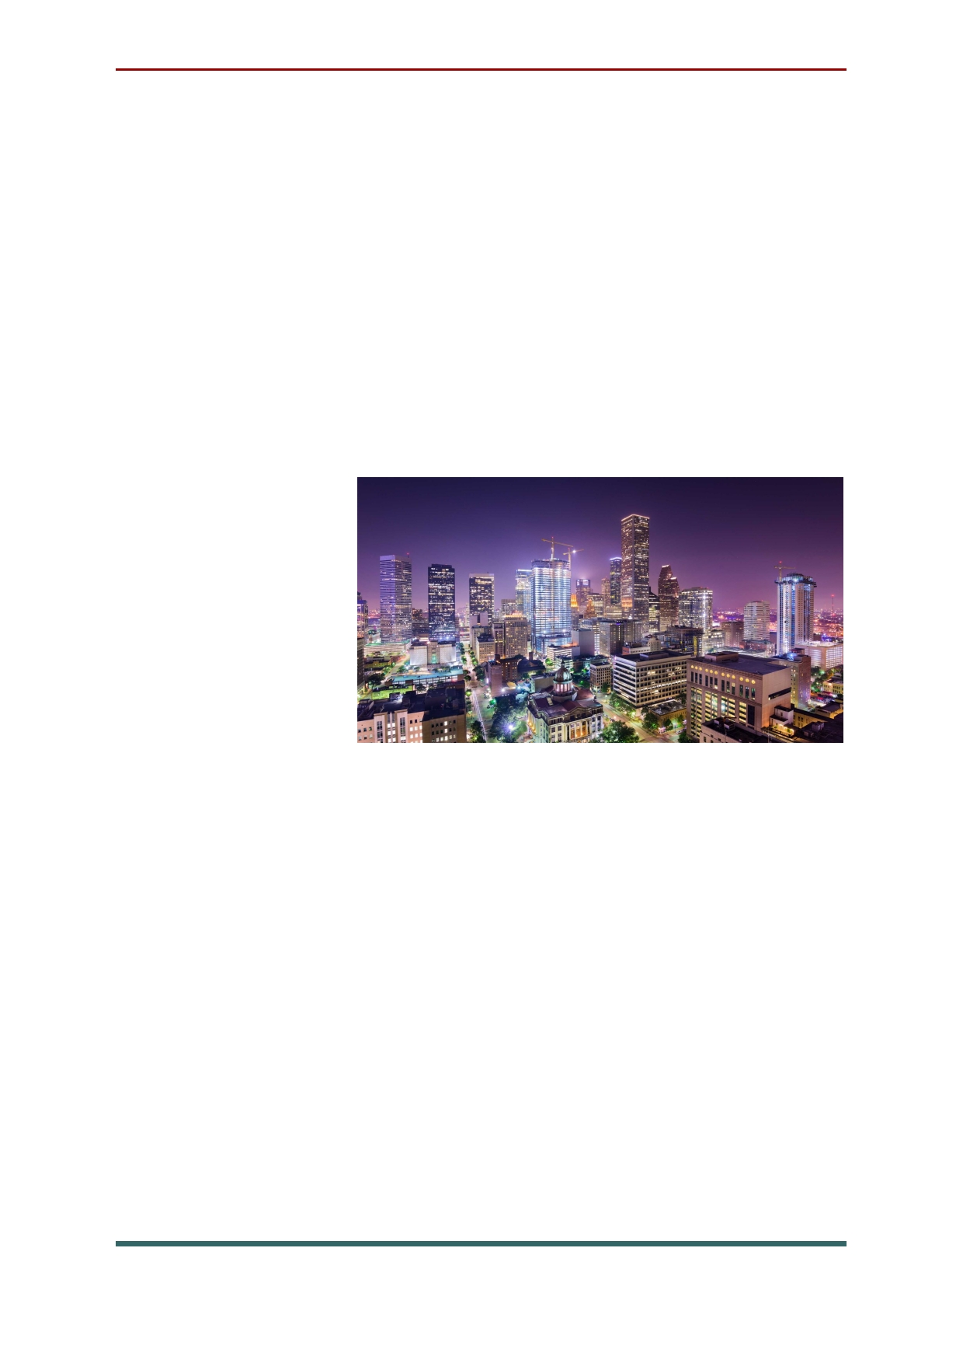Houston's stable job market, diverse economy
and ideal neighborhoods make the Texas city a
popular choice for young professionals and families. In years past, the city was ranked
number one by Forbes for paycheck worth, and
was included in Forbes list of "Best Places for
Business and Careers." AreaVibes also gives the
city high marks for its many amenities, low cost of living, affordable real estate, excellent schools and sunny weather.

Phoenix. Surrounded by desert mountains
and numerous hiking trails, Phoenix is the perfect
place to live for those who love spending time in
the great outdoors. The city also boasts year-
round sunny weather, first-class golf courses, and a low cost of living. Families, young professionals
and retirees will find the Phoenix area an ideal place to live, thanks to its many amenities and recreational opportunities.

69

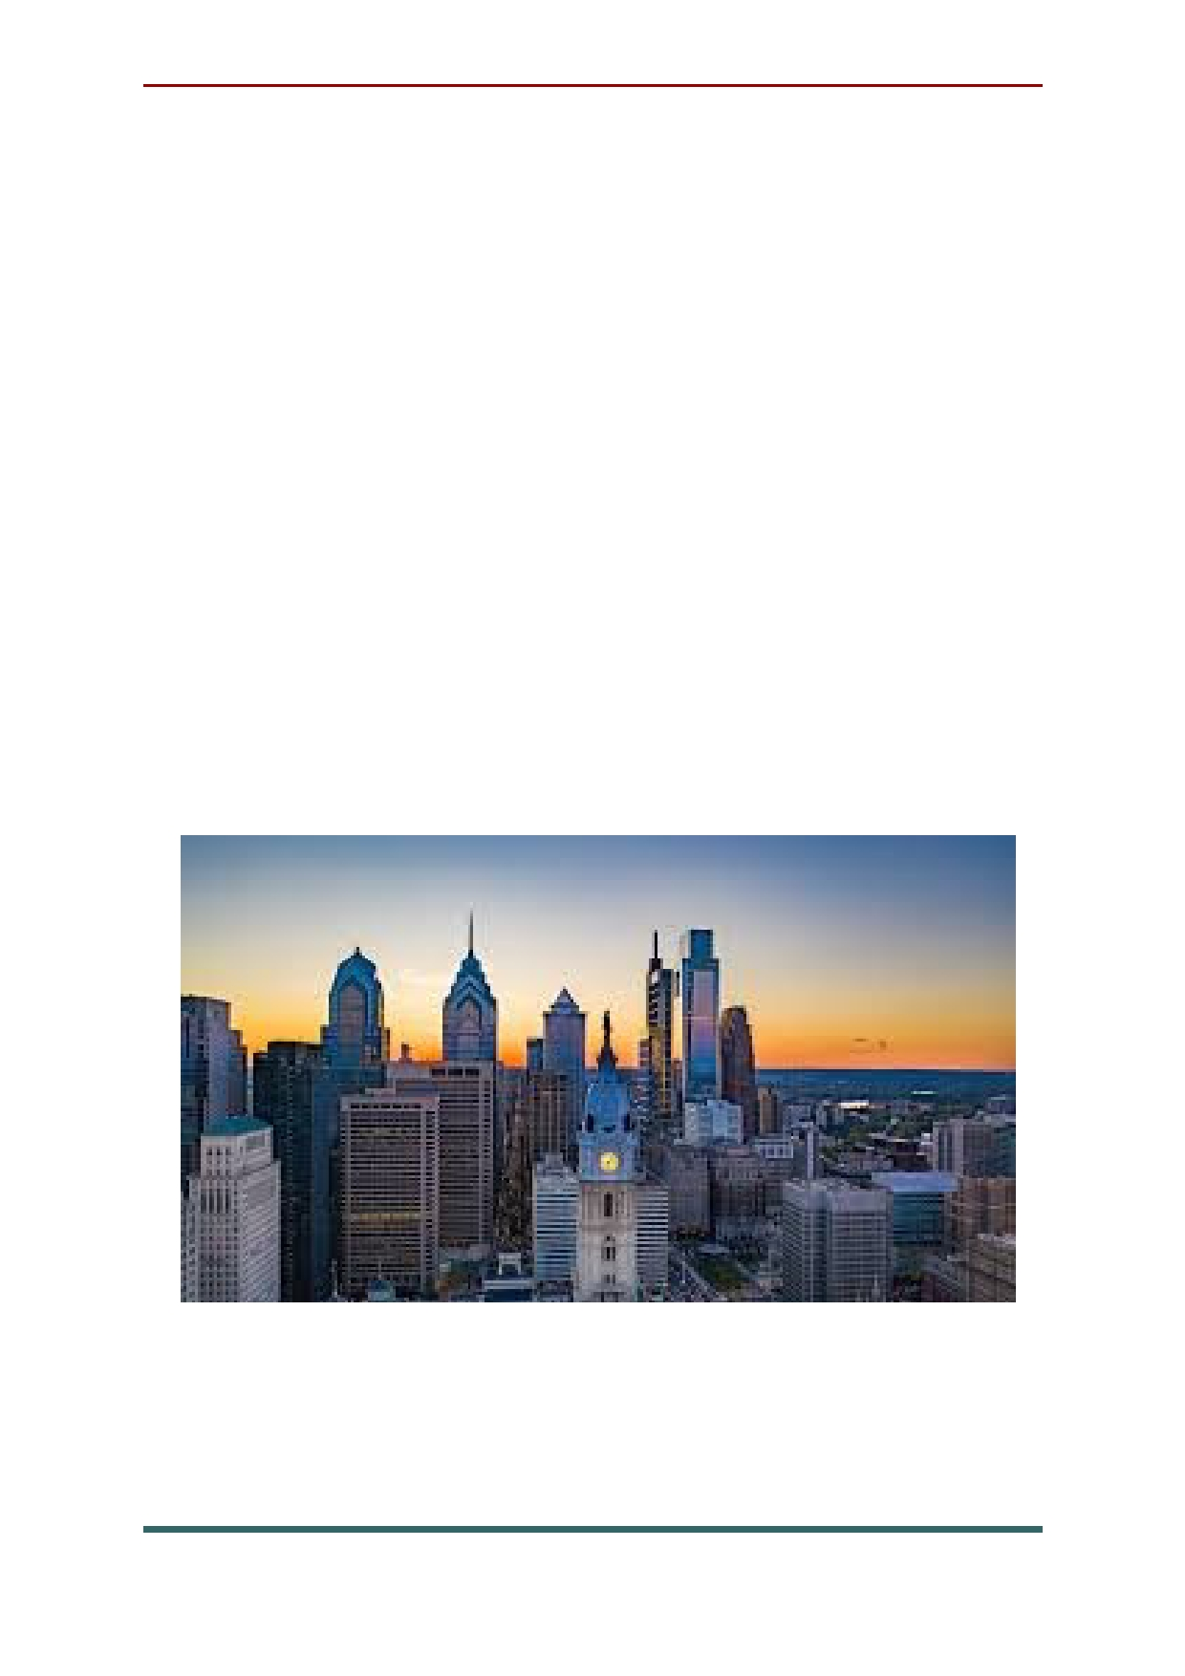Philadelphia. In addition to being one of the
most historically significant cities in the country,
Philadelphia offers a hip arts scene, multiple
music venues and plenty of trendy restaurants. The city is also a major job hub in Pennsylvania, with several large companies located in the area, including Comcast, CIGNA, Aramark and more. College and graduate students are also drawn to
Philadelphia, thanks to the many excellent schools
in the area, including the University of
Pennsylvania, Drexel University and Temple University - among many others.

70

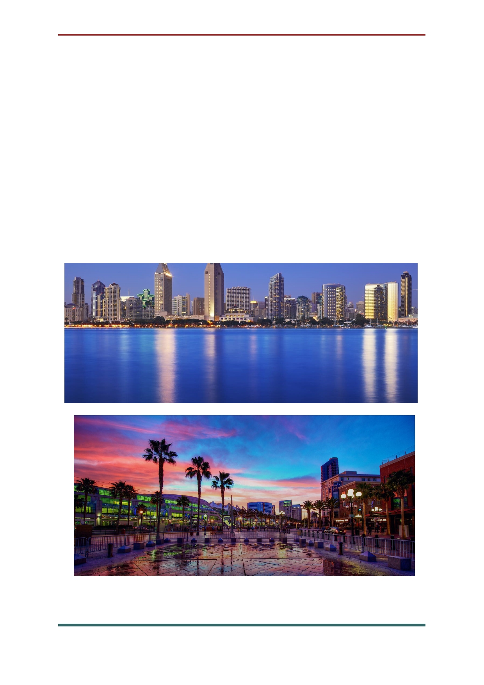San Diego. Quickly becoming one of the
fastest growing cities in the U.S., San Diego is a popular place for beach enthusiasts, foodies and young professionals. The sunny city offers a slew of outdoor recreational activities and an energetic sports culture. San Diego's business environment
is also thriving, with startups and high-tech
companies setting up shop in the area every day.
The city's highly educated workforce attracts companies nationwide.

71

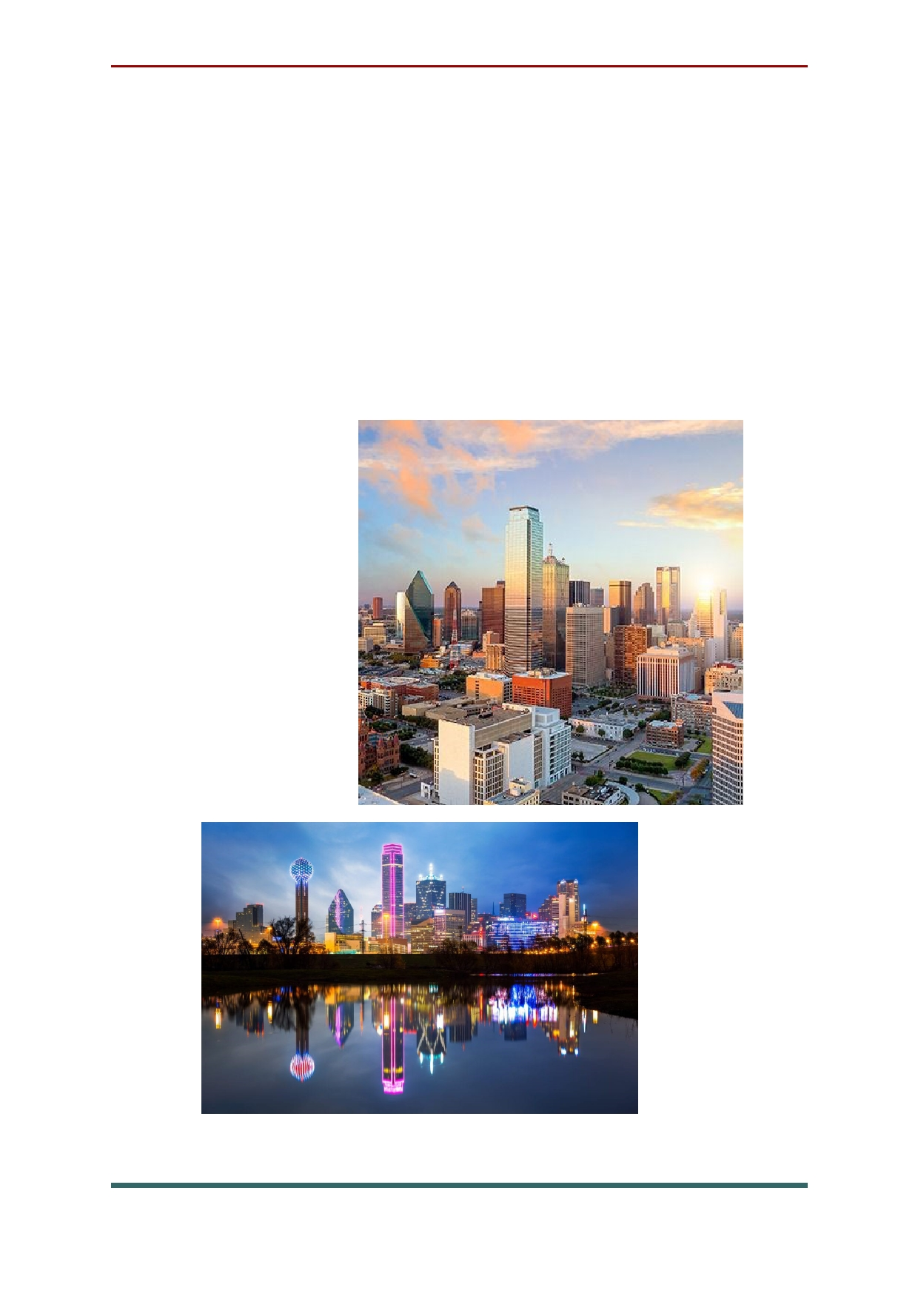Dallas. Rated as a "beta plus" world city,
Dallas is a leader in entrepreneurship, innovation
and tech. The city offers a diverse population, a booming economy and a thriving job market. In
addition, the city's top-notch public schools,
sunny weather, affordable real estate and many amenities make it the perfect place for families with school-age children, young professionals and retirees.

72

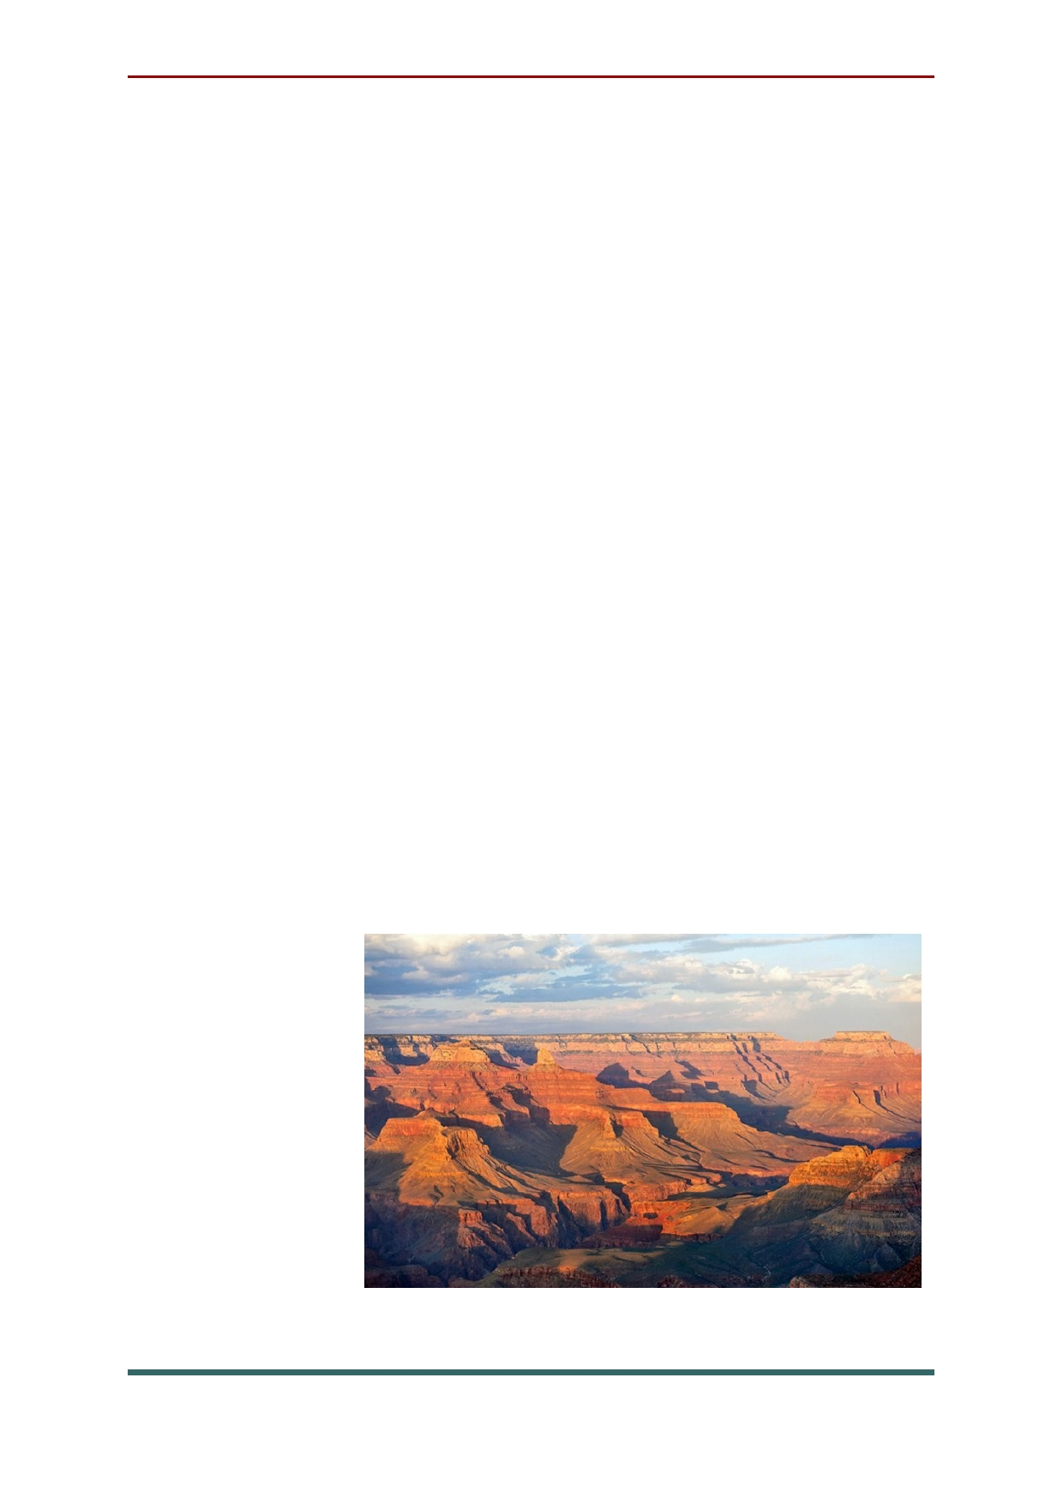The attraction of USA
Grand Canyon. This incredible natural
attractions is one of the most visited places in the United States. Carved out by the Colorado River, the Grand Canyon cuts deep into the landscape, creating dramatic cliff walls and ledges. Visitors standing on the rim of the canyon can see down
to the canyon floor a mile below, and look out
over the ridges and cliffs that run as far as the eye can see. The South Rim is the most visited section
of Grand Canyon National Park, with a large
visitors center, regular bus service along the Rim
in the high season, and a walkway that runs along
the canyon with numerous viewing points and
platforms. The North Rim, which also has lookout
areas, provides a different perspective. This
section of the park has limited access from November to May due to snow and winter conditions.

73

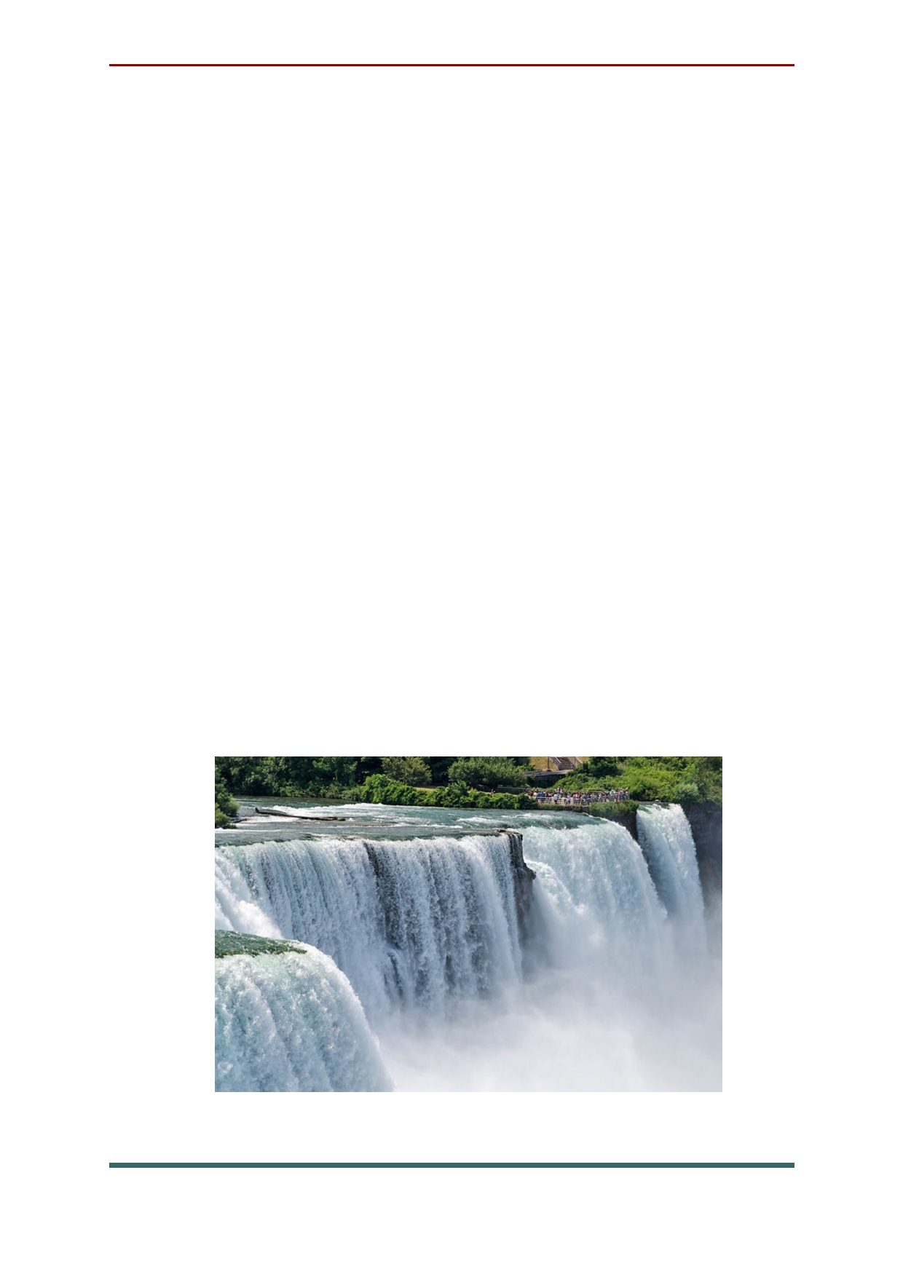Situated along the Canada-US border,
Niagara Falls is one of the most famous waterfalls in the world. The water from Lake Erie flows into
Lake Ontario over these massive waterfalls, known for the great quantity of water that is
constantly tumbling over the vertical drop. The amount of water going over the falls is actually reduced in winter, when more water is used to produce hydroelectric power. Most visitors will not notice a difference.
Niagara Falls is actually a set of three falls,
consisting of the largest section known as
Horseshoe Falls, a second section on the American side of the river known as the
American Falls, and a much thinner section
located next to the American Falls, known as Bridal Veil Falls.

74

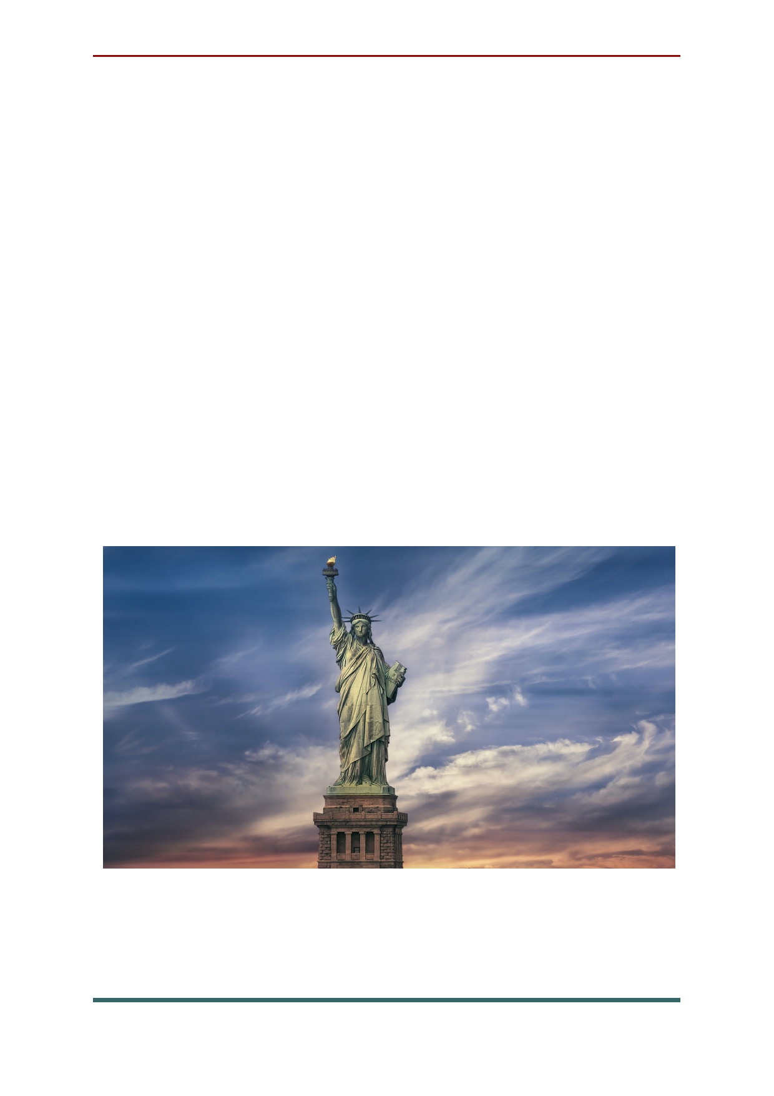A universal symbol of freedom, the Statue of
Liberty is America's most familiar icon and the
largest statue in the world. Standing 152 ft in New
York Harbor, visitors can admire the statue from
various points around the city, particularly
Battery Park, or take a ferry right to the statue. For
people who plan to go out to the statue, options
include grounds tickets, pedestal tickets, or crown
tickets, which allow different levels of access to the site. Anyone who plans on going inside the
Statue of Liberty is encouraged to make advanced ticket reservations.

75

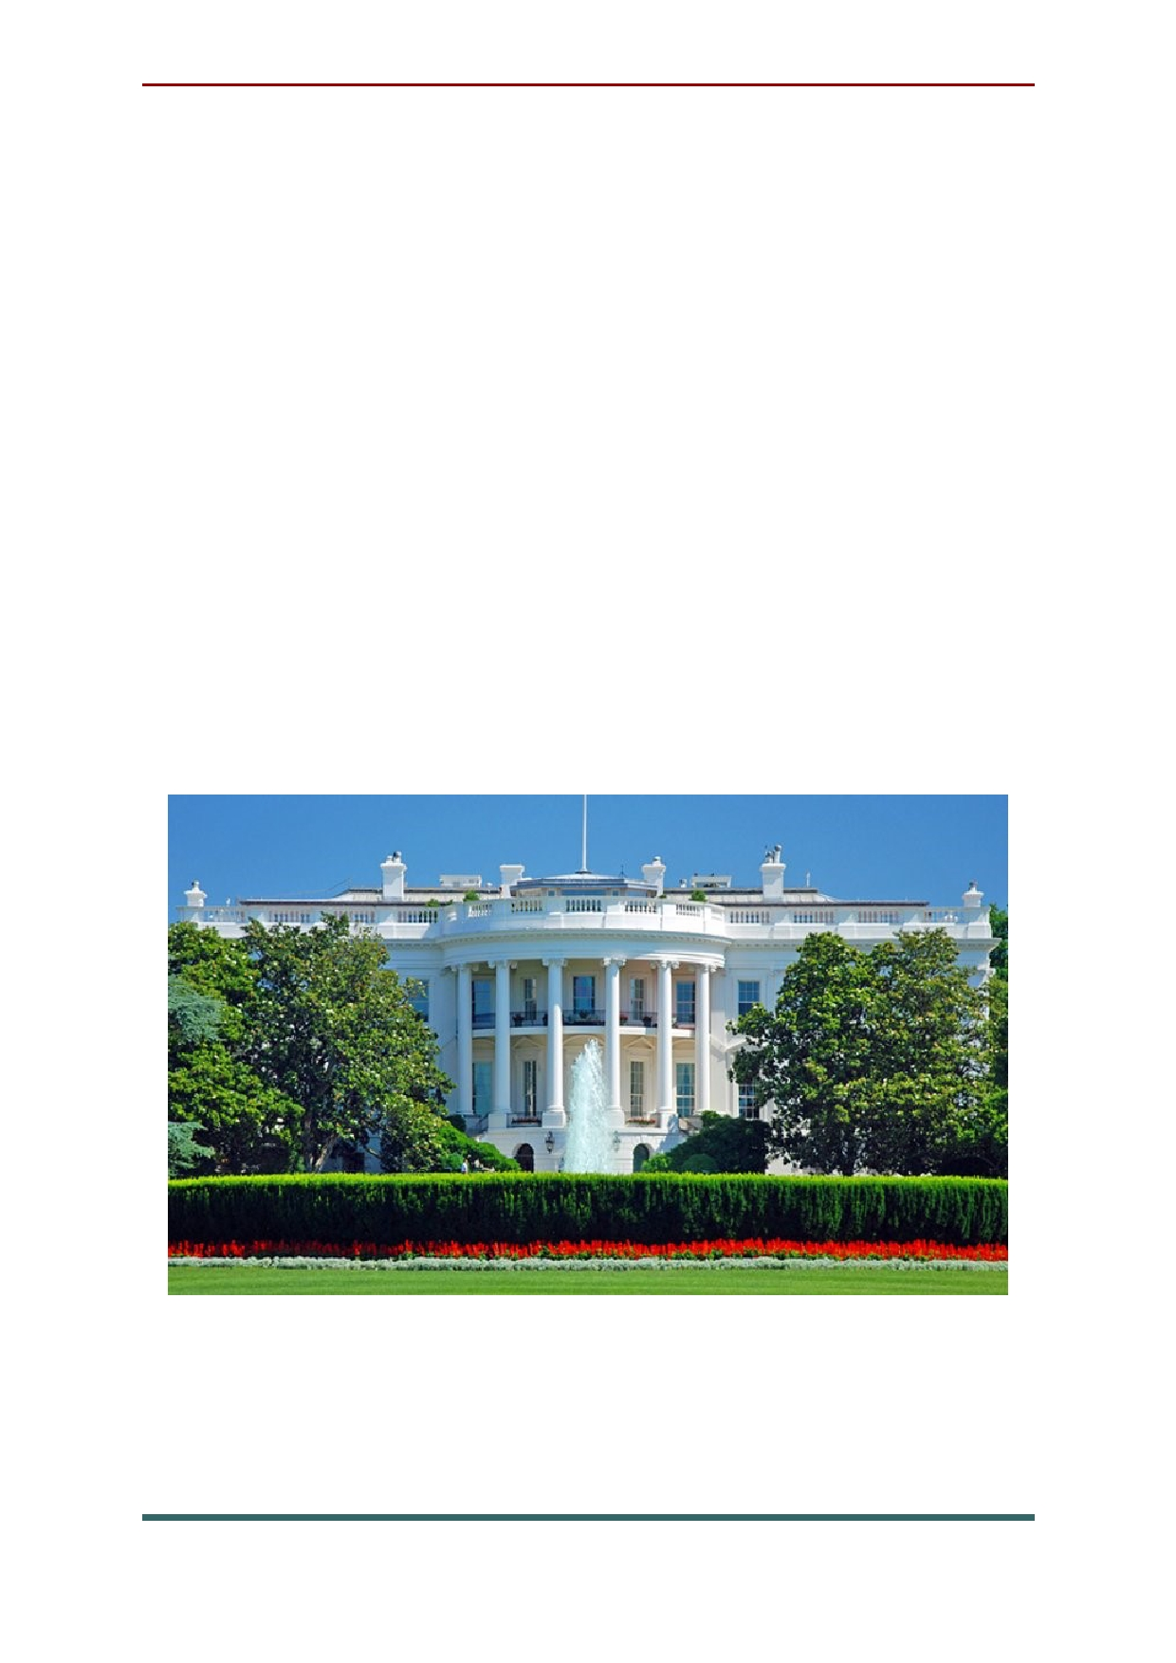The White House is the official residence of
the President of the United States, and on almost
all tourists' list of things to see in Washington.
This historic structure has been the home of every
president except George Washington. It was
originally built by James Hoban in 1792 and, after being burned down by British forces in 1814, was rebuilt in 1818. Tours of the White House are free,
but reservations must be made a minimum of
three weeks in advance. Strict security rules are always in effect.

76

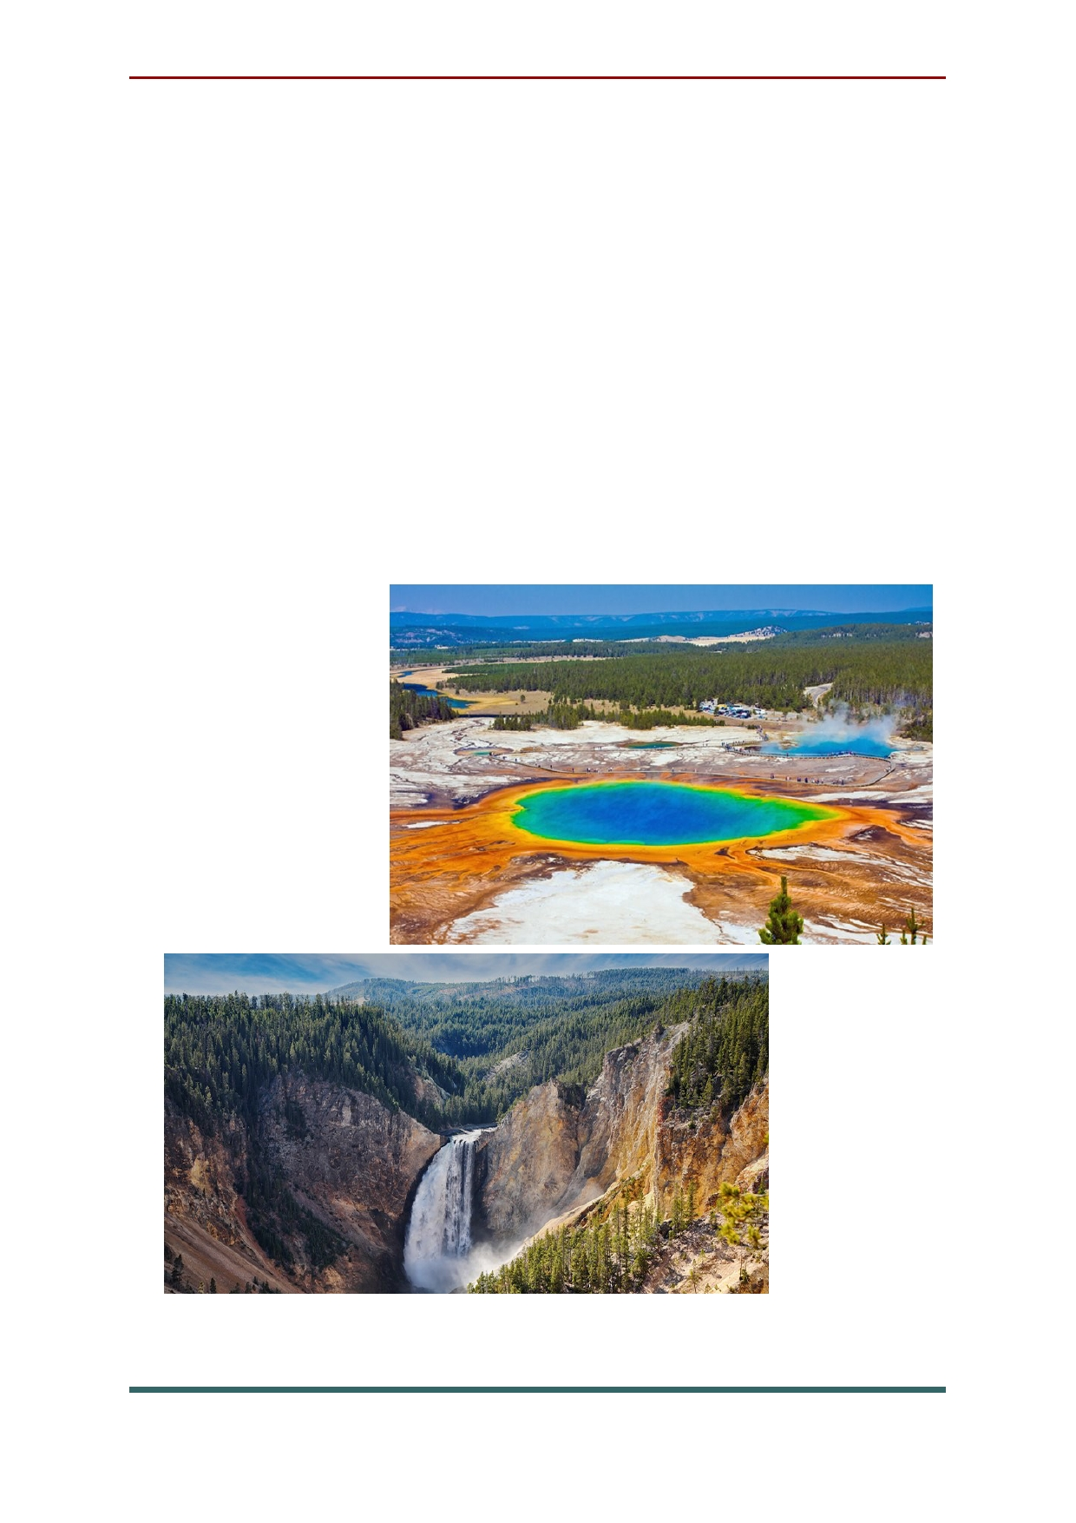Yellowstone National Park is home to a huge
ancient volcano which has resulted in a dramatic landscape and awesome natural phenomena.
Geysers and hot springs, along with incredible waterfalls along the Yellowstone River are just
some of the attractions drawing in huge numbers of tourists each year. The park, the oldest national
park in the USA, is also home to all kinds of
wildlife, with free roaming bison, bighorn sheep, antelope, black bears, and grizzly bears.

77

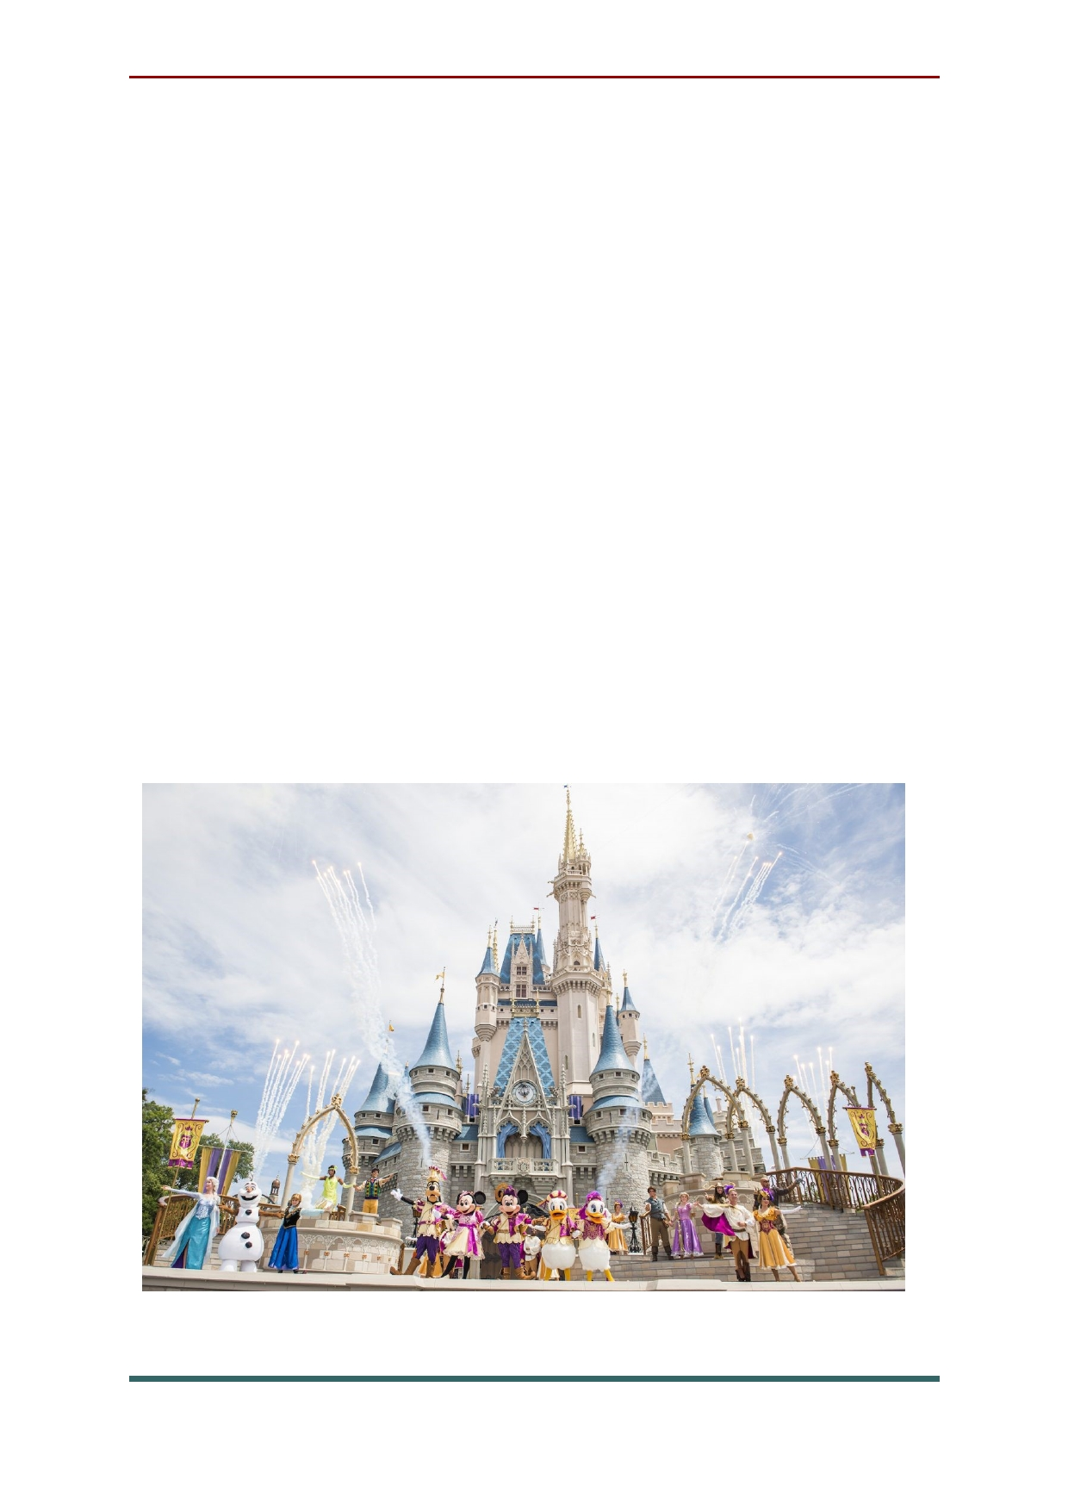Walt Disney World Resort. This mega
amusement park in Orlando is the top family
attraction in the country, and has been catering to both young and old for decades. Opened in 1971, Walt Disney World has managed to maintain its
relevance and its allure for children and even
many adults throughout the years. Walt Disney World Resort encompasses not only the various
theme parks, it also includes water parks,
Downtown Disney with shopping and theaters, and much more, from fine dining to golf.
Although many visitors plan to spend a few days
here, it's possible to spend a week or longer if
people want to take in all there is to see and do.

78

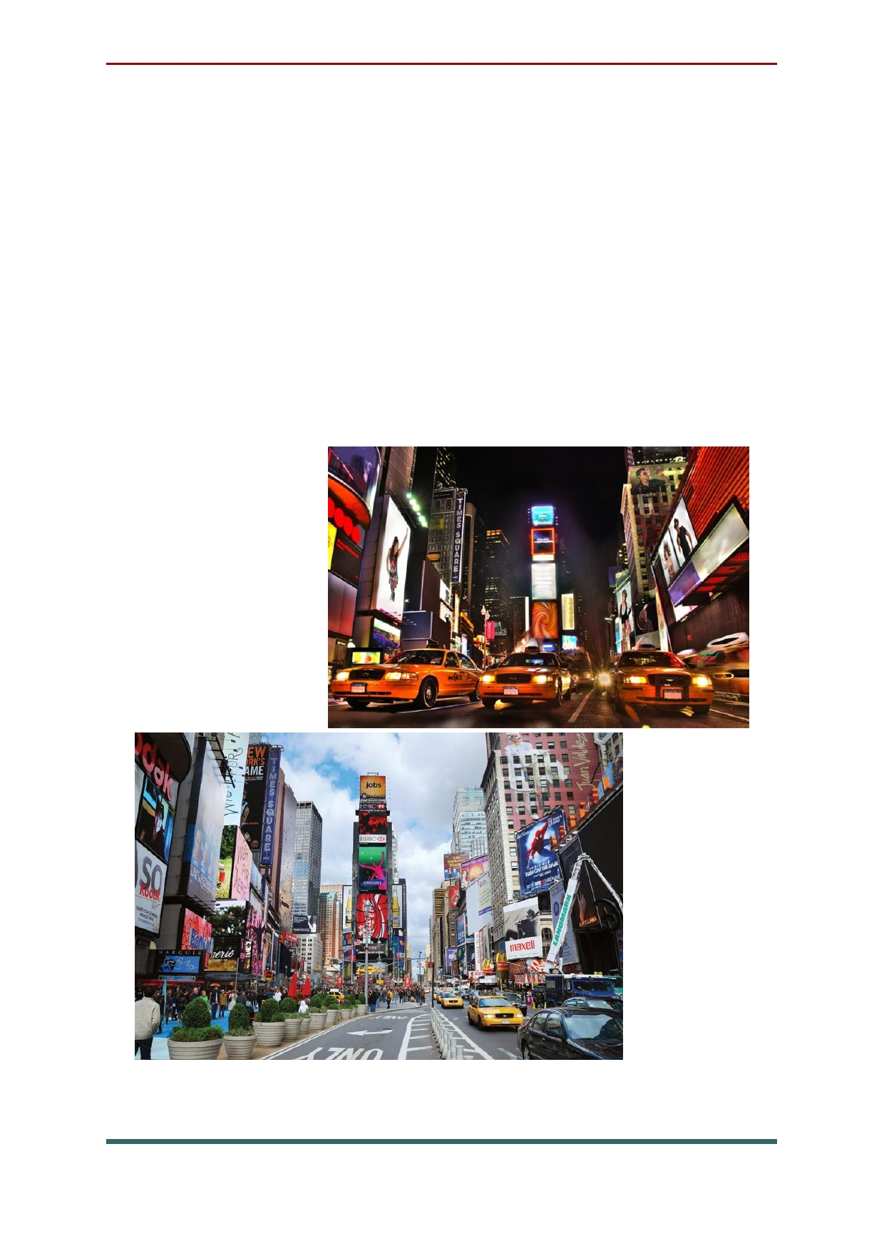Bustling Times Square, famous for its
flashing billboards, New Year's Eve count down,
and constant throngs of people, lies at the heart of
Midtown Manhattan. This intersection is really
about the energy one feels when standing on the
corner as taxi cabs rush by and lights flash
overhead, rather than any individual site on the
square. While it is an interesting place during the day, it is probably best seen at night to experience the full impact.

79

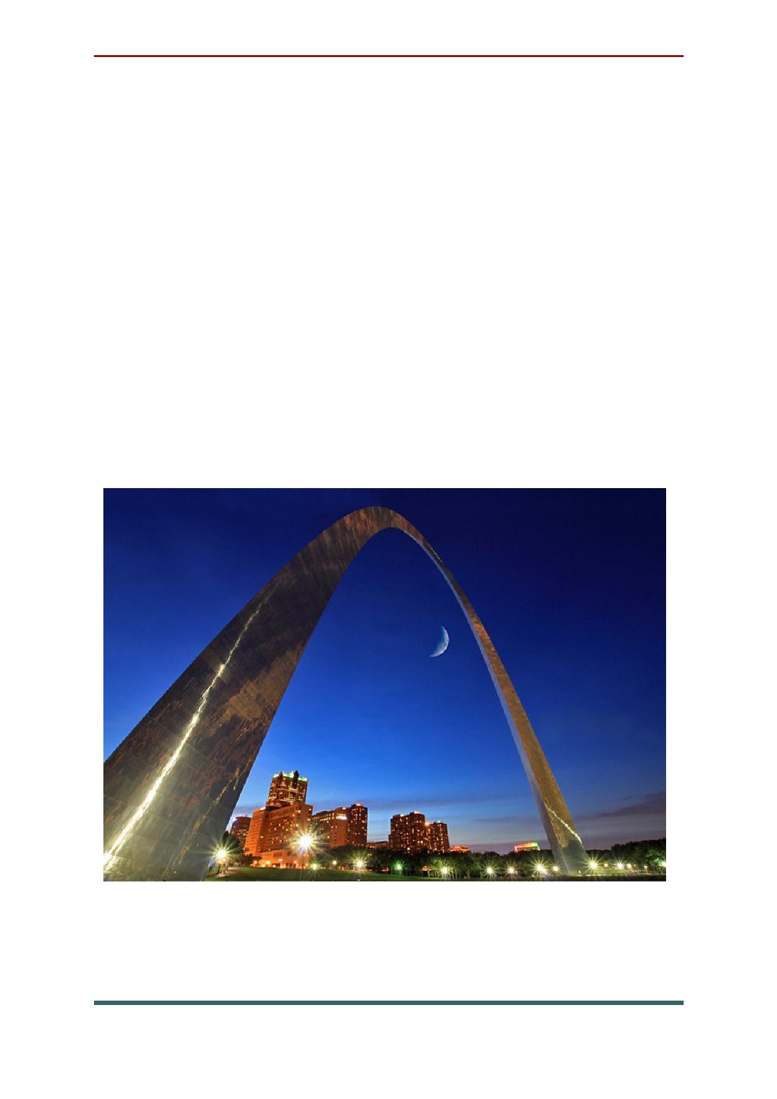St Louis Arch. This famous "Gateway to the
West" in St Louis is both symbolic and eye
catching. Rising above the city, gleaming in the
midday sun and illuminated at night, the arch can
be seen from miles away on the otherwise flat
surroundings. It was built in the early 1960s and stands in Jefferson National Expansion Memorial
Park. Elevators offer transportation to the top of the arch where visitors are treated to great views out over the city and surroundings.

80

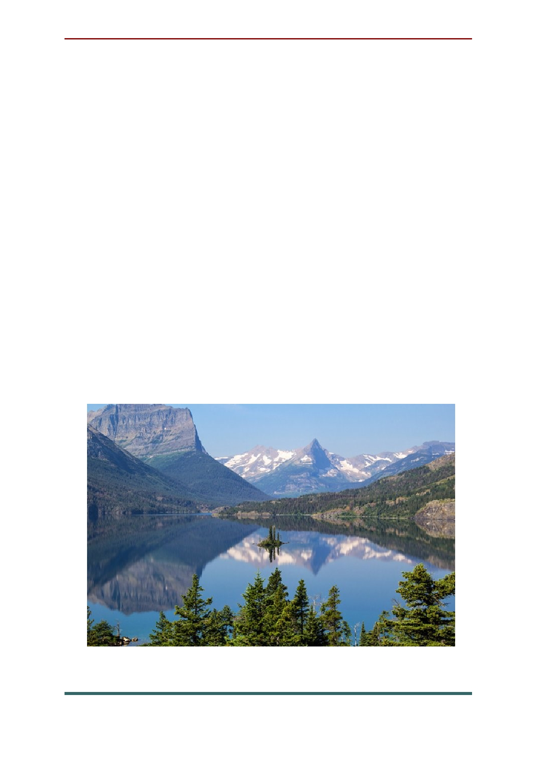Montana's Glacier National Park offers some
of the most beautiful mountain scenery in the
United States. Mountains, lakes, glaciers, valleys,
and waterfalls combine to form a spectacular
alpine landscape. One of the best ways to truly
appreciate the terrain is from the famous Going-to
-the-Sun Road. This narrow road, hugging the
mountain side as it winds its way up and over the
7,747 ft Logan pass, opened in 1932. Due to the
elevation and climate, the road is only open
during the summer months. Visitors who have
the opportunity to visit the park will not want to miss a chance to see the sights along this road.
Glacier National Park also has some unique historic lodges and lovely hiking trails.

81

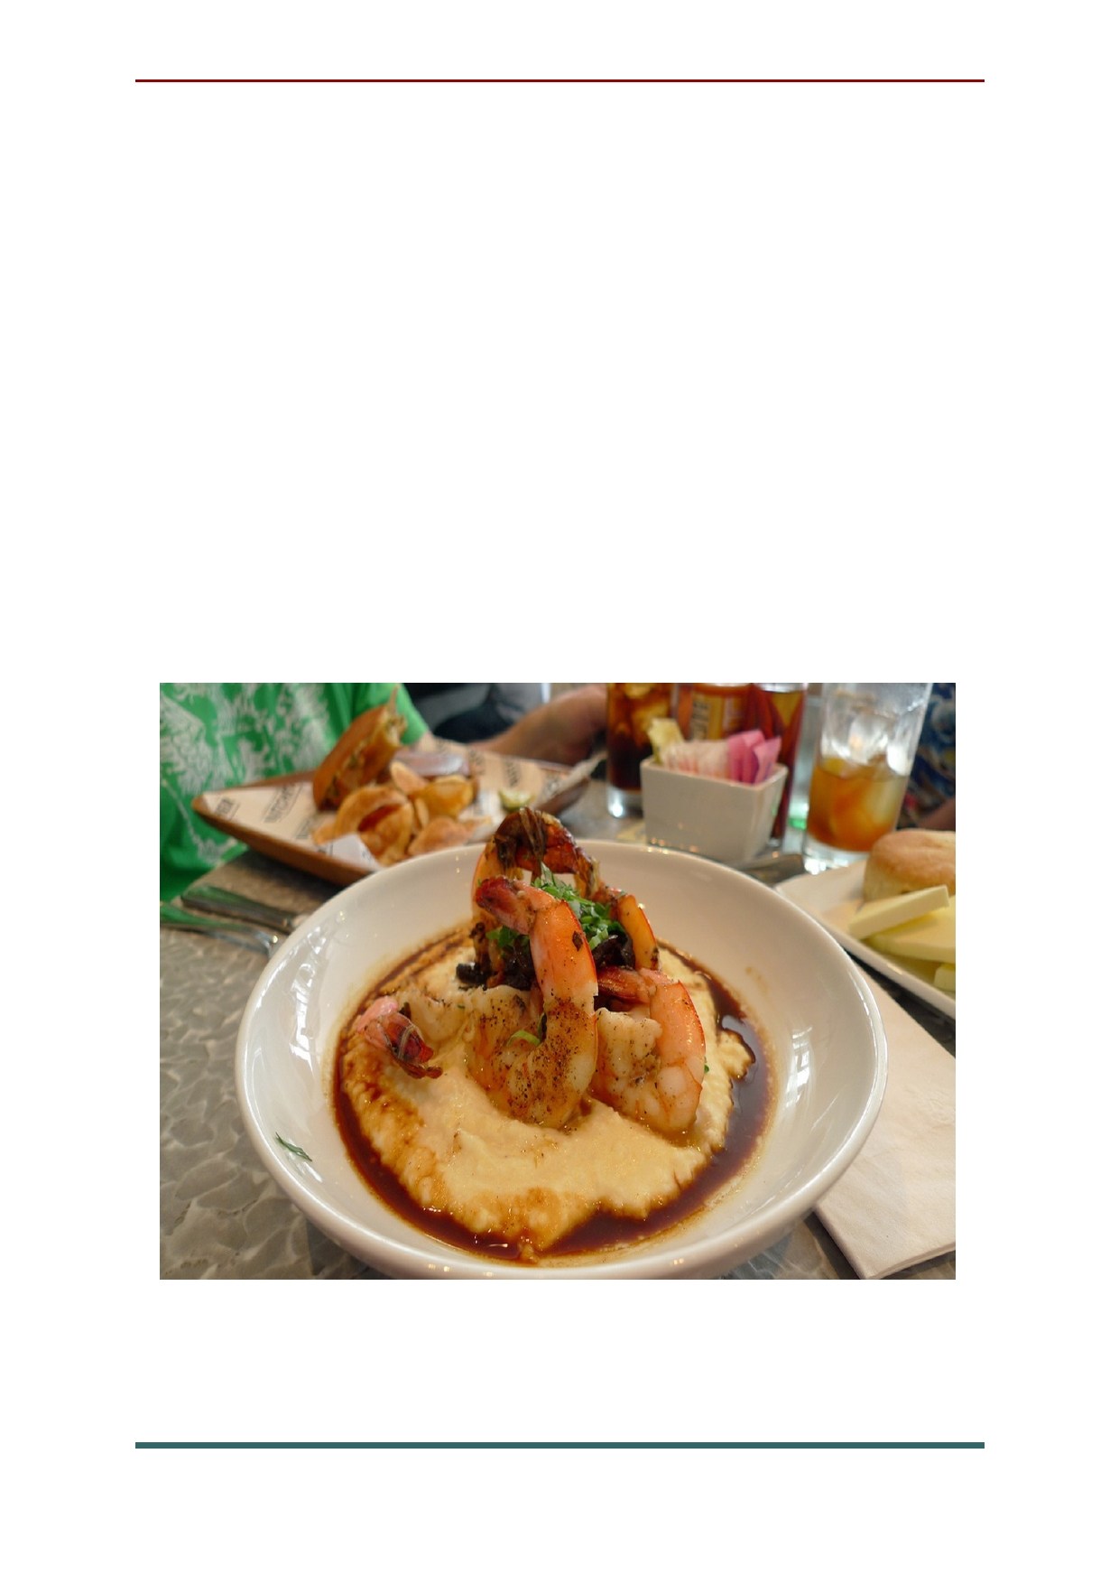The American cuisine
The first time you try grits, you probably
wonder what the heck it is. For those who grew
up eating grits (Southern US), it's something they
can't live without! A dish made from coarsely
ground corn kernels, grits can be extremely
versatile. Typically found in savory versions, they
can also be made sweet. A classic dish is shrimp
and grits, but grits are also a popular breakfast item, in place of oatmeal. Any which way, they are extremely satisfying.

82

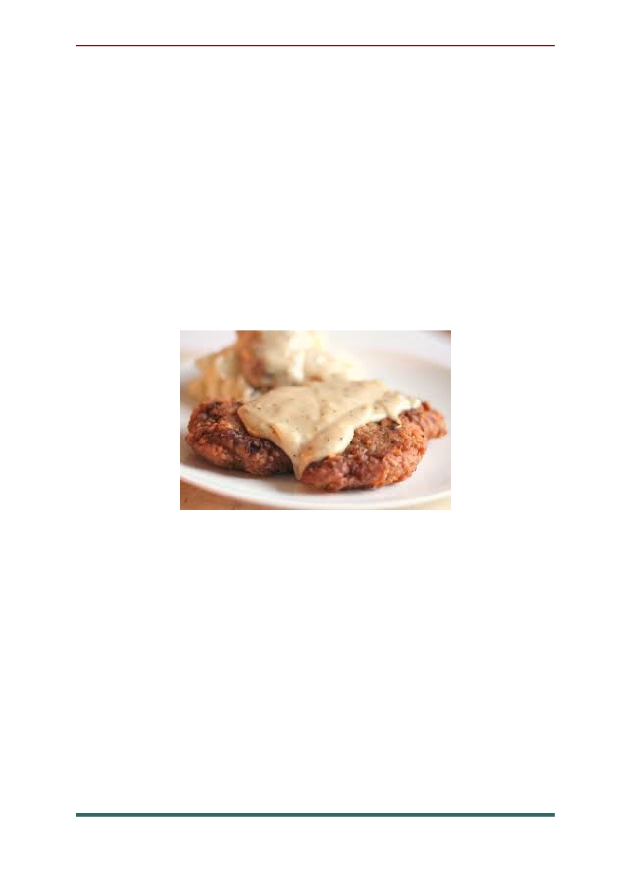Chicken fried steak. A guilty pleasure if
there ever was one, chicken fried steak was born
to go with American food classics like mashed potatoes and black-eyed peas.
A slab of tenderized steak breaded in
seasoned flour and pan fried, it's kin to the
Weiner Schnitzel brought to Texas by Austrian
and German immigrants, who adapted their veal
recipe to use the bountiful beef found in Texas.

Buffalo wings. Long before Troy Aikman
became pitchman for Wingstop, folks in Buffalo,
New York, were enjoying the hot and spicy wings
that most agree came into being by the hands of Teressa Bellissimo, who owned the Anchor Bar
and first tossed chicken wings in cayenne pepper hot sauce and butter in 1964.

83

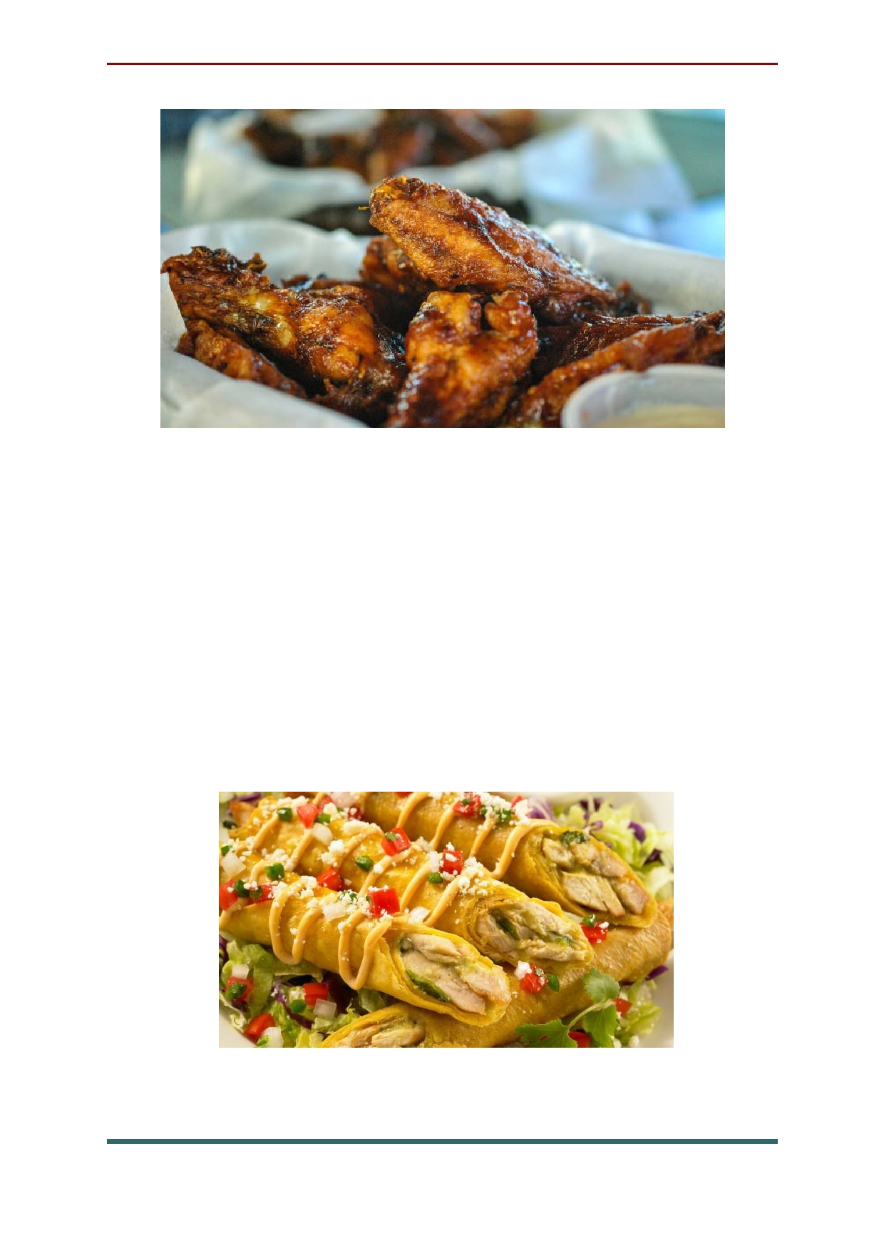Tacos. Los Angeles is a city with a taqueria on
every street corner, basically. With so many
Spanish-speakers it's possible to find anything
from greasy nachos on Venice Beach to exquisite Michoacan-style goat stews. For a good sampler, forget the chain stuff and try El Huarache Azteca,
a tiny, no-fuss eatery in the neighbourhood of Highland Park.

84

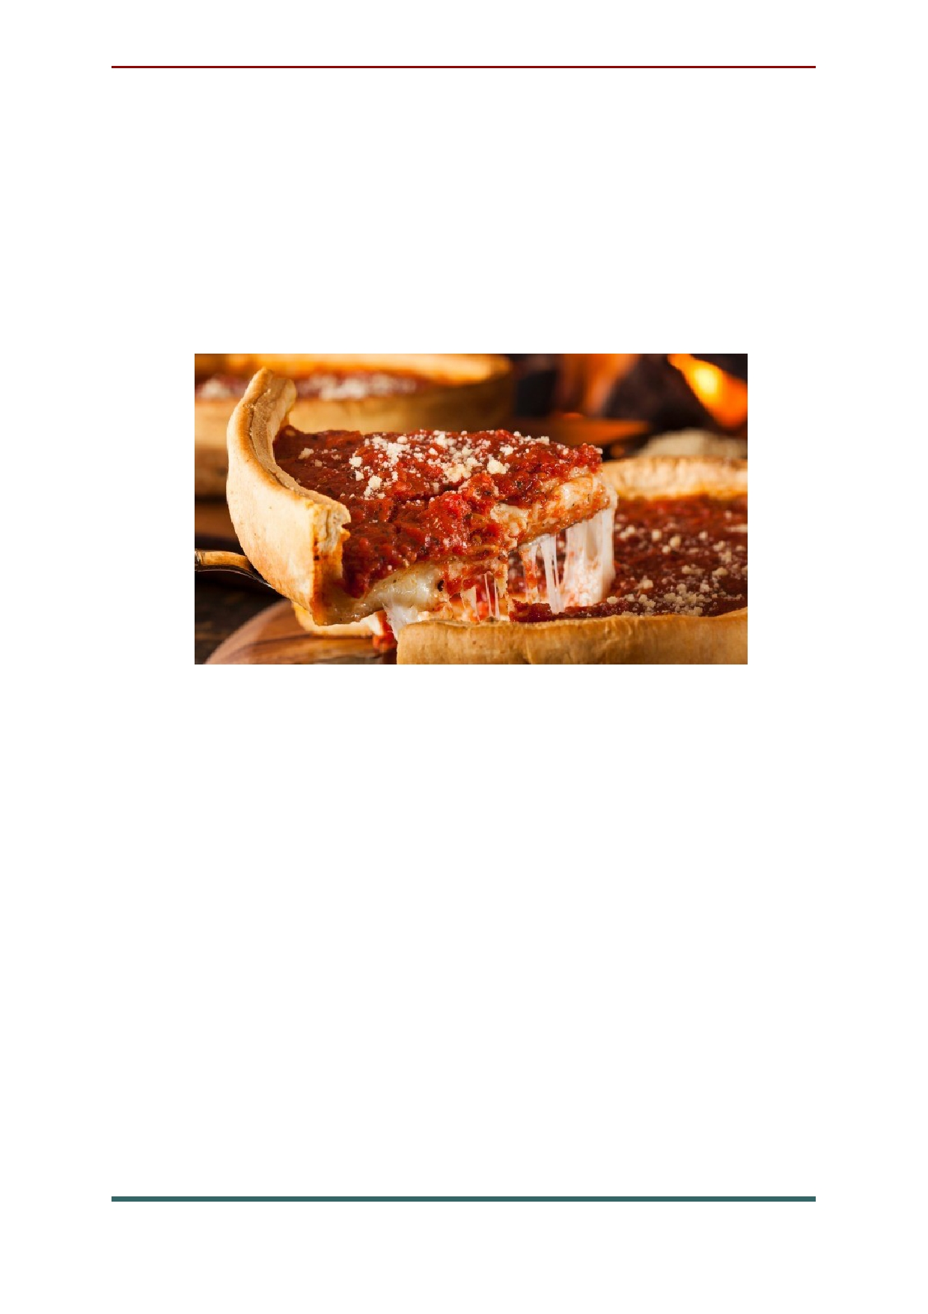Apple pie. The saying is "American as apple
pie" for a reason: this sweet treat is a national institution. The simple combination of sugar,
buttery pastry and tart sliced apples produces a
dessert so extraordinary people have devoted their entire lives to perfecting it.

Biscuits 'n' gravy. An irresistible Southern favorite, biscuits and gravy would be a cliche if
they weren't so darned delicious. The biscuits are
traditionally made with butter or lard and
buttermilk; the milk (or "sawmill" or country)
gravy with meat drippings and (usually) chunks of good fresh pork sausage and black pepper.
Cheap and requiring only widely available
ingredients, a meal of biscuits and gravy was a
filling way for slaves and sharecroppers to face a hard day in the fields.

85

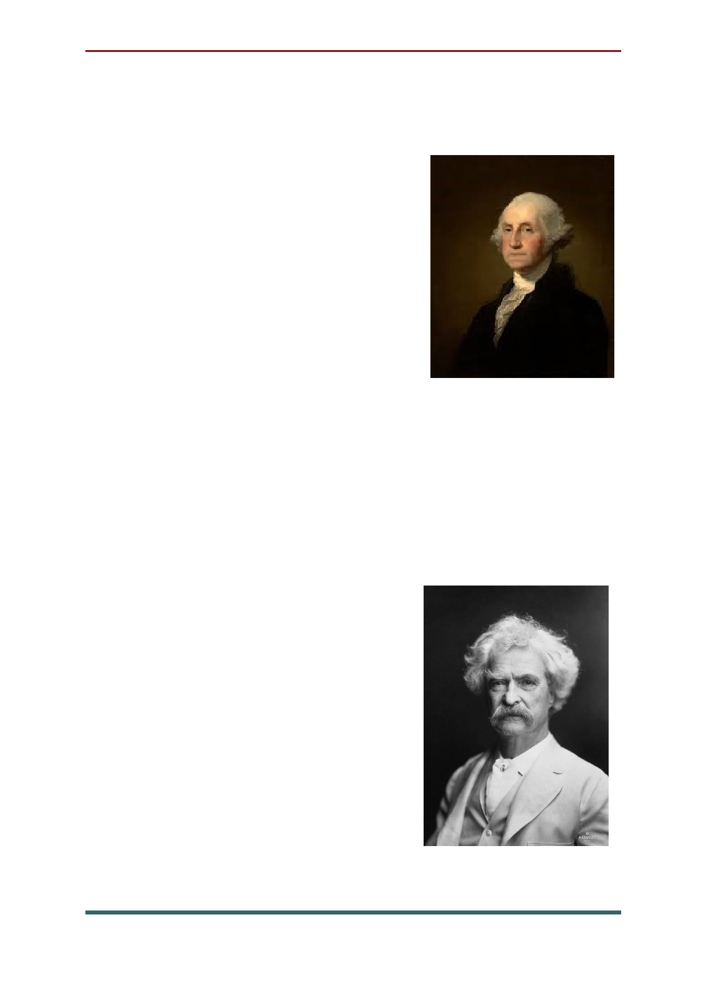Famous people of USA
George Washington. In 1789 Washington
became the first president of the
United States. Even during his
life time Washington was
labelled 'father of his country'.
Many observers praised his
horseman ship and great
physical strength - he privately opposed slavery.

Mark Twain. Although better known by his
pen name, Twain's birth name was actually
Samuel Langhorne Clemens. He was an American
author and humorist made famous by his 'great
American novel' Adventures of Huckleberry
Finn. William Faulkner called Twain the father of American literature.

Elvis Presley. Often
referred to as 'the King', Elvis was one of the most important
cultural icons of the
20th century. A shy boy he
was often bullied at school and told he could not sing.

86

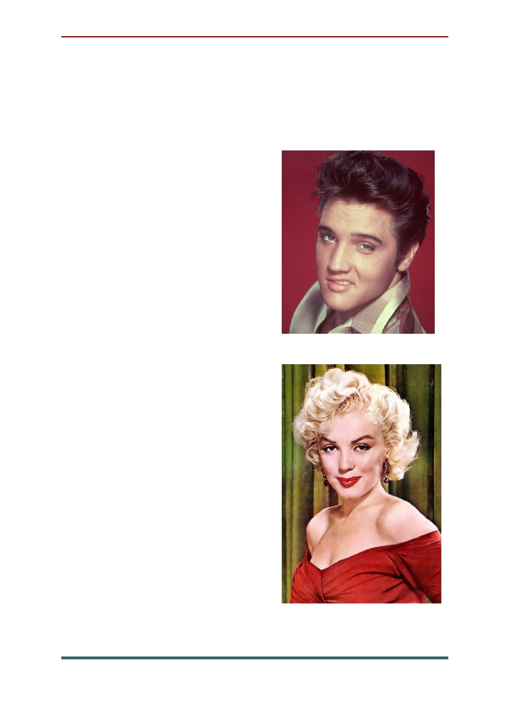He began to stand out more in his junior year
due to his appearances. His first recordings were
with Sun records in 1953 but his debut album was
released in 1956 which is famous for the single blue suede shoes.

Marilyn Monroe. Born
as Norma Mortenson,
Monroe spent much of her childhood in foster homes. She started her career as a
model but was offered a
film contract from twentieth
century-fox in 1946. She
starred in a number of
successful motion pictures
during the 1950's and
became a major sex symbol.
The film Some like it
Hot was one of her biggest
successes for which she
received a Golden Globe Award.

87

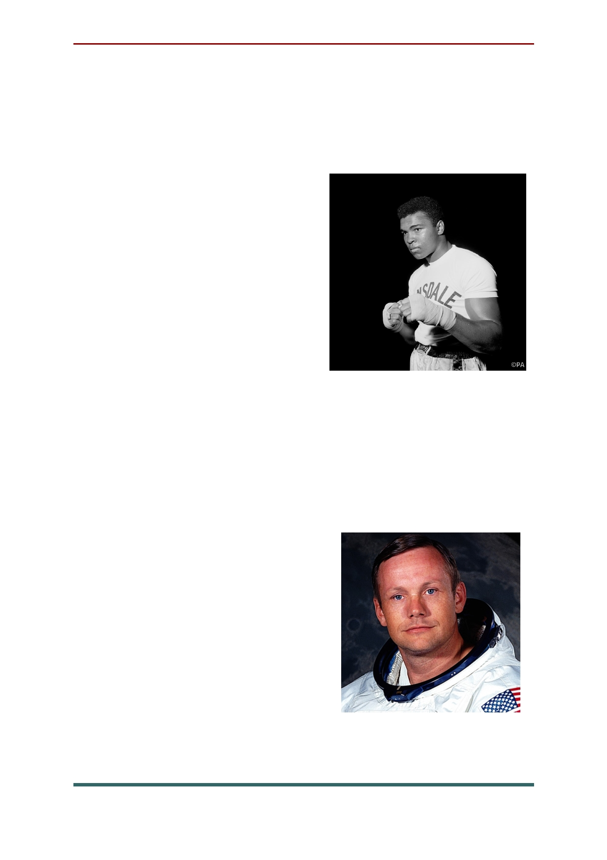Muhammad Ali. Ali is considered one of the
greatest professional heavy-weight boxers in
sports history. He is not only praised for his skills
in the ring but for the values he expresses out of
it: religious freedom and
racial justice. Born Cassius Clay he changed his name
to Muhammad Ali at the
age of 22 when he
converted to the Nation of Islam after he won World Heavy-Weight Champion
in 1964. He later went on to
become the first and only three-time lineal World Heavyweight Champion.

Neil Armstrong. A famous American
astronaut, Armstrong was the first person to walk
on the moon. Armstrong
was a very humble person
and was referred to as a
reluctant American Hero.
Before becoming an
astronaut Armstrong was an
officer in the U.S Navy and served in the Korean War.

88

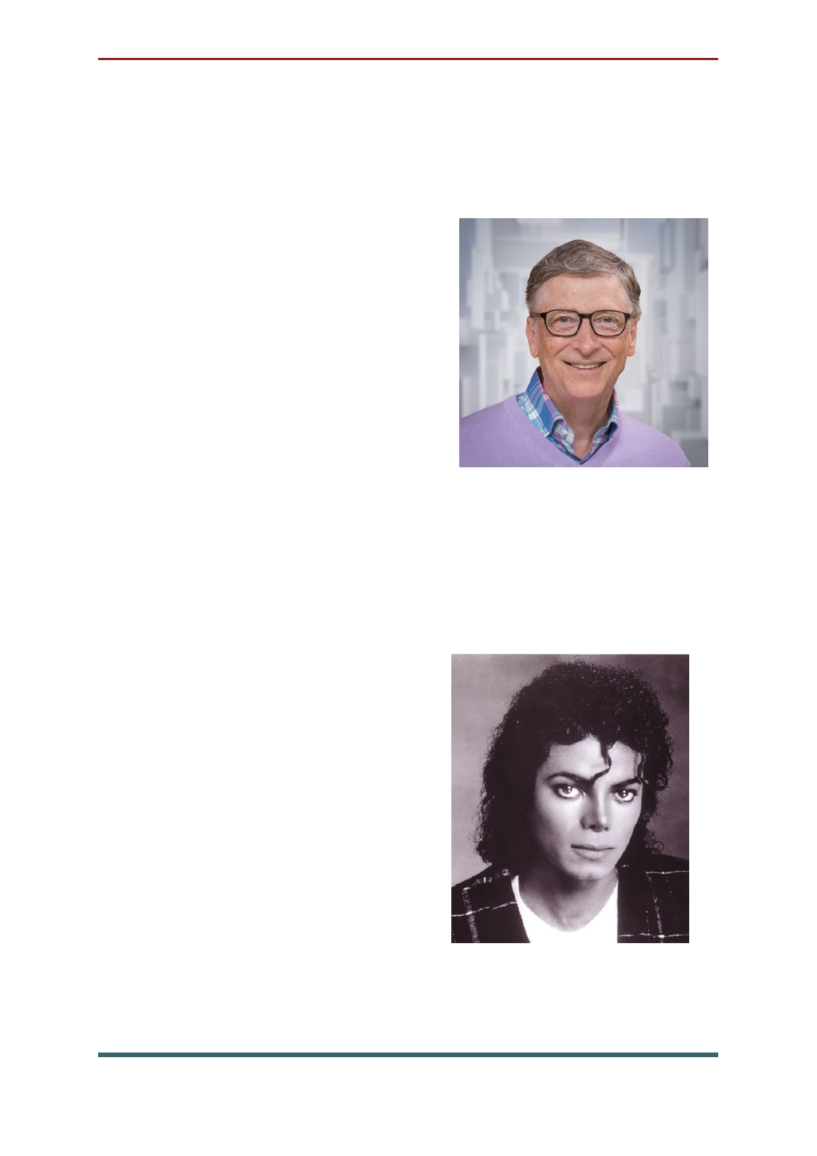Bill Gates is the current chairman and former
CEO of the world's largest personal-computer
software company, Microsoft. A Company he co- founded with Paul Allen.
According to the Bloomberg Billionaires List, Gates is the
world's richest person this year - a title he also held in
2007. Time magazine named
Gates one of the 100 people
who most influenced the 20th century.

The well known singer-songwriter, dancer
and business man, Michael Jackson is referred to as 'The King of Pop.' The Guinness book of world
records recognised him as
the most successful
entertainer of all time; he
was a global figure in
popular culture for over 4 decades. MJ started off his career in the Jackson 5 and later became a solo act. His
album Thiller is the best selling album of all time.

89

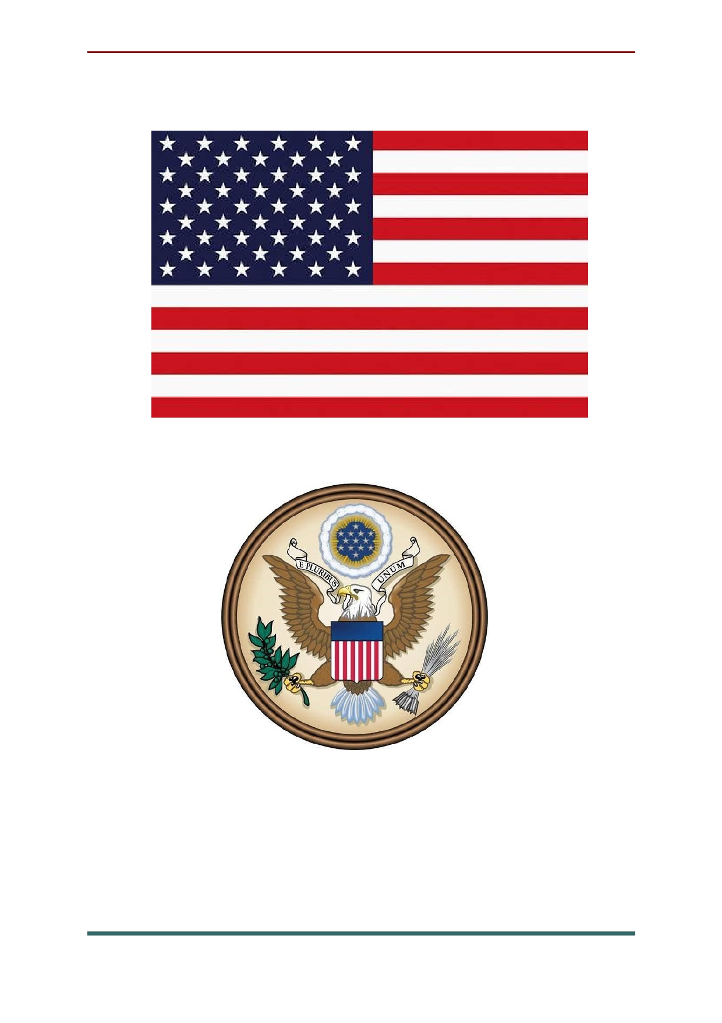The national symbols of USA

Flag of the United States

Seal of the United States (emblem)

90

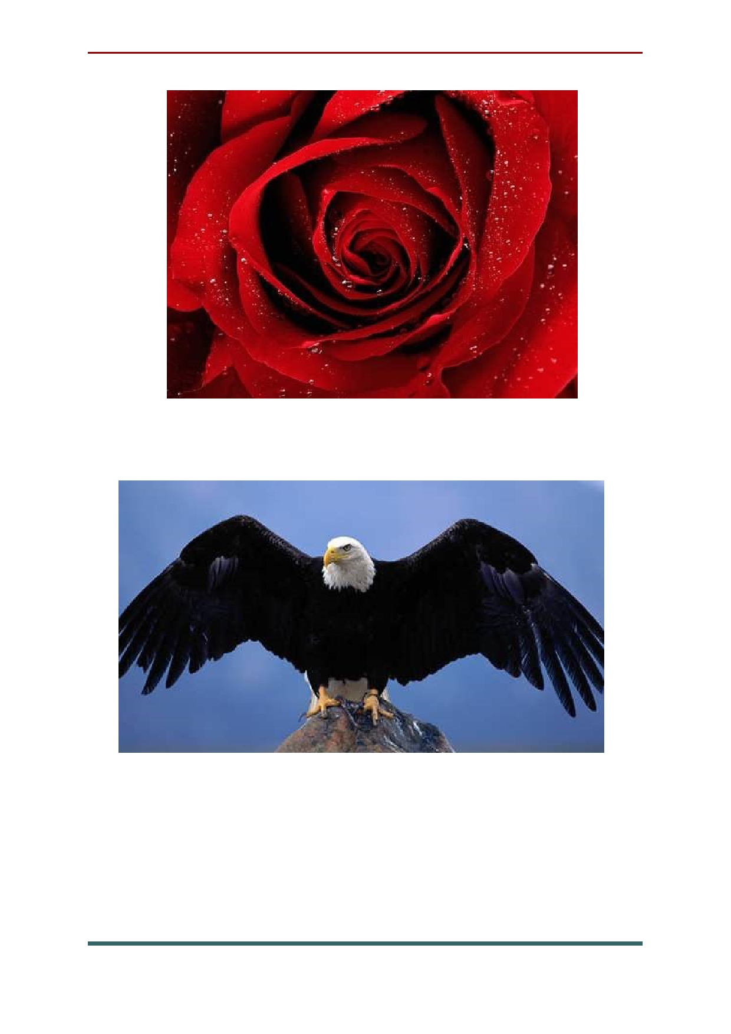National floral emblem: Rose

National bird: Bald Eagle

91

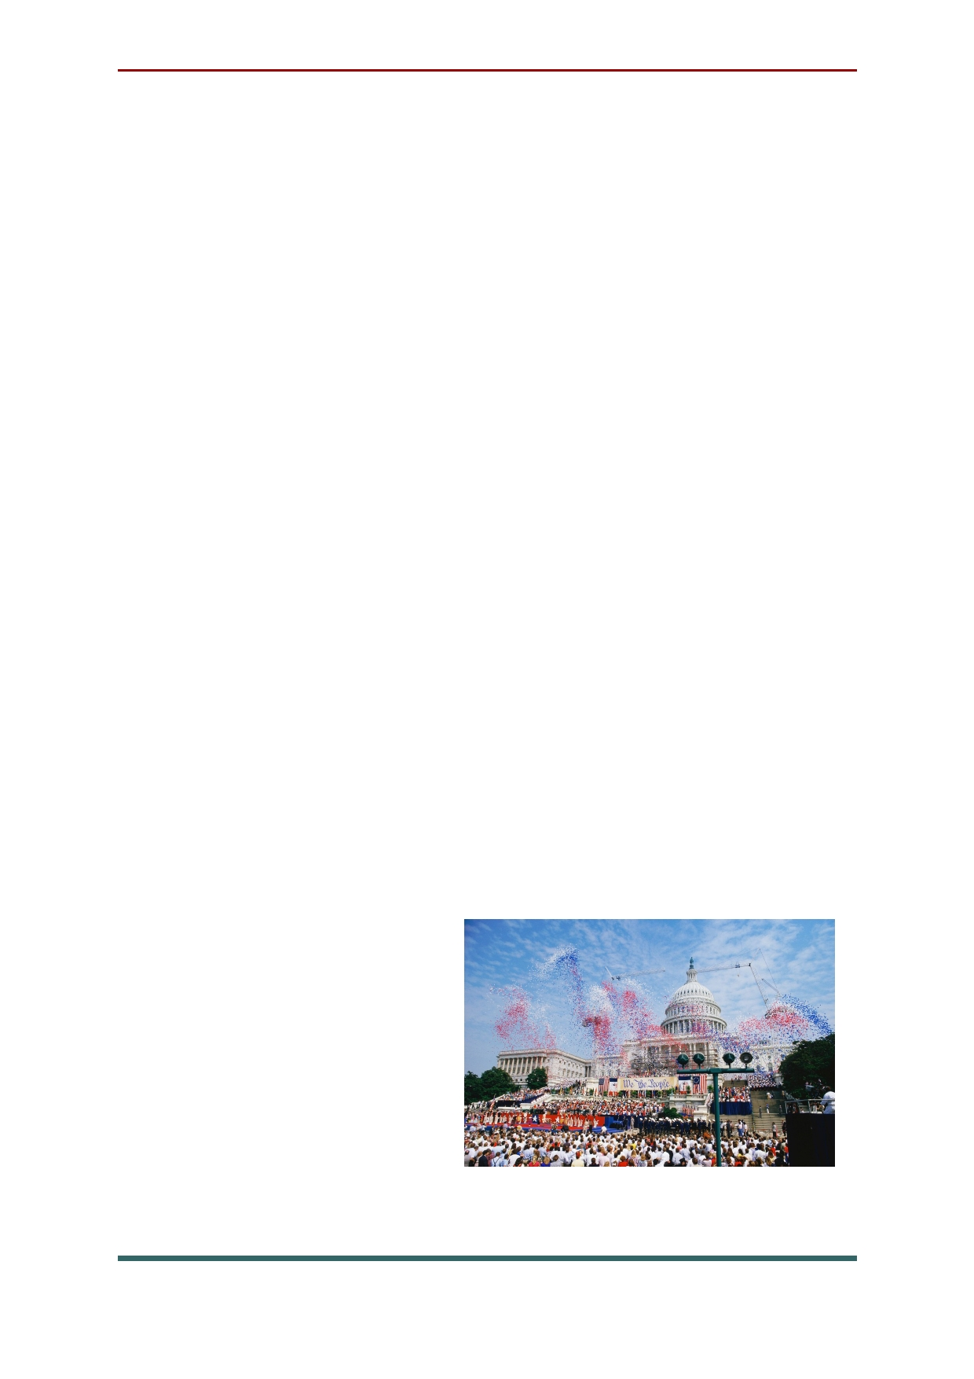National holidays and traditions in USA
Independence Day is the national holiday of
the United States, and possibly one of the most important holidays of the year. The celebration
commemorates the fact that back in 1776, the members of the Second Continental Congress declared their independence from the British
Crown. Nowadays, this day is a celebration of all-
things-American, from hot dogs and country
music to exercising the freedom to choose and express yourself.
Americans often celebrate this day with their
families and friends, enjoying the multiple
Independence Day parades and outdoor
celebrations, since it occurs during the summer
time. If the weather permits, people set up picnics
and barbecues in parks and their backyards and watch fireworks in the evening. American flags
and red, white, and blue decorations such as
banners and streamers
appear everywhere, and most shops offer traditional American
and flag-colored goods.

92

Thanksgiving is a celebration that originates from
a tradition to give thanks for a good harvest. It is said
to have its origins in 1621 when the first colonists in
New England and Native Americans came together to
enjoy a large feast at the end of the first harvest.
Although historians doubt the accuracy of this story,
it is the official version most Americans accept as fact.
Nowadays, Thanksgiving is usually celebrated
with the extended family and, occasionally, also with very close friends. Even family members who live far away from their relatives come home for this holiday
to spend time with their loved ones. In some cases,
since Thanksgiving and Christmas are so close to each
other, many family members choose to go home for
Christmas only, and organize a Thanksgiving
celebration in their city of residence among friends, calling it "Friendsgiving".
A traditional Thanksgiving dinner includes a roast turkey, cranberry sauce, sweet potatoes, and other foods of the season that are served for a huge
dinner. At the start of the dinner, people take time to
share with everyone what they are grateful for that
year. When the turkey is carved, people take out the
wishbone and break it to see whose wish will be granted. They do it by pulling on each side of the bone: whoever gets the bigger part wins.

93

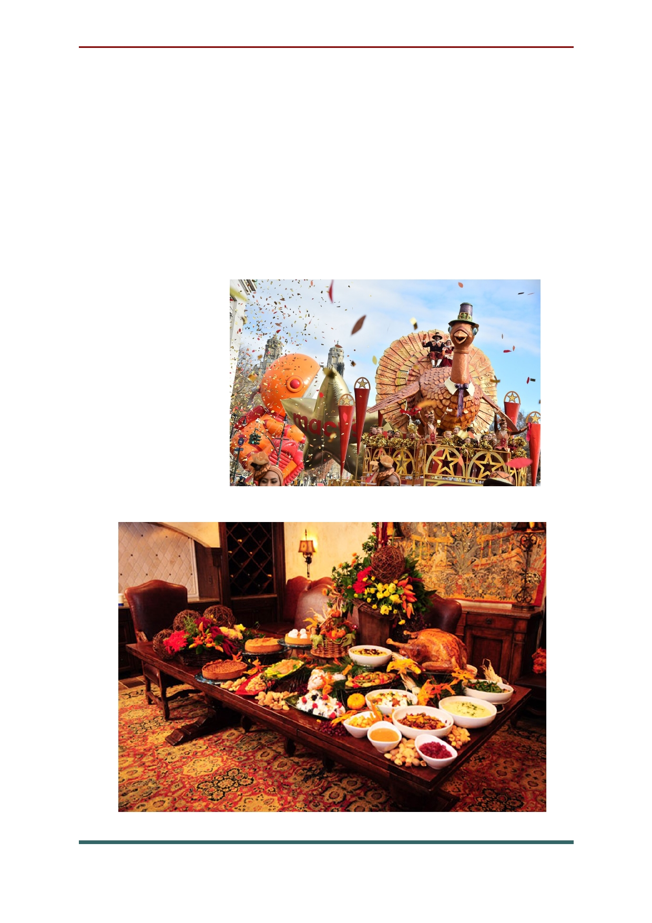The day leading up to the dinner is often
spent cooking and watching the Macy's
Thanksgiving Day Parade or a football game on
TV. Another televised story is the turkey pardon: The President of the United States grants life to a live turkey that has been gifted to them, allowing
it to continue living on the farm until the end of its days.

94

Christmas Eve/Day. Although this Christian
festival is celebrated in many countries around the
globe, Americans came up with a number of original
holiday traditions. In recent years, Christmas
decorations now go up almost immediately after
Thanksgiving. Houses are decorated with mistletoes,
fairy lights, a Christmas tree, and other seasonal
indoor and outdoor decorations. Many people use this
time to shop for gifts and take it as an opportunity to do charitable work.
The more religious people often attend the
Midnight Mass held on Christmas Eve. While there's
still a tradition to hang stockings (often with your
name on it) for Saint Nicolas to fill it up with presents,
most children expect Santa Claus to slide down the
chimney at night and leave presents under the
Christmas tree. In anticipation, kids often leave milk
and cookies out for Santa as well as carrots for his reindeers.
On Christmas morning everyone unwraps their
gifts. People spend the day with their family and
friends watching holiday classics (movies like It's a
Wonderful Life or A Charlie Brown Christmas) or
basketball on TV or taking a stroll around the
neighborhood admiring the Christmas lights. The
main celebration takes place with a big dinner.

95

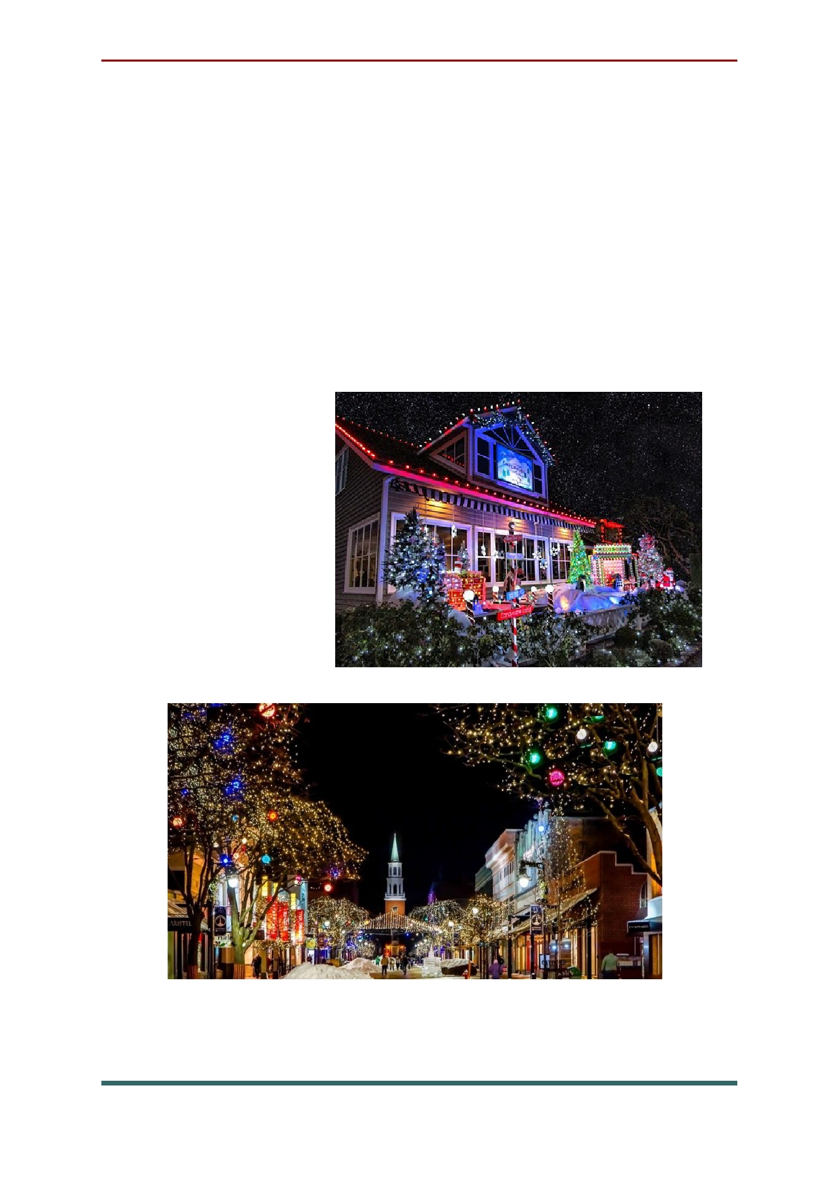The star dish of the dinner depends on the
state, but, in most cases, it's roast turkey or ham. As the US is home to a highly diverse populace,
Christmas is only one of a number of festivals taking place towards the end of the year.
Hanukkah and Kwanzaa are celebrated around
this time of the year as well, therefore this period is usually referred to as "the holiday season".

96
The sources of information

- https://www.planetware.com/tourist-attractions/england-eng.htm
- https://www.planetware.com/tourist-attractions/australia-aus.htm
- https://en.wikipedia.org/wiki/List_of_English_dishes
- https://edition.cnn.com/travel/article/classic-british-food/index.html
- https://www.thespruce.com/what-is-boxing-day-435060
- https://www.timeanddate.com/holidays/uk/spring-bank-holiday
- https://www.timeanddate.com/holidays/uk/summer-bank-holiday#:~:text=In%20England%2C%20Wales%20and%20Northern,or%20school%20in%20the%20autumn.
- https://en.wikipedia.org/wiki/Thanksgiving
- https://en.wikipedia.org/wiki/Independence_Day_(United_States)
- http://projectbritain.com/famous_people.htm
- https://www.thefamouspeople.com/united_states.php

