Ответы

2024
ФГБОУ ВО «Вятский государственный университет»
ОП Дирекция Пединститута

ФГБОУ ВО «Вятский государственный университет»
ОП Дирекция Пединститута

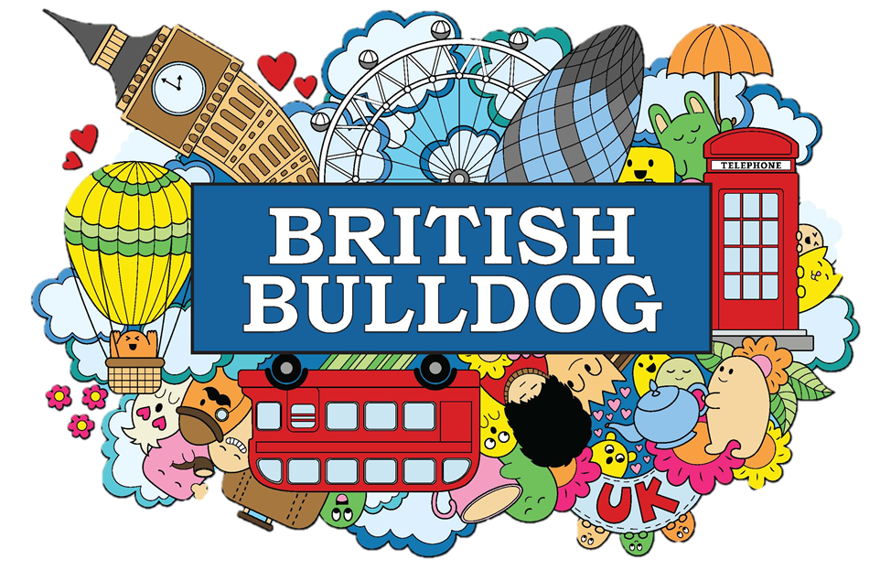

В этом сборнике ответов представлены ответы
на вопросы из карточек настольной игры «Britain».

Все вопросы поделены на темы, которые с лёгкостью
можно открыть благодаря ярлычкам сбоку.

Government structer
1. What is the name of the head of the British government?
b) Prime Minister

The Prime Minister is the head of the British government and leads the party that holds the majority of seats in the House of Commons.

2. The British Parliament is made up of two houses. What are they called?
b) House of Lords and House of Commons
The House of Commons is the elected body with members representing different constituencies, while the House of Lords has members appointed or inherited their position.
3. Who is the current monarch of the United Kingdom?
c) King Charles III
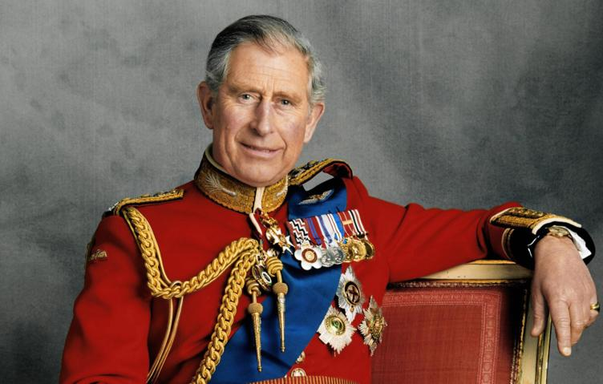
King Charles III ascended the throne after the death of his mother, Queen Elizabeth II, in September 2022.

4. What is the role of the Monarch in the British government?
b) Head of State with mainly ceremonial duties.
The Monarch has limited political power and acts as a figurehead for the nation, performing ceremonial duties like opening Parliament and appointing the Prime Minister.

5. What is the main function of the House of Commons?
b) To make laws and approve the government's budget.
The House of Commons debates and votes on legislation, and also scrutinizes the government's spending plans.

6. What is the name of the system of government in the UK?
b) Parliamentary system
The UK has a parliamentary system where the executive branch (the government) is accountable to the legislative branch (Parliament).

7. Which of these is NOT a part of the British government?
c) The House of Representatives
The House of Representatives is part of the US government, not the British government.

8. What is the main responsibility of the Prime Minister?
c) To lead the government and represent the country internationally.
The Prime Minister is responsible for forming the government, setting its agenda, and representing the UK in international affairs.

9. How often are general elections held in the UK?
b) Every 5 years
General elections in the UK are usually held every five years, although the Prime Minister can call an election earlier.

10. What is the name of the political party that currently holds the majority of seats in the House of Commons?
a) Conservative Party
As of October 2023, the Conservative Party currently holds the majority of seats in the House of Commons, although this can change with future elections.



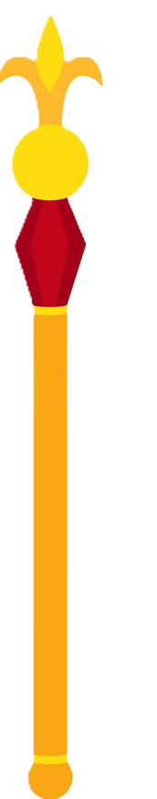
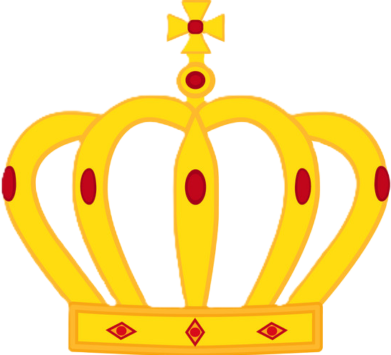
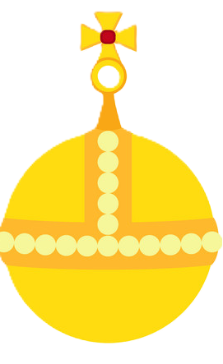
MONARCHY

Territorial Structure

1. What is the official name of the country that includes England, Scotland, Wales and Northern Ireland?
b) United Kingdom of Great Britain and Northern Ireland
This is the official and full name of the country. "Great Britain" refers only to England, Scotland, and Wales.

2. Which country in the United Kingdom is known for its highlands and bagpipes?
c) Scotland

Scotland is famous for its rugged highlands, dramatic scenery, and traditional bagpipe music. It has a distinct culture and history.

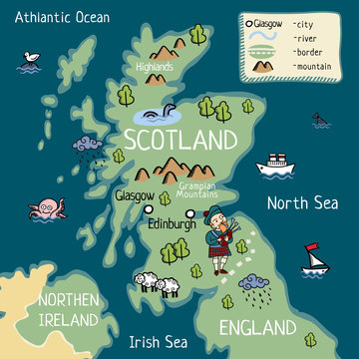

3. What is the capital city of Wales?
a) Cardiff
Cardiff is the capital city of Wales, a vibrant city with a rich history and modern attractions.
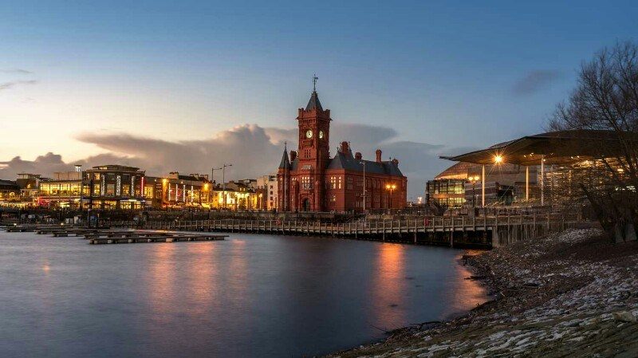

4. Which country is known for its rolling hills and sheep farming?
c) Wales
Wales is known for its picturesque rolling hills, sheep farming (a significant part of its economy), and charming villages.
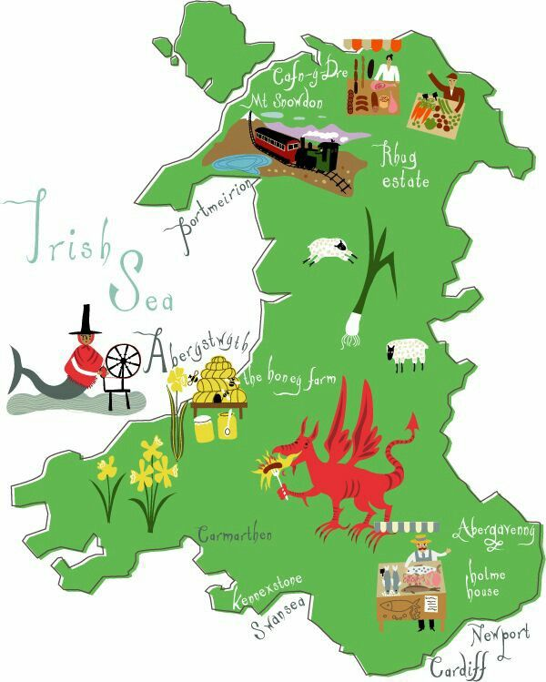

England

5. Which city is the largest in the United Kingdom?
b) London
London is a global city and the largest city in the UK, a major center for finance, culture, and tourism.
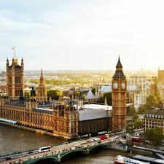

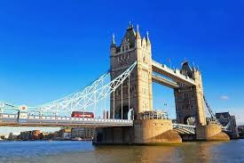

6. Which country has a long coastline and is famous for its castles?
c) Wales
Wales boasts a stunning coastline with dramatic cliffs, sandy beaches, and numerous historic castles, many dating back to medieval times.

7. Which of these is NOT a constituent country of the United Kingdom?
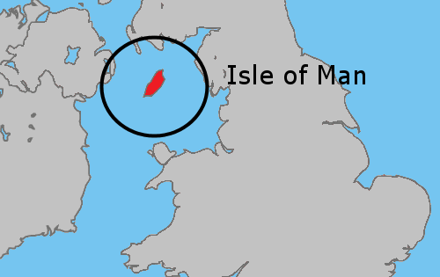
a) Isle of Man
The Isle of Man is a Crown dependency, not a constituent country of the United Kingdom. It has its own parliament and legal system.
United Kingdom
8. What is the name of the largest lake in the UK?
c) Lough Neagh
Lough Neagh is located in Northern Ireland and is the largest lake in the British Isles by surface area.
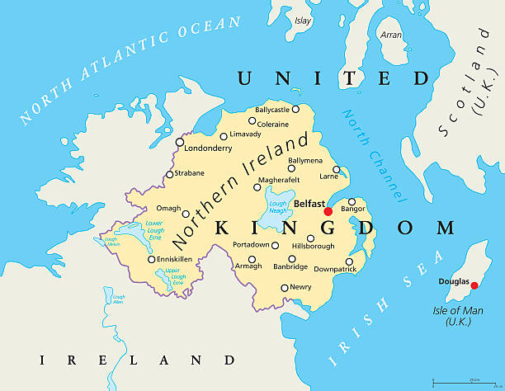
9. Which country in the UK is known for its Giant's Causeway?
c) Northern Ireland
The Giant's Causeway, a unique geological formation of interlocking basalt columns, is a major tourist attraction in Northern Ireland.
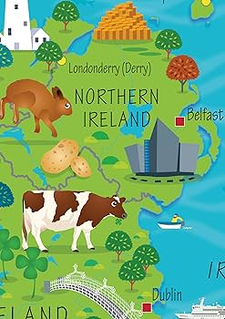

10. What is the main difference between Great Britain and the United Kingdom?
a) Great Britain is a geographic term, while the UK is a political one.
Great Britain refers to the landmass comprising England, Scotland, and Wales. The United Kingdom includes these three and also Northern Ireland, a political union. The terms are often used interchangeably informally, but technically they have different meanings.

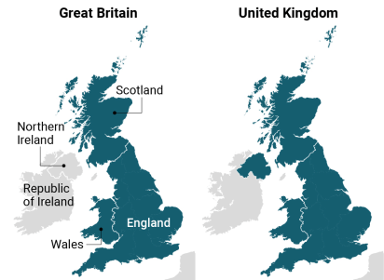

History

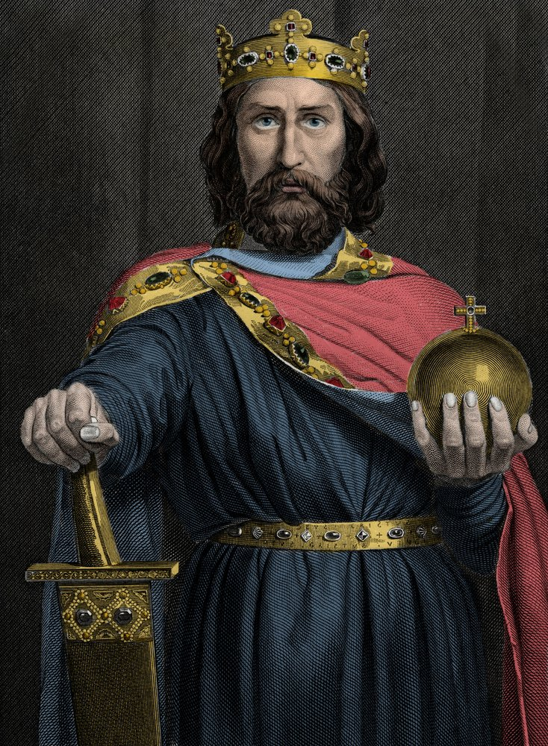
1. Which of these historical figures was NOT a Roman emperor associated with Britain?
c) Charlemagne
Charlemagne was the King of the Franks and Holy Roman Emperor, not associated with Roman Britain.

2. The Battle of Hastings, a pivotal moment in English history, resulted in the Norman Conquest. Who was the victorious Norman leader?
a) William the Conqueror

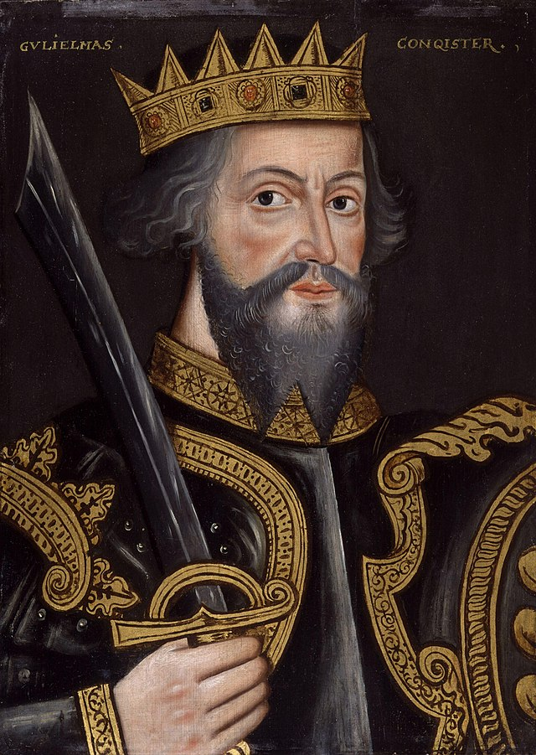
He led the Norman invasion and became the first Norman King of England.

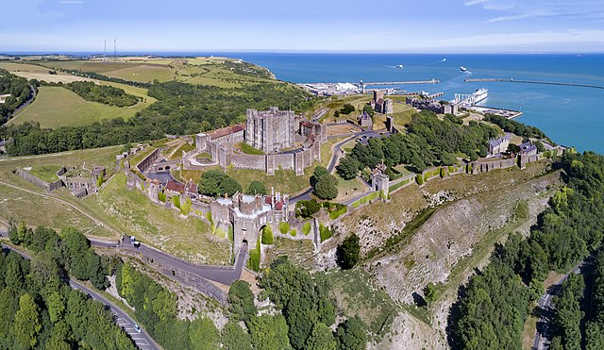
3. Which of these famous castles was built by William the Conqueror after the Norman Conquest?
c) Dover Castle
It was built by William the Conqueror as a strategic stronghold to defend against invasion.

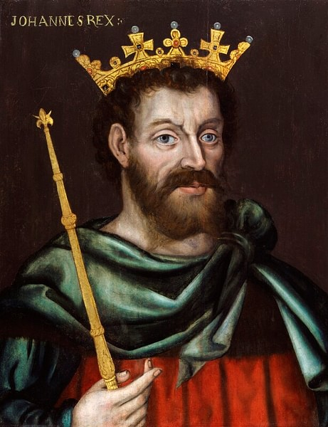
4. During the Middle Ages, the Magna Carta was a significant document that limited the power of the king. Who was the English monarch forced to sign it?
a) King John
He was forced to sign the Magna Carta in 1215 by English barons demanding limits on his power.

5. What was the name of the religious movement that led to the creation of the Church of England, breaking away from the Roman Catholic Church?
a) The Reformation
This religious movement led by Martin Luther in the 16th century challenged the authority of the Catholic Church and sparked the English Reformation under Henry VIII.

6. Which famous English explorer, renowned for circumnavigating the globe, sailed under the flag of Queen Elizabeth I?
a) Francis Drake
He was a renowned privateer and explorer who completed the circumnavigation of the globe in 1580.
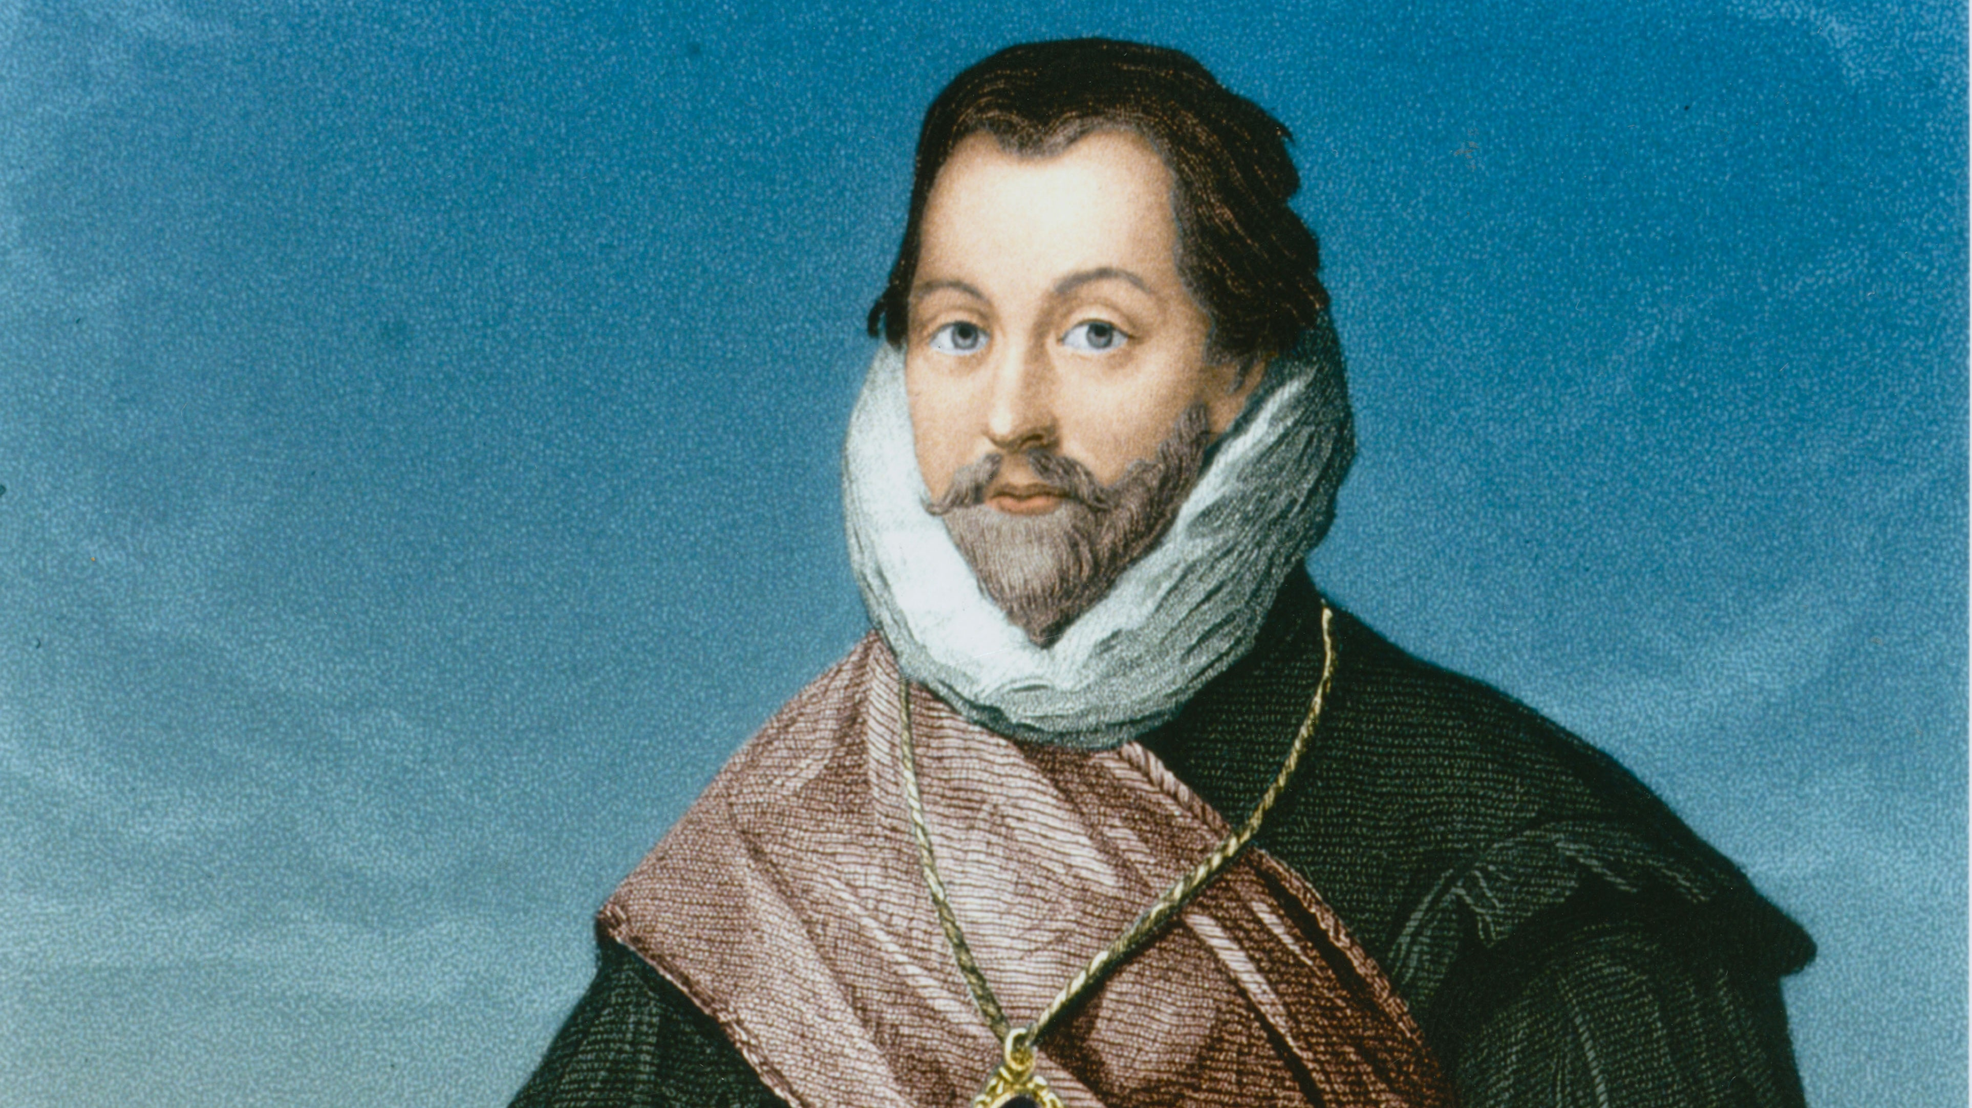

7. The Industrial Revolution transformed British society with new technologies and inventions. Which of these inventions was NOT a major product of this era?
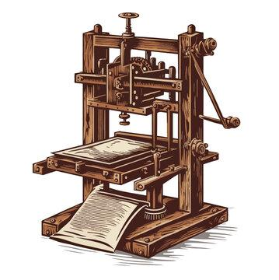
b) The printing press
The printing press was invented by Johannes Gutenberg in the 15th century, well before the Industrial Revolution.

8. Which of these historical events took place during the reign of Queen Victoria, often known as the "Victorian Era"?
c) The First World War
Queen Victoria's reign ended in 1901, well before the outbreak of World War I in 1914.

9. The British Empire, at its height, controlled vast territories around the world. Which of these countries was NOT a British colony at some point in history?

c) Japan
Japan was never a British colony, though there were periods of strong diplomatic and trade relations.

10. Which World War saw Britain fight alongside other Allied nations against Nazi Germany?
b) World War II
Britain joined forces with the Allies, including the United States, to defeat Nazi Germany and its Axis powers.
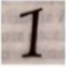
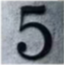
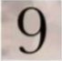

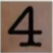
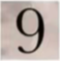

Sights

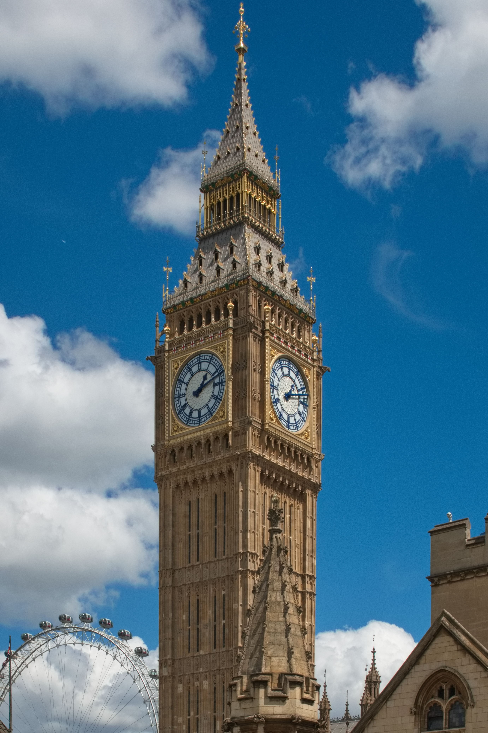
1. Which iconic landmark is a large clock tower in London?
a) Big Ben
Big Ben is actually the nickname for the Great Bell of the Elizabeth Tower, a clock tower located at the north end of the Palace of Westminster in London. It's one of the most recognizable landmarks in the world, known for its imposing size and iconic clock face.
2. What is the name of the famous bridge in London with two towers and a suspension design?
a) Tower Bridge
Tower Bridge is a combination drawbridge and suspension bridge spanning the River Thames in London. Its unique design, featuring two towers and a bascule section, makes it an instantly recognizable landmark.
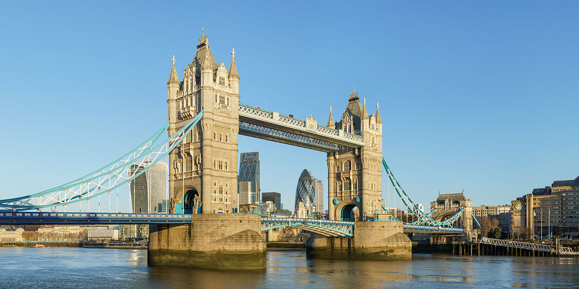

3. Which palace is the official residence of the British monarch?
a) Buckingham Palace
Buckingham Palace is the official London residence of the British monarch. It's a grand and historic palace known for its state rooms, iconic balcony, and the Changing of the Guard ceremony.
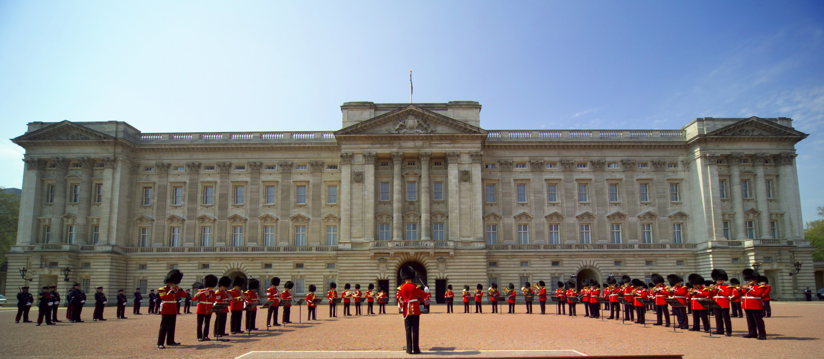
4. What is the name of the ancient stone circle in England?
a) Stonehenge
Stonehenge is a prehistoric monument located in Wiltshire, England, consisting of a ring of standing stones. It's a mysterious site, with its purpose and construction still debated by archaeologists and historians.
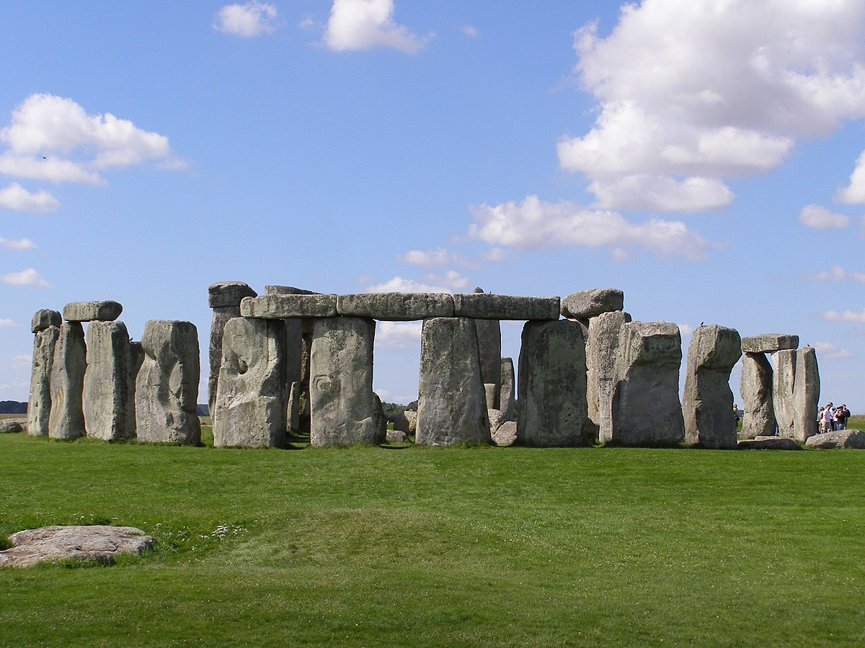

5. Which castle is located in the Scottish Highlands and is known for its loch?
a) Edinburgh Castle
Edinburgh Castle is a historic fortress located in the Scottish capital, Edinburgh, situated atop a volcanic rock. It's a popular tourist destination, offering stunning views of the city and a glimpse into Scotland's rich history.
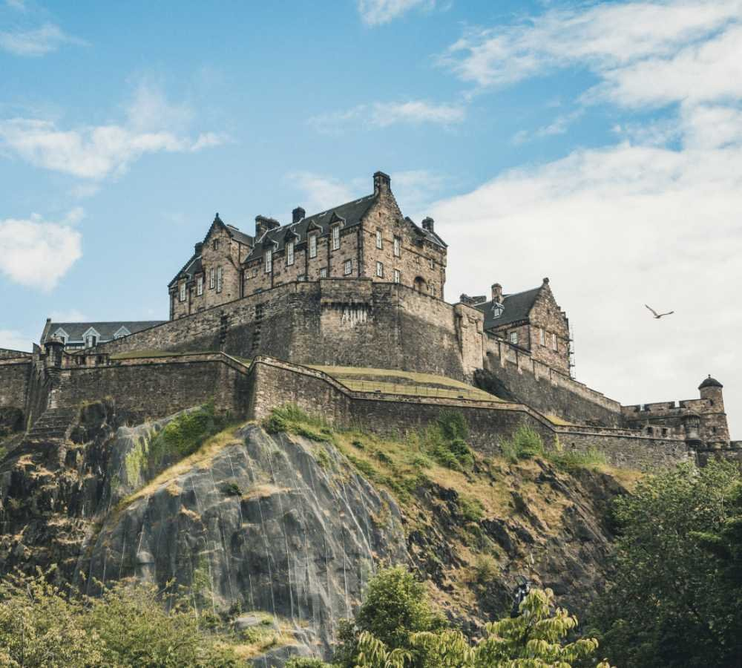

6. What is the name of the large Ferris wheel on the South Bank of the River Thames in London?
a) The London Eye
The London Eye, also known as the Millennium Wheel, is a giant Ferris wheel on the South Bank of the River Thames. It offers panoramic views of London, making it a popular tourist attraction.

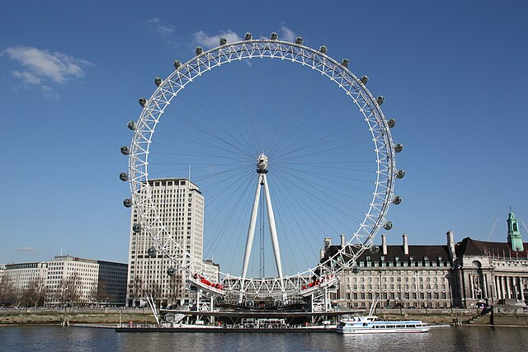

7. Which cathedral is located in London and is a famous example of Gothic architecture?
b) St. Paul's Cathedral
St. Paul's Cathedral, located in the City of London, is one of the most famous churches in England. It's a masterpiece of Baroque architecture designed by Sir Christopher Wren, and its dome is a recognizable London skyline feature.
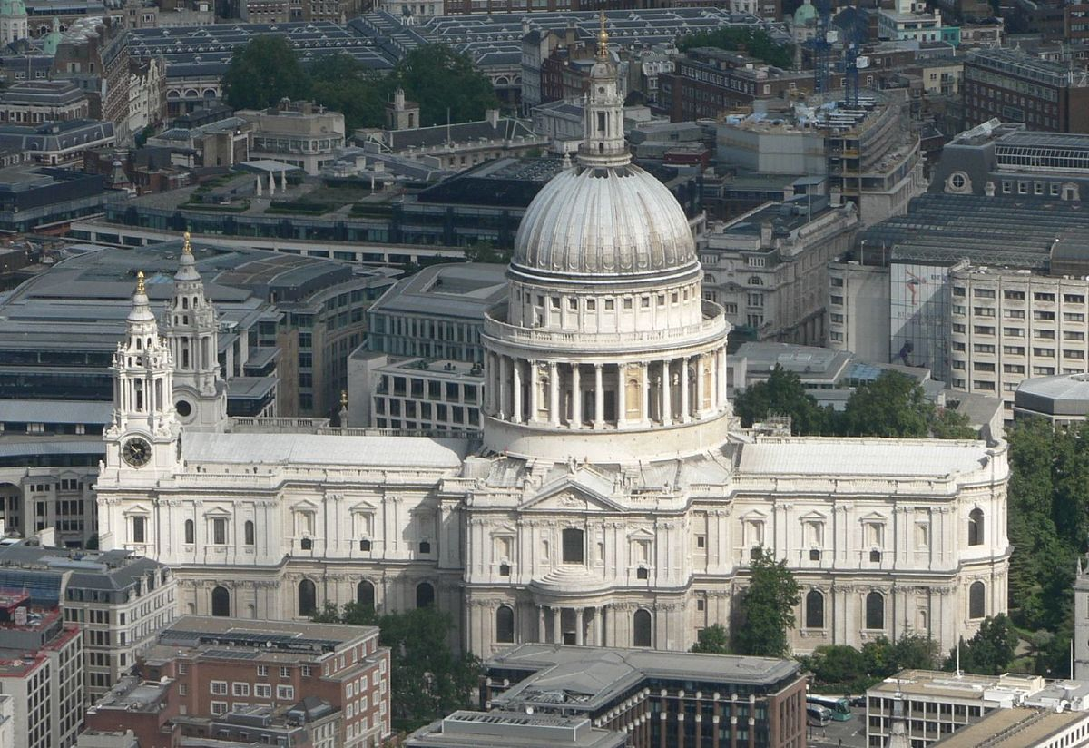

8. What is the name of the famous street in London known for its shops and theaters?
a) Oxford Street
Oxford Street is a major shopping street in London, known for its department stores, boutiques, and bustling atmosphere. It's a shopper's paradise, offering a wide variety of goods.
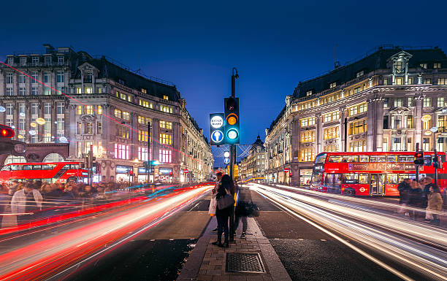
9. Which castle is located in Wales and is known for its dramatic location on a cliff?
a) Caernarfon Castle
Caernarfon Castle is a medieval castle located in Caernarfon, Wales. It's renowned for its impressive defensive walls and towers, and its location on a rocky headland facing the Menai Strait.

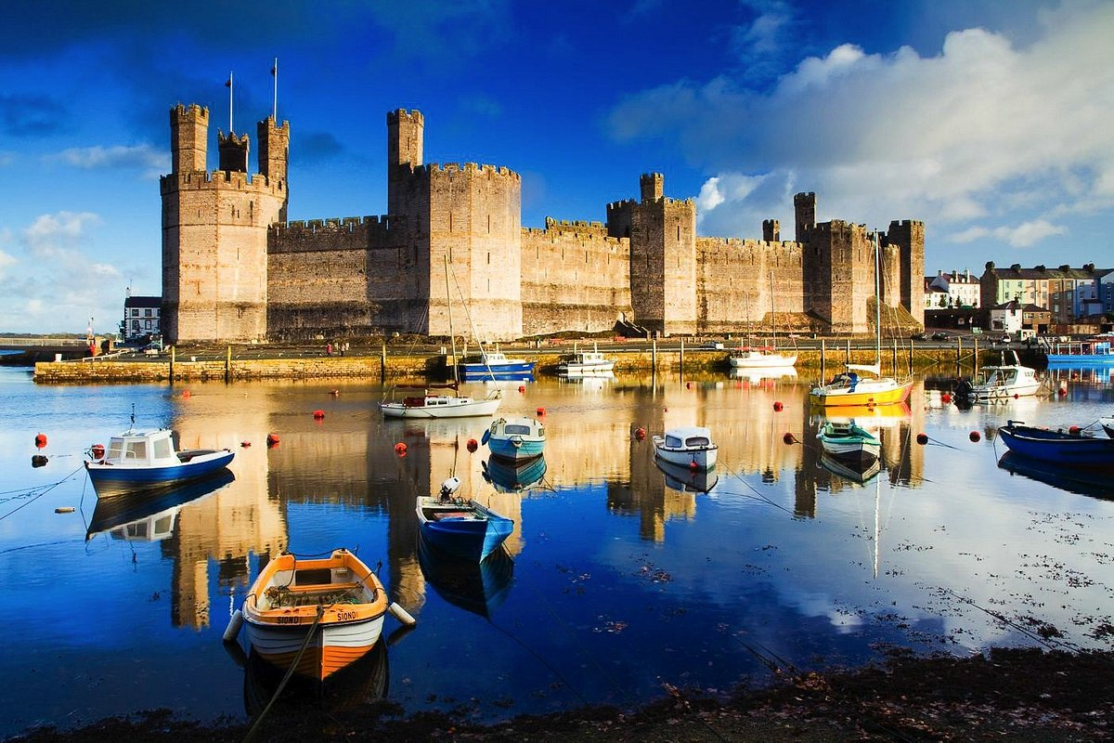

10. What is the name of the iconic street in London where the Houses of Parliament are located?
b) Whitehall
Whitehall is a street in London that runs from Trafalgar Square to Parliament Square. It's a historic street, home to government buildings, including the Houses of Parliament, Downing Street (the official residence of the Prime Minister), and various government departments.
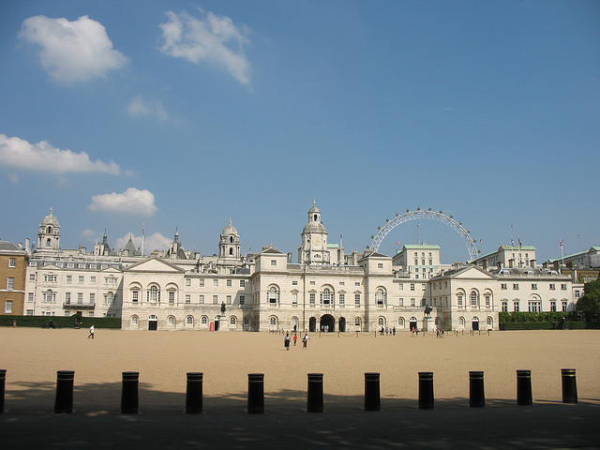

State symbols

1. Which animal, alongside the lion, graces the Royal Coat of Arms?
b) The unicorn
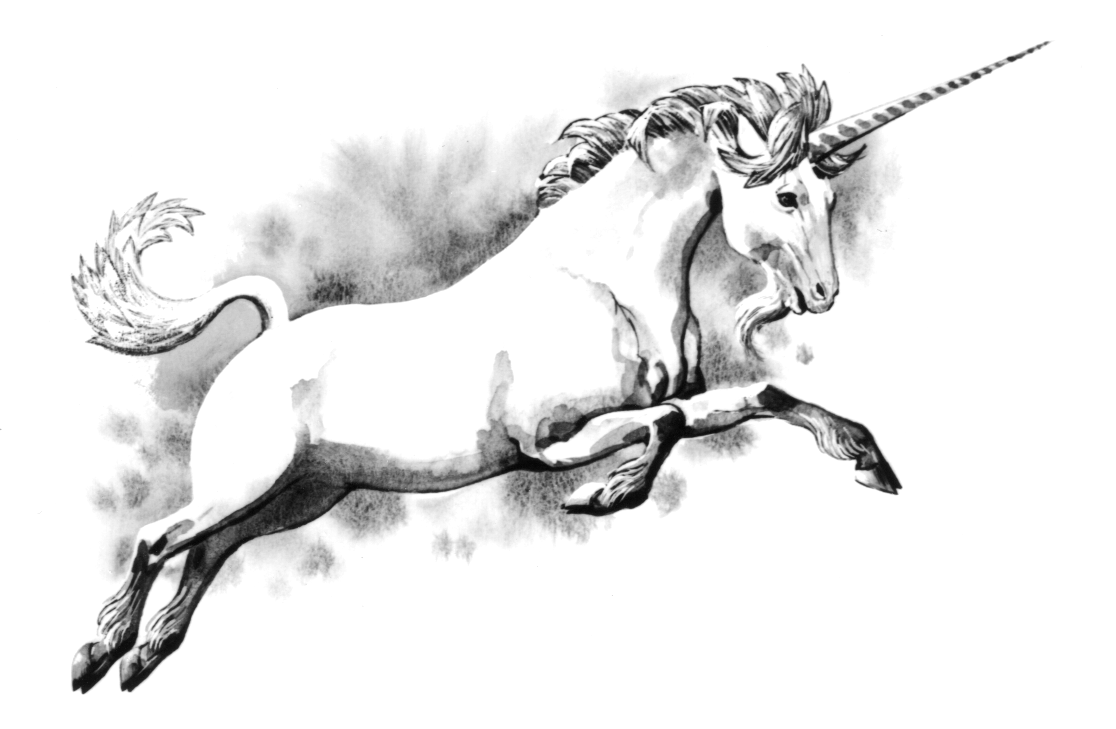
The unicorn represents purity, innocence, and power, alongside the lion, which symbolizes courage and strength.

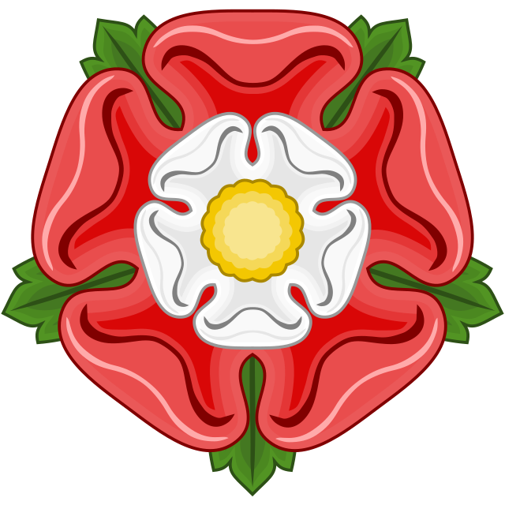
2. The national flower of England, known for its beauty and symbolism, is:
b) The rose
The Tudor rose, a combination of the white rose of York and the red rose of Lancaster, is a symbol of unity and national identity.

3. What is the traditional headwear worn by the British monarch, symbolizing power and authority?
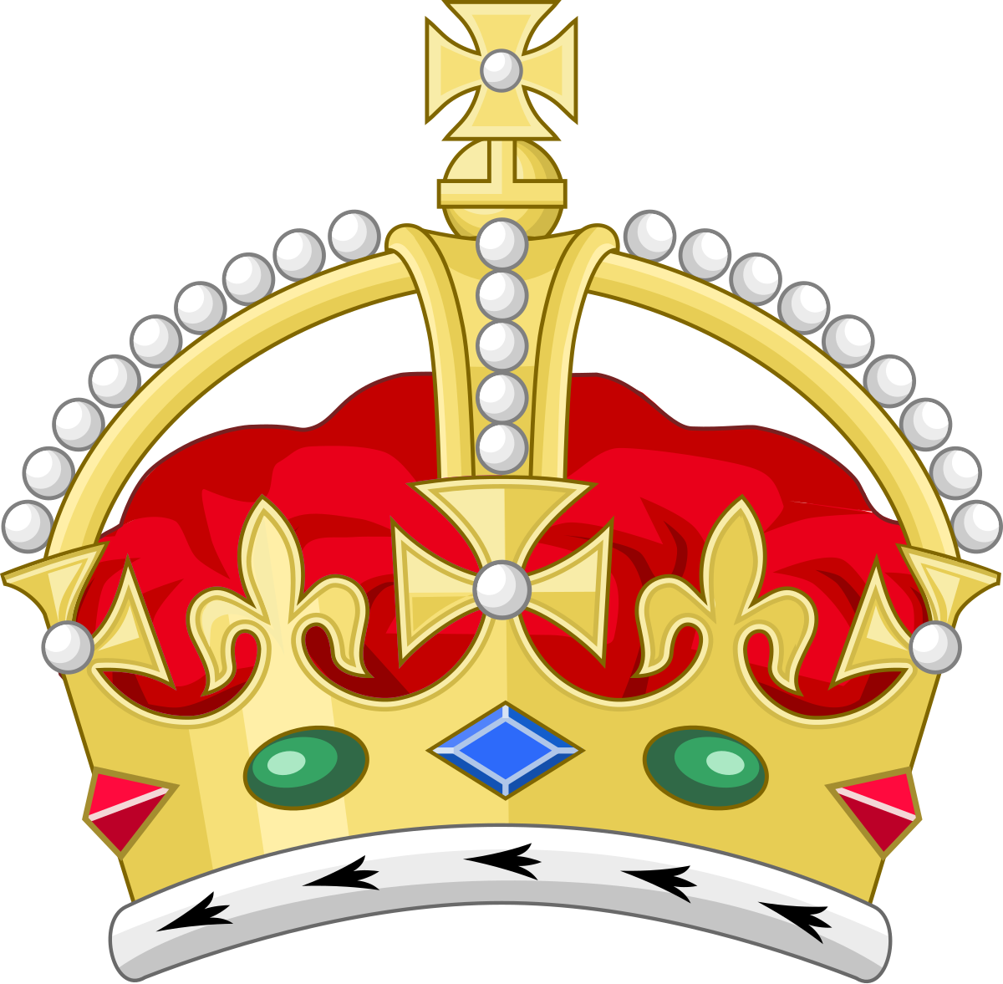
a) The crown
The crown is the most prominent symbol of the British monarchy, representing sovereignty and authority.
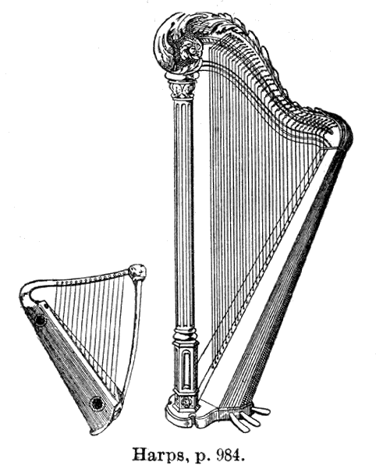
4. The national instrument of Wales, with its melodious sound, is:
b) The harp
The Welsh harp is a traditional instrument and a symbol of Welsh culture and heritage.

5. The official motto of the United Kingdom, embodying its spirit and strength, is:
b) "Dieu et mon droit" (God and my right)
This French phrase reflects the monarch's divine right to rule.

6. Which country's flag boasts a fierce red dragon, representing its heritage and pride?
c) Wales
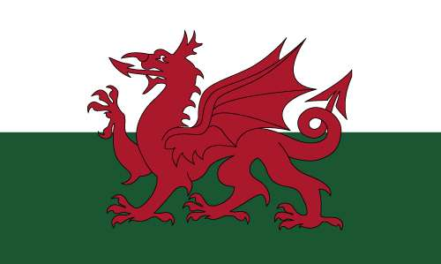
The Welsh flag, known as the "Y Ddraig Goch" (the Red Dragon), is a proud symbol of Welsh heritage and independence.

7. The national anthem of the United Kingdom, a powerful symbol of unity, is:
b) "God Save the King/Queen"
This anthem, also known as the National Anthem, is a symbol of unity and loyalty to the monarch.

8. What iconic structure, synonymous with London and the UK, serves as a symbol of power and time?
c) Big Ben
Big Ben is the nickname for the Great Bell of the Elizabeth Tower, a prominent landmark of London and the UK.

9. The oak tree, a symbol of strength and resilience in the UK, is known for its:
b) Durable wood
Oak trees are known for their strong, durable wood, making them valuable for shipbuilding and construction.
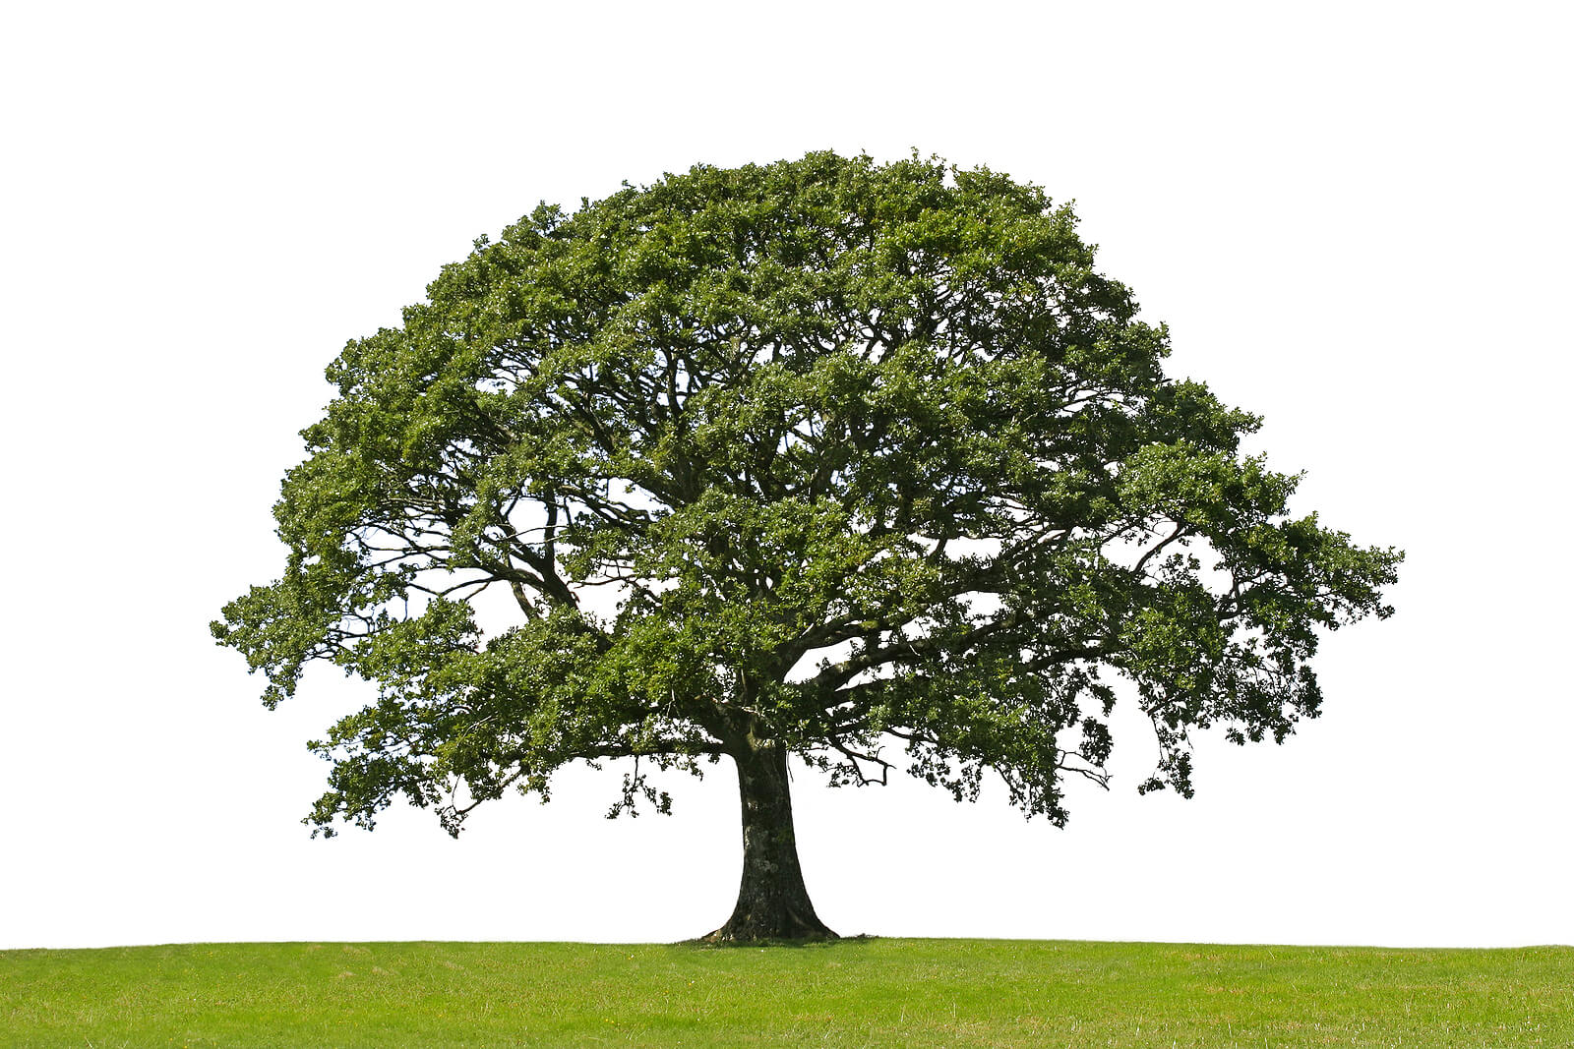

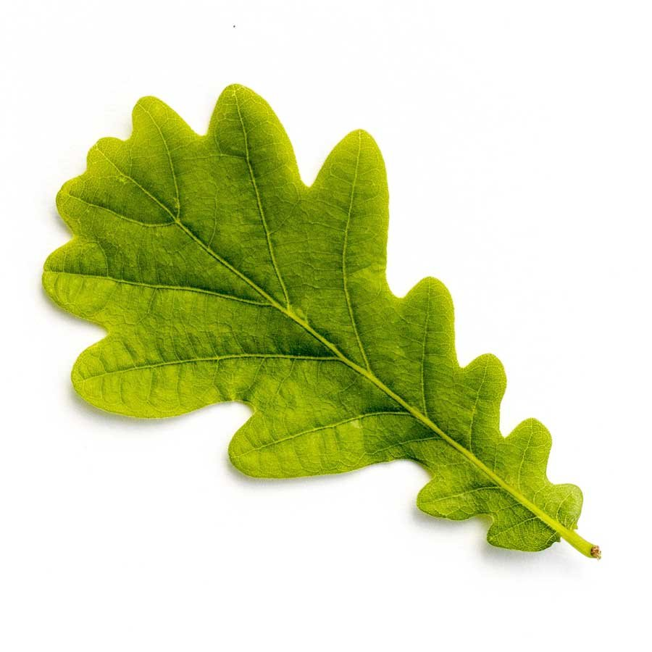

10. What colour, traditionally associated with the British monarchy, represents royalty and power?
c) Purple

Purple, associated with royalty and power, has been a traditional color of British monarchs for centuries.

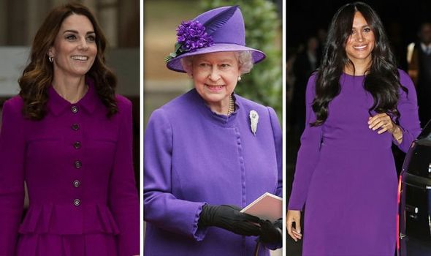

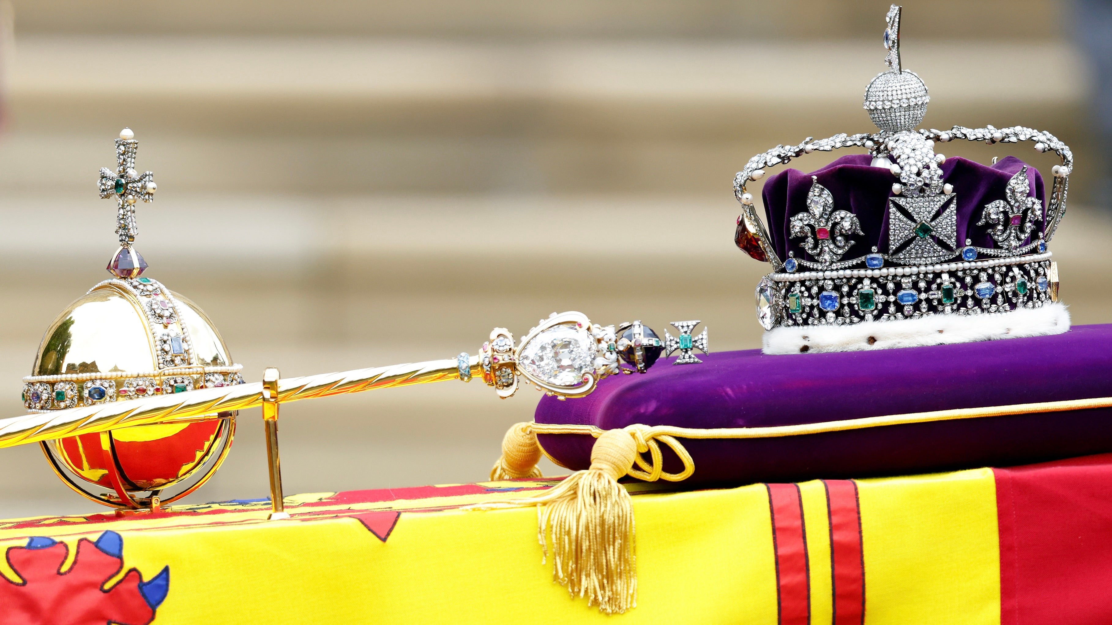

Traditions

1. What is the traditional British holiday celebrated on November 5th?
b) Bonfire Night
Bonfire Night, also known as Guy Fawkes Night, commemorates the failed Gunpowder Plot of 1605. On this night, people light bonfires and set off fireworks to celebrate the survival of King James I from the plot to blow up the Houses of Parliament. It has become a significant cultural event in the UK.
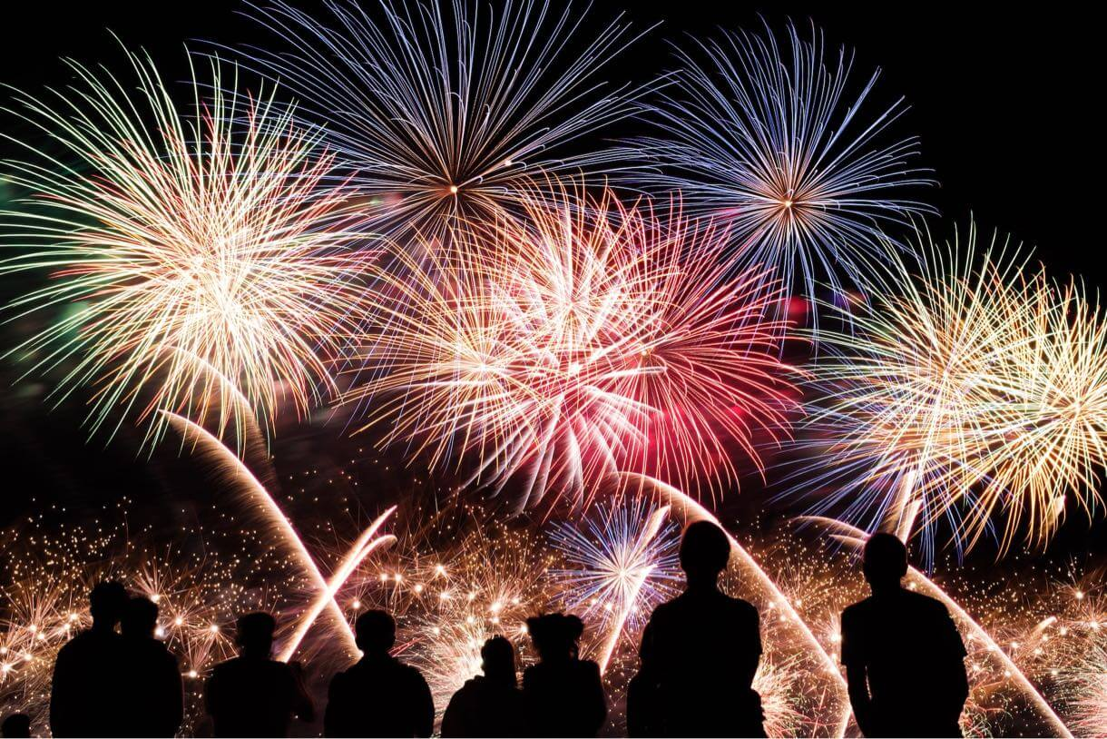
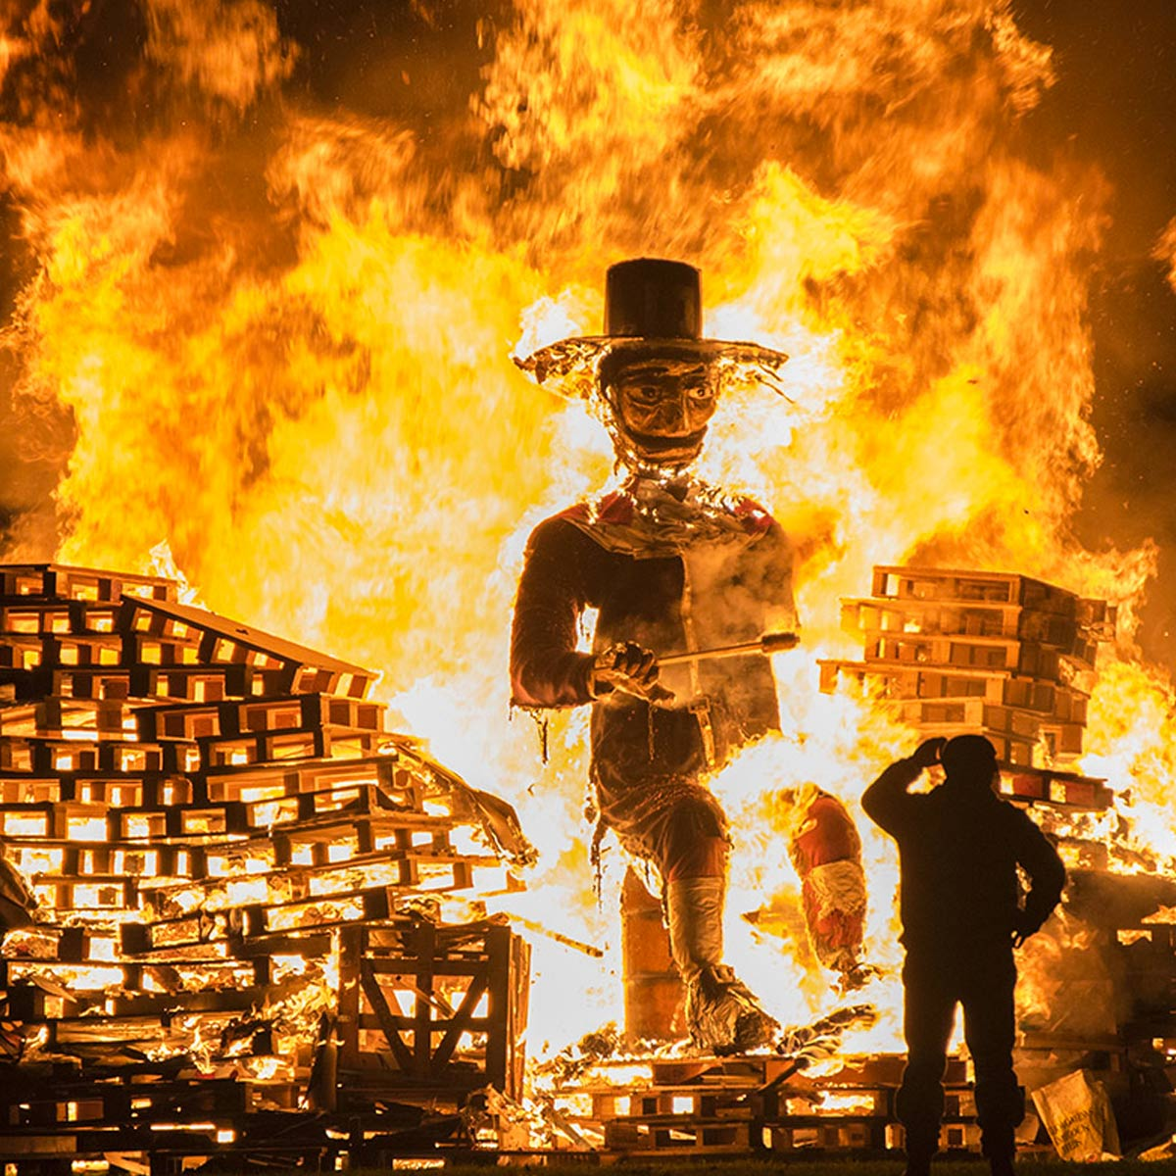

2. Which event features the changing of the guards at Buckingham Palace?
a) Trooping the Colour
Trooping the Colour is an annual ceremony that celebrates the official birthday of the British monarch. During this event, the Queen's Guard participates in a well-choreographed changing of the guard ceremony, which is attended by a large crowd and often includes a parade and military music.
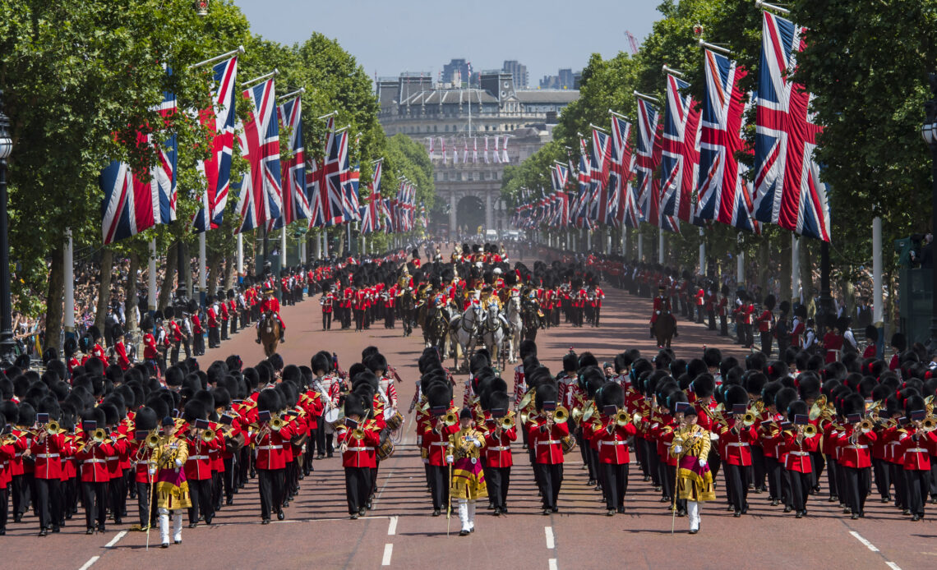
3. What type of food is traditionally served at a British afternoon tea?
b) Scones
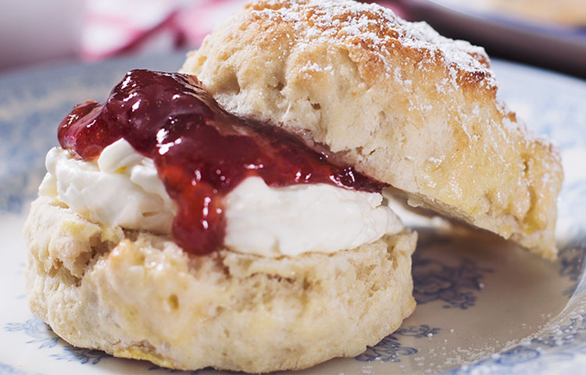
Scones are a quintessential component of British afternoon tea, served with clotted cream and jam. Afternoon tea is a light meal that originated in the early 19th century, featuring a variety of sandwiches, cakes, and pastries, alongside tea.
4. What annual boat race takes place between Oxford and Cambridge?
b) The Oxford-Cambridge Boat Race
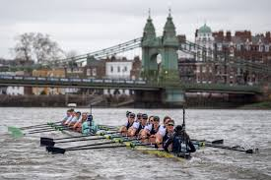
The Oxford-Cambridge Boat Race is a prestigious rowing race that has taken place annually since 1829 on the River Thames. This event showcases the competitive spirit of both universities and attracts thousands of spectators along the riverbanks and millions watching on television.

5. What is the famous British tradition where people wear flowers on their lapels to commemorate fallen soldiers?
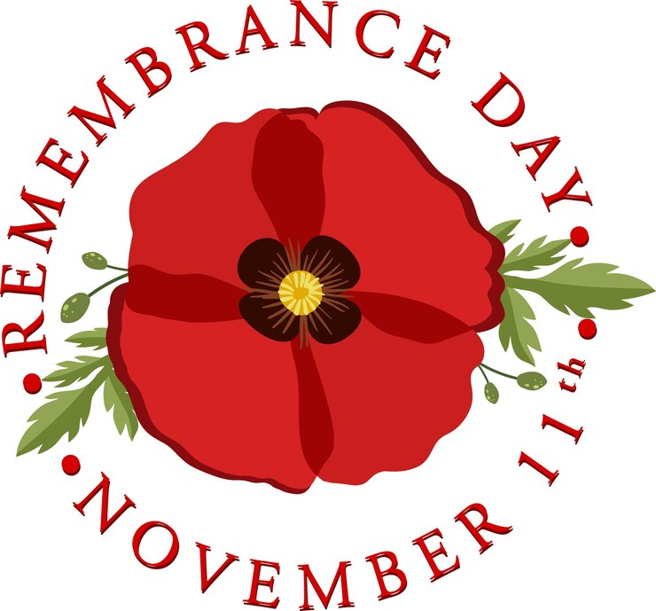
b) Poppy Day
Poppy Day, also known as Remembrance Day, takes place on November 11th each year. People wear poppy flowers to honor the bravery of soldiers who fought and died in World War I and subsequent conflicts, reminding the public of the sacrifices made for peace.
6. Which traditional British dish consists of sausages and mashed potatoes?
b) Bangers and Mash
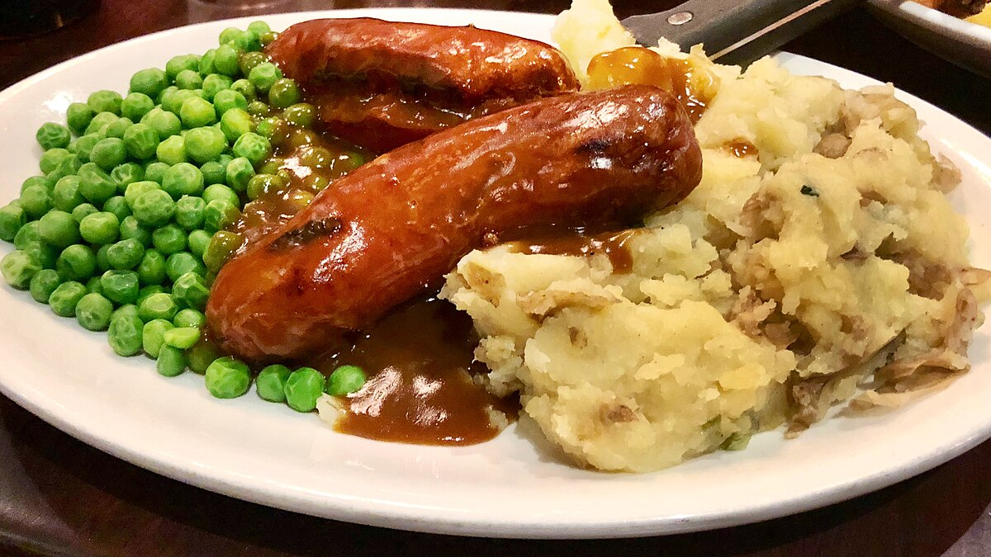
Bangers and Mash is a classic British comfort food dish made of sausages ("bangers") served with mashed potatoes ("mash"). Often accompanied by onion gravy and peas, it is a hearty meal that is popular in pubs and homes across the UK.

7. What is the name of the British ceremony that marks the start of the harvest season?
a) Harvest Festival
The Harvest Festival is a British tradition that celebrates the gathering of the harvest. This event typically takes place in the autumn and involves church services, decorations with harvested crops, and community events to give thanks for the food produced.
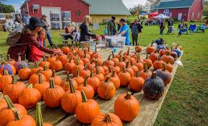

8. During which celebration do people traditionally dress in costumes and go door to door for treats?
b) Halloween
Halloween is celebrated on October 31st and involves children dressing in costumes and going door to door to collect sweets, a practice known as "trick-or-treating." The holiday has roots in ancient Celtic traditions and has become a fun and festive occasion in the UK.
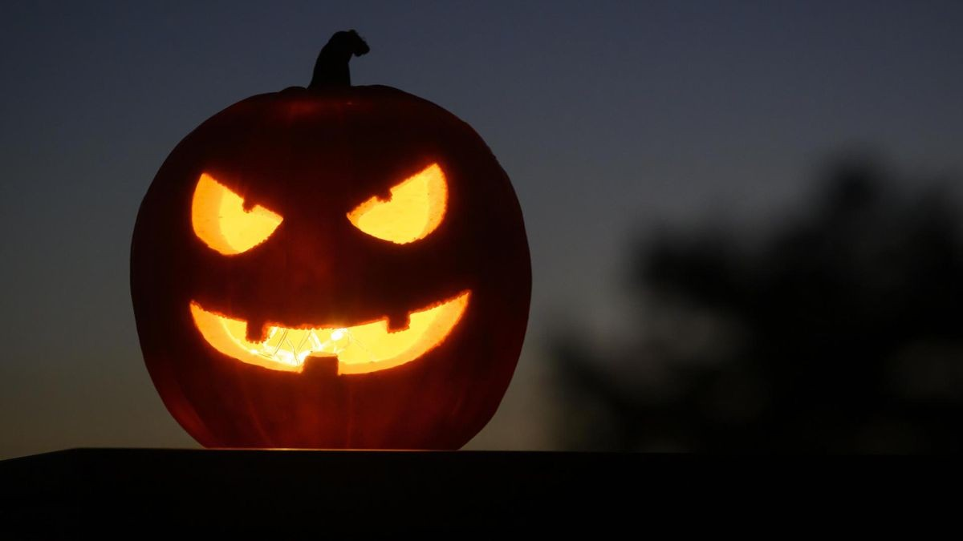

9. What is the name of the traditional British folk dance that involves group movements in a circular formation?
b) Morris Dancing
Morris Dancing is a form of English folk dance characterized by rhythmic stepping and the use of props such as sticks, swords, and handkerchiefs. Typically performed in a group, this energetic dance is often associated with seasonal celebrations and village festivals.
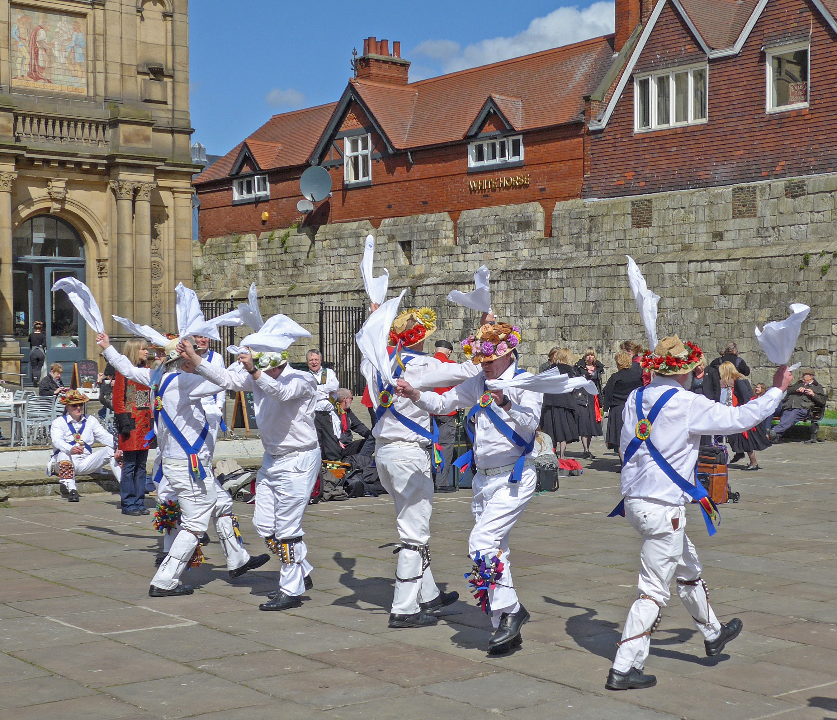

10. Which celebration features parades, music, and fireworks to honor the queen’s birthday?
Answer: b) Trooping the Colour
Trooping the Colour is a grand event held each June, celebrating the official birthday of the British monarch. The ceremony features a lavish parade with soldiers from the British Army, and it ends with an impressive display of fireworks, making it a highlight of the royal calendar.

National holidays

1. Which of these is a national holiday in the UK?
b) St. George's Day
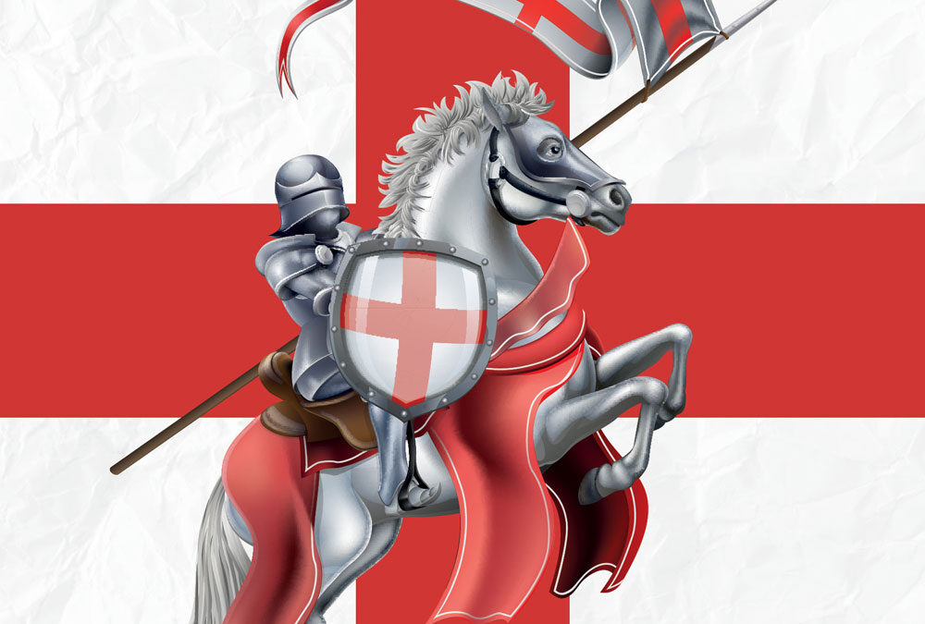
St. George's Day is celebrated on April 23rd and is recognized as England's national day. While it is not a public holiday, it is important for many English people as they commemorate their patron saint.

2. When is Christmas Day celebrated?
a) 25th December
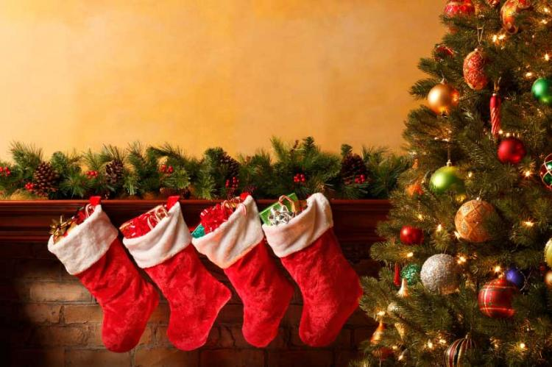
Christmas Day is celebrated on December 25th each year. It is a significant holiday in the UK, marked by festive traditions, family gatherings, and the exchange of gifts.

3. What do many people do on New Year's Day?
b)New Year's Day
On New Year's Day, many people celebrate with fireworks as a way to ring in the new year. Celebrations often include parties and community events, creating a joyful atmosphere.
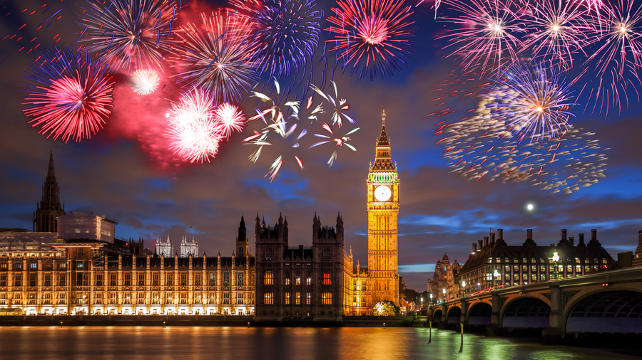

4. Good Friday is a holiday that celebrates:
c)Jesus's crucifixion
Good Friday commemorates Jesus's crucifixion, which is a central event in Christian belief. It is observed during Holy Week, leading up to Easter Sunday, and is a day of reflection and mourning.

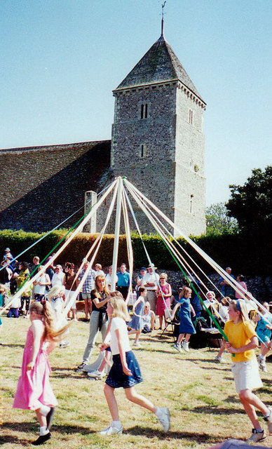
5. Which holiday often involves dressing up in costumes?
a)May Day
May Day, celebrated on May 1st, often involves dressing up in costumes, particularly in traditions like dancing around the maypole. The holiday marks the arrival of spring and is associated with various festivities.

6. What is a traditional food eaten at Easter?
c)Hot Cross Buns
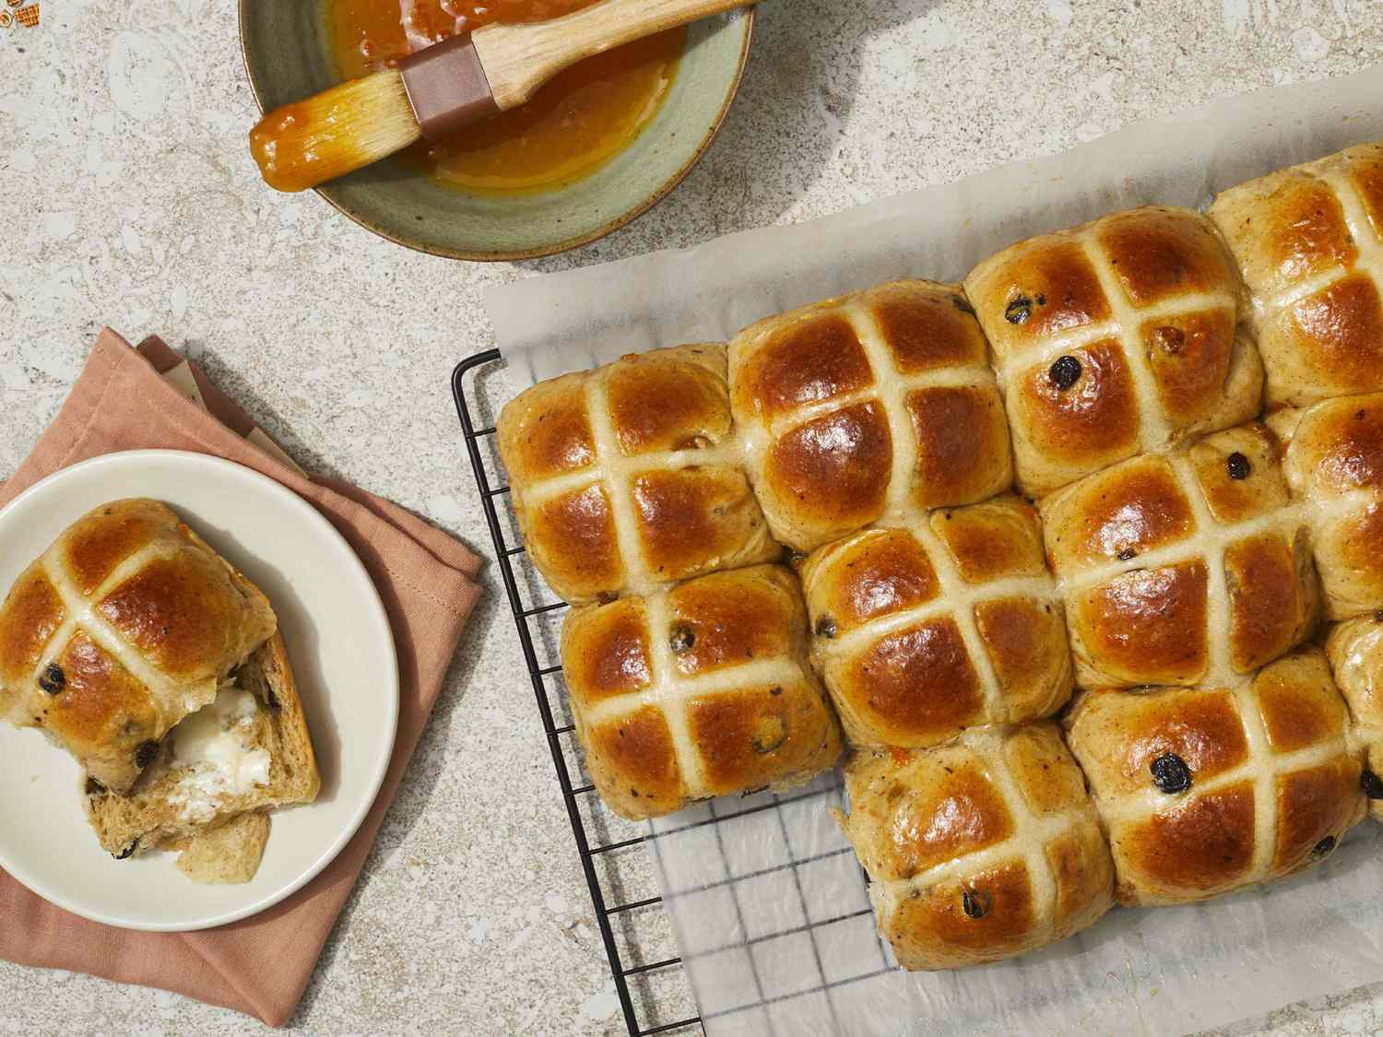
Hot Cross Buns are a traditional food eaten at Easter. These spiced sweet buns, marked with a cross, symbolize the crucifixion and are often enjoyed during the Easter season.

7. What is special about the Spring Bank Holiday?
b)The Spring Bank Holiday
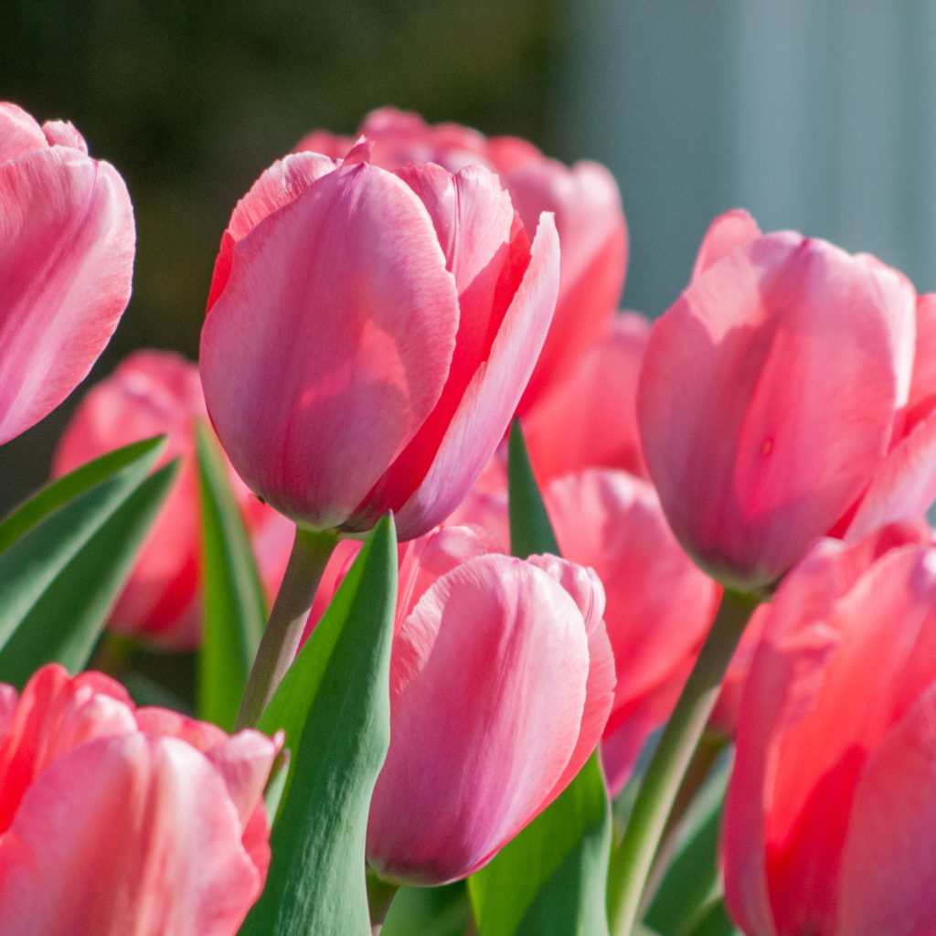
The Spring Bank Holiday is typically observed in late May and is known for its association with springtime celebrations. While it does not always fall in June, it occasionally aligns with events celebrating the Queen's official birthday.
8. Which holiday is closest to Halloween?
c) Christmas
Christmas is the holiday closest to Halloween in the calendar year. Halloween is celebrated on October 31st, while Christmas follows on December 25th, with various festivities between the two holidays.

выв
9. What do people often do on a bank holiday?
b) Have a day off
On a bank holiday, people generally have a day off from work. This allows individuals to relax, enjoy recreational activities, or spend time with family and friends.
10. Which of these is NOT a UK bank holiday?
a)St. Patrick's Day
St. Patrick's Day, celebrated on March 17th, is not a UK bank holiday. It is recognized in Ireland and among the Irish diaspora, but it is not officially observed as a public holiday in England, Scotland, or Wales.

National clothes

1. What is a traditional Scottish garment that is often worn on formal occasions?
a) A kilt
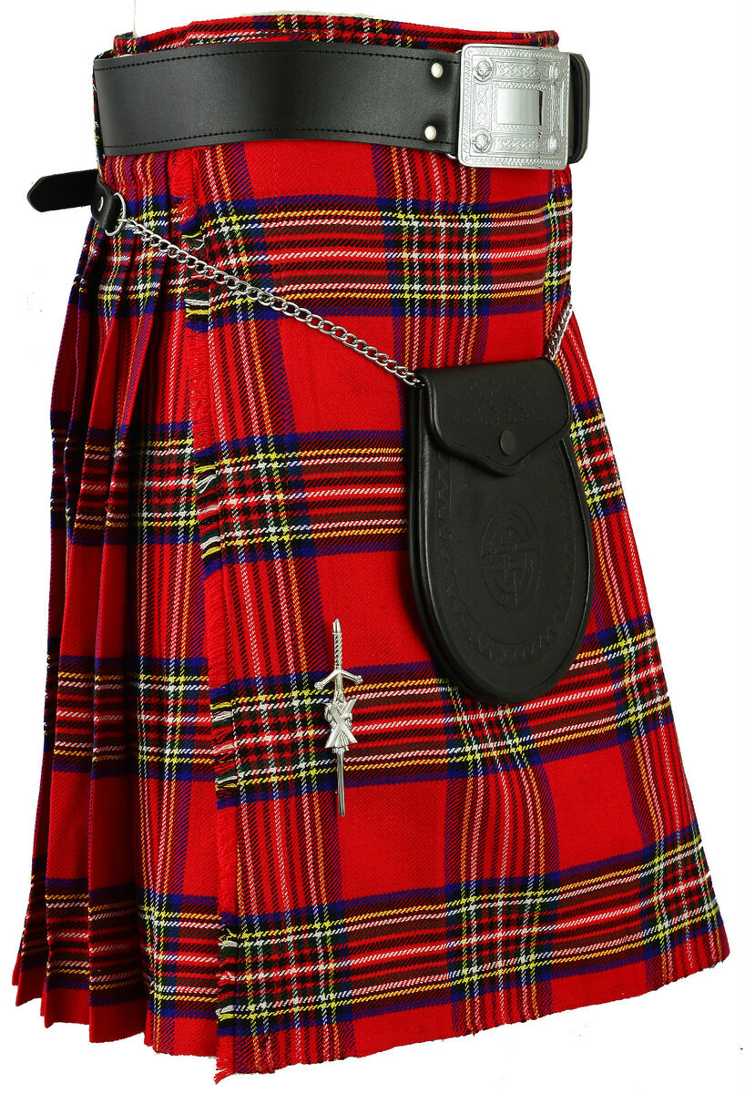
The kilt is a knee-length skirt-like garment that is a key part of traditional Scottish dress. Made of tartan fabric, it is typically worn during formal events such as weddings and ceilidhs, celebrating Scottish heritage.

2. Which headwear is commonly associated with British aristocracy and formal events?
b) A top hat
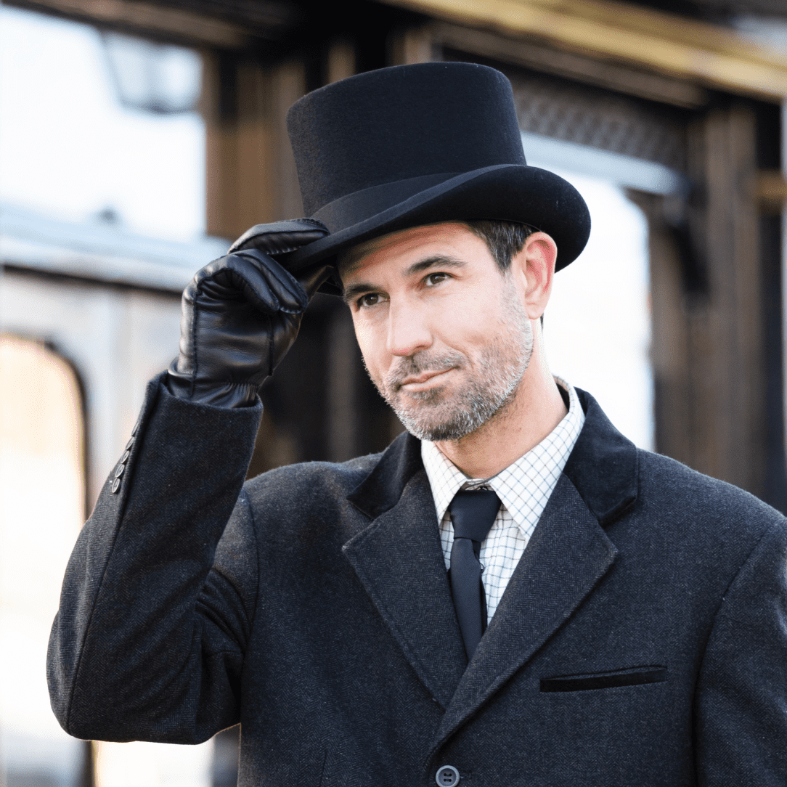
The top hat is a cylindrical hat that has been a symbol of high society and formal attire in Britain for centuries. Often worn at events like weddings and horse races, it represents elegance and status.
3. What type of footwear is often worn with traditional English country attire?
b) Wellington boots
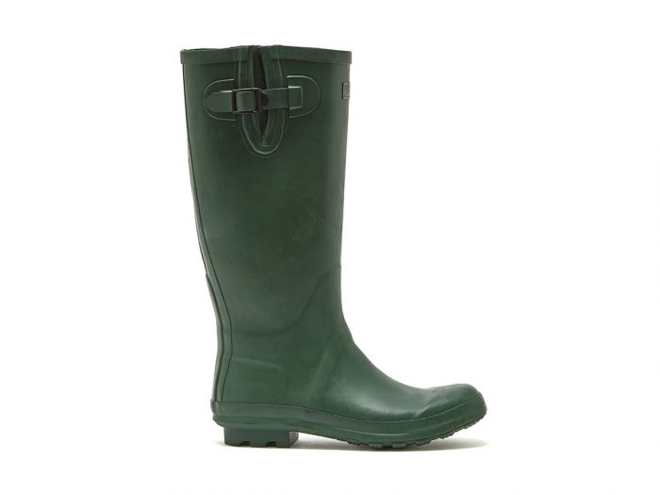
Wellington boots, also known as "Wellies," are waterproof rubber boots commonly seen in traditional English country attire. They are practical for outdoor activities, especially in wet or muddy conditions.

4. What is a popular textile pattern often seen on Scottish tartans?
c) Plaid
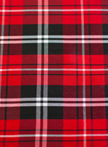
Plaid is a design consisting of crisscrossed horizontal and vertical bands in two or more colors. This pattern is central to Scottish tartans and represents various clans and regions in Scotland.
5. Which clothing item is commonly associated with the British school uniform?
b) Blazer and tie
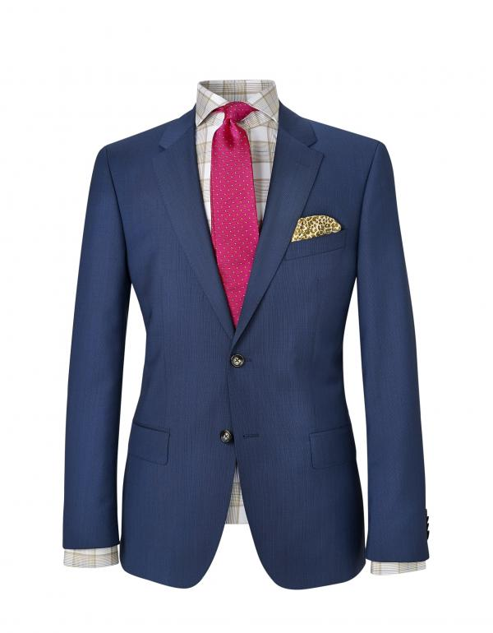
The blazer and tie combination is a traditional part of many British school uniforms. It conveys a sense of discipline and identity among students, often accompanied by other elements like trousers or skirts.
6. What is a traditional Irish garment worn by men during special occasions?
a) A waistcoat
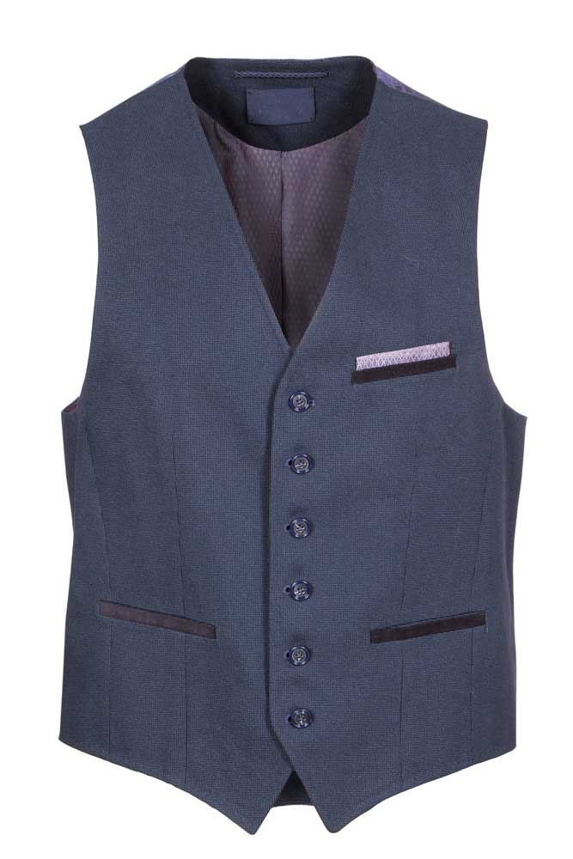
The waistcoat is a sleeveless garment worn over a shirt and under a jacket, often associated with formal or traditional Irish attire. It adds elegance and is often made from rich fabrics for special events.
7. What is the traditional dress for women in Wales called?
b) A traditional Welsh dress
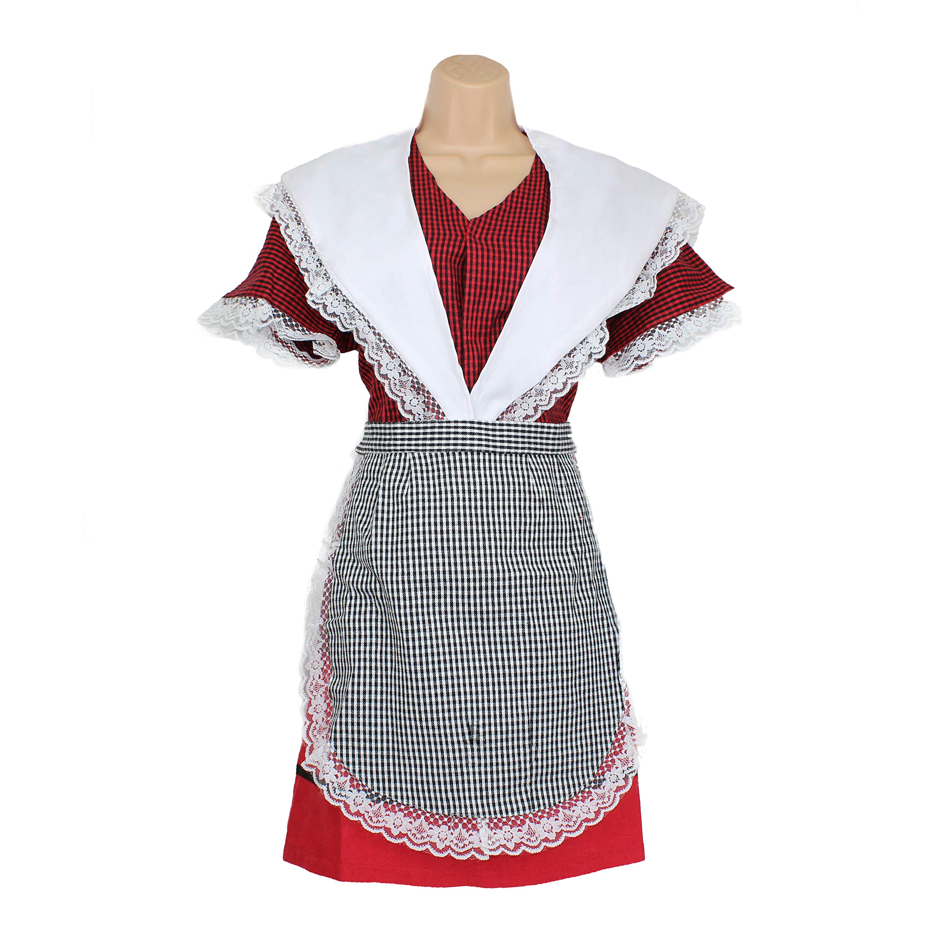
The traditional Welsh dress typically includes a long skirt, white blouse, and a “straw bonnet.” This attire is a symbol of Welsh identity and is often worn during national celebrations and cultural events.
8. What iconic British garment is often made of tweed?
b) A suit jacket
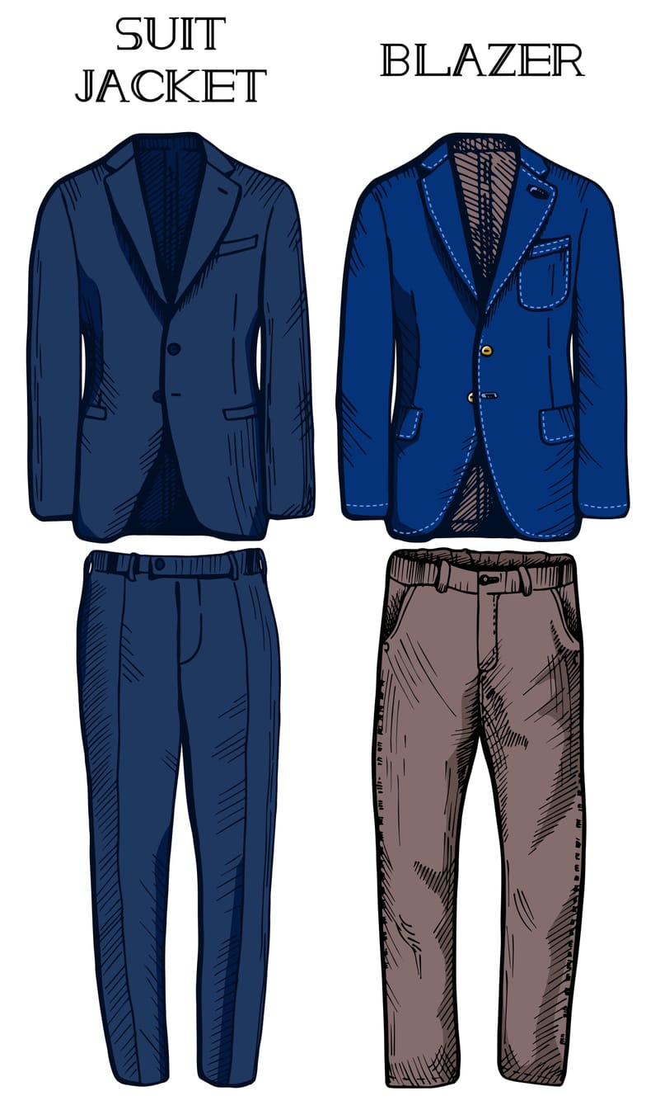
A suit jacket made of tweed is a classic British garment known for its warmth and durability. Tweed is a woolen fabric that is associated with country living and is often seen in smart casual wear.

See the Differences

9. What type of jacket is often worn with traditional hunting attire in the UK?
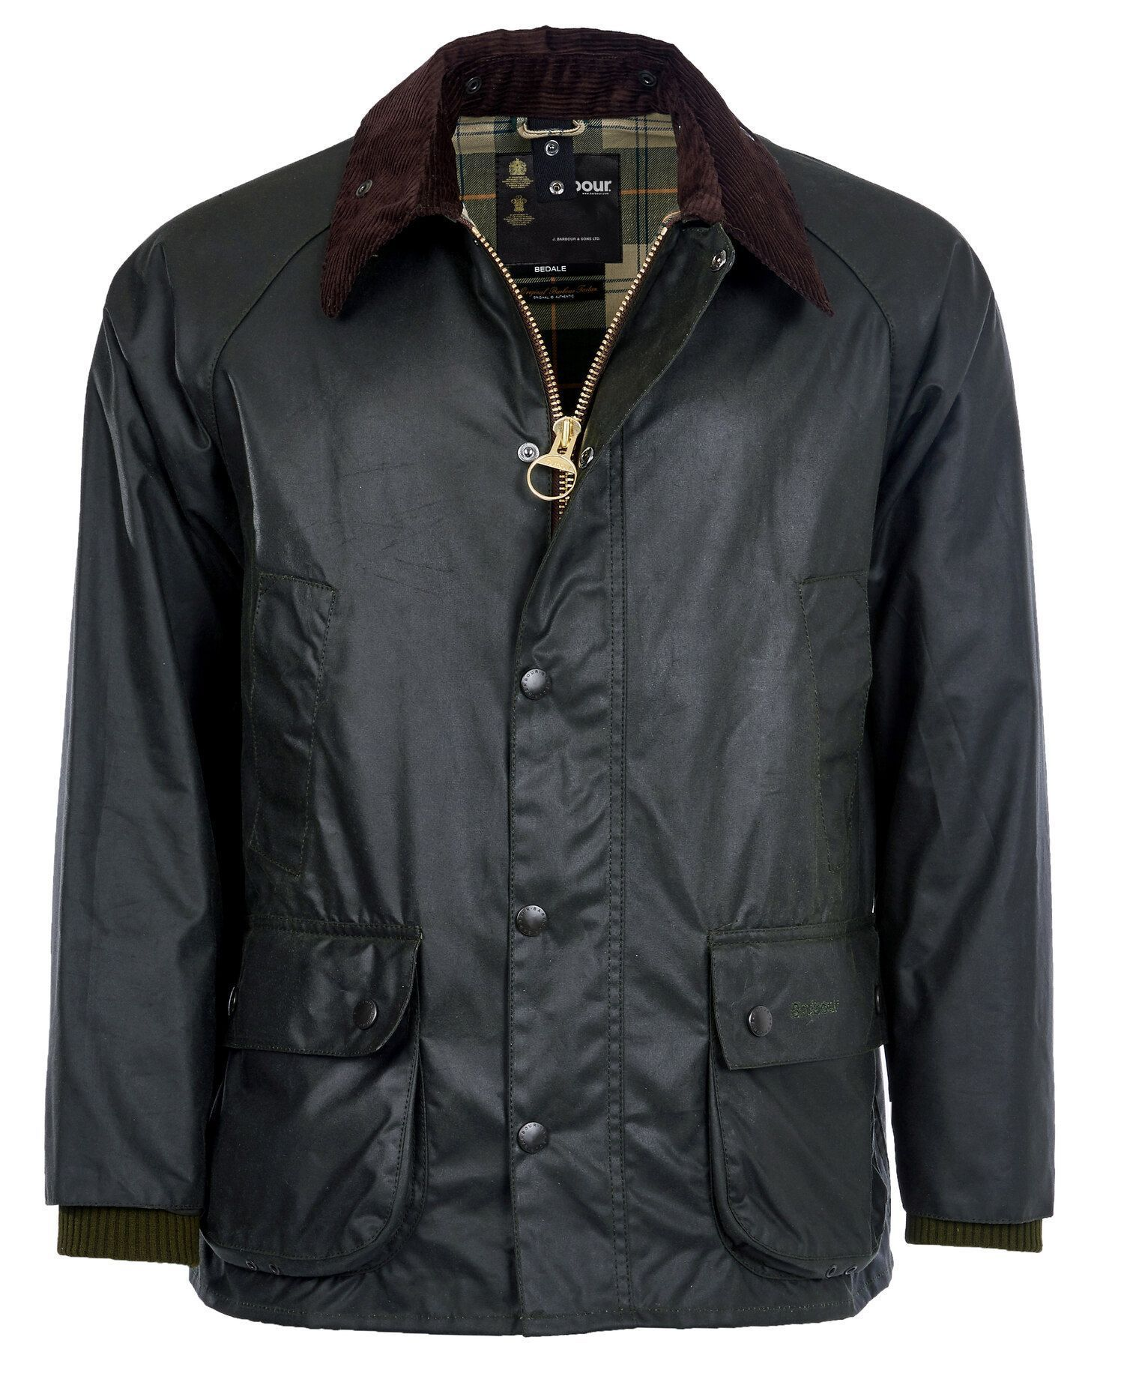
b) A Barbour jacket
The Barbour jacket is a type of waterproof and windproof jacket that has gained popularity among outdoor enthusiasts, especially hunters.
Its practical design and durability are ideal for country pursuits.

10. What accessory is traditionally worn by women in Scotland as part of their national dress?
b) A tam o'shanter
A tam o'shanter is a traditional Scottish hat made of wool, typically adorned with a pom-pom on top. Worn by women as part of their national dress, it is often associated with festive occasions and kilts.

There is also a plaid print here!

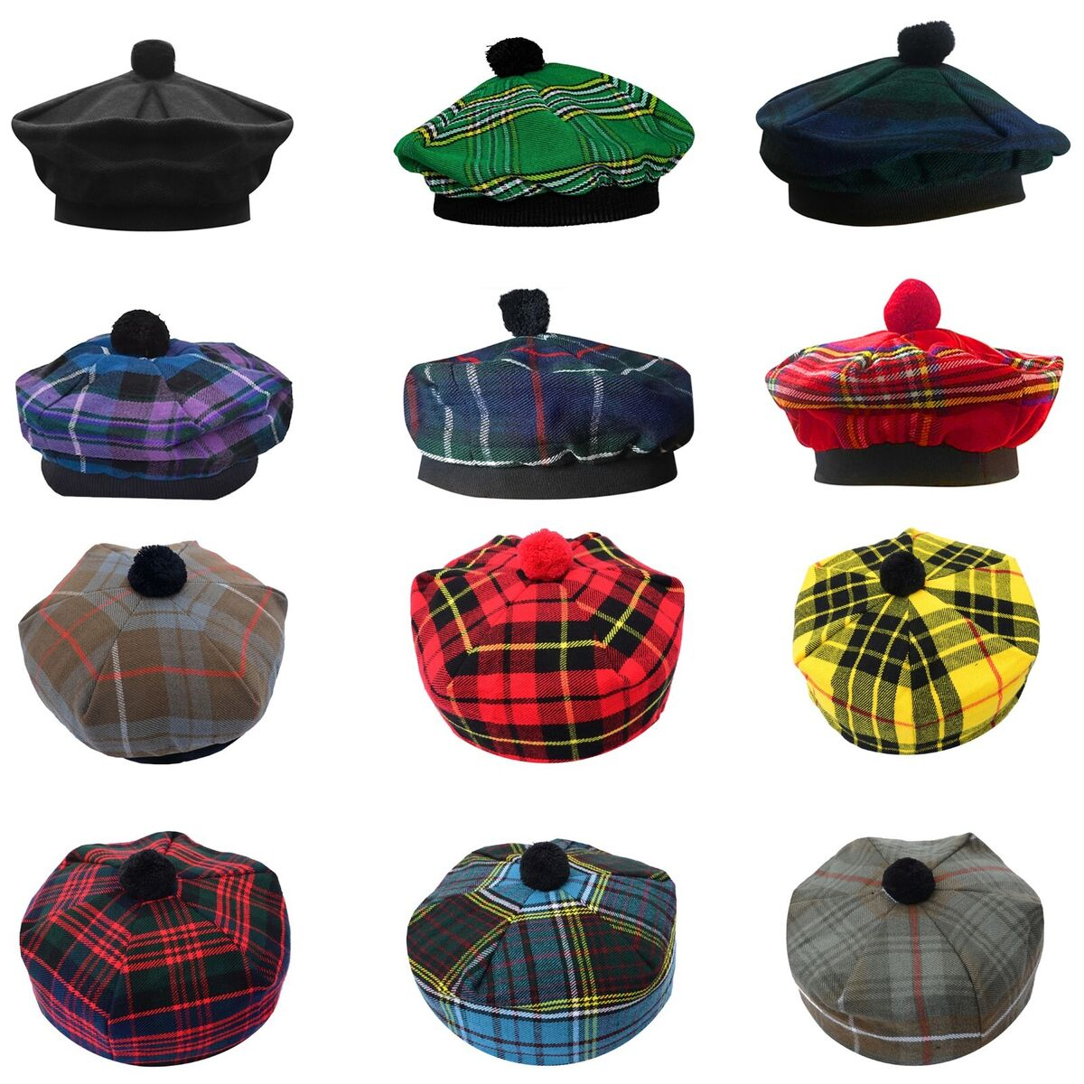

Etiquette features

1. What is a common way to show respect when meeting someone new in the UK?
b) Shake hands and make eye contact.
In the UK, it is customary to greet someone new with a handshake accompanied by direct eye contact. This gesture demonstrates respect and attentiveness, making the introduction feel polite and friendly. On the other hand, giving a thumbs up or avoiding eye contact could be seen as unprofessional or disinterested.

✔

2. How should you handle an invitation to a formal event?
b) RSVP politely, either accepting or declining.
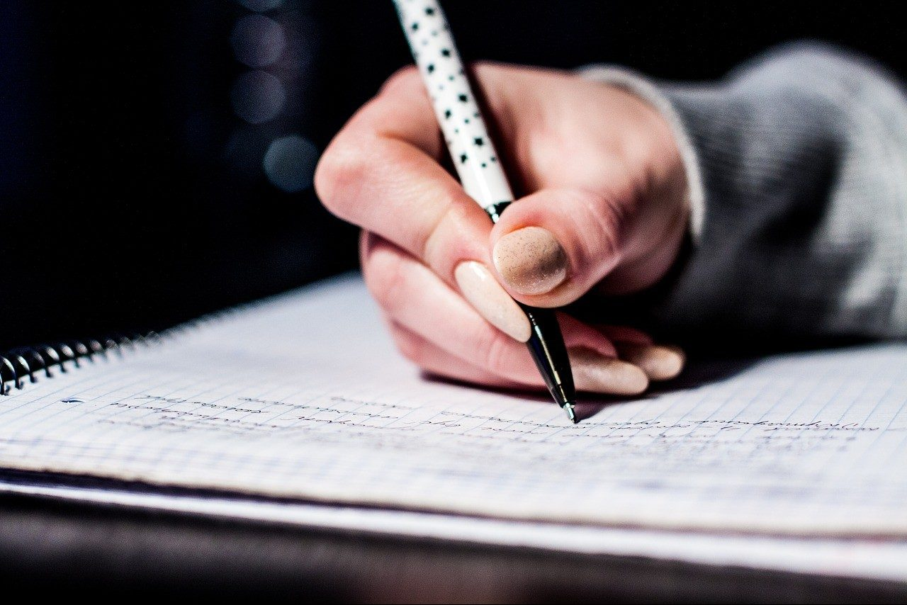
When you receive an invitation to a formal event, the appropriate action is to respond politely to RSVP, indicating whether you will attend or not. This shows respect for the host’s efforts and helps them with their planning. Ignoring the invitation or showing up uninvited would be considered rude.
3. In the UK, what should you do if you need to clear your throat during a meeting?
c) Politely apologize and cover your mouth when coughing.
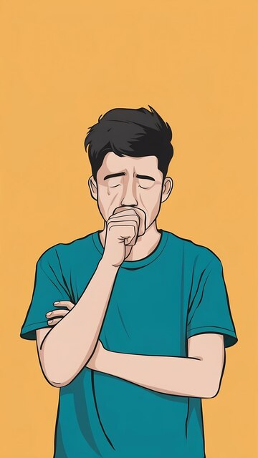
If you feel the need to clear your throat during a meeting, the polite response is to quietly apologize to those around you and cover your mouth while doing so. This is seen as maintaining decorum and respect for the ongoing discussion. Coughing loudly without covering your mouth would be considered disruptive.

4. What is the correct way to address someone you don’t know in conversation?
b) Use "sir" or "madam."
When speaking to someone you do not know, addressing them as "sir" or "madam" is considered polite and respectful. This formal approach establishes boundaries and shows that you acknowledge their status. Calling someone by their first name or using a made-up title can seem presumptuous or overly familiar.
- Madam, did you drop your gloves
- Oh, yes, thank you!

5. If you are late to an appointment, what is the best etiquette to follow?
b) Apologize sincerely upon arrival.
If you arrive late to an appointment, the best course of action is to sincerely apologize immediately. This demonstrates accountability and respect for the other person's time. Arriving without acknowledging your lateness or trying to blame traffic when that’s not the case would be viewed as inconsiderate.
6. How should you behave when someone is speaking at a public event?
b) Listen quietly and pay attention.
At a public event, it is essential to listen quietly and pay attention to the speaker. This reflects your respect for them and the importance of their message. Chatting loudly or walking around can distract not only the speaker but also the audience, leading to a negative experience for everyone involved.
7. When entering a shop, what is the polite gesture to show?
b) Say "hello" or nod to the staff.
Upon entering a shop, it is polite to acknowledge the staff by saying "hello" or nodding. This small gesture establishes a friendly and respectful atmosphere, signaling that you appreciate their presence and assistance. Yelling demands or ignoring the staff altogether can create an unpleasant shopping experience.
8. How should you express disagreement in a discussion?
b) Agree to disagree respectfully.
When disagreeing in a discussion, it’s best to express your views while agreeing to disagree respectfully. This approach helps maintain a cordial atmosphere and acknowledges the validity of differing opinions. Shouting your opinion or completely dismissing the other person's views can lead to unnecessary conflict.
I agree with. I think we should...
9. What should you do if someone accidentally bumps into you?
b) Calmly say, "That's alright."
If someone accidentally bumps into you, the appropriate response is to calmly say, "That's alright." This reaction demonstrates understanding and helps ease any embarrassment the other person may feel. Getting angry or ignoring the situation could create a more uncomfortable atmosphere.
10. When drinking tea in the UK, what is an accepted etiquette tip?
c) Sip quietly without slurping.
When enjoying tea in the UK, it is considered good etiquette to sip quietly without slurping. This conveys respect for those around you and maintains a civilized atmosphere.Stirring loudly or raising your pinky finger while holding the cup may be viewed as improper or theatrical.

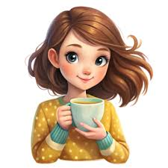

National Food

1. Which of these is a traditional British dish made with beef, onions, and potatoes?
a) Shepherd's pie
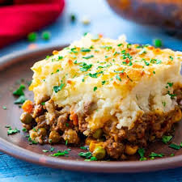
Shepherd's pie is a comforting and hearty dish consisting of minced meat (typically lamb or beef) topped with a layer of mashed potatoes. It's a classic example of British comfort food.

2. What is the name of the popular British dessert made with layers of pastry, jam, and custard?
b) Eton mess
Eton mess is a delightful dessert, typically made with meringue, strawberries, and whipped cream. Its light and airy texture makes it a popular choice, especially during summer.
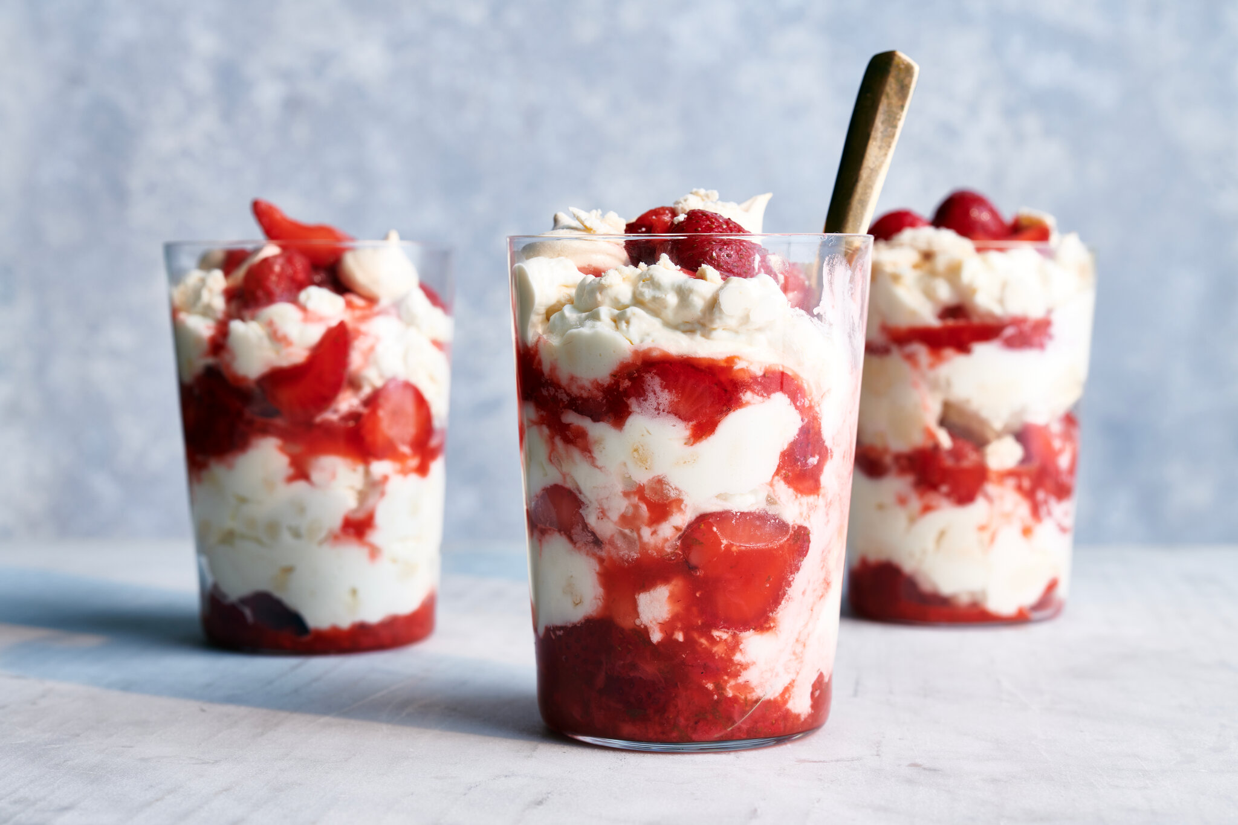

3. What is the name of the savory pastry filled with meat and gravy?
a) Cornish pasty
The Cornish pasty is a savory hand-held pastry filled with meat and vegetables (often beef, potato, swede, and onion). It originated in Cornwall, a county in southwest England, and is a traditional workingman's lunch.
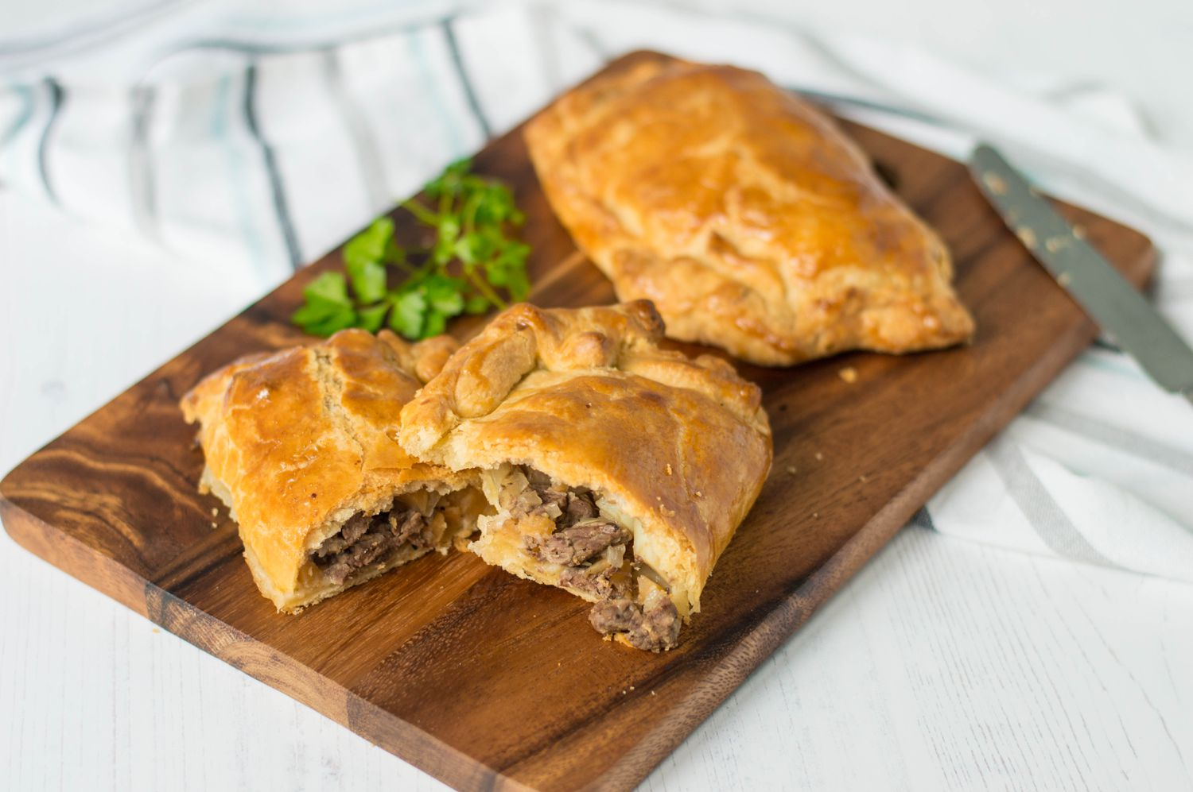
4. Which of these is a traditional British breakfast dish?
a) Full English breakfast
The Full English breakfast is a hearty and substantial meal typically consisting of bacon, sausages, eggs, baked beans, grilled tomatoes, mushrooms, toast, and often black pudding. It's a popular weekend treat.

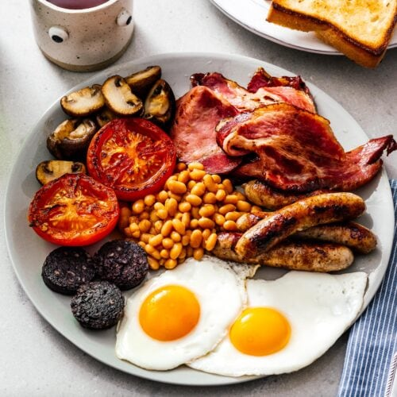

5. Which of these is a popular British cheese?
a) Cheddar
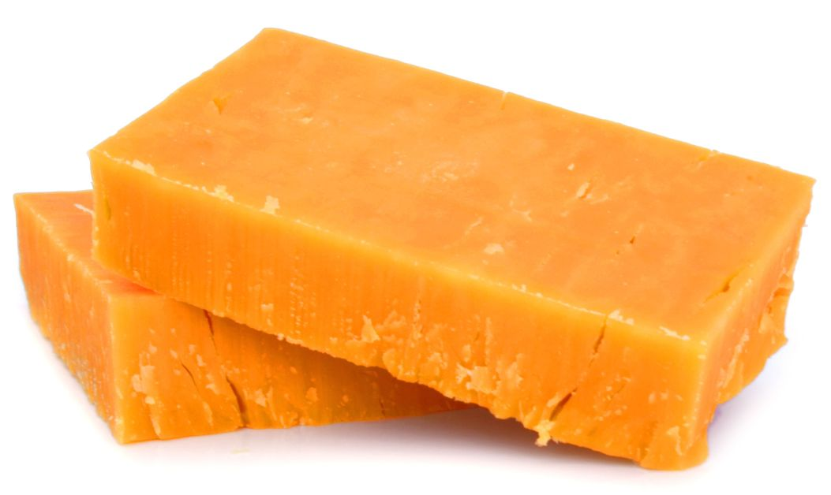
Cheddar cheese is one of the most popular and widely known British cheeses. It comes in various ages and has a distinctive sharp and sometimes nutty flavour.
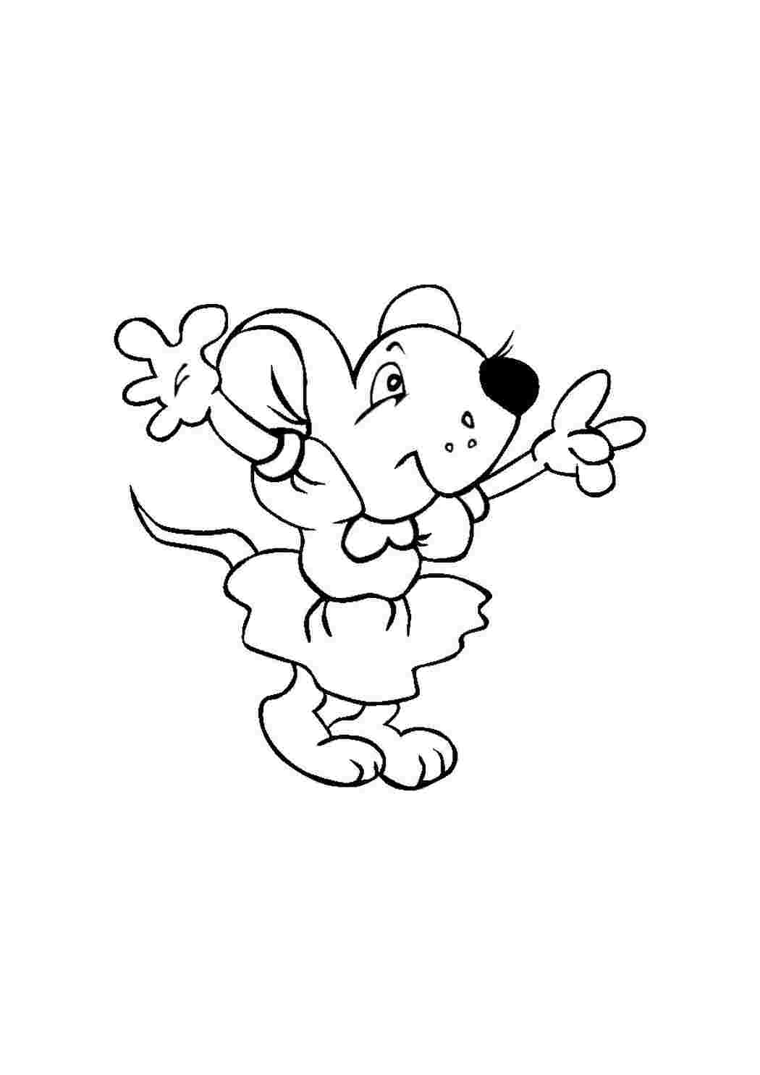
6. What is the name of the traditional British cake served at afternoon tea?
a) Victoria sponge cake
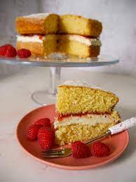
The Victoria sponge cake is a classic British sponge cake, usually layered with jam and buttercream, and is a staple of afternoon tea. It's named after Queen Victoria.

7. Which of the following is a traditional British dish, often featuring a variety of vegetables, meat, and gravy, and typically eaten on a Sunday?
c) Sunday Roast
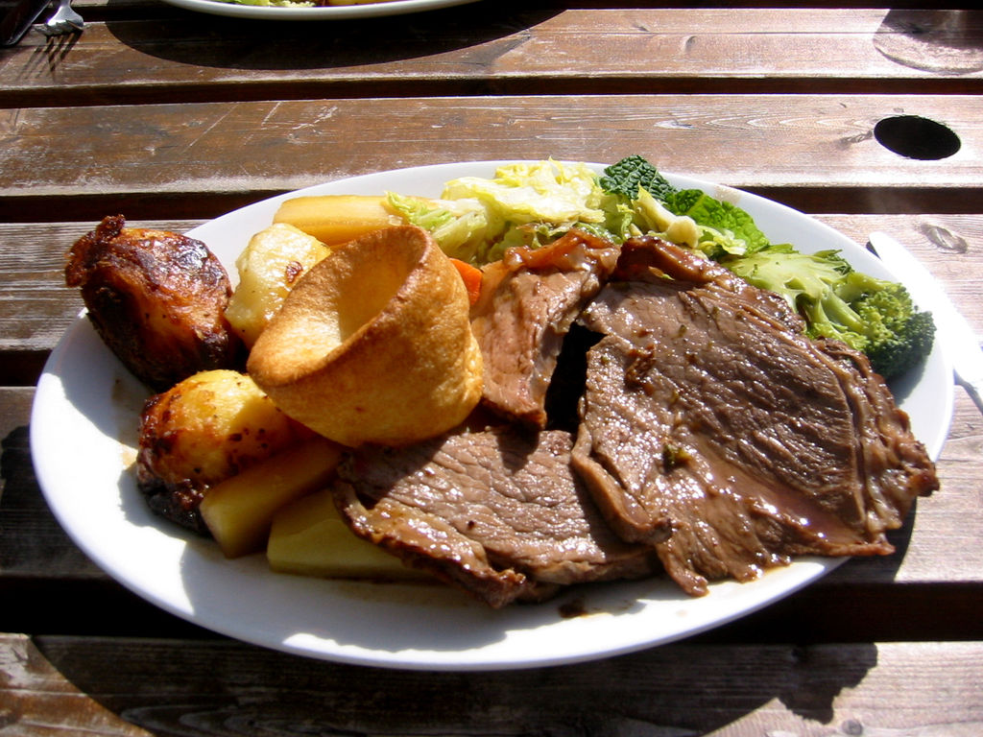
A Sunday roast is a traditional British meal, often enjoyed on a Sunday. It typically includes a roasted meat (like beef, lamb, or chicken), a range of seasonal vegetables (like carrots, potatoes, and parsnips), and gravy.
8. Which of these is a traditional British soup made with lentils, vegetables, and stock?
b) Lentil soup
Lentil soup is a hearty and nutritious soup, traditionally made with lentils, vegetables, and stock. It's a warming and flavorful option, often served during colder months.
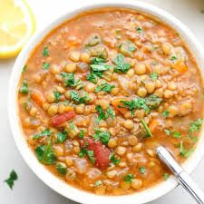

9. What is the name of the sweet, creamy pudding made with milk, sugar, and eggs?
b) Custard
Custard is a creamy dessert made with milk, eggs, and sugar, often flavored with vanilla. It's a versatile base for many other desserts and can be served hot or cold.

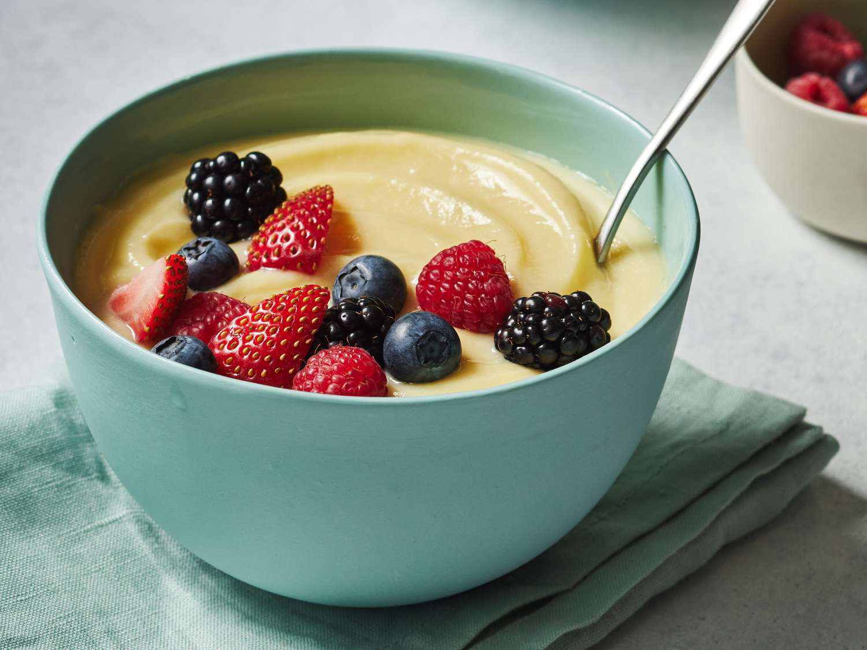

10. Which of these is a traditional British snack?
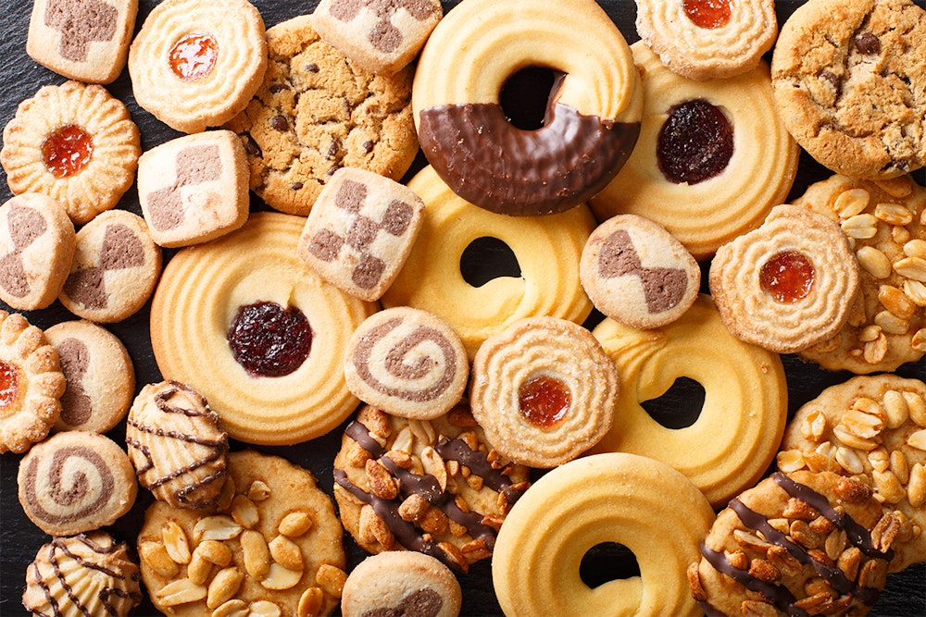
a) Biscuits
In British English, "biscuits" refer to what Americans would call "cookies" or "crackers". They come in a vast array of flavors and are a common snack enjoyed with tea or coffee.

- Yammy!
- Tasty!
- Delicious!

Many variants of Biscuits

National Sport

1. Which sport is considered the national sport of England?
a) Cricket
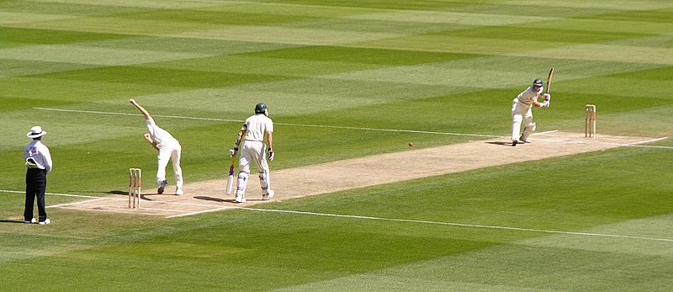
While football (soccer) is arguably the most popular sport in England, cricket holds the title of the national sport. It has a long and storied history in the country, and cricket matches are significant cultural events.

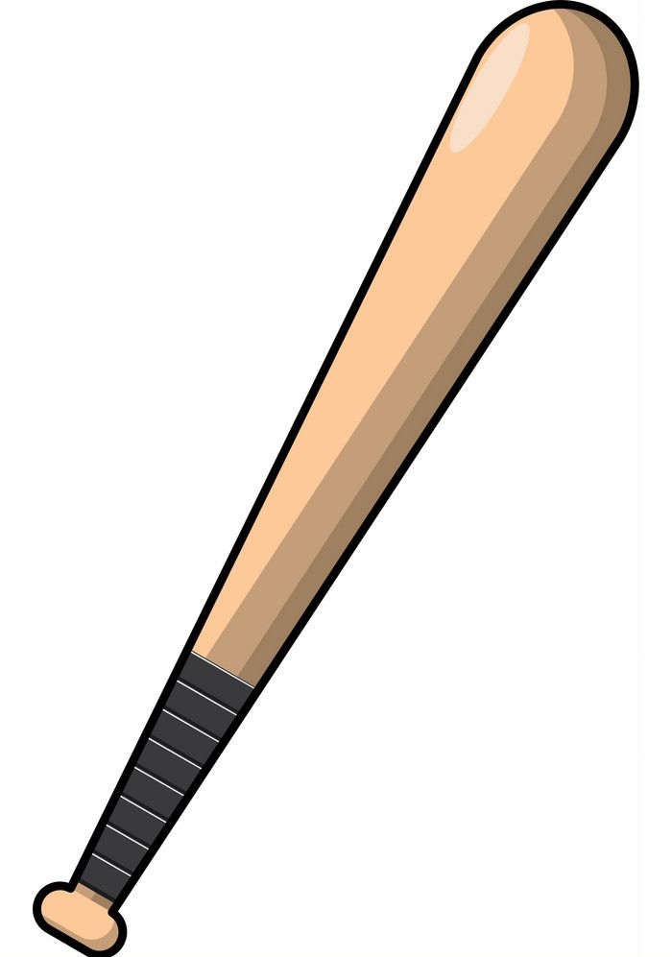

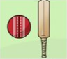
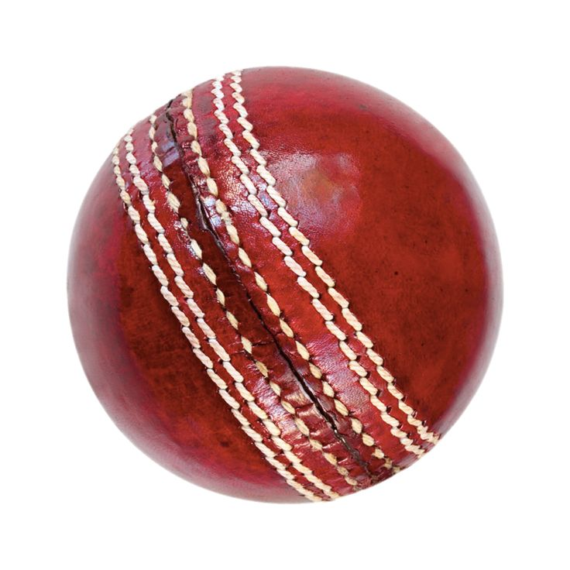

2. What is the name of the famous football (soccer) team from Manchester?
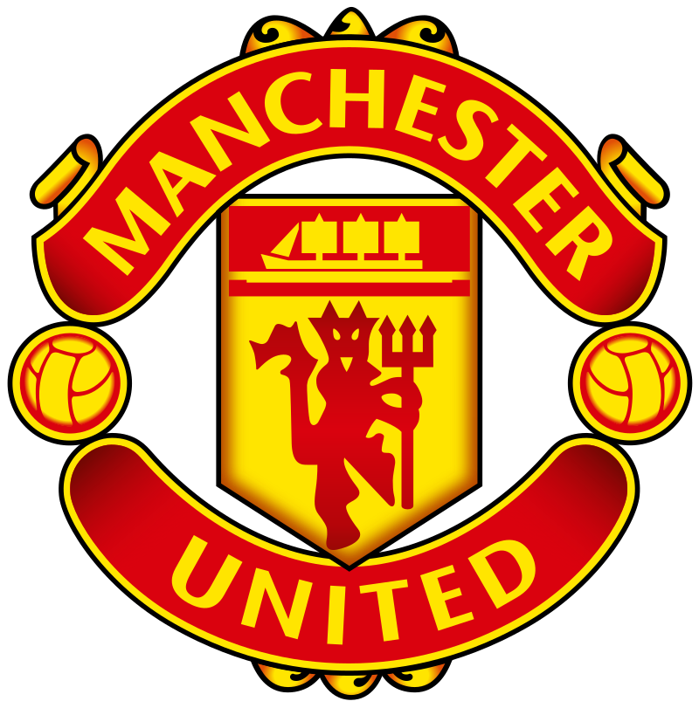
b) Manchester United
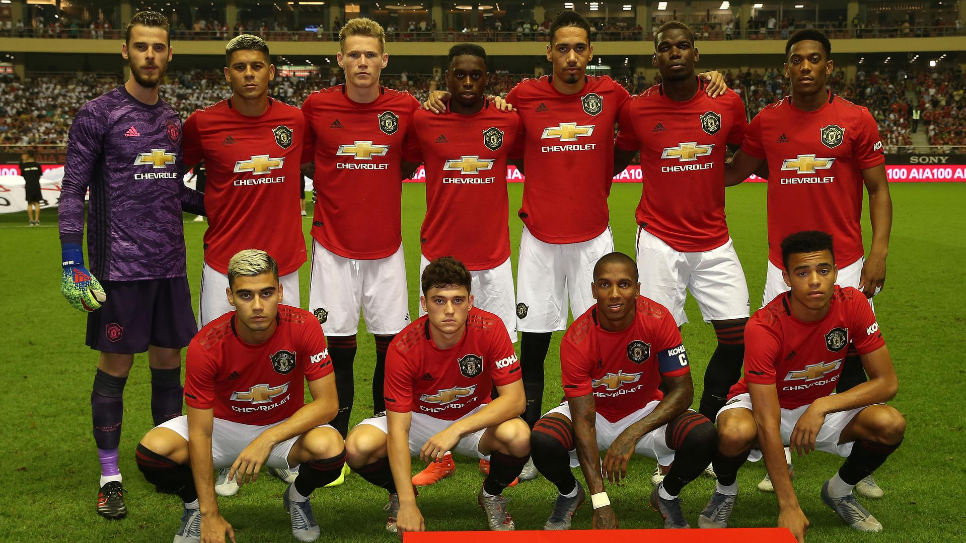
Manchester United is one of the most famous and successful football (soccer) clubs in the national titles.

The Team in 2019\2020

3. What is the name of the famous football (soccer) team from Manchester?
a) Lord's Cricket Ground
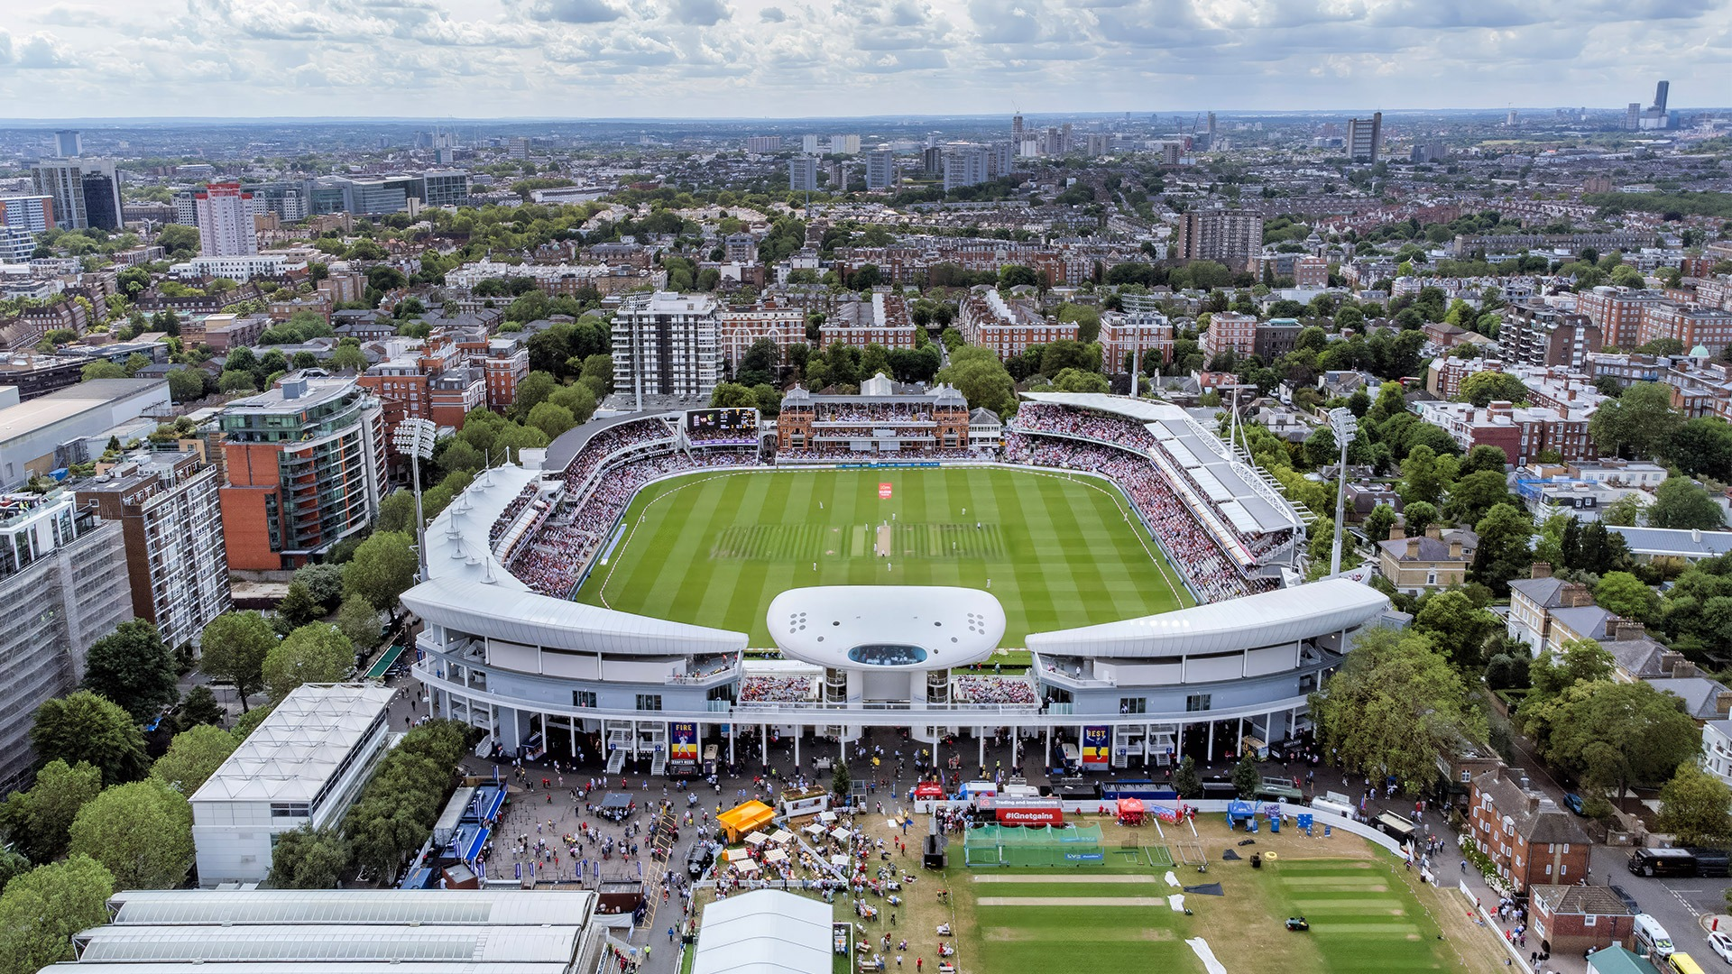
Lord's Cricket Ground, located in London, is considered the "Home of Cricket" and is one of the most famous cricket grounds globally. It's known for its prestigious history and is the headquarters of the Marylebone Cricket Club (MCC).

4. Which sport is played with a bat and ball, and is often played in the summer?
a) Cricket
Cricket is a bat-and-ball sport played between two teams of eleven players each. It is known for its long matches, strategic play, and is particularly popular during the summer months in the UK.

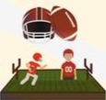
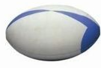
5. Which sport is known for its "try" and "conversion"?
a) Rugby
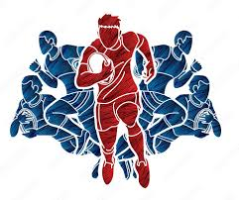
In rugby, a "try" is scored by grounding the ball in the opponent's end zone, and a "conversion" is a kick at goal following a try. This scoring system is unique to rugby union and rugby league.

6. What is the name of the famous tennis tournament held at Wimbledon?
b) Wimbledon Championships
The Wimbledon Championships, held annually in London, is one of the four Grand Slam tennis tournaments and is renowned for its prestigious history, tradition, and grass courts.
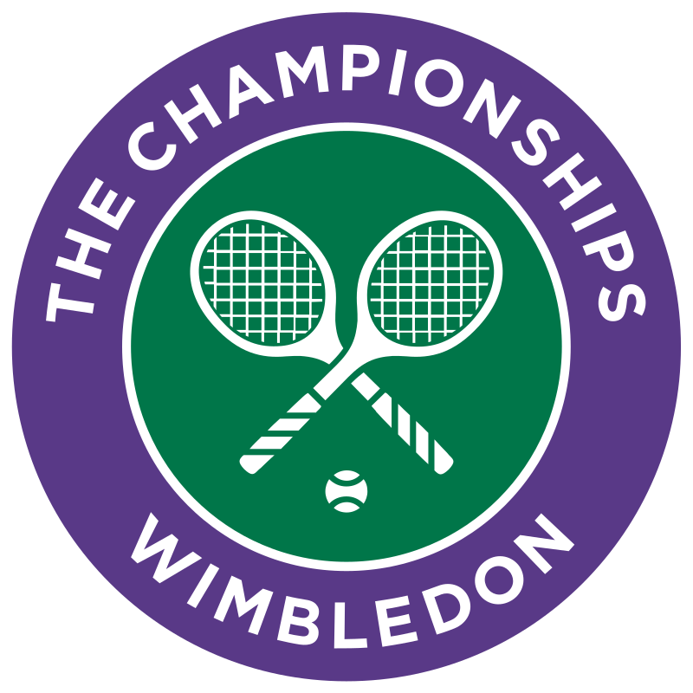
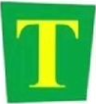

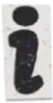



7. Which sport is played with a rectangular ball and involves kicking and passing?
c) Football (Soccer)


Football, or soccer, is played with a spherical ball and involves two teams trying to score by kicking the ball into the opponent's goal. It is the world's most popular sport and incredibly popular in the UK.

8. What is the name of the famous rugby stadium in London?
b) Twickenham Stadium
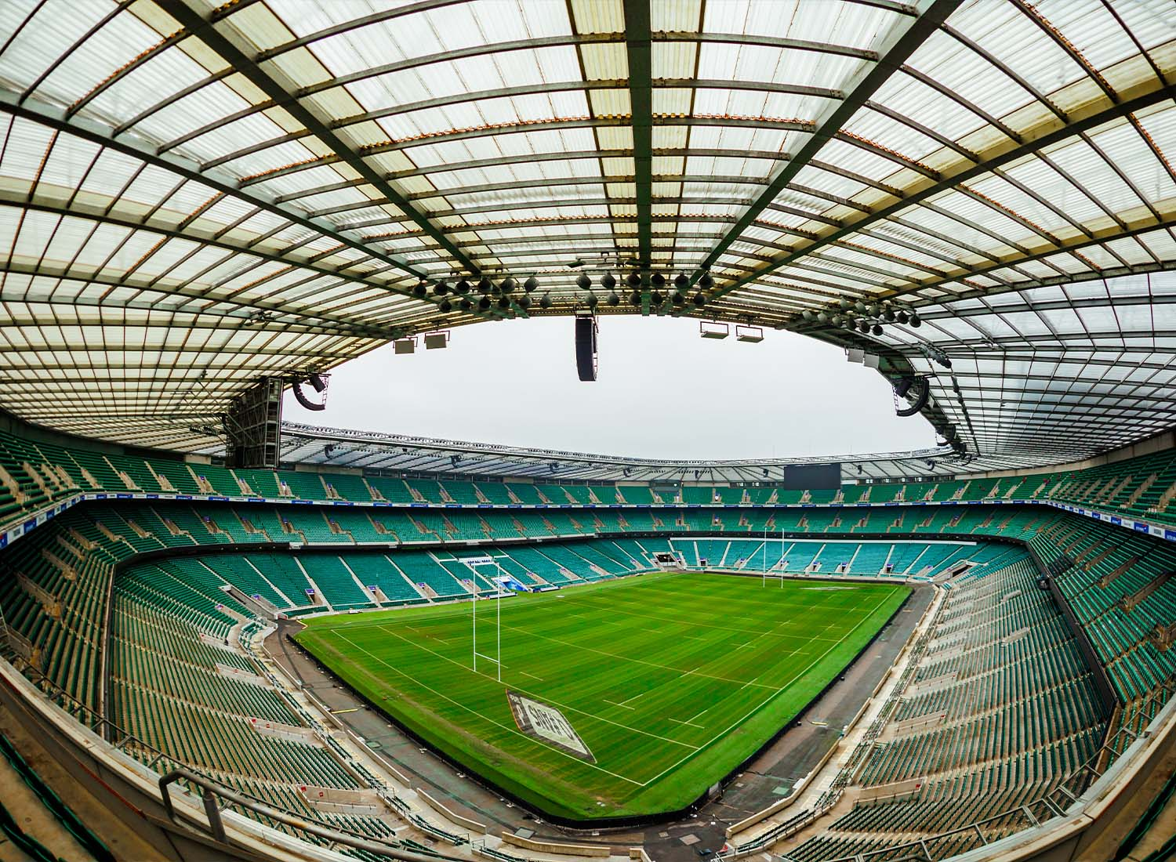
Twickenham Stadium, located in southwest London, is the home of English rugby union and is one of the largest and most iconic rugby stadiums globally.

9. Which sport involves hitting a ball with a racquet over a net?
a) Tennis
Tennis is a racquet sport played individually against a single opponent (singles) or between two teams of two players each (doubles), where the players compete by hitting a ball over a net.





10. Which of these is NOT a major sporting event held in the UK?
c) The Super Bowl
The Super Bowl is the championship game of the National Football League (NFL) in the United States. While the UK has a thriving sporting scene and hosts many major international events, the Super Bowl is exclusively an American event.
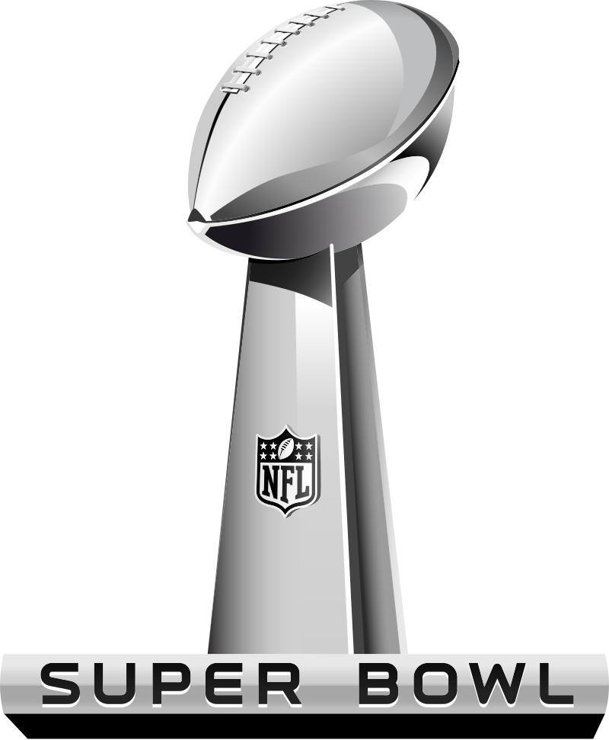
American,
not UK’s

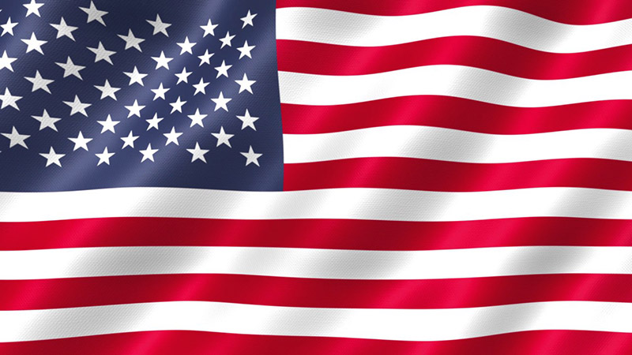

Famous Personalities

1. Which famous scientist developed the theory of evolution?
c) Charles Darwin
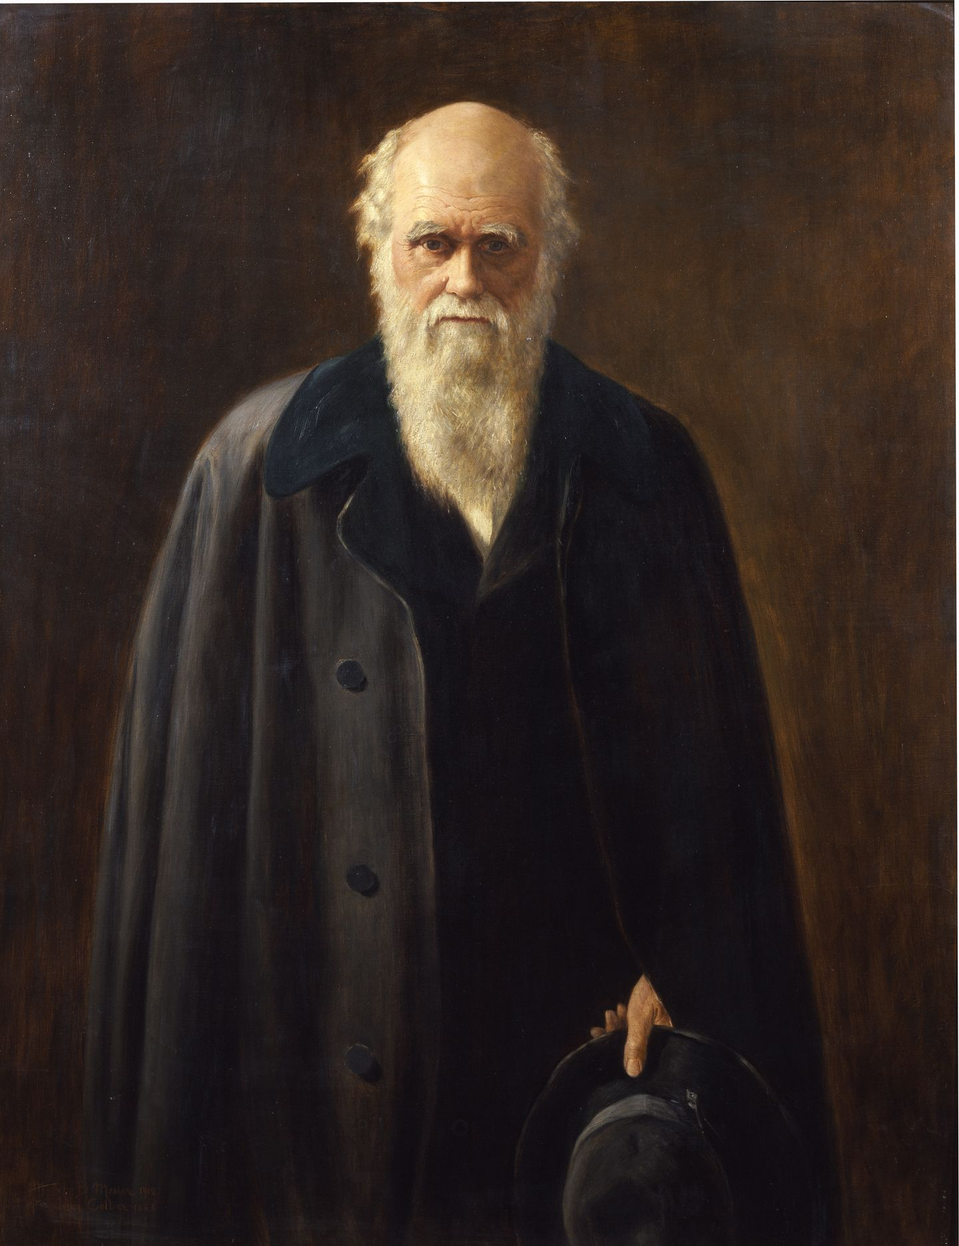
Charles Darwin's theory of evolution by natural selection revolutionized biology and our understanding of the natural world. His work, «On the Origin of Species», is a cornerstone of modern biology.

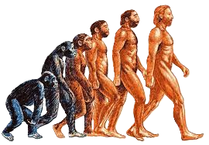

2. Which author wrote the Harry Potter series?
b) J.K. Rowling
Joanne Kathleen Rowling's Harry Potter series is a global phenomenon, captivating readers of all ages and spawning a massive franchise including films, theme parks, and video games.


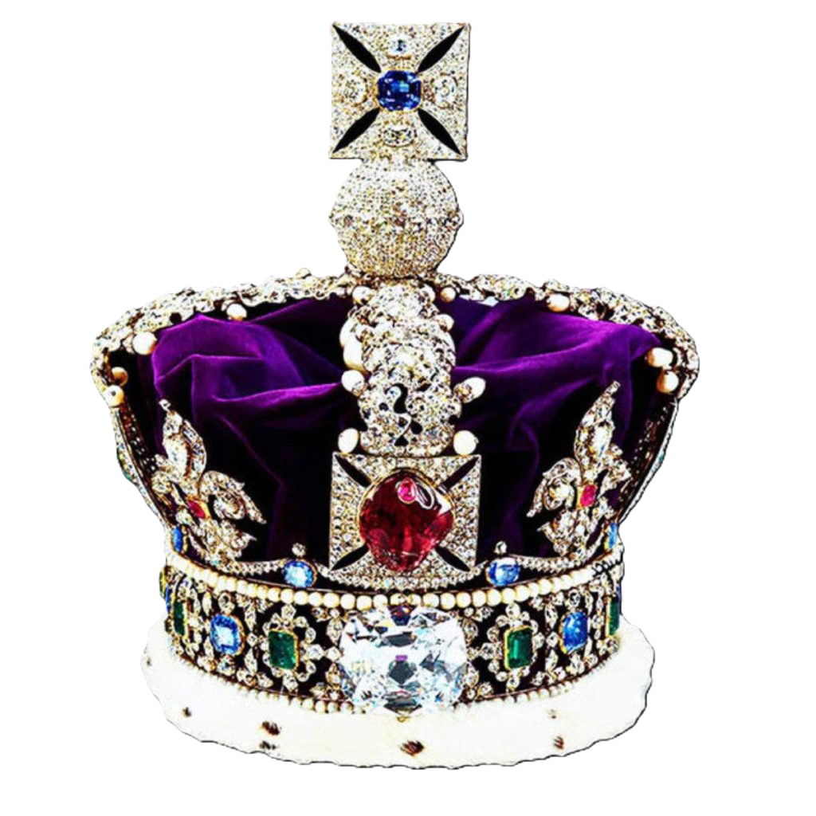
3. Which British monarch reigned for over 70 years?
b) Queen Elizabeth II
Queen Elizabeth II's reign was the longest in British history, spanning over seven decades and marking a significant period of change and transformation in the UK and the world.

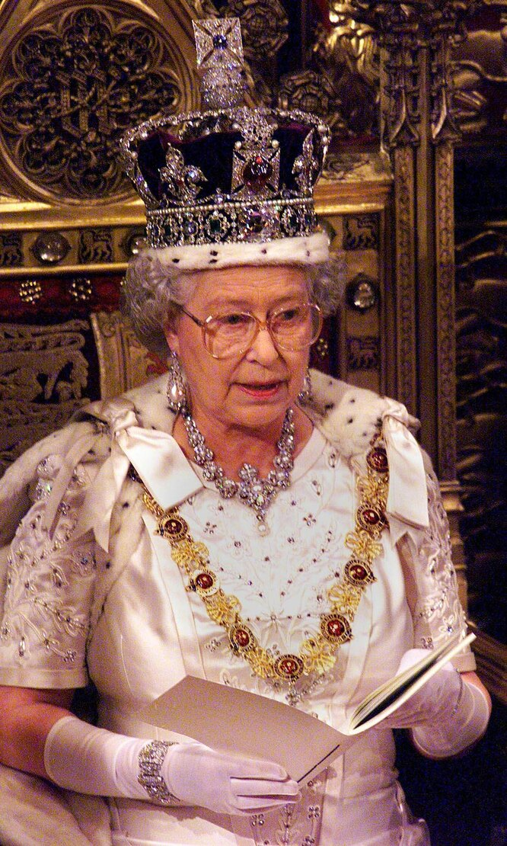

4. Who painted many famous portraits, including one of Queen Elizabeth I?
c) Nicholas Hilliard
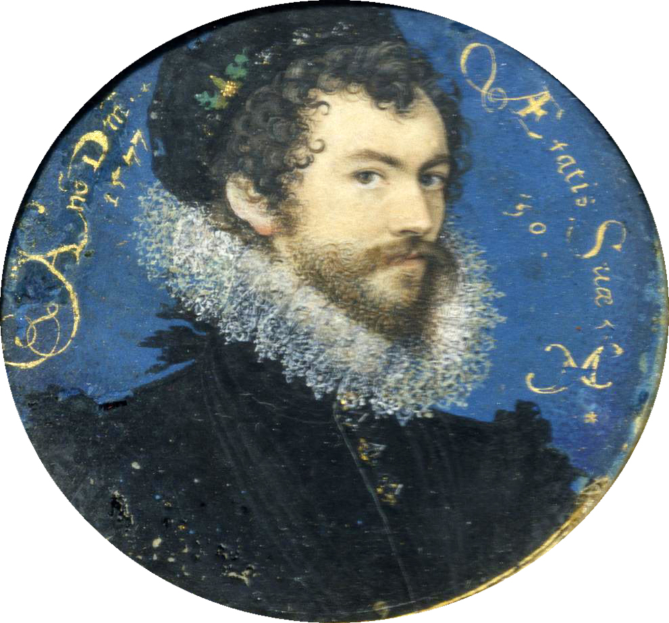
Nicholas Hilliard was a highly skilled miniaturist painter during the Elizabethan era, known for his exquisite portraits capturing the details of his subjects, including the iconic Queen Elizabeth I.

5. Which famous British band created "Here comes the sun" and "Hey Jude"?
b. The Beatles
The Beatles were an English rock band formed in Liverpool in 1960. They are widely regarded as the most influential band of all time, revolutionizing popular music with their innovative songwriting, studio techniques, and cultural impact.
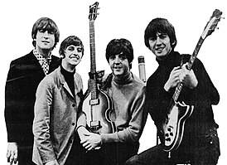
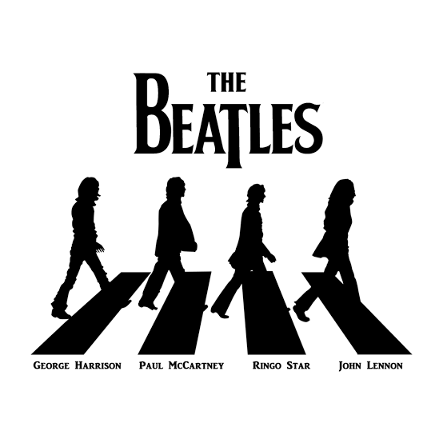

6. Who wrote "Pride and Prejudice"?
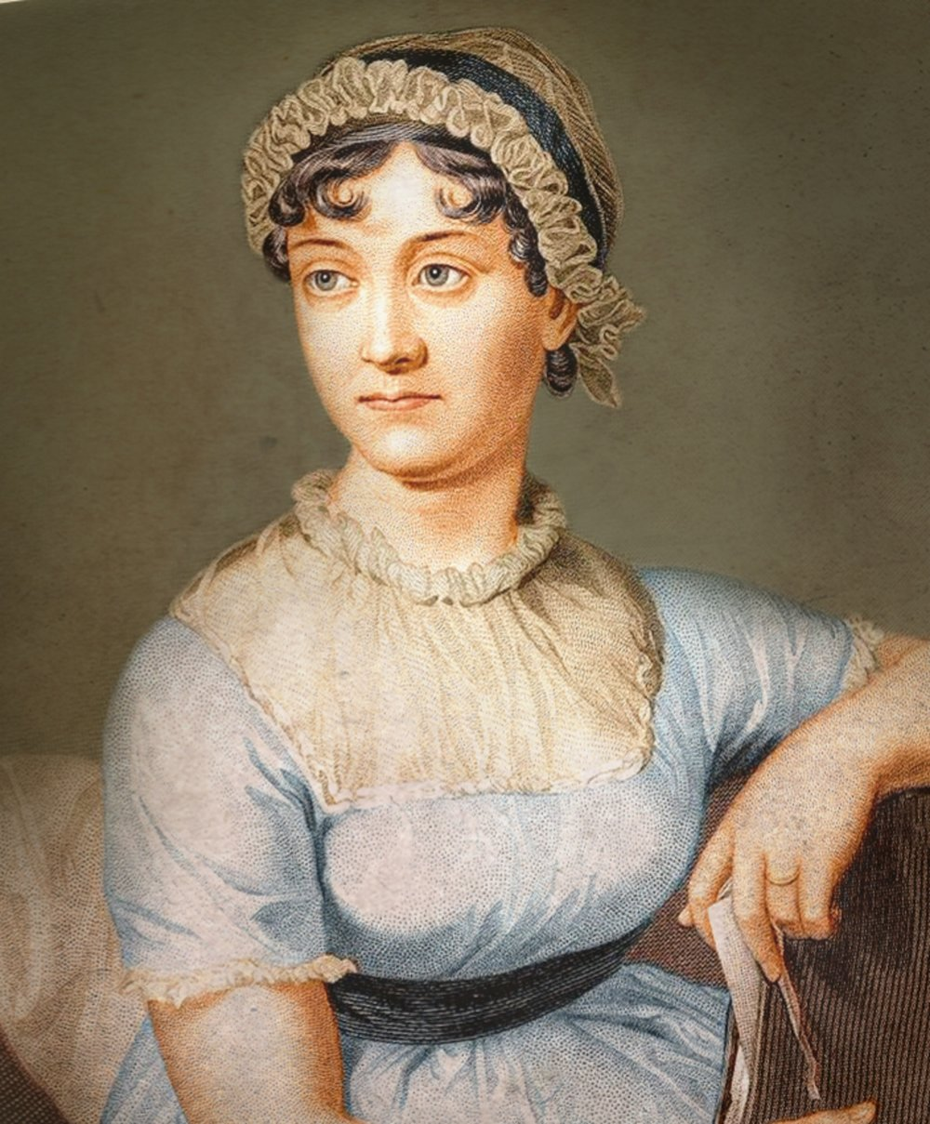
a) Jane Austen
Jane Austen's novels are celebrated for their witty social commentary, insightful characters, and enduring appeal. "Pride and Prejudice" is arguably her most famous work.
7. Which Beatles member is known for his songwriting and distinctive voice?
b) Paul McCartney
While all the Beatles were talented songwriters, Paul McCartney is widely recognized for his prolific output and contributions to many of the band's most beloved songs. His melodic style and distinctive basslines are instantly recognizable.
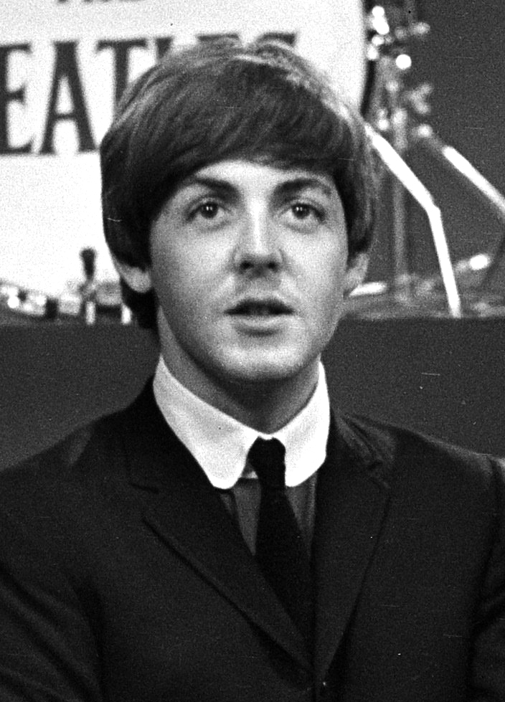

Now
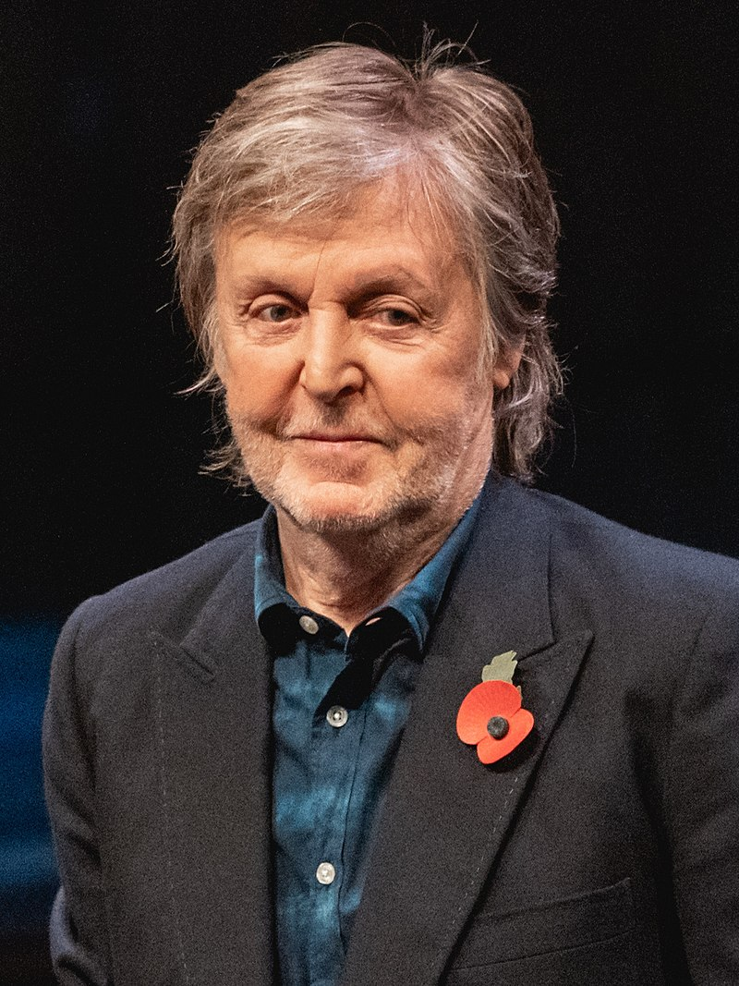

Then

8. Which British Prime Minister is famous for his wartime leadership during World War II?
b) Winston Churchill
Winston Churchill's leadership during World War II is legendary. His powerful speeches and unwavering resolve inspired the British people and played a key role in the Allied victory.

«Success consist of going from failure to failure without loss of enthusiasm»
W. Churchill

9. Which playwright wrote Hamlet, Macbeth, and Romeo and Juliet?
b) William Shakespeare
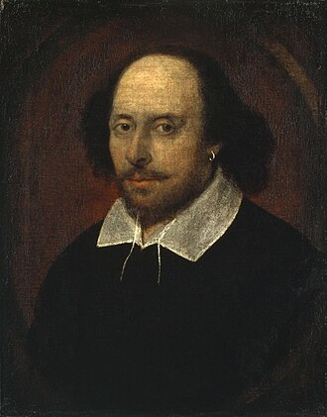
William Shakespeare is considered the greatest writer in the English language and one of the world's most influential playwrights. His works continue to be performed and studied globally.

10. Which scientist is credited with discovering the structure of DNA?
b) Francis Crick
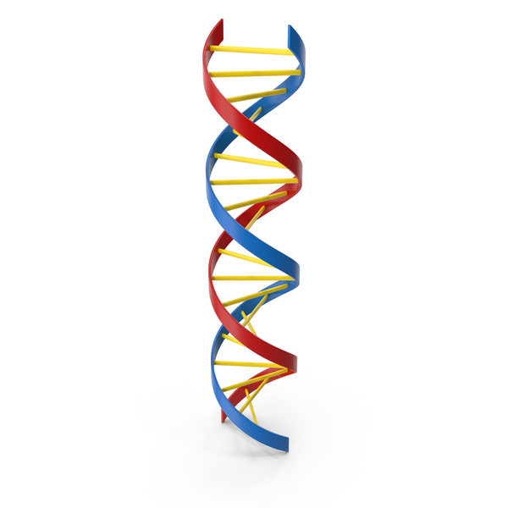
Francis Crick, along with James Watson and Maurice Wilkins, received the Nobel Prize for their discovery of the double helix structure of DNA, a landmark
achievement in molecular biology. Their work laid the foundation for modern genetics and
biotechnology.
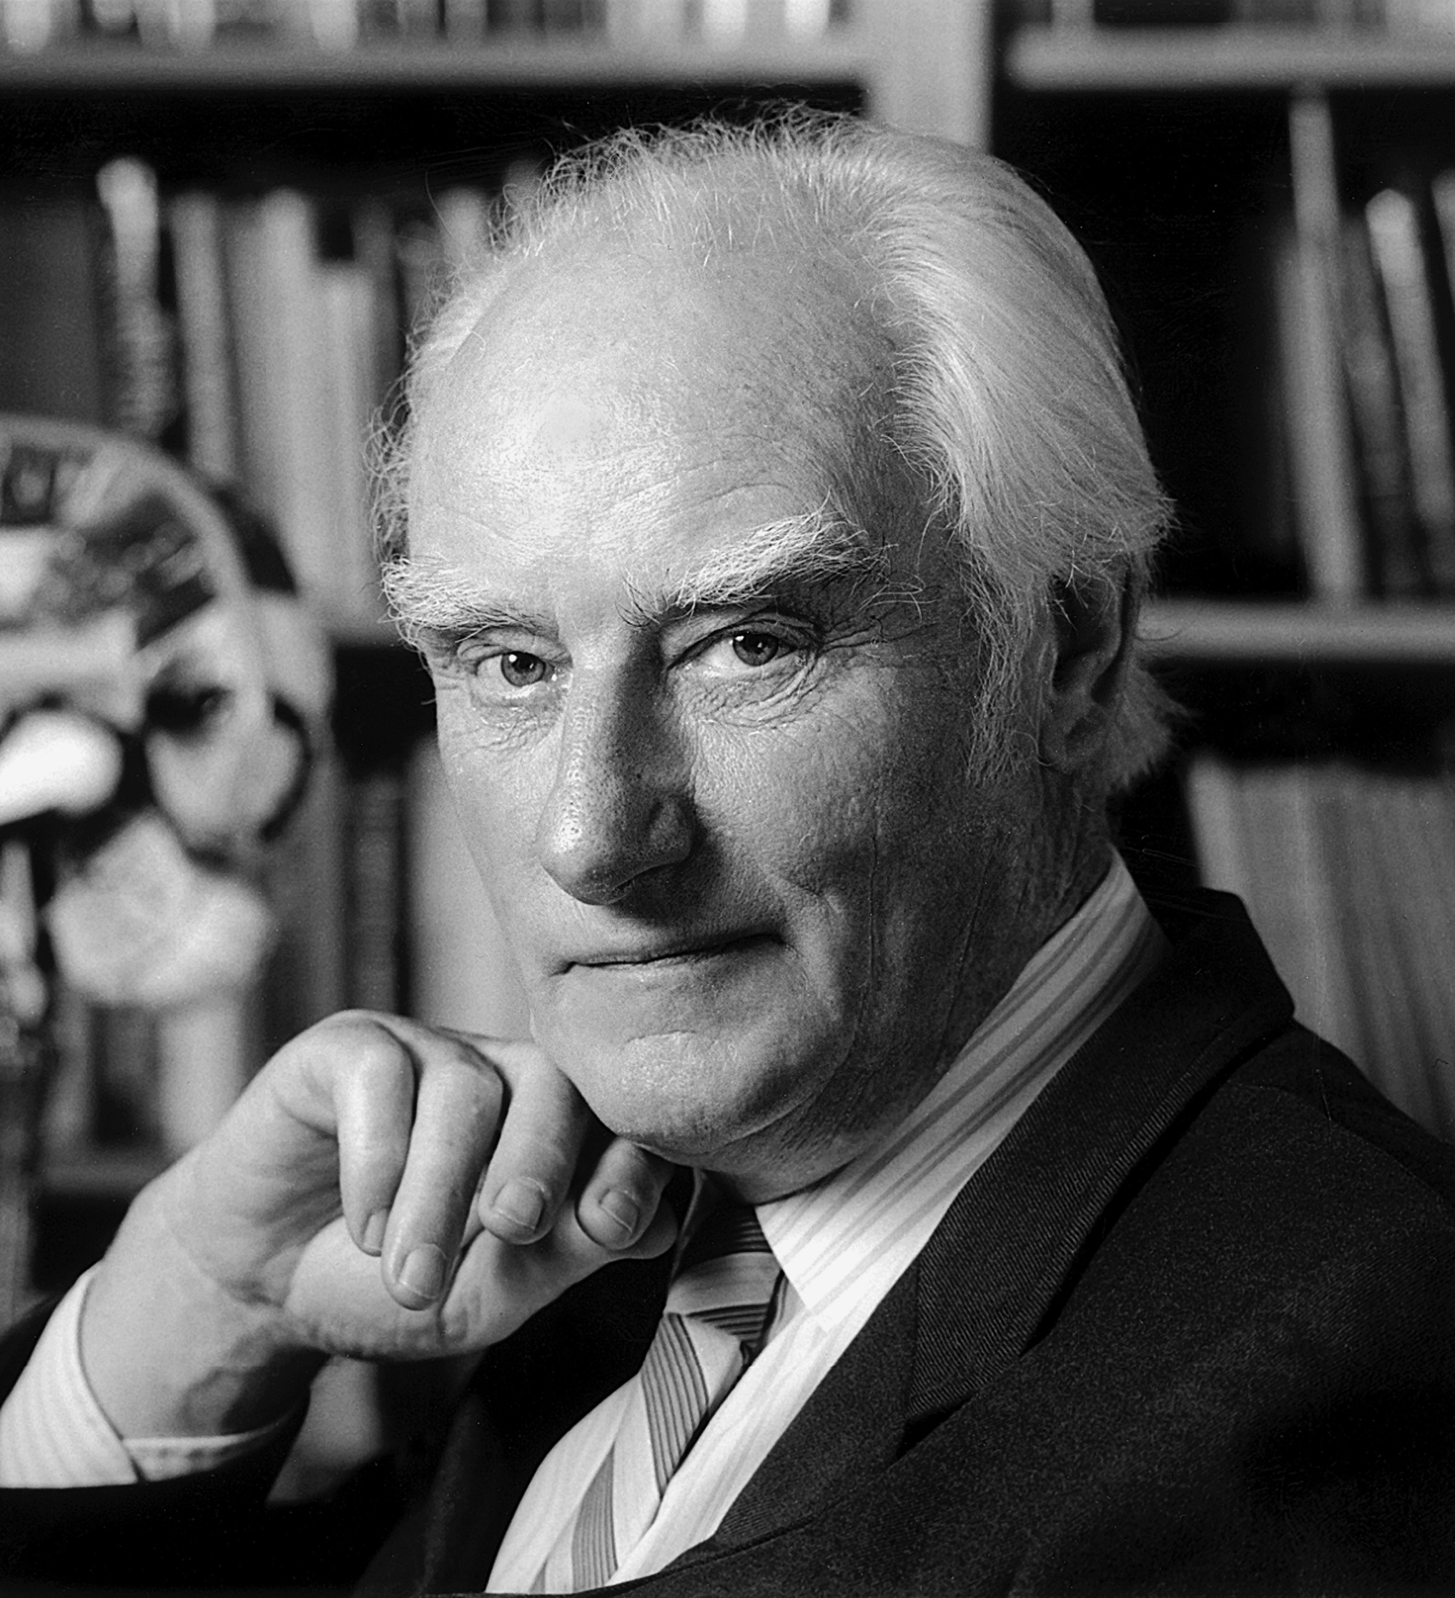


Literary Characters

1. Which character lives at 4 Privet Drive and is known for his love of magic?
a) Harry Potter
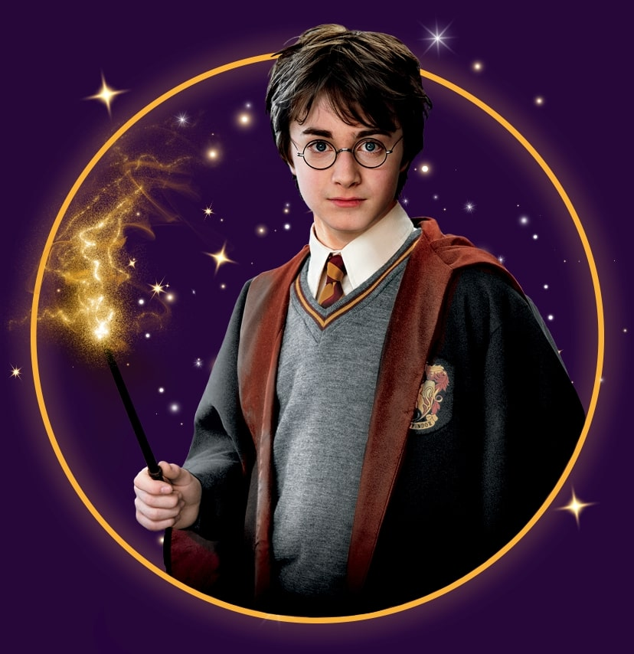

Harry Potter, the titular character of the series, is orphaned and forced to live with his neglectful aunt, uncle, and cousin at 4 Privet Drive. He discovers his magical heritage on his eleventh birthday and begins his journey at Hogwarts School of Witchcraft and Wizardry.

2. Who is the adventurous boy who travels to Neverland and meets Peter Pan?
c) Wendy Darling
Wendy Darling is the main girl character in J.M. Barrie's classic story, "Peter Pan". She is a young girl who, along with her brothers, flies to Neverland and meets Peter Pan, a boy who never grows up.
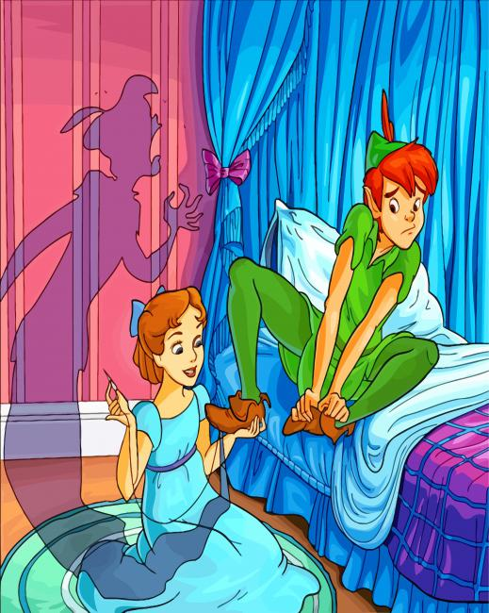

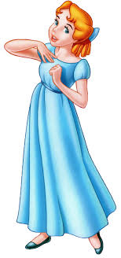

3. Which character is a detective who solves mysteries with his faithful companion, Dr. Watson?
a) Sherlock Holmes
Sherlock Holmes, created by Sir Arthur Conan Doyle, is a brilliant and eccentric detective known for his deductive reasoning and ability to solve complex crimes. He is assisted by his loyal friend Dr. Watson, who often chronicles their adventures.
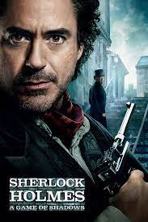
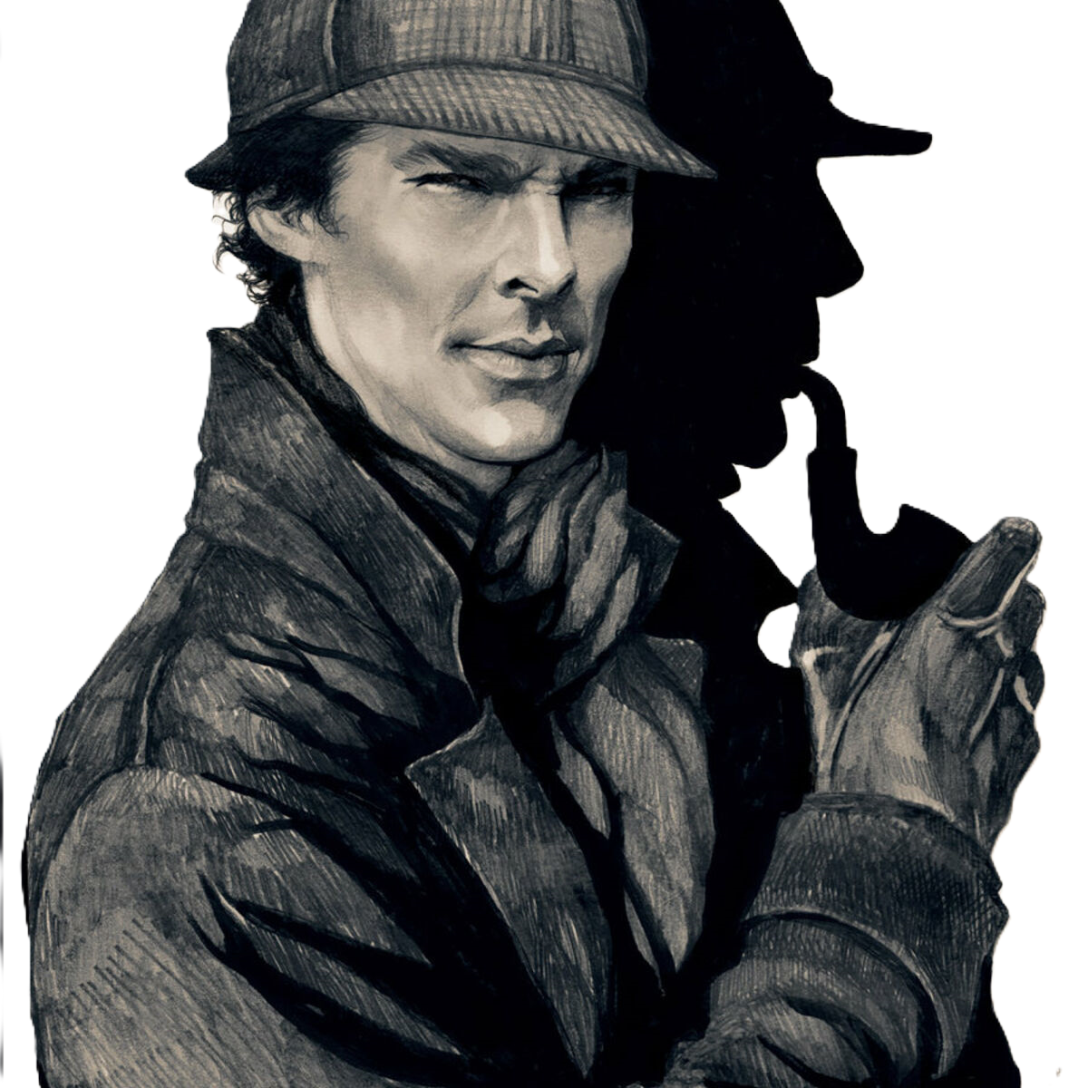

4. Who is the young orphan who lives with the cruel Mr. and Mrs. Sowerberry?
a) Oliver Twist Oliver
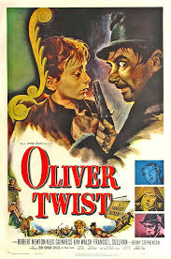
Twist is the young protagonist of Charles Dickens's novel, "Oliver Twist". He is an orphan who endures hardship and abuse in a workhouse and later falls into the world of crime before finding redemption.

5. Which character is a young girl who travels through time with a talking rabbit?
a) Alice
Alice is the main character in Lewis Carroll's "Alice's Adventures in Wonderland", a fantastical story about a young girl who falls down a rabbit hole and enters a surreal world full of talking animals and peculiar characters.
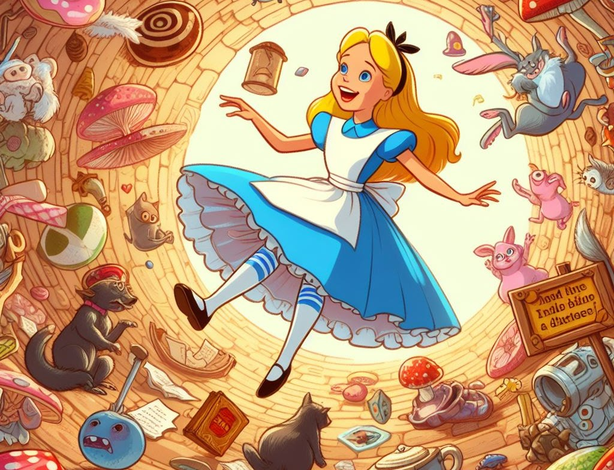

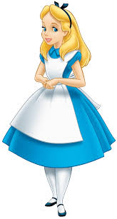

6. Who is the character who is known for his bravery and fighting skills in the epic poem "Beowulf"?
a) Beowulf
Beowulf is the main character in the epic poem "Beowulf". He is a legendary warrior known for his strength, courage, and skill in combat. He defeats the monstrous Grendel and his mother, saving the kingdom of the Danes.
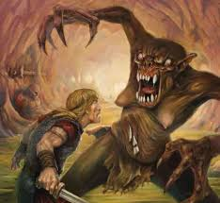

7. Which character is a young girl who lives with her aunt and uncle in a small village and is a skilled horsewoman?
a) Anne of Green Gables
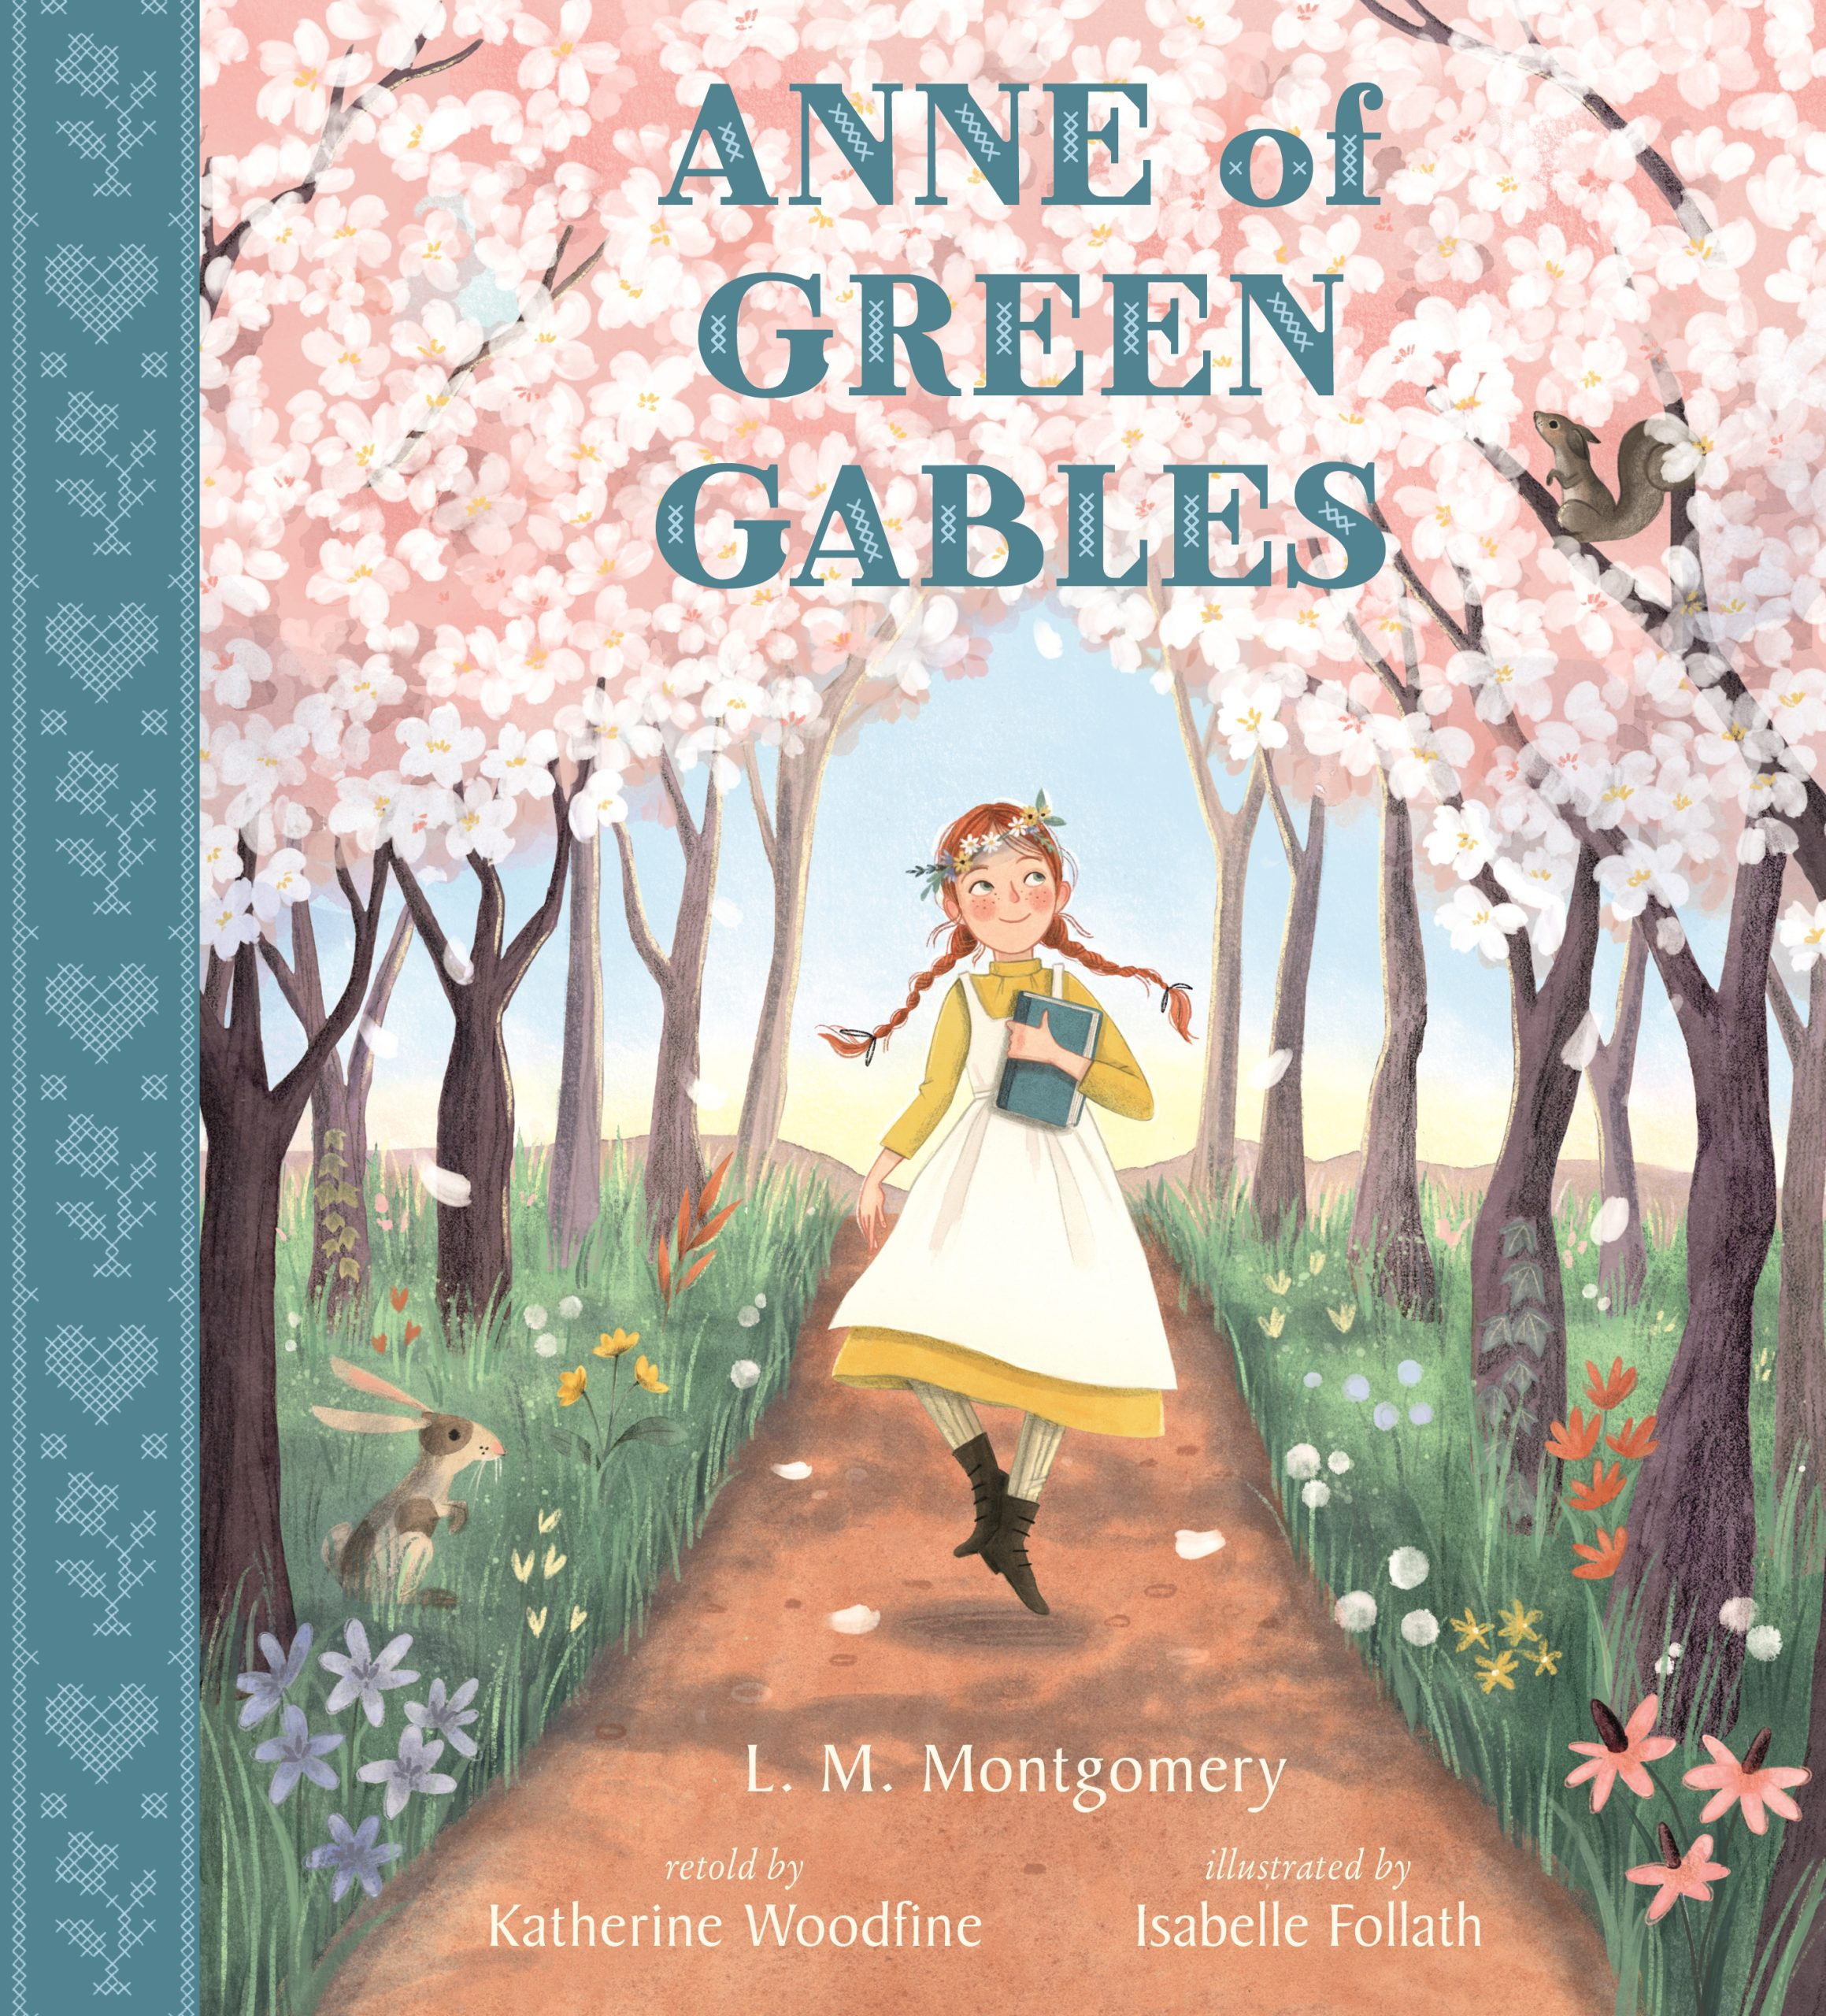
Anne of Green Gables is the main character in L.M. Montgomery's classic novel. She is an orphan who is adopted by Matthew and Marilla Cuthbert, two elderly siblings who live on a farm on Prince Edward Island. Anne is known for her imagination, her love of books, and her determination to make the best of her life.

8. Which character is a young boy who learns about the power of friendship and courage in the book "The Lion, the Witch, and the Wardrobe"?
a) Peter Pevensie
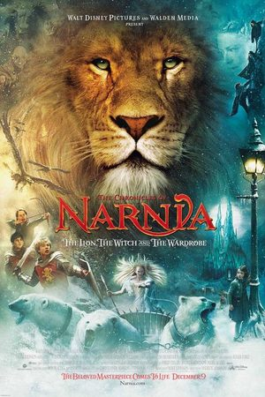
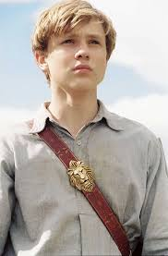
Peter Pevensie is the oldest of the four Pevensie siblings in C.S. Lewis's "The Chronicles of Narnia" series. He is a brave and responsible leader, who helps to liberate Narnia from the White Witch and becomes King Peter.

9. Which character is known for his greed and desire for wealth in the novel "A Christmas Carol"?
a) Ebenezer Scrooge
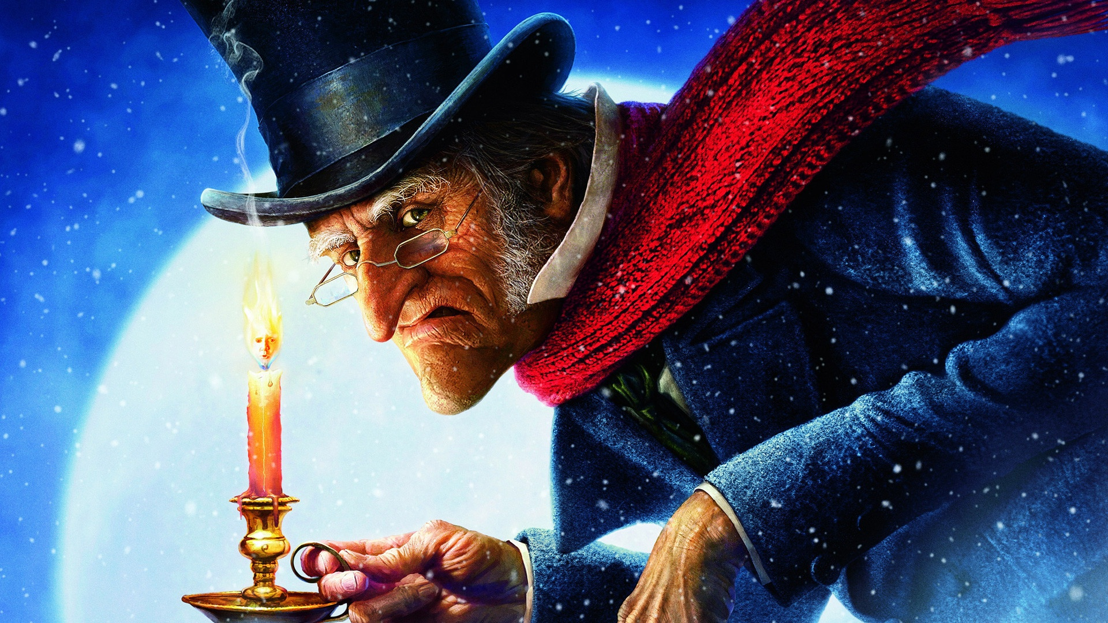
Ebenezer Scrooge is the main character in Charles Dickens's novella, "A Christmas Carol". He is a miserly and grumpy old man who hates Christmas. After being visited by the ghosts of Christmas Past, Present, and Future, he learns the error of his ways and becomes a kinder and more generous person.

10. Which character is a young girl who travels to a magical land with her stuffed rabbit, Mr. Bunnies?
b) Winnie-the-Pooh
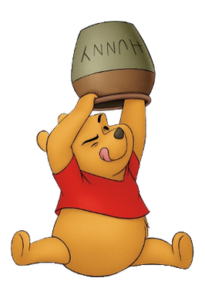
Winnie-the-Pooh is a beloved character in A.A. Milne's classic children's stories. He is a teddy bear who lives in the Hundred Acre Wood and enjoys honey, his friend Piglet, and exploring the forest.

Plants and Flora

1. Which of these is a type of tree?
b) Oak
Oak trees are large, deciduous trees known for their strong wood and acorns. They are a common sight in many parts of the world, including Europe and North America, and are often associated with strength and longevity.
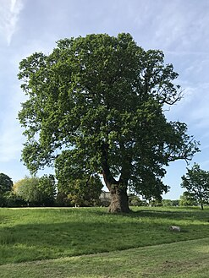

2. What is the name of the flower that is often associated with England and is known for its red, white, and blue colors?
c) Rose
Rose is a flower with many cultivars, displaying a wide range of colors, including red, white, and blue. The Tudor rose, a combination of red and white, is a famous symbol of England. The rose is often associated with love and beauty.
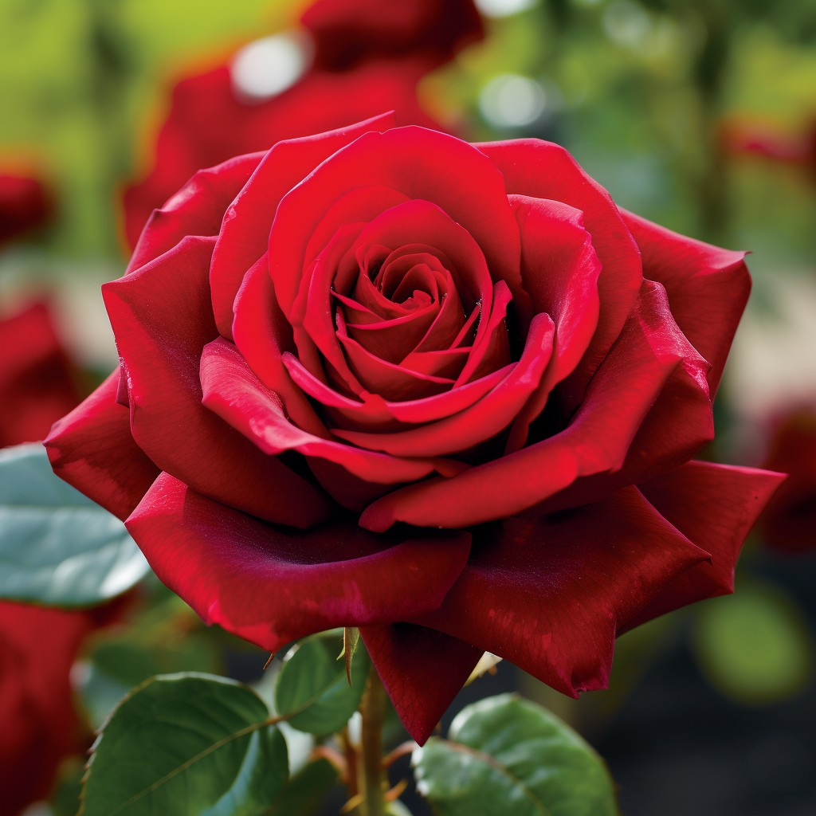

3. Which of these is a type of fruit?
b) Apple
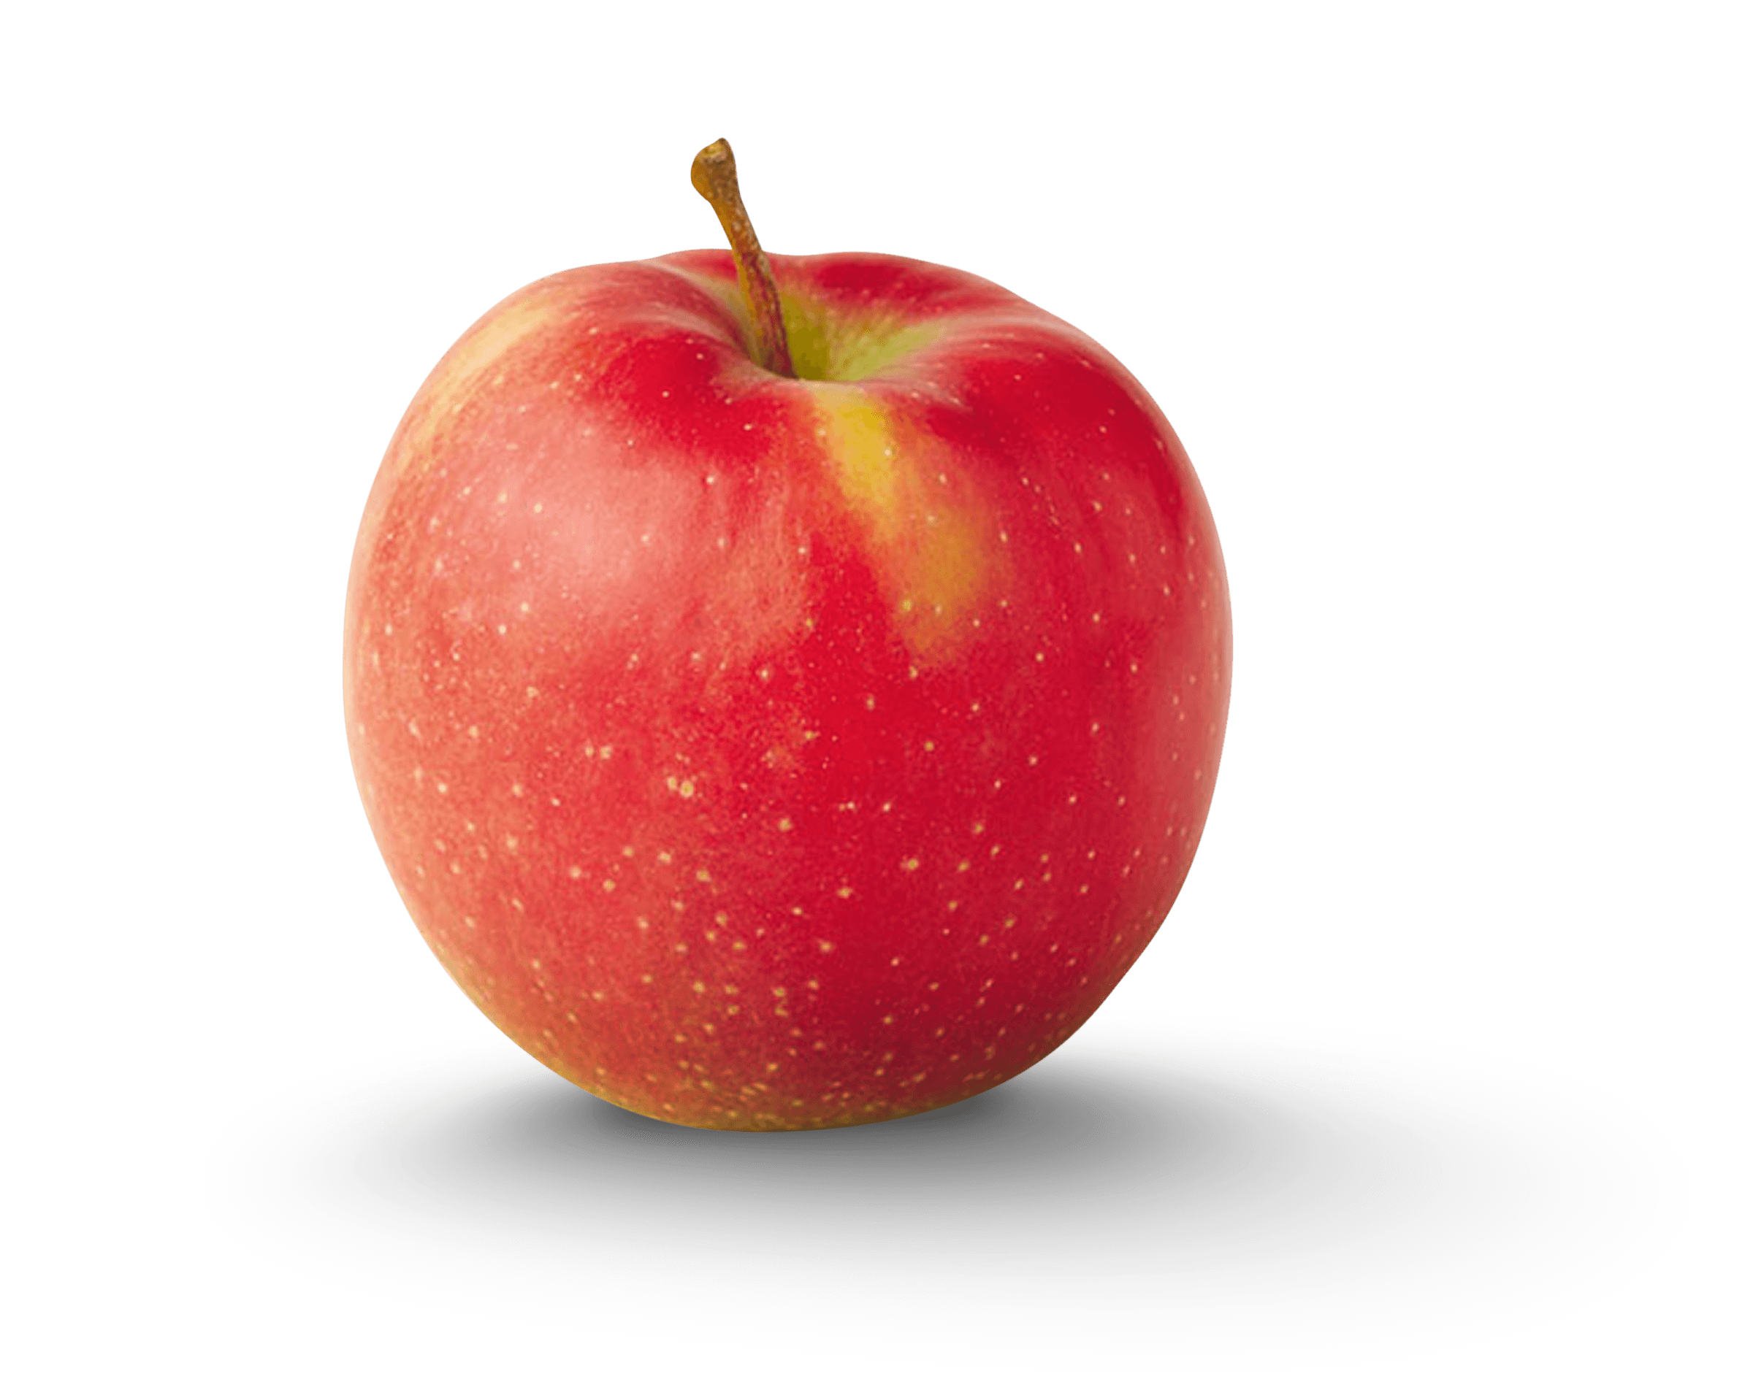
Apples are a type of pome fruit, grown on apple trees. They are widely cultivated and consumed worldwide, enjoyed both fresh and in various processed forms like juice and pies.
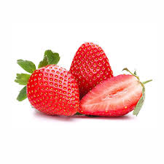
4. What is the name of the plant that produces the fruit we call strawberries?
b) Strawberry
Strawberry plants are perennial herbs, meaning they live for more than two years. The "fruit" we eat is actually an aggregate accessory fruit, meaning that the fleshy part we eat is derived from the receptacle of the flower, not the ovaries.
5. Which of these is a type of vegetable?
b) Carrot
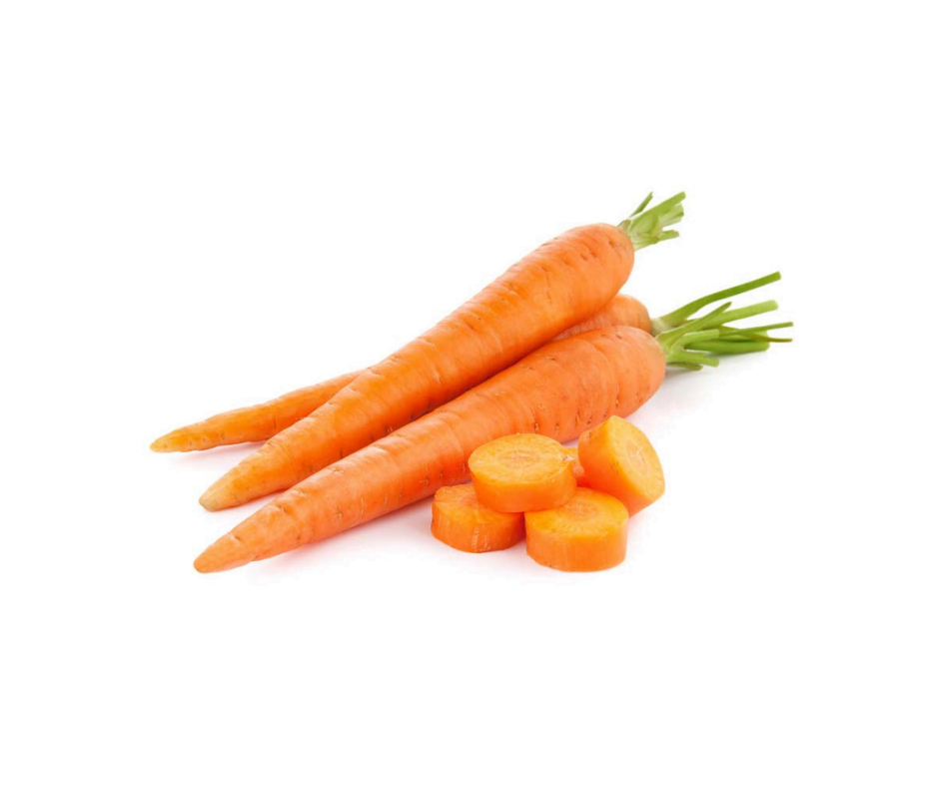
Carrots are root vegetables, meaning the edible part grows underground. They are a good source of beta-carotene, which the body converts to Vitamin A. They are typically orange but can also be other colors like purple or yellow.

6. What is the name of the tree that produces acorns?
b) Oak
Oak trees produce acorns, which are small, nut-like fruits that are a food source for various animals. Acorns also have historical significance, having been used by humans as a food source in the past.
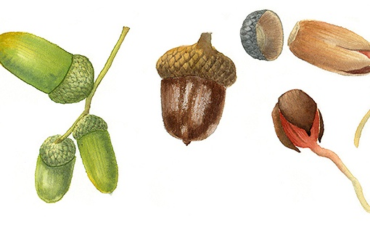

7. Which of these is a type of flower?
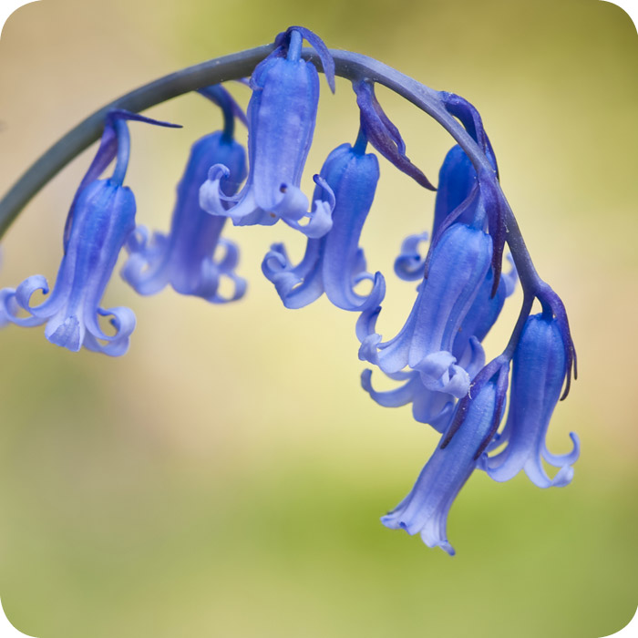
a) Bluebell
Bluebells are delicate, bell-shaped flowers that commonly bloom in woodlands, creating stunning displays of blue in spring. They are a familiar sight in many parts of Europe, particularly the UK.

8. What is the name of the flower that is a symbol of Scotland and is known for its prickly leaves and purple blooms?
b) Thistle
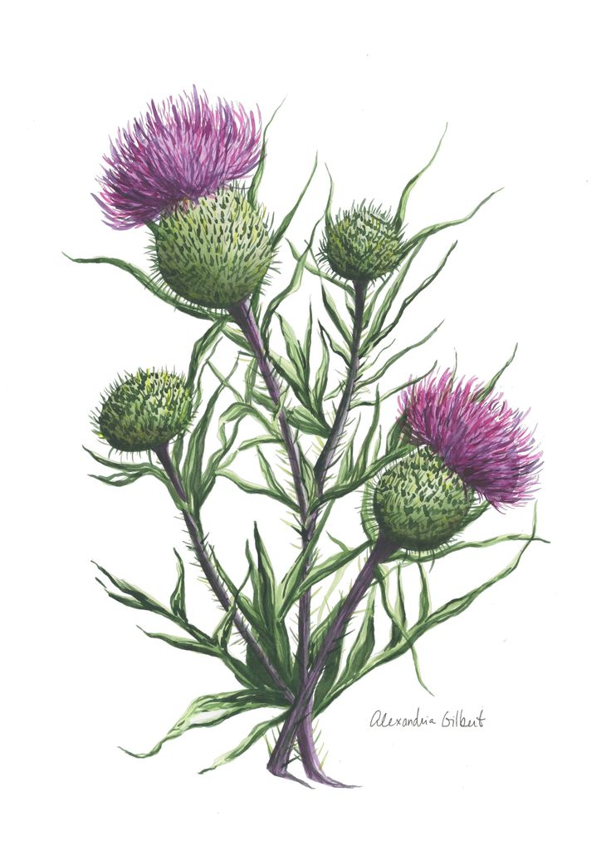
The thistle is a prickly plant with purple flowers. It is the national flower of Scotland and symbolizes strength and resilience.

9. Which of these is a type of tree?
b) Pine
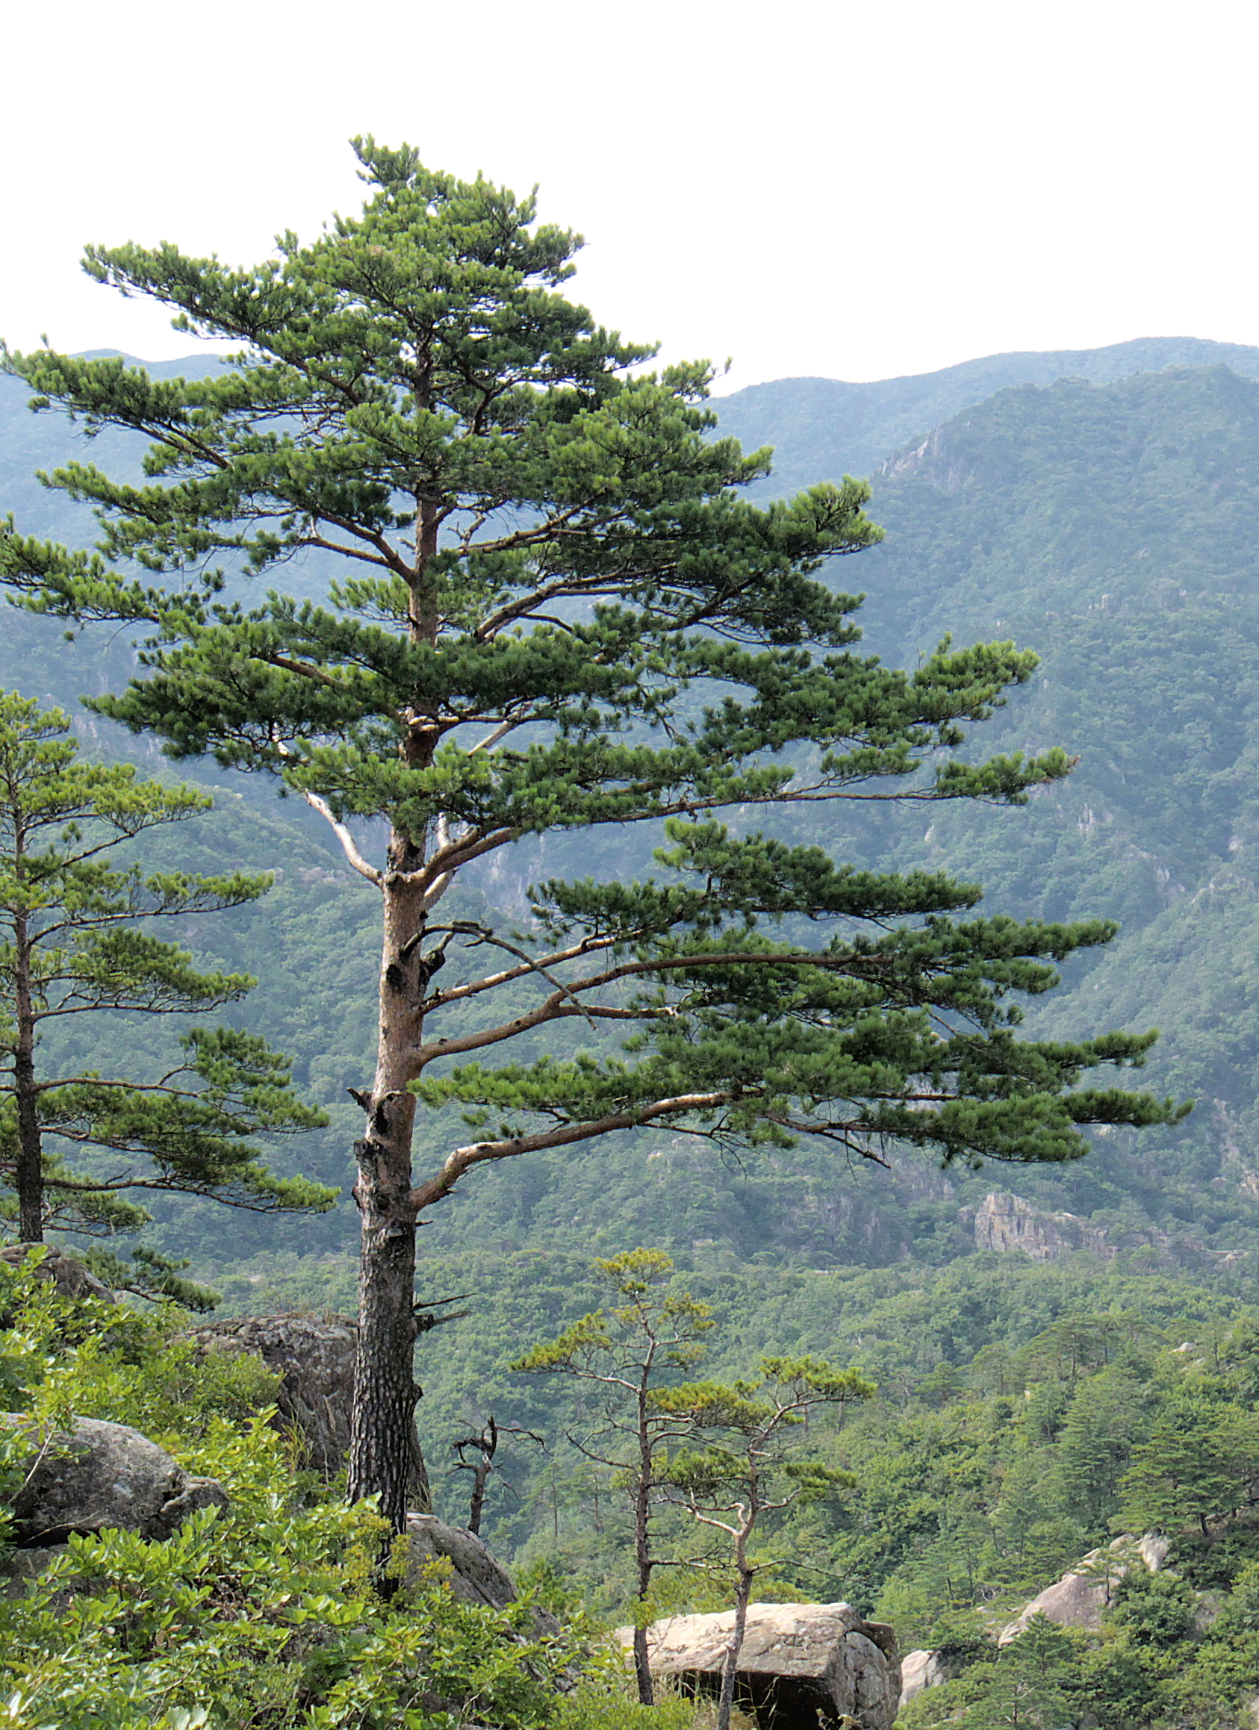
Pine trees are evergreen coniferous trees, meaning they retain their needles year-round. They are found in many parts of the world and are known for their tall, slender shape and conical form.

10. What is the name of the flower that is often associated with remembrance and is known for its distinctive red color?
a) Poppy

The poppy, particularly the red poppy (Papaver rhoeas), is widely recognized as a symbol of remembrance, especially for those who died in war. Wearing a poppy is a common practice on Remembrance Day in many Commonwealth countries.
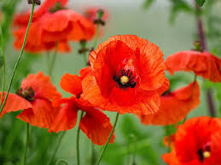

Fauna

1. What is the national bird of the United Kingdom?
a) European Robin
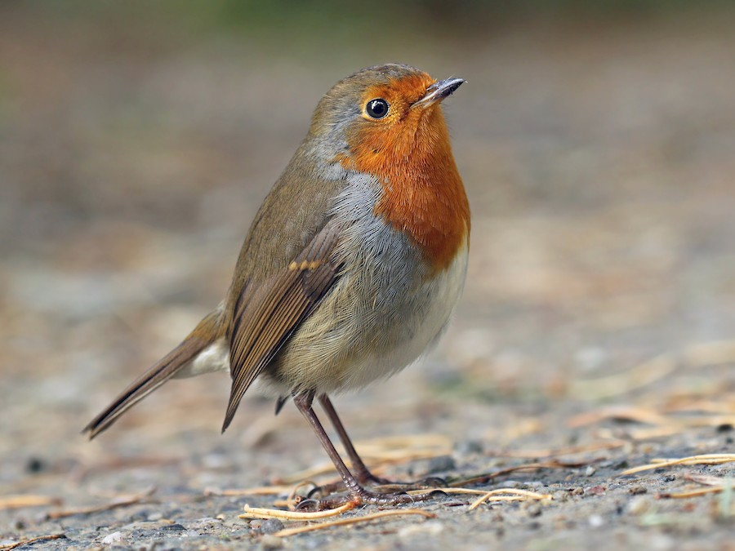
The European Robin is the national bird of the UK, recognized for its distinctive orange-red breast and cheerful song. It is often found in gardens, parks, and woodlands, symbolizing the arrival of spring in British culture.

2. Which large mammal is commonly found in the UK's woodlands and forests?
a) Red Deer
Red Deer are the largest land mammals in the UK, primarily found in Scotland but also across many woodlands in England and Wales. They are known for their impressive antlers, which are shed and regrown annually.
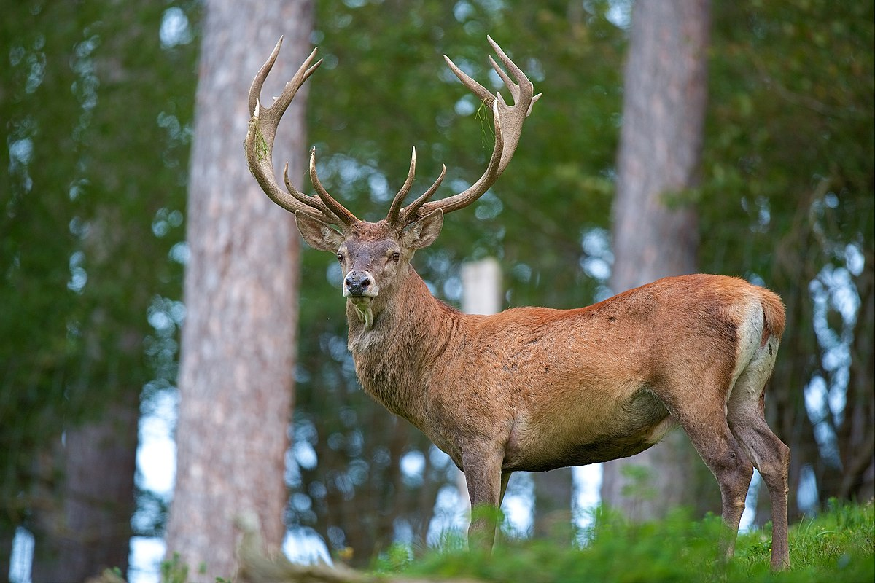

3. What type of animal is a "Common Frog"?
c) Amphibian
The Common Frog is classified as an amphibian, a group of animals that live both on land and in water. They have smooth skin, and they undergo a metamorphosis from tadpole to adult frog, making them an interesting species to study.
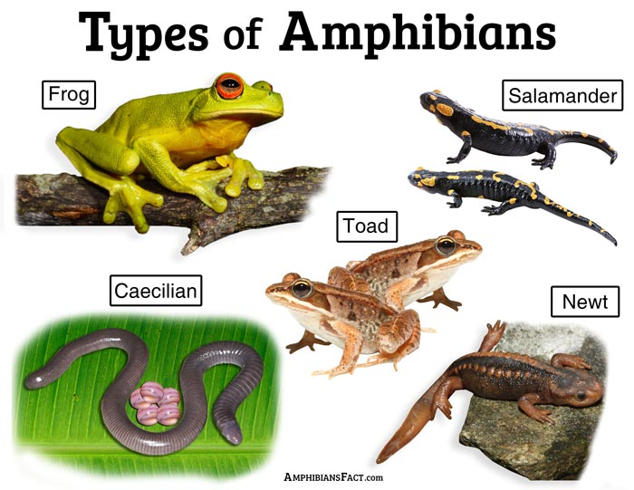

4. Which of these animals is a native species to the UK?
b) European Hedgehog
The European Hedgehog is a native species often found in gardens, parks, and rural areas throughout the UK. They are nocturnal creatures known for their spiny coat and ability to curl into a ball when threatened.

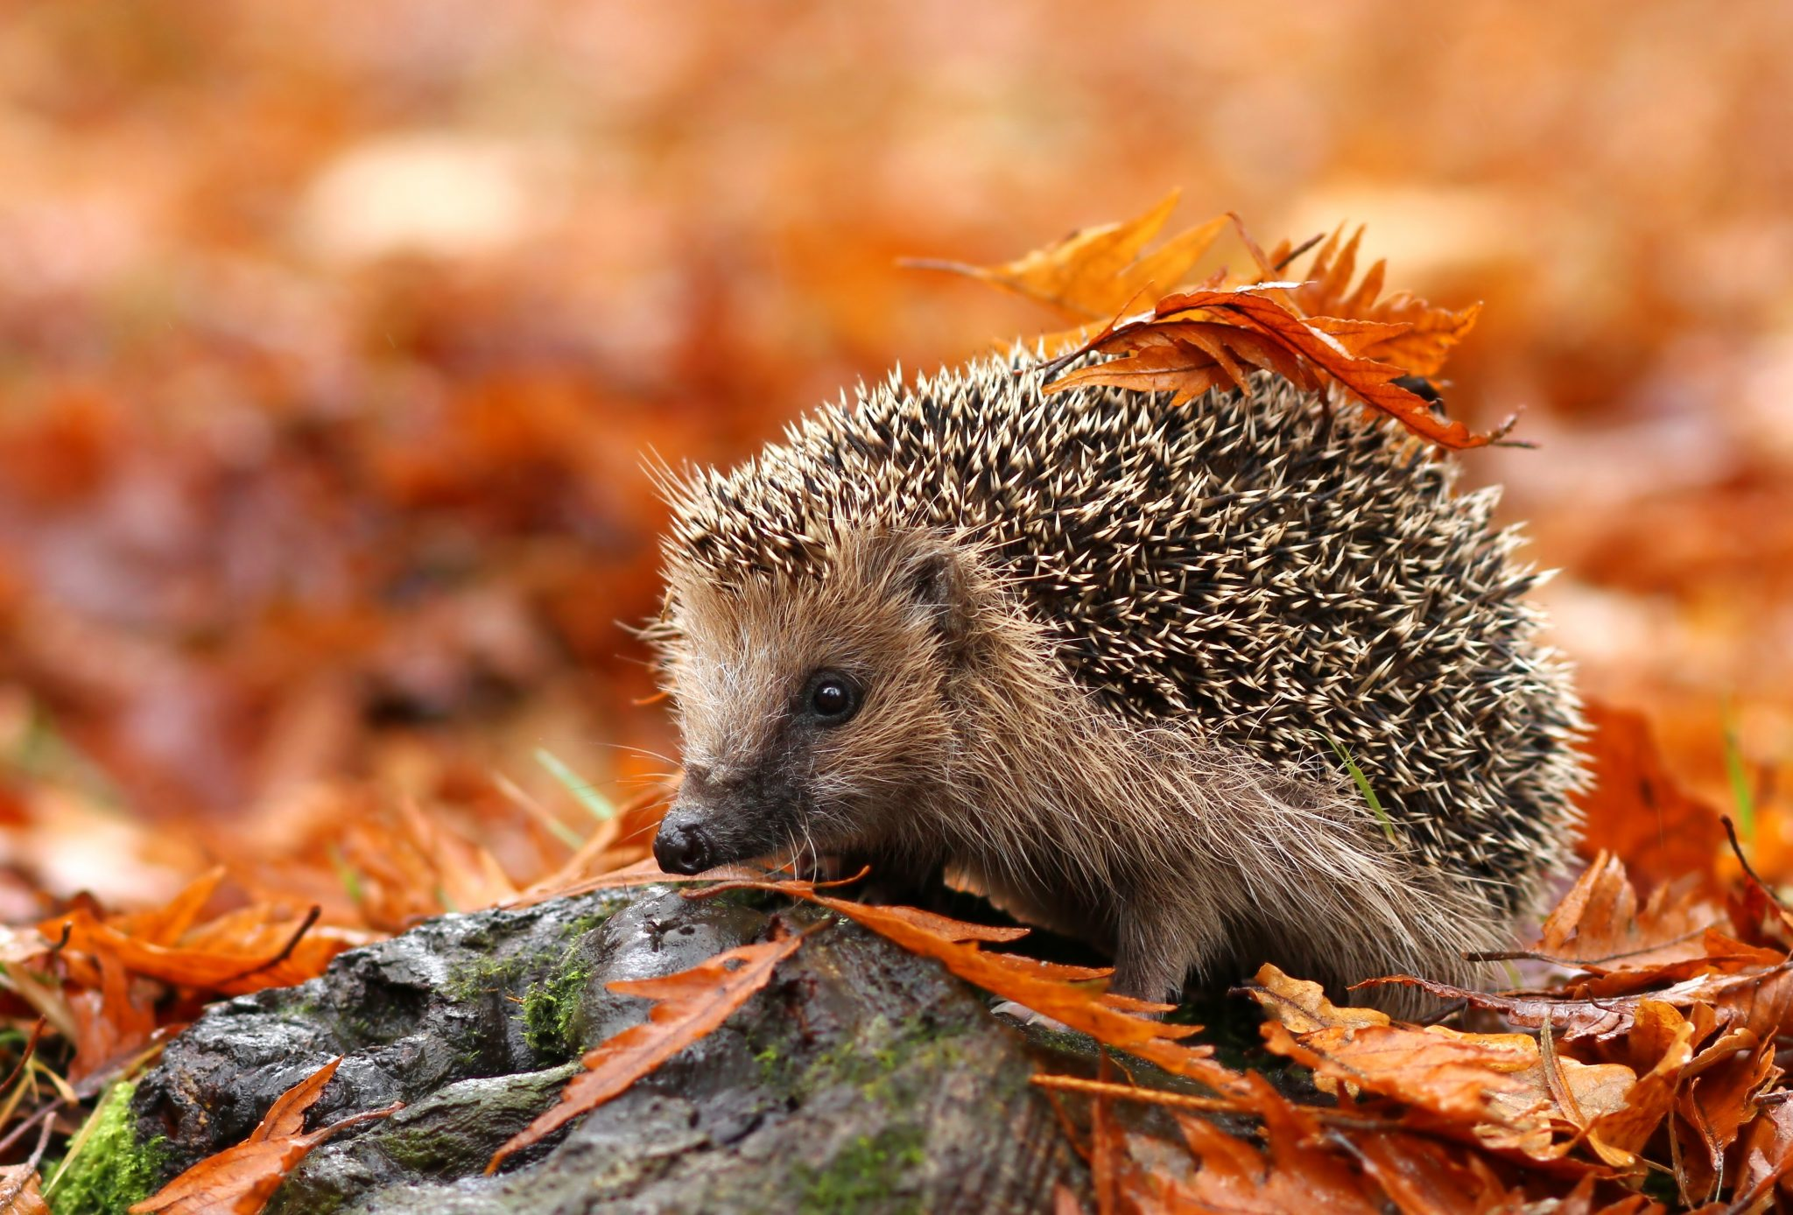

5. What is the main habitat of the Red Squirrel in the UK?
c) Pine forests
Red Squirrels primarily inhabit pine forests, where they thrive on a diet of nuts, seeds, and berries. They are now considered endangered in some areas of the UK, largely due to habitat loss and competition from the non-native Grey Squirrel.
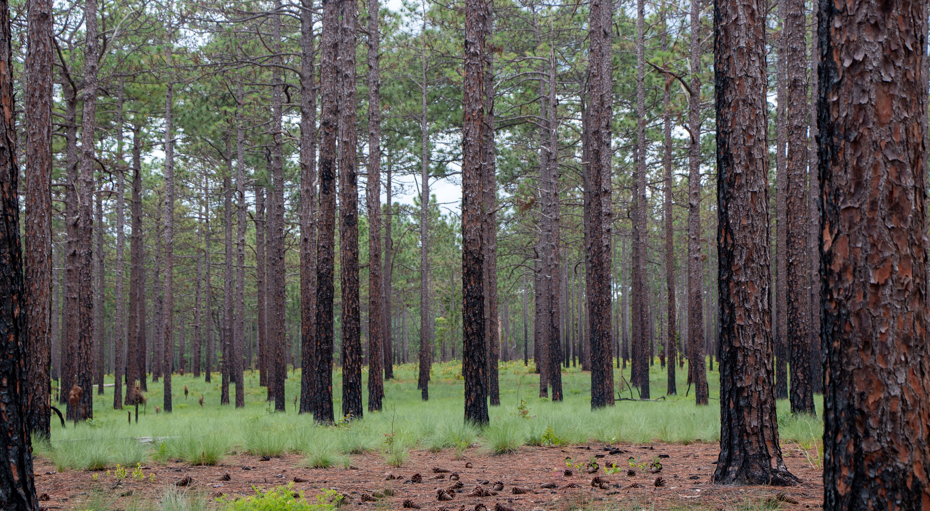
6. Which sea mammal is often seen around the coasts of the UK?
a) Dolphin
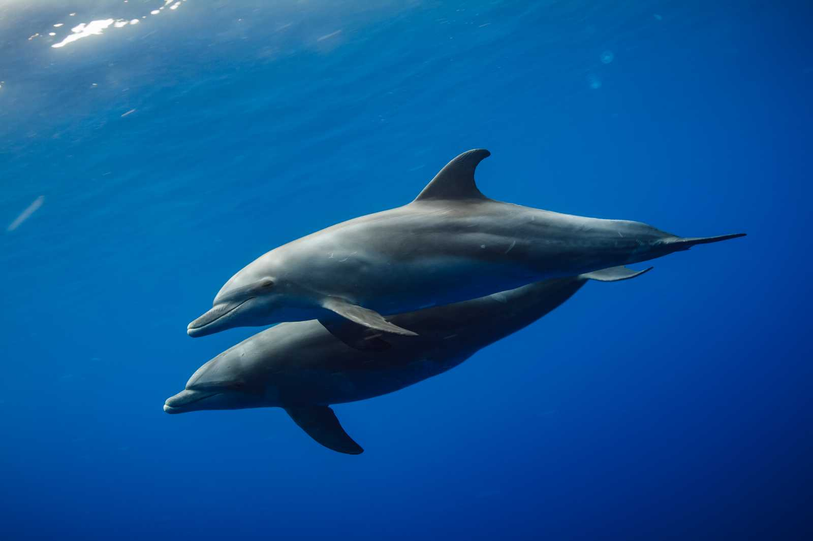
Dolphins are commonly spotted along the UK coast and are known for their playful behavior and intelligence. Various species, such as the Bottlenose Dolphin, can often be seen in coastal waters.

7. What is the largest land predator in the UK?
c) Eurasian Lynx
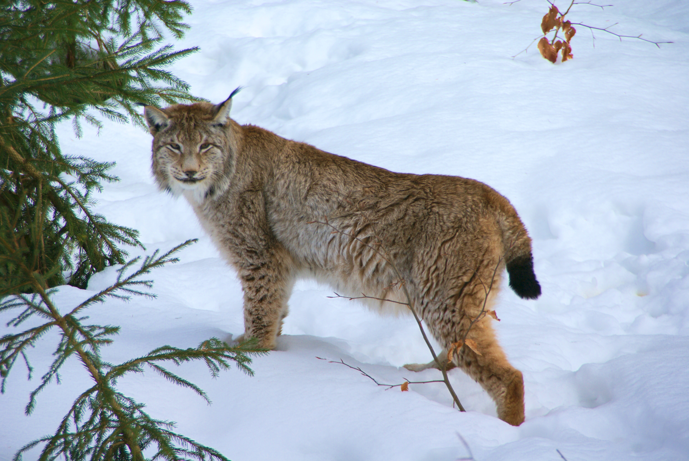
While the Eurasian Lynx is not currently present in the UK, it is the largest land predator that once roamed these parts. It is important to note that the Grey Wolf used to be common as well, contributing to their significant role in the ecosystem.

8. Which bird is famous for its beautiful song and is often found in gardens?
a) Nightingale
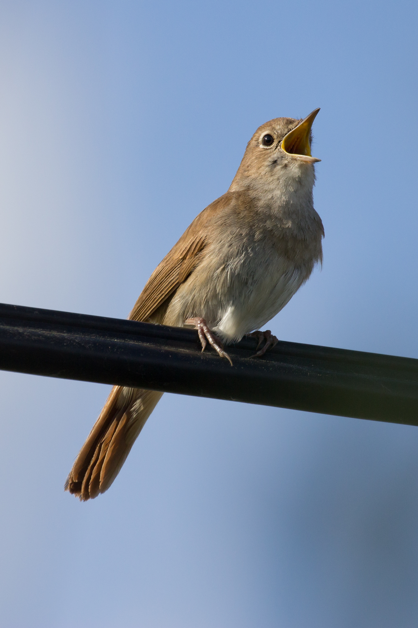
The Nightingale is renowned for its melodious and rich song, often sung at night. These birds typically inhabit dense shrubs and gardens, making them a delightful presence in the UK during the breeding season.

9. What insect is known for its role in pollination and is frequently seen in gardens?
b) Honeybee
Honeybees are crucial pollinators, playing a vital role in the reproduction of flowering plants. They are commonly seen in gardens, actively collecting nectar and pollen, and are important for maintaining biodiversity.
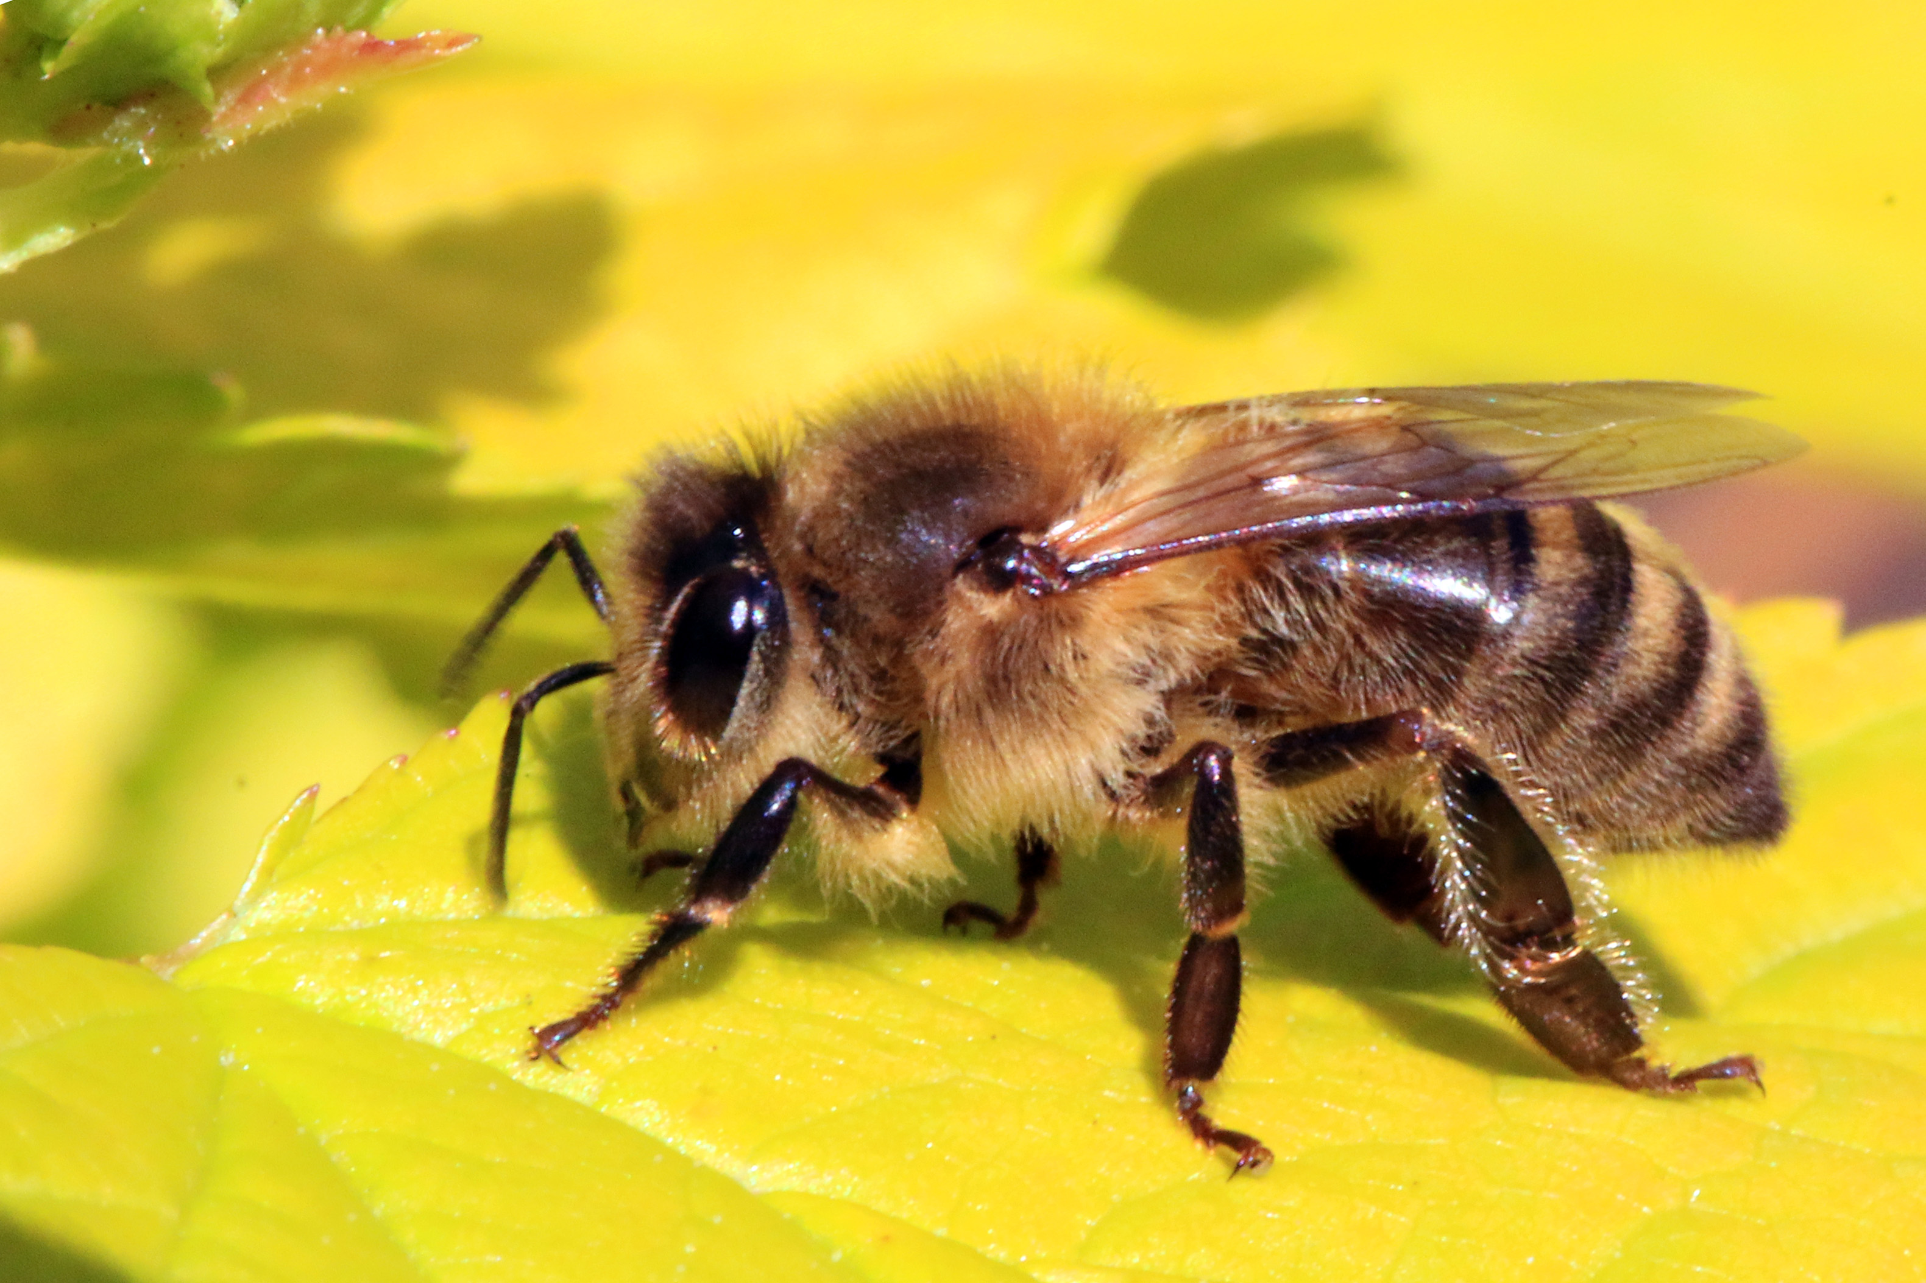

10. Which of these reptiles can be found in the UK?
b) Common Lizard
The Common Lizard is one of the few reptile species native to the UK. They are typically found in a variety of habitats, including heathlands and grasslands, and are known for their ability to bask in the sun to regulate their body temperature.
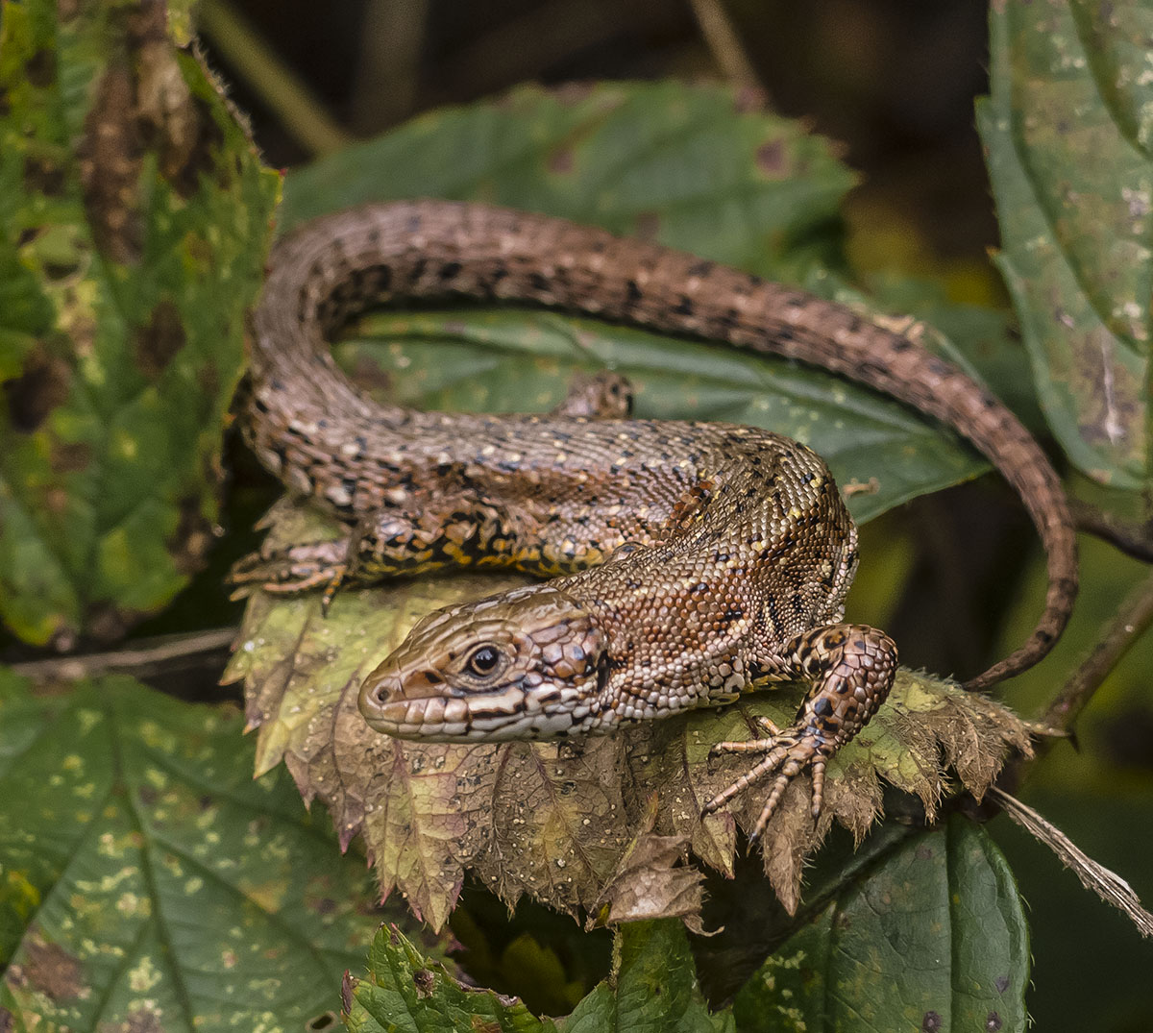

Содержание
Government structer 3
Territorial Structure 6
History 11
Sights 14
State symbols 19
Traditions 22
National holidays 27
National clothes 30
Etiquette features 34
National Food 38
National Sport 43
Famous Personalities 47
Literary Characters 52
Plants and Flora 57

Авторы:
Баранова Анастасия Владимировна
Деревянных Екатерина Олеговна
Шушпанов Александр Николаевич

