

Авторы: Некрасова Полина Анатольевна, Пикалова Марина Витальевна, Решетникова Дарья Леонидовна, Широких Евгения Дмитриевна.

Наставник: Поздеева Екатерина Владимировна

Around Kirov

Сборник видеосюжетов с рабочей тетрадью для 5-9 классов.

Киров

2024

Оглавление

Alexander Garden 4

The Kirov Drama Theater 6

Kirov Park 8

The museum of the History of chocolate «Criollo» 10

The Paleontological Museum 12

The Kirov Puppet Theater 14

Spasskaya Street 16

The Wish Tree 18

Аудиоскрипты 20

Введение

Around Kirov – это сборник видеосюжетов с рабочей тетрадью для

5 - 9 классов на основе страноведческого материала о родном городе.

Проект создан для учителей английского языка города Киров с целью повышение уровня развития навыков аудирования учащихся 5–9-х классов на уроках английского языка через использование аудиовизуальных материалов на основе страноведческих сведений о родном городе. Наша рабочая тетрадь с видеосюжетами о достопримечательностях Кирова поможет не только повысить знание английского языка учащихся, но и воспитать патриотизм, любовь и уважение к истории и культуре родного города.

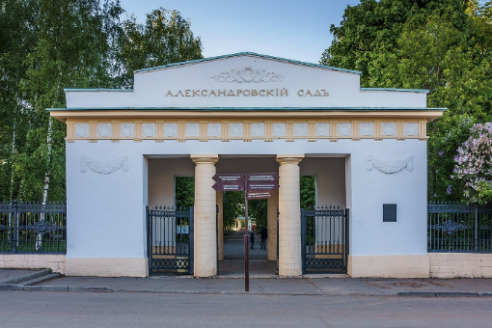

1. Alexander Garden
2. **Look at the pictures.**

* What sight do you see?
* Do you like this place? Why?
* How often do you visit this place?

1. **Match the words with their description.**

|  |  |
| --- | --- |
| a venue | to join together as a group, or to make people join together as a group; to combine |
| a permission | attractive in appearance, especially in an old-fashioned way (especially of a place) |
| picturesque | the act of allowing someone to do something, or of allowing something to happen |
| to unite | the place where a public event or meeting happens |
| to arrange | to plan, prepare for, or organize something |

**Read the sentences and fill the gaps with the words from the table.**

1. I'm trying _________ my work so that I can have a couple of days off next week.
2. The thirteen American colonies ________ to form a new nation.
3. We walked through the __________ streets of the old city.
4. Parents have to give their _________ for their children to go on school trips.
5. The hotel is an ideal _____ for conferences and business meetings.



Now you are going to watch a video about Alexander Garden and then do some tasks.

**3. Watch the video and fill the gaps with suitable words.**

1. It was arranged in ___ after Emperor Alexander I visited the city.
2. In 1835, with the permission of the ________, the garden was named "Alexander Garden" in honor of the heir to the throne, ________.
3. A lot of trees, a peaceful view of the _______________, elegant rotundas, architectural monuments and picturesque views – all this _______ the Alexander Garden.
4. This garden becomes the _______ for various city events and concerts.
5. It is also a favourite ________ spot of people who live in Kirov and guests of the city.

**4. Watch the video again and answer the questions.**

1. When was the Alexander Garden arranged?
2. In honor of whom was the park named?
3. View of what is in the park?
4. What happens in the park?
5. For whom is the park favourite vacation spot?

**5. You are going to give a talk about the sights of your city. You will have to start in 1.5 minutes and speak for not more than 2 minutes (10–12 sentences). Remember to say:**

**- what sight is there in the photos;**

**- what do you know about it;**

**- how often you usually visit this place;**

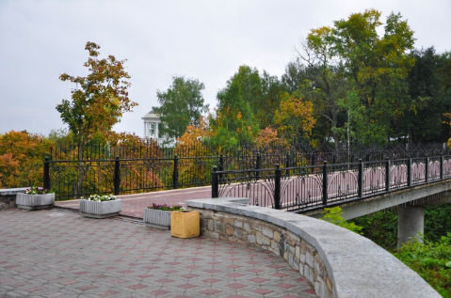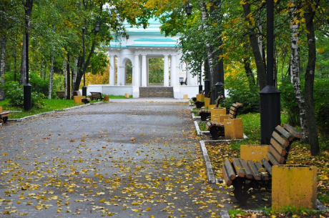**- what is your attitude to this place.**

1. 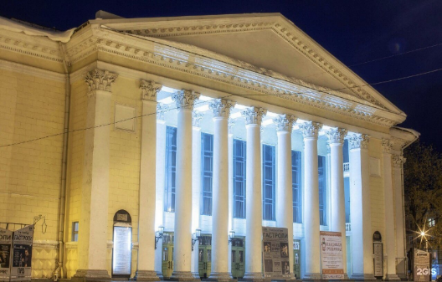The Kirov Drama Theater

**1. Look at the pictures.**

- What sight do you see?

- Do you like this place? Why?

- How often do you visit this place?

1. **Match the words with their description.**

|  |  |
| --- | --- |
| to complement | to bring something into existence |
| a demand | to take part in or become involved in an activity |
| to participate | a strong request |
| to lay down | to officially establish a rule, or to officially state the way in which something should be done |
| to found | to make something else seem better or more attractive when combining with it |

**Read the sentences and fill in the gaps with the words from the table.**

1. This is in line with the policy ______ by the management.
2. The music _______ her voice perfectly.
3. Boston was ______ in 1630 by Puritan colonists from England.
4. She never ________ in any of our discussions, does she?
5. You can't give in to children's ________ all the time.



Now you are going to watch a video about The Kirov Drama Theater and then do some tasks.

**3. Watch the video and fill in the gaps with suitable words.**

1. Kirov Drama Theatre is one of the _______ theatres in Russia.
2. A lot of the most popular ________ plays were staged here.
3. The _________ is complemented by performances of foreign classics.
4. In addition, the theater has its own ________, where more than 100 excursions are held.
5. Dozens of generations of Kirov residents grew up in love with art and in a ___________ attitude to their native theater, and today the ideas laid down by the founders are alive and developing in accordance with the demands of the ______.

**4. Watch the video again and answer the questions.**

1. When was the theatre founded?
2. Whose plays were performed first?
3. By what is the repertoire complemented?
4. How many excursions are held in the theater’s museum?
5. What do Kirov residents respect?

**5. You are going to give a talk about the sights of your city. You will have to start in 1.5 minutes and speak for not more than 2 minutes (10–12 sentences). Remember to say:**

**- what sight is there in the photos;**

**- what do you know about this place;**

**- how often you usually visit this place;**

**- what is your attitude to this place.**

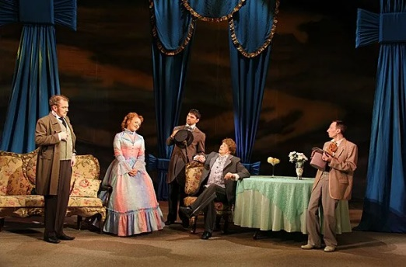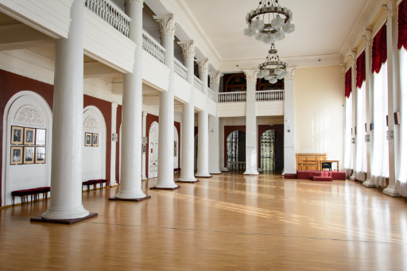

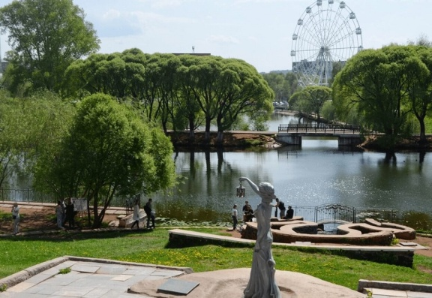III. Kirov Park

**1. Look at the pictures.**

**- What sight can you see?**

**- Have you ever been there?**

**- Do you like this place? Why?**

**- How often do you visit this place?**

**2. Match the words with their descriptions.**

|  |  |
| --- | --- |
| World War II | a designed area where people can relax |
| Female | a [global conflict](https://en.wikipedia.org/wiki/World_war) that lasted from 1939 to 1945. |
| To appear | A [large](https://dictionary.cambridge.org/dictionary/english/large), [vertical](https://dictionary.cambridge.org/dictionary/english/vertical) [wheel](https://dictionary.cambridge.org/dictionary/english/wheel) in an [amusement](https://dictionary.cambridge.org/dictionary/english/amusement) [park](https://dictionary.cambridge.org/dictionary/english/park) with [seats](https://dictionary.cambridge.org/dictionary/english/seat) that [stay](https://dictionary.cambridge.org/dictionary/english/stay) [horizontal](https://dictionary.cambridge.org/dictionary/english/horizontal) as the [wheel](https://dictionary.cambridge.org/dictionary/english/wheel) [turns](https://dictionary.cambridge.org/dictionary/english/turn) round |
| A pond | [belonging](https://dictionary.cambridge.org/dictionary/english/belonging) or [relating](https://dictionary.cambridge.org/dictionary/english/relate) to women: |
| A recreation place | to [start](https://dictionary.cambridge.org/dictionary/english/start) to be [seen](https://dictionary.cambridge.org/dictionary/english/seen) or to be [present](https://dictionary.cambridge.org/dictionary/english/present) |
| Ferris wheel | a still [area](https://dictionary.cambridge.org/dictionary/english/area) of [water](https://dictionary.cambridge.org/dictionary/english/water) [smaller](https://dictionary.cambridge.org/dictionary/english/small) than a [lake](https://dictionary.cambridge.org/dictionary/english/lake), often [artificially](https://dictionary.cambridge.org/dictionary/english/artificially) made |

**Read the sentences and fill in the gaps with the words from the table**

1) During my history class, we learned about _________ and how it affected many countries.

2) My friend visited a _______ monastery and said the architecture was beautiful.

3) A rabbit ________ out of a magician’s hat.

4) There are ducks swimming in the ______ at the park near my house.

5) We're planning to go to a __________ this weekend, I'm very excited!

6) My family and I rode on the _________l and had an amazing view of the city.



Now you are going to watch a video about Kirov Park and then do some tasks.

**3.Watch the video and fill in the gaps with suitable words.**

1) Kirov Park is the _______ park of the city.

2) There was a female Preobrazhensky _________ on the area of the main city park.

3) It was decided to build a _________ in the lower part of the park.

4) All the buildings of the park formed a _________ complex.

5) There are children’s _________ in the park

**4. Watch the video again and answer the questions.**

1) When was the hotel “Vyatka” built?

2) What historical event is associated with appearance of the “Diorama”?

3) How many meters high is the Ferris wheel?

4) What other buildings are there in the park?

5) Why do people like visiting this park?

**5. You are going to give a talk about the sights of your city. You will have to start in 1.5 minutes and speak for not more than 2 minutes (10–12 sentences). Remember to say:**

- what sight is there in the photos;

- where is it located;

- how often you usually visit this place;

- what is your attitude to this place.

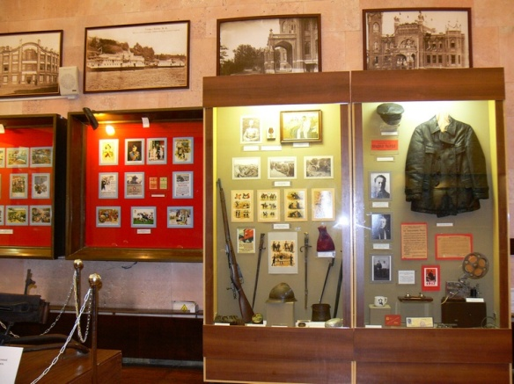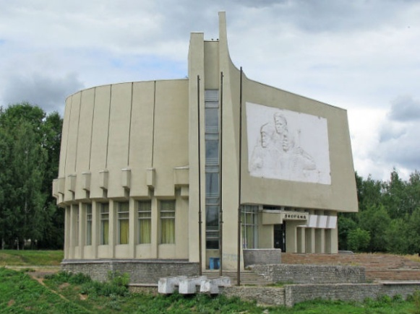

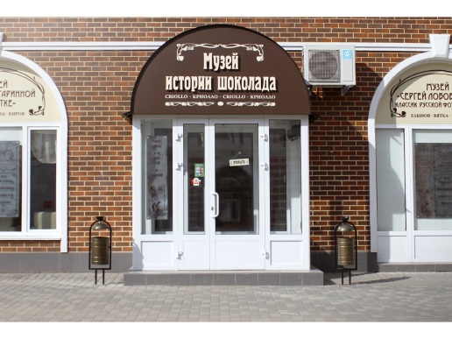IV. The museum of the History of chocolate «Criollo»

**1. Look at the pictures.**

**-What sight can you see?**

**-Have you ever been there?**

**-Do you like this place? Why?**

**-How often do you visit this place?**

**2. Match the words with their description.**

|  |  |
| --- | --- |
| To plunge | whole or complete, with nothing missing |
| To acquaint | to show, express, or be a sign of something: |
| Foamy | to (cause someone or something to) move or fall suddenly and often a long way forward, down, or into something |
| An invention | to make someone or yourself familiar with something |
| To reflect | something that has never been made before, or the process of creating something that has never been made before |
| Entire | made of or producing a mass of very small bubbles |

**Read the sentences and fill in the gaps with the words from the table.**

1. But besides the _______ ocean and golden beaches, the city gives the atmosphere of a tropical carnival and bright sun all year round.
2. We ran down to the beach and _______ into the sea.
3. Take time ______ yourself with the rules.
4. Between them they ate an ______ cake.
5. The statistics reflect a change in people's spending habits.
6. The world changed rapidly after the invention of the phone.



Now you are going to watch a video about The Museum of the History of chocolate «Criollo» and then do some tasks.

**3. Watch the video and fill in the gaps with suitable words.**

1) The museum’s exposition reflects the entire ______of the invention of _______ beloved by people of all ages.

2) Visitors will be able to plunge into the atmosphere of the Mexican _______ …

3)…take pictures with the ______ dog Shanni - the _______ of the museum…

**4. Watch the video again and answer the questions.**

1) What does the museum show?

2) Who is the curator of the museum?

3) What drink can visitors of the museum taste?

4) What things can visitors buy in the boutique?

**5. You are going to give a talk about the sights of your city. You will have to start in 1.5 minutes and speak for not more than 2 minutes (10–12 sentences). Remember to say:**

**-What is this museum about;**

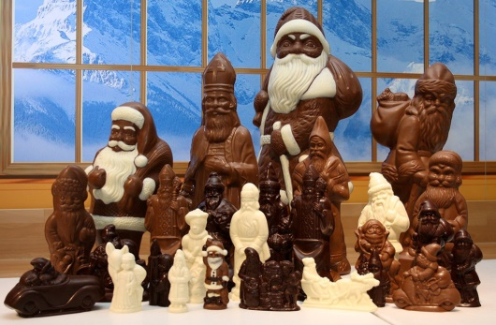**-What can people do in this museum;**

**-Have you ever been there;**

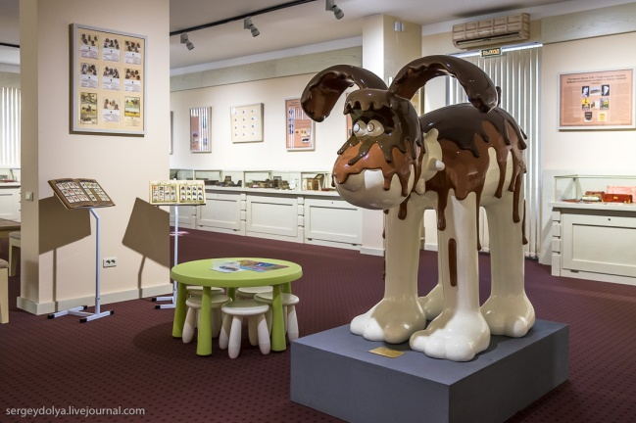**-What is your attitude to this place.**

V. The Paleontological Museum

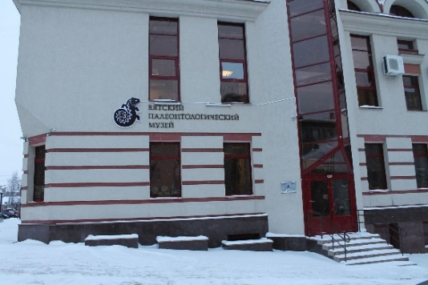**1. Look at the pictures.**

**-What sight can you see?**

**- Have you ever been there?**

**- Do you like this place?**

**Why?**

**- How often do you visit this place?**

**2. Match the words with their descriptions.**

|  |  |
| --- | --- |
| Annually | Opening up the ground to  investigate archaeological sites. |
| Excavations | A collection of objects on  display, and the place where  they are displayed. |
| Consists of | A large homogeneous group,  a type of |
| Exhibition | Every year (regularly) |
| Species | Eating animal food |
| Predatory | Tools for working (digging,  clearing, carrying) with soil  and bulk materials |
| Shovel | include sb-something |

**Read the sentences and fill in the gaps with the words from the table**

1. Victory Day is celebrated in Russia __________on 9 May.
2. Phase One will _______a new high speed rail line between London

and the West Midlands.

1. Oh, and you're gonna need a_________ to bury your poop.
2. Last ____________carried out here in the thirties.
3. Well, my dad said don't bring home any more dogs, cats, turtles or

snakes, but he never said anything about ___________ birds.

1. The House of Culture comprises a theatre, a cinema, ____________

facilities and offices.

1. Will geeks become endangered ________?



Now you are going to watch a video about The Paleontological Museum and then do some tasks.

**3.Watch the video and fill in the gaps with suitable words.**

1) The Vyatka Paleontological Museum is one of the most _______ museums in Kirov.

2) Since the 30s of the last century, excavations began near the city of ________.

3) In the second hall there is an exhibition that tells about the origin of biological ________ on our planet and the path of their development.

4) Parts of the skeletons of other inhabitants of the ________ era are also located in the hall.

**4. Watch the video again and answer the questions.**

1) How many people visit the museum annually?

2) Why do children go to this museum?

3) What can you see on display in the hall?

4) What is there in the museum that makes you feel like a paleontologist?

**5.You are going to give a talk about the sights of your city. You will have to start in 1.5 minutes and speak for not more than 2 minutes (10-12 sentences). Remember to say:**

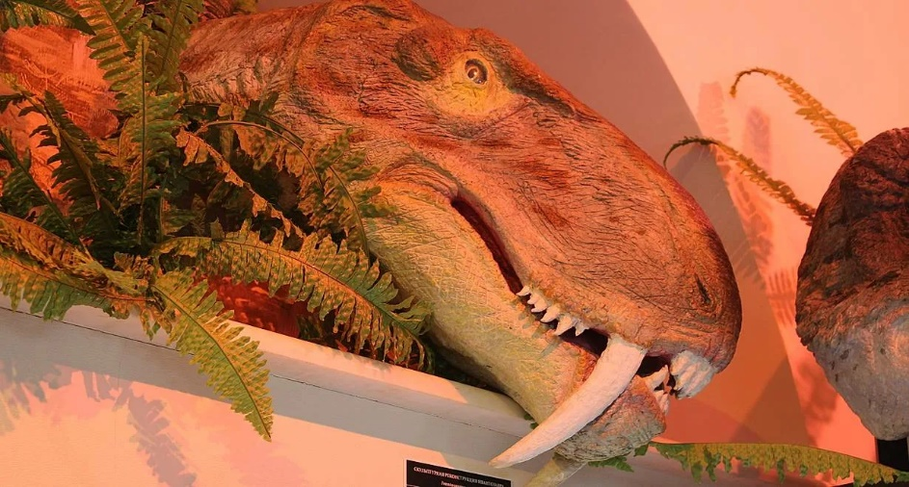-what sights there are in the photos;

- where and when they are located;

- how often you usually visit these places;

- what your attitude to these places is.

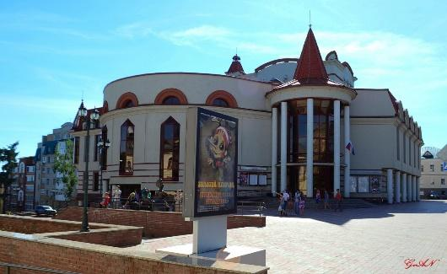VI. The Kirov Puppet Theater

**1. Look at the pictures.**

**-What sight can you see?**

**- Have you ever been there?**

**- Do you like this place?**

**Why?**

**- How often do you visit this place?**

**2. Match the words with their descriptions.**

|  |  |
| --- | --- |
| Equipment | A prominently displayed announcement  of upcoming events |
| Spacious | Property carried by the traveler  or passenger |
| Playbill | Loose, not tight |
| Baggage | The location of the main  theatrical action. |
| Stage | A set of utensils, devices, mechanisms  and appliances necessary for an activity |

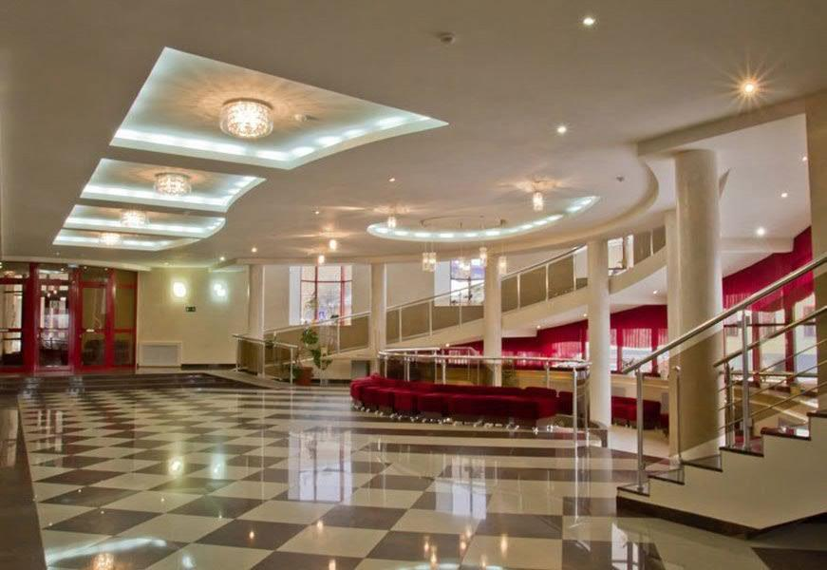**Read the sentences and fill in the gaps with the words from the table**

1. Where can I get diving ___________?
2. He acted on the ______.
3. We got the ___________ today at the playhouse of the play I'm in!
4. The room is __________ and light.
5. Shall I carry your ____________?



Now you are going to watch a video about The Kirov Puppet Theater and then do some tasks.

**3.Watch the video and fill in the gaps with suitable words.**

1) Today it is one of _______ in Russia.

2) Today the Kirov Puppet Theater is located in a beautiful modern building in ___________ of Kirov.

3) The Kirov Puppet Theater's playbill is regularly ________with new productions.

4) At the puppet theater in Kirov, little visitors can watch _________productions, musical performances and other spectacular shows.

5) The first performance of the «________ from China» was based on a play by unknown author.

6) On the _____ of the Kirov Puppet Theater you can see completely different productions that are interesting to both children and adult visitors.

**4. Watch the video again and answer the questions**.

1) Who is the Kirov Puppet Theater named after?

2) What is the name of the first performance?

3) In what year did the theater gain independent status?

4) Where is the theater located?

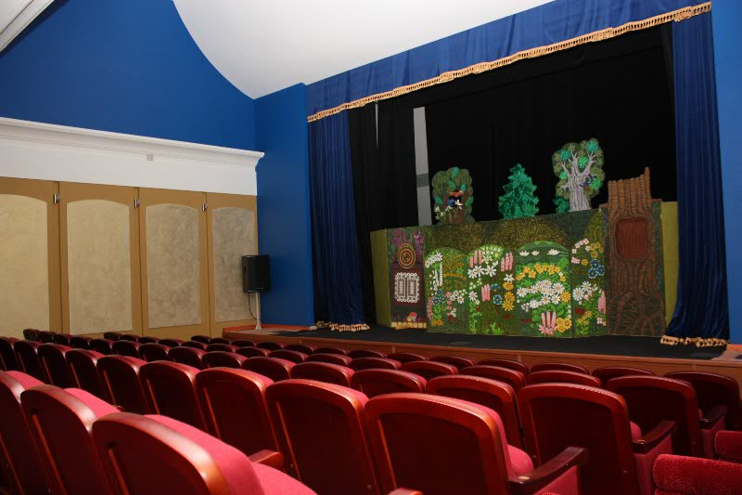**5. You are going to give a talk about the sights of your city. You will have to start in 1.5 minutes and speak for not more than 2 minutes (10-12 sentences). Remember to say:**

-what sights is there in the photo;

- where is it located;

- how often do you usually visit this place;

- what is your attitude to this place.

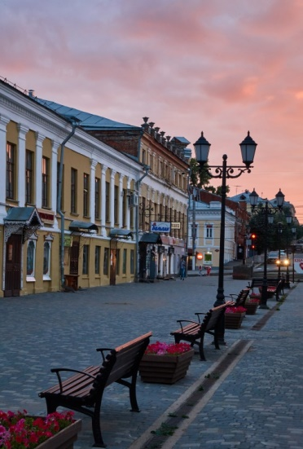VII. Spasskaya Street

**1. Look at the pictures.**

**-What sight can you see?**

**-Have you ever been there?**

**-Do you like this place? Why?**

**-How often do you visit this place?**

**2. Match the words with their description.**

|  |  |
| --- | --- |
| Century | some; an amount that is not exact but is fewer than many |
| paving stone­s | at the present time, in comparison to the past |
| Several | made by shaping a material such as wood, clay, metal, or stone; a piece of music that someone has written |
| Nowadays | a period of 100 years |
| Sculptural | the way that people or things are arranged in a painting or photograph |
| Composition | a flat piece of stone, usually used in groups to cover a path or an area |

**Read the sentences and fill in the gaps with the words from the table**

1. Who remembers those movies ________?
2. _______ of my friends are learning English
3. The main part of the temple's ________ decoration has been lost.
4. The area is partially covered with _______, it is closed to cars.
5. In 19th _______ capitalism most people had nothing.
6. This concerto is one of her earlier _______.



Now you are going to watch a video about Spasskaya Street and then do some tasks.

**3. Watch a video and fill in the gaps with suitable words.**

1) At the beginning of the XX century, Spasskaya Street was one __________ beautiful streets in Vyatka.  
2) The houses standing here are _________ of history.  
3) Nowadays, the street has not _________.  
4) Today on Spasskaya Street there are several _________, two _________ and many different art objects.

**4. Watch the video again and answer the questions.**

1) Who visited Spasskaya Street?

2) What is the Sculptural composition "Meeting place" made of?

3) Where are the gentleman and the lady meeting?

4) What does the clock do?

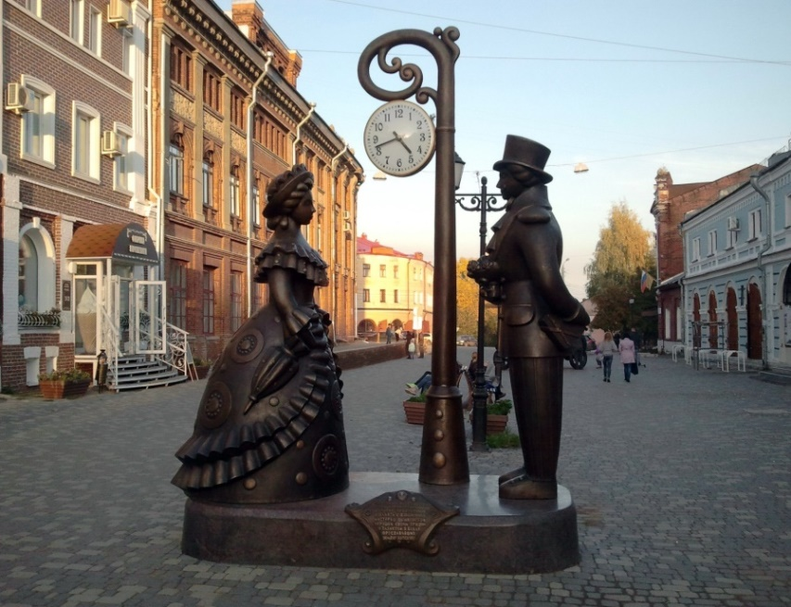**5. You are going to give a talk about the sights of your city. You will have to start in 1.5 minutes and speak for not more than 2 minutes (10–12 sentences). Remember to say:**

**- What did the street look like before;**

**- What else is located on Spasskaya Street;**

**- How often do you usually visit this street;**

**- What is your attitude to this street.**

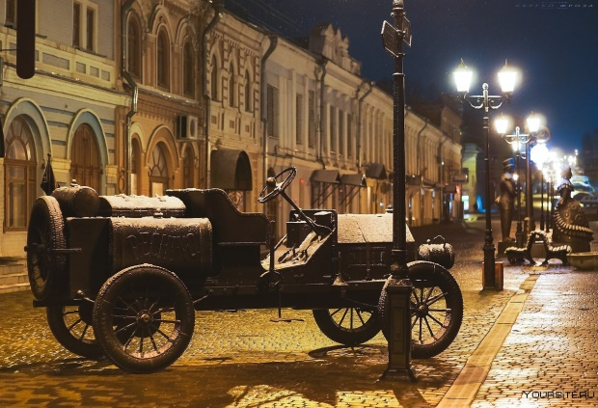

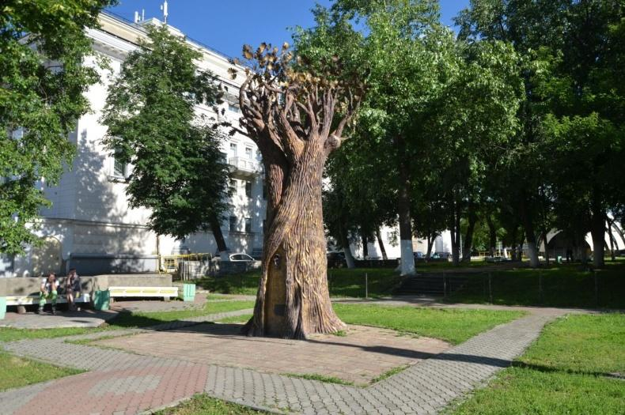

VIII. The Wish Tree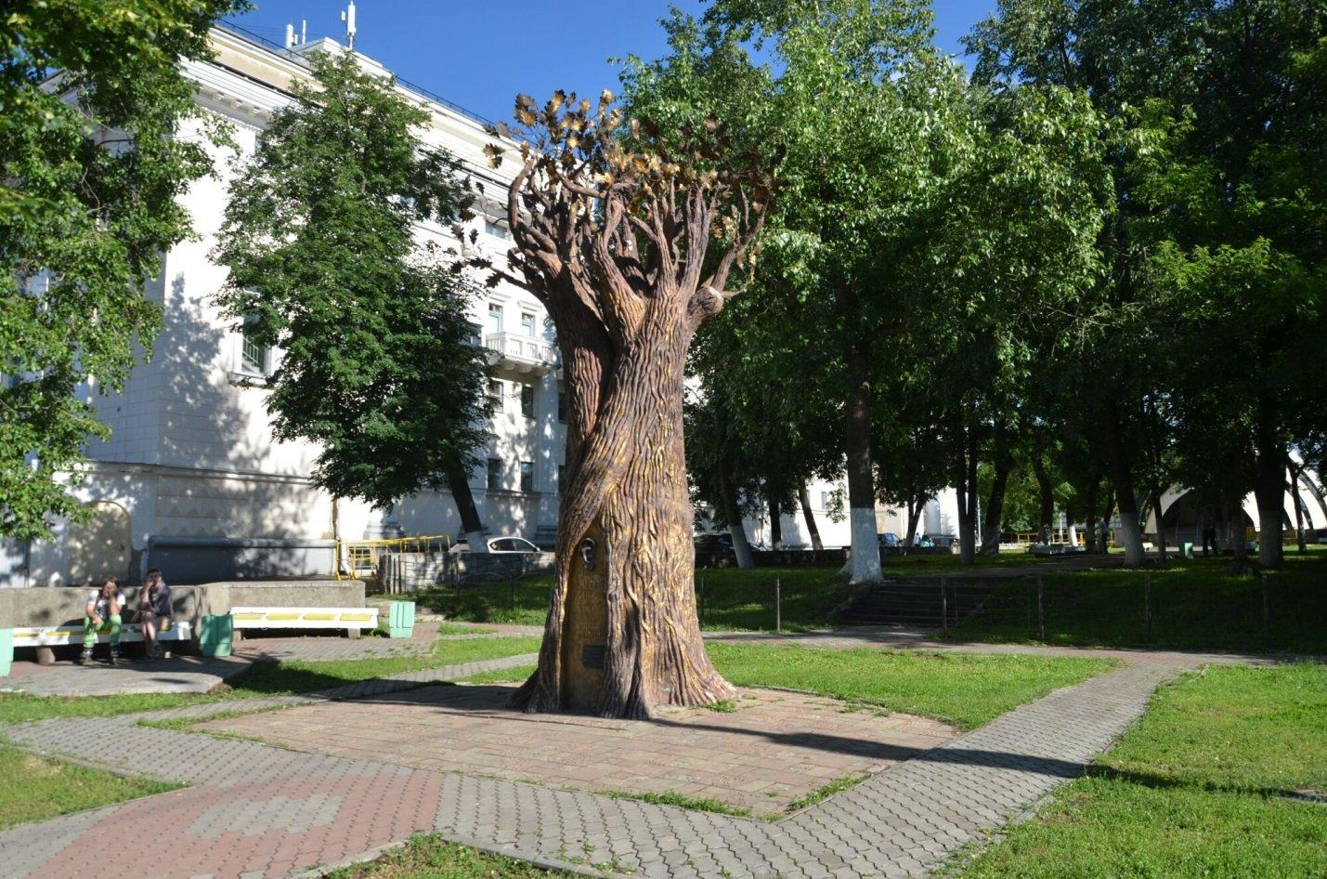

**1. Look at the pictures.**

**-What sight can you see?**

**- Have you ever been there?**

**- Do you like this place?**

**Why?**

**- How often do you visit this place?**

**2. Match the words with their descriptions.**

|  |  |
| --- | --- |
| A wizard | important or noticeable |
| A foundation | someone who lives in a particular town or city |
| A citizen | to speak extremely quietly so that other people cannot hear |
| An inscription | the part of a building, road, bridge that is under the ground and supports it |
| To whisper | a man who has magical powers |
| Significant | words that are written or cut in something |

**Read the sentences and fill in the gaps with the words from the table**

1) The __________ of this building was laid during the Second World War.

2) She came close to him and __________ in his ear that he should go away.

3) Writers often left an __________ at the end of their stories.

4) The celebration of Thanksgiving is a very __________ event for our family.

5) __________ of the city celebrated the New Year on the square.

6) Little __________ worked in an enchanted castle.



Now you are going to watch a video about The Wish Tree and then do some tasks.

**3. Watch the video and fill in the gaps with suitable words.**

1) Wizards cast spells to make people’s _________ come true.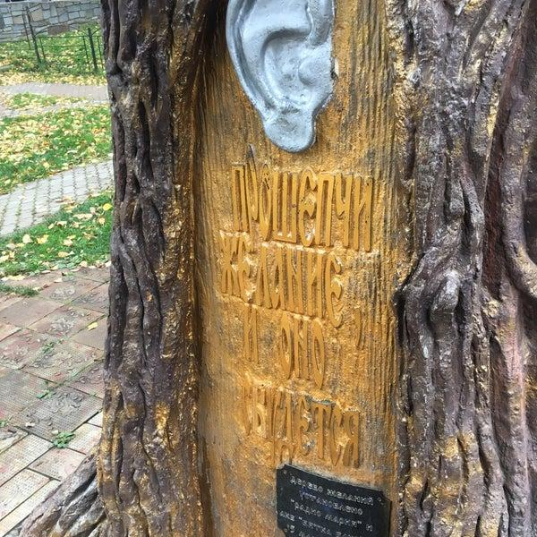

2) About a _________ wishes were laid in the foundation.

3) People wrote their wishes on _________ of paper and brought them to the radio station.

4) The inscription _________ people to whisper a wish.

5) The opening of the Wish Tree was a very _________ event.

**4. Watch the video again and answer the questions.**

1) Where did the Wish Tree appear?

2) Who was the author of the monument?

3) Who was invited to lay the foundation?

4) What does the Wish Tree look like?

**5. You are going to give a talk about the sights of your city. You will have to start in 1.5 minutes and speak for not more than 2 minutes (10–12 sentences). Remember to say:**

**- what sight is there in the photos;**

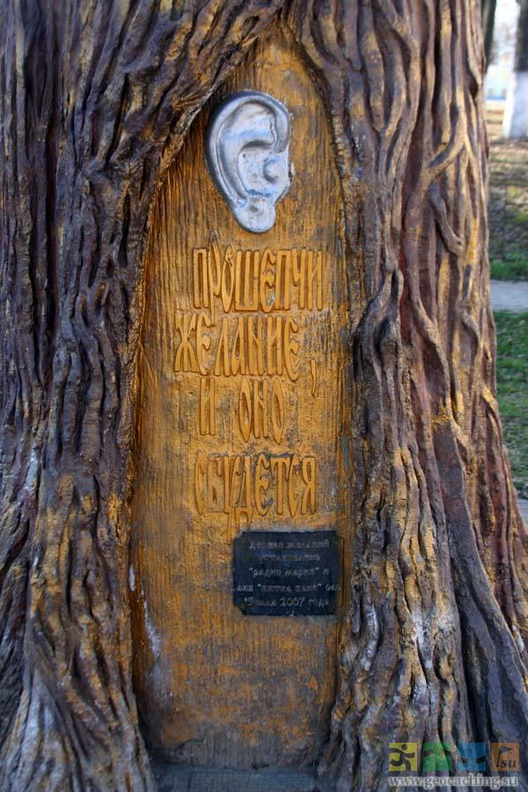**- where is it located;**

**- how often do you usually visit this place;**

**- what is your attitude to this place.**

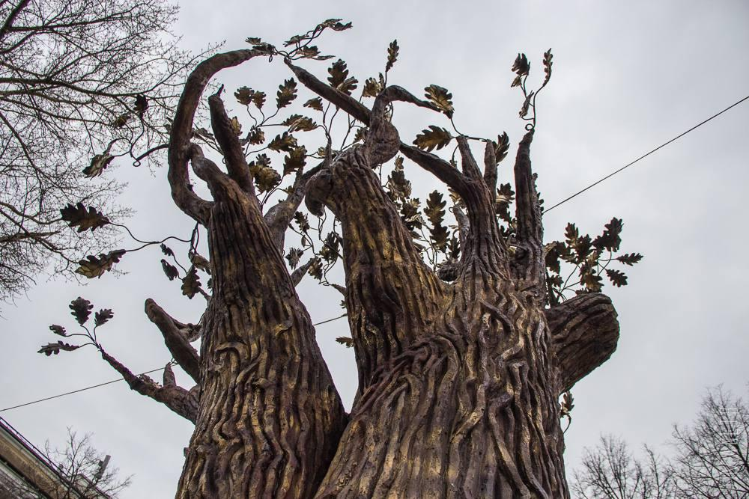

Аудиоскрипты

1. Alexander Garden is one of the oldest parks in the city of Kirov. It was arranged in 1825 after Emperor Alexander I visited the city. The official opening of the garden took place on the 30th of August in 1835. In 1835, with the permission of the emperor, the garden was named "Alexander Garden" in honor of the heir to the throne, Alexander II.

A lot of trees, a peaceful view of the Vyatka River, elegant rotundas, architectural monuments and picturesque views – all this unites the Alexander Garden.

Nowadays the Alexander Garden is the most beautiful place in the Kirov region. This garden becomes the main venue for various city events and concerts. It is also a favorite vacation spot of people who live in Kirov and guests of the city.

1. The Kirov Drama Theatre is one of the oldest theatres in Russia. It was founded in 1877. A lot of the most popular classical plays were staged here. Plays by Alexander Ostrovsky and Alexey Tolstoy were the first.

There are about 30 performances in the theatre every year now. There are performances based on the best plays of Russian classics. The repertoire is complemented by performances of foreign classics.

The Kirov Drama Theater also participates in touring projects. In addition, the theater has its own museum, where more than 100 excursions are held.

Dozens of generations of Kirov residents grew up in love with art and in a respectful attitude to their native theater, and today the ideas laid down by the founders are alive and developing in accordance with the demands of the time.

**III.** Kirov Park is the central park of the city. It was built after the second World War.

Until 1917 there was Solovyevskaya village and the fields of the Vyatka female Preobrazhensky Monastery.

In 1967, it was decided to build a hotel "Vyatka", a swimming pool in the lower part of the park, and a circus in the center.

Later, a "Diorama" appeared, which opened the visual history of the October Revolution.

As a result, the hotel "Vyatka", the circus building, the Diorama and the cascade of ponds formed a single park complex.

Kirov Park has become one of the city residents' favorite recreation places.

Afterwards, children's attractions appeared in the park. Also, a Ferris wheel with a 50-meter height is installed.

**IV.** The museum’s exposition reflects the entire history of the invention of sweets beloved by people of all ages. Visitors will be able to plunge into the atmosphere of the Mexican jungle and visit a mini-plantation of cocoa trees, get acquainted with the Mayan Indian and taste the foamy drink "Chocoatl", take pictures with the chocolate dog Shanni - the curator of the museum, and learn many interesting stories from the world of chocolate. After the tour, visitors can make chocolate, and then visit a chocolate boutique and buy unusual handmade sweets.

**V.** The Vyatka Paleontological Museum is one of the most popular museums in Kirov. More than 23 thousand people visit it annually. Most visitors are children of preschool and school age who are interested in learning how our Earth came to be. But adults will find it no less interesting. Since the 30s of the last century, excavations began near the city of Kotelnich. As a result, twenty completely new species of dinosaurs were discovered. The museum consists of two halls. One of them contains exhibits from the Kotelnichsky location of pareiasaurs and demonstrates the Permian period in the history of the earth. There are complete skeletons of these ancient animals on display. In the second hall there is an exhibition that tells about the origin of biological species on our planet and the path of their development. The centerpiece of this exhibition is the skeleton of Tarbosaurus, a predatory and dangerous dinosaur. Parts of the skeletons of other inhabitants of the Mesozoic era are also located in the hall. The museum organizers also thought about children. In the hall there is a kind of “sandbox” in which everyone can try themselves in the role of paleontologists. With the help of special brushes and shovels, they will be able to dig up the bones of a real ancient dinosaur.

**VI.** The Kirov Puppet Theater named after A.N. Afanasyev was founded in 1935. Today it is one of the oldest in Russia. The first performance of the «Baggage from China» was based on a play by unknown author. A. N. Afanasyev was the most famous director who staged more than 150 plays for children. And in 1937, the Kirov Regional Puppet Theatre got an independent status. Today the Kirov Puppet Theater is located in a beautiful modern building in the old center of Kirov. The theater has two auditoriums, a stage, the latest electric lighting and sound equipment, and spacious and bright art workshops. On the stage of the Kirov Puppet Theater you can see completely different productions that are interesting to both children and adult visitors. The Kirov Puppet Theater's playbill is regularly updated with new productions. At the puppet theater in Kirov, little visitors can watch fairy-tale productions, musical performances and other spectacular shows.

**VII**. At the beginning of the XX century, Spasskaya Street was one of the most beautiful streets in Vyatka. There were paving stones and trees everywhere. The houses standing here are full of history. For example, the scientist Konstantin Eduardovich Tsiolkovsky and Natalya Nikolaevna Goncharova, the wife of A. S. Pushkin visited the street. Nowadays, the street has not changed. Today on Spasskaya Street there are several museums, two theaters and many different art objects. For example, the Sculptural composition "Meeting place". The composition is made of bronze in the style of a Dymkovo toy. The gentleman and the lady are meeting at the city clock, which not only shows the time, but also gives a sound signal every hour.

**VIII.** The Wish Tree is one of the unusual sights of Kirov. It appeared in a small square near the Drama theater in 2007. The author of this amazing monument was Viktor Seleznev. Wizards were invited to lay the foundation, who cast spells to make people's wishes come true. Also, about a thousand real wishes of citizens were laid in the foundation, which people wrote on pieces of paper and brought to the radio station.

The Wish Tree looks like an oak with an ear on it. There is an inscription inviting people to whisper a wish. The opening of the Wish Tree was a very bright event.

Nowadays the Wish Tree is one of the most significant attractions. There are always a lot of people around him, each of whom believes that his wish will come true.